10PEARLS
10Shine Internship Program

Assignment No. 7

Selenium/Playwright Automation
Project: Daraz.pk
Domain: Quality Assurance (Manual + Automation)

Submitted by: Muhammad Faizan Anwar
QA Intern – 10Shine Cohort

1. Executive Summary
This report documents the successful end-to-end (E2E) UI automation of the Daraz.pk e-commerce platform. Based on the technical sync-up recommendations, Microsoft Playwright was selected over Selenium due to its superior handling of modern, dynamic web applications, built-in auto-waiting, and advanced trace viewing capabilities.
- Key Technical Milestones Achieved:
- Implemented a highly robust Page Object Model (POM) architecture to manage complex, dynamic locators across multiple pages.
- Successfully automated complex filtering logic (Brand and Price boundaries) on a heavily dynamic DOM.
- Engineered a custom URL-hijacking strategy to bypass unpredictable 'new tab' behaviors and pop-up blockers native to Daraz.
- Utilized Playwright's native HTML reporting and Trace Viewer for deep test execution analytics.

2. Framework Design: Page Object Model (POM)
To ensure code maintainability and scalability against a constantly updating site like Daraz, the automation logic was strictly separated from the web locators using the Page Object Model.

2.1 HomePage.js
Handled the initial navigation and search execution. Playwright's 'networkidle' state was utilized to ensure the heavy homepage fully loaded before the 'electronics' keyword was injected and submitted via a simulated 'Enter' keypress.

2.2 SearchResultsPage.js
Managed the dynamic filtering. The script dynamically located the 'Samsung Electronics' brand text and applied a price boundary (Rs. 500 - 5000). A dynamic element counter was implemented to verify that the search yielded valid results (Count > 0) before proceeding.

2.3 ProductDetailsPage.js
Responsible for analyzing the final product page. It scans the entire DOM body text to verify the existence of 'Free Delivery' or 'Free Shipping' strings, returning a strict boolean result to the test runner.

3. Technical Challenges & Engineering Solutions
Automating a production-level, heavily trafficked site like Daraz.pk presented several real-world QA challenges, which were resolved using Senior-level automation techniques.
A. Dynamic Accessible Names (UI Mutations):
During the price filter execution, Daraz's backend dynamically stripped the accessible 'name' attribute from the submit button, causing standard locator timeouts.
Resolution: The test was refactored to bypass the button click entirely, instead utilizing a direct keyboard simulation (page.press('Enter')) on the input field, guaranteeing execution regardless of UI mutations.
B. The 'Phantom Tab' & Pop-up Suppression:
Daraz products are designed to open in a new tab (_blank). However, automated browsers often suppress these events, causing context.waitForEvent('page') commands to time out.
Resolution (URL Hijacking): A custom method was written to locate the first product card, extract the raw 'href' attribute directly from the HTML, append the 'https:' protocol, and force the current active tab to navigate directly to the product. This completely neutralized the cross-tab flakiness.

4. Execution Evidence & Reporting
The test suite executed successfully, traversing the entire E2E flow in under 50 seconds. Playwright's native reporting engine generated an interactive dashboard and execution trace.

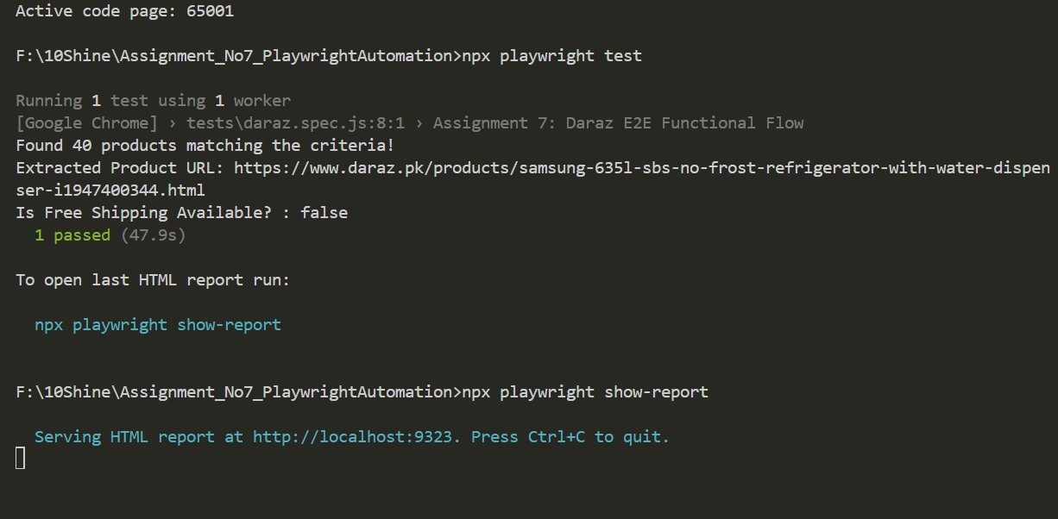

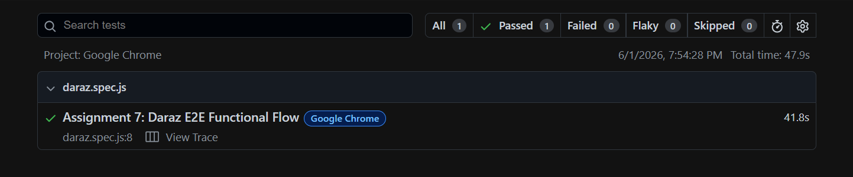

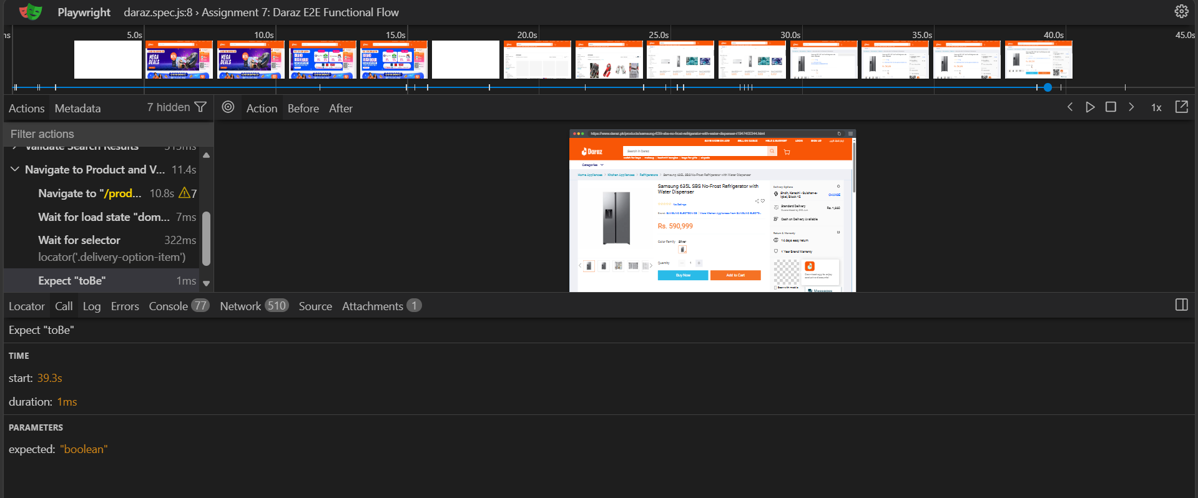

End of Submission — 10Shine Internship Program | Quality Assurance Domain

