**Introduction**

The threat of flooding has escalated in South Asia due to heightened susceptibility and exposure. The massive flood in Pakistan in August 2022 serves as a stark example of the potential scale and destruction that may continue to grow in a warming climate. The 2022 flood's impact on Pakistan's southern provinces was unprecedented, surpassing recent incidents in terms of extensive geographical and temporal reach. This event resulted in the second-highest human death toll (in Pakistan) while being the foremost incident that displaced approximately 33 million individuals within the country.

As per a preliminary evaluation by the Atlantic Council's Uzair Younus and economist Ammar Khan, the direct harm to infrastructure, residences, livestock, and agriculture exceeds $3 billion – a staggering sum for a developing nation such as Pakistan. By analyzing observations and climate forecasts, this report explores the potential origins of the floods (United States Institute of Peace). The 2022 flood in Pakistan emphasizes the adaptation difficulties South Asia faces, as well as the pressing need for climate mitigation measures to decrease the likelihood of similar events.

**Damages**

Half a year following the unparalleled flooding that devastated Pakistan, over 10 million individuals residing in the impacted regions continue to lack access to clean drinking water, compelling them to resort to using and consuming potentially harmful, disease-carrying water.

Approximately 20.6 million people, 9.6 million of whom are children, require humanitarian aid. Several of the most severely affected areas are among Pakistan's most susceptible regions, where children already face high levels of malnutrition, limited access to water and sanitation, and low school attendance.

The recovery process for families dealing with the overwhelming destruction will span months, if not years. The floods impacted 33 million people, claimed over 1,700 lives, and damaged or destroyed more than 2.2 million homes. The water infrastructure in the affected zones was severely damaged, forcing over 5.4 million people, including 2.5 million children, to depend entirely on polluted water from ponds and wells. (UNICEF)

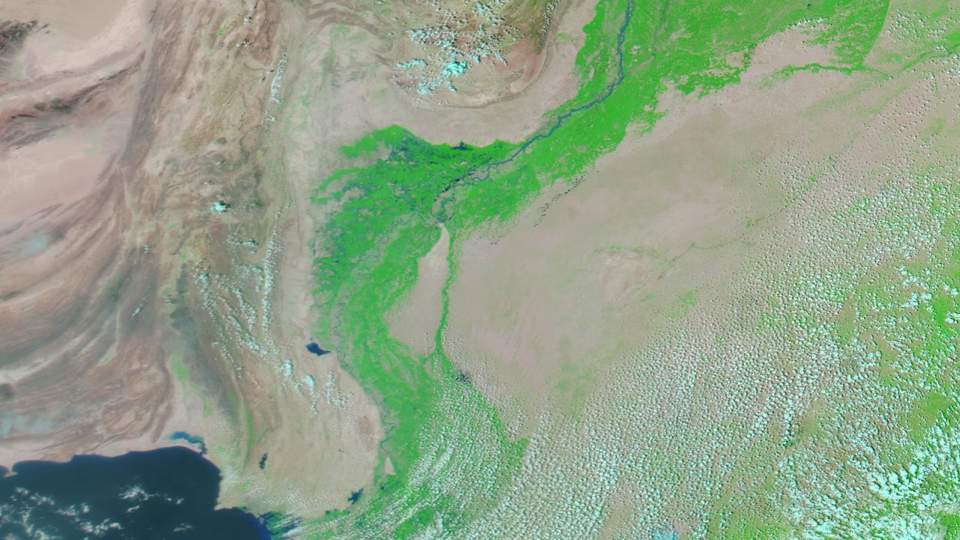

Satellite Image by NASA 2021

Satellite Image by NASA 2022

**Monsoon Rainfall**

Between June and August, Pakistan experienced an extraordinary 190 percent of its typical rainfall. In July alone, rainfall surpassed the average monsoon total by approximately 26 percent, making it the rainiest July on record since 1961. The intense precipitation led to saturated soil, inhibiting the ground's ability to absorb further water during August's storms. August is typically the peak of monsoon season, and it continued to witness remarkable downpours and flooding.

U.N. Secretary-General António Guterres [said](https://www.cnn.com/2022/08/29/asia/pakistan-flood-damage-imf-bailout-intl-hnk/index.html), “The Pakistani people are facing a monsoon on steroids”. The regions of Baluchistan and Sindh experienced extraordinarily intense rainfall, leading to extensive and widespread damage. Between mid-June and August, Baluchistan received 430 percent of its typical rainfall, while Sindh experienced 460 percent of its average precipitation. Approximately 50 different urban areas witnessed monthly rainfall levels substantially higher than the norm. (Washington Post)

The figures below show the drastic spike in the monsoon rainfall in 2022 as recorded by different organizations:

|  |  |
| --- | --- |
| Legend for Abbreviations | |
| CPC | Climate Prediction Center |
| IMERG | Integrated Multi-satellite Retrievals (NASA) |
| ERA5 | European Centre for Medium-Range Weather Forecasts |
| Station | [Pakistan Meteorological Department](https://www.pmd.gov.pk/) |

Monsoon in Pakistan is primarily due to the seasonal reversal of winds and the differential heating of land and water. This weather phenomenon typically occurs during the summer months, between June and September.

During the summer, the Indian subcontinent experiences intense heating from the sun, causing the land to become much warmer than the surrounding Indian Ocean. This temperature difference leads to the creation of a low-pressure system over the subcontinent. As a result, moist air from the Indian Ocean is drawn towards the landmass.

The moisture-laden winds from the southwest Indian Ocean are forced to rise as they encounter the mountain ranges of the Western Ghats and the Himalayas. As the air rises, it cools and condenses, forming clouds and eventually leading to heavy rainfall across the region, including Pakistan.

Figure X and Z shows the typical path of Monsoon Winds that enter through the north of Pakistan. In comparison to this, Figure Y by Pakistan Meteorological Department shows the path of these winds in the year 2022.

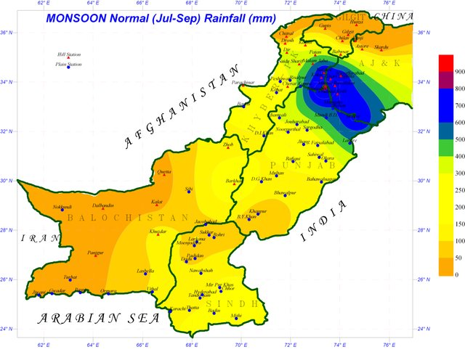

This phenomenon can be linked to a study conducted in 2021 by You and Ting which showed that in the period 1979 – 2018, the secular variation of rainfall extremes over India is characterized by a dipole-like pattern with increased rainfall extremes over south-central India and decreased rainfall extremes over north-central India.

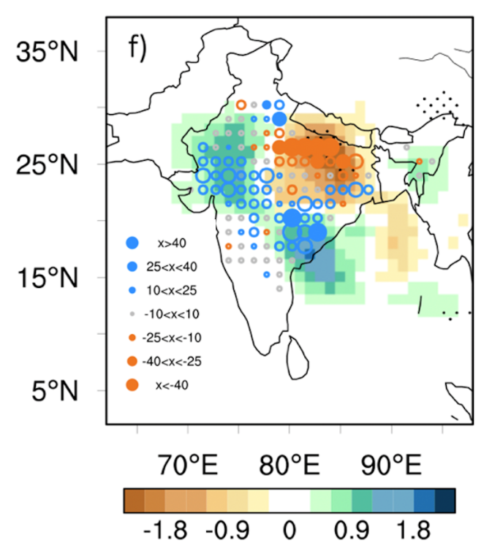It shows that, since the inception of satellite records in the late 1970s, the pathways of low-pressure systems have experienced a southward shift. The study's map, as seen below, demonstrates the altered systems that contribute to heightened precipitation events (represented by blue dots) along a southeastern to northwestern corridor, spanning from Andhra Pradesh to Rajasthan, and potentially extending into Pakistan.

**Global Warming and Heat Waves**

The 2022 heat wave in India and Pakistan resulted in hottest March in the subcontinent since 1901. The historical temperature from the PMD archives of Pakistan revealed the anomalous nature of 2022 temperature between March and May. Figure X shows the monthly temperatures up till February 2023.

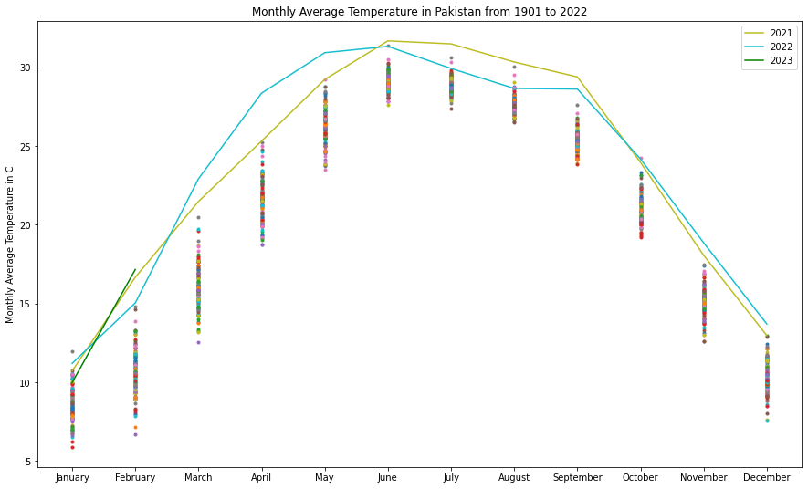

Figure Z shows visualizes the trend in the average annual temperature of Pakistan from 1901 – 2022. The trend shows a sharp rise in temperatures in the last two decades as a result of global warming. The meteoric rise in the average temperature in 2022 can also be observed.

In order to explore whether such temperature anomalies can be predicted, temperatures from 2010 – 2022 were forecasted using LSTM neural network. LSTMs have shown to give better performance than the traditional ARIMA and SARIMA in the domain of time series forecasting (Feng, 2022)

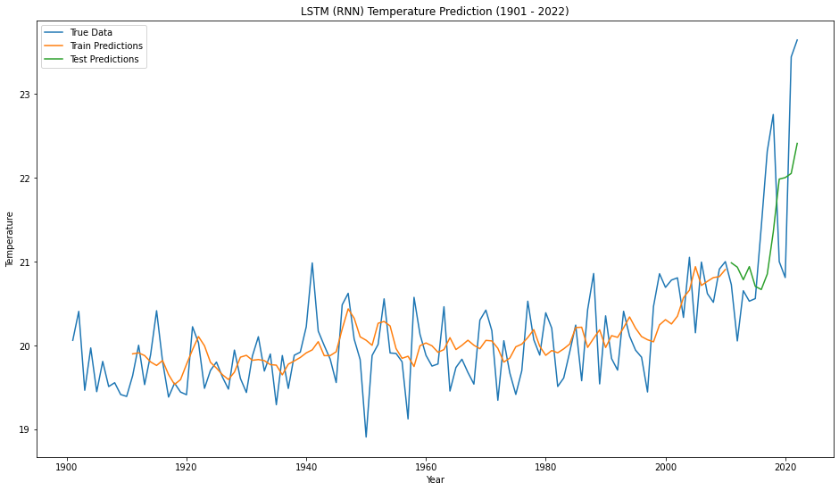

**Conclusion**

**References**

<https://doi.org/10.1029/2022EF003230>

<https://www.unicef.org/emergencies/devastating-floods-pakistan-2022>

<https://www.carbonbrief.org/climate-change-likely-increased-extreme-rainfall-that-led-to-pakistan-flooding/>

<https://www.usip.org/publications/2022/09/why-pakistan-drowning>

(<https://doi.org/10.3389%2Ffpubh.2022.946563>).

https://edition.cnn.com/2022/08/31/asia/pakistan-floods-forms-inland-lake-satellite-intl-hnk/index.html