**Pre-Board 1 (December 2024) Class – X**

**Subject – Mathematics**

**Time allowed: 3 hours M.M: 80**

**GENERAL INSTRUCTIONS:**

*Answers to this Paper must be written on the paper provided separately.*

*You will not be allowed to write during the first 15 minutes.*

*This time is to be spent in reading the question paper.*

*The time given at the head of this Paper is the time allowed for writing the answers.*

*Attempt* ***all*** *questions from* ***section A*** *and* ***any four*** *questions from* ***section B.***

***All working including rough work, must be clearly shown and must be done on the same sheet as the rest of the answer****.*

***Omission of essential working will result in loss of marks.***

*The intended marks for questions or parts of questions are given in brackets [ ] .*

***Mathematical tables are provided****.*

**Section – A (40 marks) (Attempt all questions from this section)**

**Question 1**:

**Choose the correct answers to the questions from the given options**: [15]

1. Vimla had a recurring deposit account in ICICI bank and deposited ₹ 1000 per month

1

for 2

2

years. If the rate of interest was 10% p.a., then the matured value of this

account is:

a. ₹ 32,775 b. ₹ 33,875 c. ₹ 23,775 d. ₹ 34,975

1. The list price of an article is ₹ 885. The rate of GST is 18%. Then, shopkeeper reduce the price of the article and sell the article at ₹ 885 inclusive GST. The reduction of the article is

a. ₹ 135 b. ₹ 150 c. ₹ 185 d. ₹ 235

1. Observe the table and find if X and Y are directly proportional. Then the values of M and N are:

|  |  |  |  |  |  |  |  |
| --- | --- | --- | --- | --- | --- | --- | --- |
| X | 20 | 17 | 14 | 11 | 8 | N | 2 |
| Y | 40 | M | 28 | 22 | 16 | 10 | 4 |

* 1. No
  2. Yes, M = 34 and N = 5
  3. Yes, M = 51 and N = 1
  4. Yes, M = 1 and N = 20

A

D

x

1. In the figure, the product ab is equal to:
   1. c + x b. cx

c. bc d. b + c a

B b C

1. The pair of equations y = 0 and y = – 3 has:
   1. no solution b. one solution

c. two solution d. infinitely many solutions

1. If x = p sec 𝜃 and y = q tan 𝜃, then
   1. 𝑥2 − 𝑦2 = p2q2 b. 𝑥2𝑞2 − 𝑦2𝑝2 = 𝑝𝑞

𝑥2𝑞2 − 𝑦2𝑝2 = 1

c.

𝑝2𝑞2

d. 𝑥2𝑞2 − 𝑦2𝑝2 = 𝑝2𝑞2

1. In the given figure, the height of boy is 1.8 m and the height is 14.8 m. If PQ = 13√3 m, then the angle of elevation of the top of the building from his eyes is:

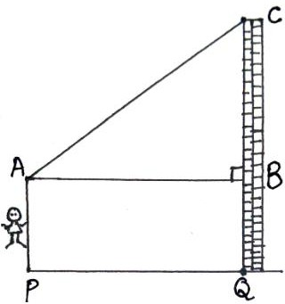

a. 30° b. 60° c. 45° d. 90°

1. A semi – circular sheet of radius 5 cm is folded into the shape of a cone as shown in figure.

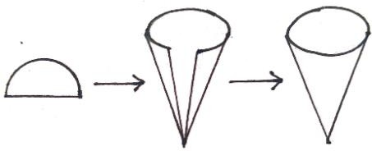

Due to overlapping during folding, the radius of the base of the cone becomes 80% of what it would have been without overlap.

**Statement 1**: The base radius of the cone with overlap is 2.5 cm.

**Statement 2**: Volume of the cone is 21cm3. (Approx) [𝑈𝑠𝑒 𝜋 = 22]

7

**Which of the following is valid?**

* 1. Both the statements are true.
  2. Both the statements are false.
  3. Statement 1 is true, and statement 2 is false.
  4. Statement 1 is false, and statement 2 is true.

1. If a regular hexagon is inscribed in a circle of radius r, then its perimeter is:

a. 3r b. 6r c. 9𝑟 d. 12𝑟

1. The co-ordinates of the point Q obtained from reflection of P (4, 1) in line y = 3 are:

a. (– 4, 1) b. (4, –1) c. (4, 5) d. (5, 4)

1. The ratio of diameter to height of a Borosil cylindrical glass is 3:5. If the actual diameter of the glass is 6 cm, then the curved surface area of the glass is:

a. 120π b. 60π c. 30π d. 18π

1. Two vertices of a triangle are (– 1, 2) and (2, 7) and its centroid is at the origin. The third vertex of the triangle is:
   1. (1, 9) b. (– 1, – 9)

c. (– 1, 9) d. (1, – 9)



Q

O

55°

R

1. In the adjoining figure, PQ and PR are tangents from P to a circle with centre O.

If ∠POR = 55°, then ∠QPR is: P

* 1. 35° b. 55°

c. 70° d. 80°

1. The probability that a number selected at random from the numbers 1, 2, 3, ………,15

is a multiple of 4 is

4 2 1 1

* 1. b. c. d. 

15 15 15 5

1. **Assertion** (A): The difference in class marks of the modal class and the median class of the following frequency distribution table is 0.

|  |  |  |  |  |  |
| --- | --- | --- | --- | --- | --- |
| Class interval | 20 – 30 | 30 – 40 | 40 – 50 | 50 – 60 | 60 – 70 |
| Frequency | 1 | 3 | 2 | 6 | 4 |

**Reason** (R): Modal class and median class are always the same for a given frequency distribution.

* 1. Both A and R are true, and R is the correct reason for A.
  2. Both A and R are true, and R is the incorrect reason for A.
  3. A is true, R is false.
  4. A is false, R is true.

**Question 2**:

1. If a, b, c, d are in continued proportion, prove that [4]

(𝑏 − 𝑐)2 + (𝑐 − 𝑎)2 + (𝑑 − 𝑏)2 = (𝑎 − 𝑑)2

1. 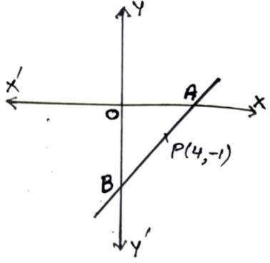A line AB meets x – axis at A and y – axis at B. P (4, –1) divides AB in the ratio of 1: 2. Find:
   1. the coordinates of A and B.
   2. slope of the line AB.
   3. slope of the line perpendicular to AB.
   4. the equation of the line through P and perpendicular to AB.

[4]

1. In the given figure, an isosceles ∆ABC is inscribed in a

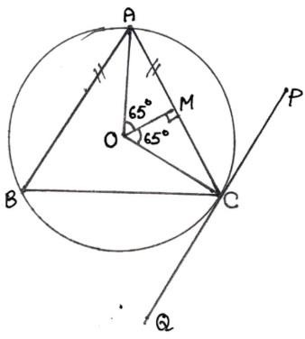circle with centre O. PQ is a tangent to the circle at C. OM is perpendicular to chord AC and ∠COM = 65°.

Hence find:

* 1. ∠ABC
  2. ∠BAC
  3. ∠BCQ

[4]

**Question 3**:

1. A car covers a distance of 400 km at a certain speed. Had the speed been 12km/h more, the time taken for the journey would have been 1hr 40min less? Find the original speed of the car. [4]
2. From a solid cylinder, whose height is 8 cm and radius is 6 cm, a conical cavity of height 8 cm and of base radius 6 cm is hollowed out. Find the volume of the remaining solid. Also, find the total surface area of the remaining solid. [4]
3. Study the graph and answer each of the following. [5]
   1. Write the coordinates of points A, B, C & D.
   2. Given that, point C is the image of point A. Name write equation of the line of reflection.
   3. Write the coordinates of the image of the point D under reflection in y-axis.
   4. What is name given to a point whose image is the point itself?
   5. On joining the points A, B, C, D and A in order, a figure is formed. Name the closed figure.

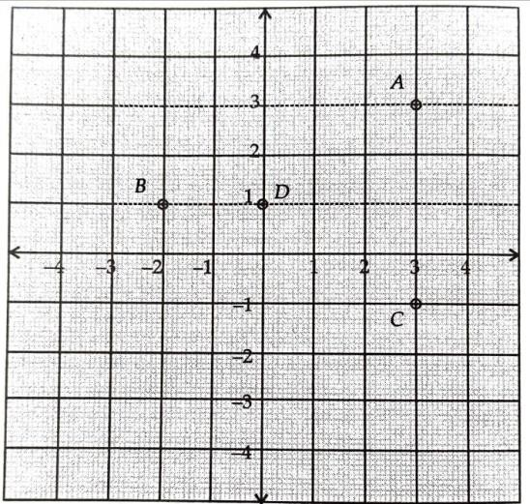

**Section – B (40 marks)**

**(Attempt any four questions from this section)**

**Question 4**:

1. A retailer buys an air – conditioner from a wholesaler for ₹ 35,000 and sells it to a consumer at a profit of 8%. If the rate of GST is 28%, then calculate the tax liability of the retailer. [3]
2. Find the equation of a line parallel to the line 2x + y – 7 = 0 and passing through the intersection of the lines x + y – 4 = 0 and 2x – y = 8. [3]
3. Prove by trigonometric identity: √cosec 𝐴 − 1 + √cosec 𝐴 + 1 = 2sec 𝐴. [4]

cosec 𝐴 + 1 cosec 𝐴 − 1

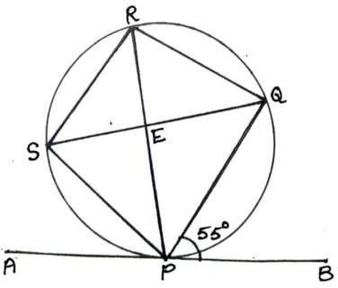**Question 5**:

1. In the given figure, AB is a tangent to the circle at point

P. PQ and PS are bisector of ∠RPB and ∠RPA, respectively. If ∠QPB = 55°, then prove that:

1. SQ is the diameter of the circle.
2. PQR is an isosceles triangle.

[3]

1. Rekha opened a recurring deposit account for 20 months. The rate of interest is 9% per annum and Rekha receives Rs.441 as interest at the time of maturity. Find the amount Rekha deposited each month. [3]
2. Using the step-deviation method, find the mean for the following frequency distribution: [4]

|  |  |  |  |  |  |  |
| --- | --- | --- | --- | --- | --- | --- |
| Class | 0-20 | 20-40 | 40-60 | 60-80 | 80-100 | 100-120 |
| Frequency | 6 | 10 | 14 | 8 | 5 | 2 |

**Question 6**:

1. The line joining (– 2, 5) and (–5, –6) is divided by the line 2x + y = –4. The ratio in which this line is divided in 𝜆: 1. Hence find: [3]
   1. the abscissa in terms of 𝜆.
   2. the ordinate in terms of 𝜆.
   3. the ratio in which the line 2x + y = –4 is divided.
2. Prove the following identity:

(sin 𝐴 + cosec 𝐴)2 + (cos 𝐴 + sec 𝐴)2 = 5 + sec2 𝐴 . cosec2 𝐴 [3]

1. Mr. Raman bought the following for his family: [4]

|  |  |  |  |
| --- | --- | --- | --- |
| Item | Price per item (Rs.) | Quantity | GST% |
| Biscuit | 100 | 25 | 12 |
| Cake | 200 | 30 | 12 |
| Chocolate | 250 | 40 | 18 |
| Chips | 150 | 50 | 18 |
| Dry fruit packs | 300 | 60 | 18 |

Find the amount for intra-state transaction.

**Question 7**:

1. The shadow of a vertical tower on a level ground increases by 10m, when the altitude of the Sun changes from 45° to 30°. Find the height of the tower correct to two decimal places. [5]
2. Use a graph sheet for this question. The daily wages of 120 workers at a site are given below: [5]

|  |  |  |  |  |  |  |  |
| --- | --- | --- | --- | --- | --- | --- | --- |
| Wages (Rs.) | 250-300 | 300-350 | 350-400 | 400-450 | 450-500 | 500-550 | 550-600 |
| No. of workers | 8 | 15 | 20 | 30 | 25 | 15 | 7 |

Use 2cm = ₹ 50 and 2cm = ₹ 20 workers along x-axis and y-axis respectively to draw an ogive and hence estimate:

* 1. the median wages.
  2. the inter-quartile range of wages.
  3. Percentage of workers whose daily wages is above Rs.475.

**Question 8**:

1. A contestant chooses to use the “ask the expert” helpline to contact one of three experts Nayra, Neha or Lavika for assistance during a quiz competition. There are five possible answers to the research she poses to one of the experts. Calculate the probability that: [3]
   1. Nayra is selected to assist.
   2. Nayra fails to provide the correct solution.
2. Using properties of proportion find x : y, given: [3]

𝑥2 + 2𝑥 2𝑥 + 4

𝑦2 + 3𝑦

=

3𝑦 + 9

1. A tent is in the shape of a cylinder surmounted by a conical top. If the height and

radius of the cylindrical part are 7m each and the total height of the tent is 14m. Find the: [4]

* 1. Quantity of air contained inside the tent.
  2. Radius of a sphere whose volume is equal to the quantity of air inside the tent.

(Use π = 22

)

7

**Question 9**:

1. The following distribution gives the annual profit earned by 120 stores of a shopping complex. [3]

|  |  |  |  |  |  |  |
| --- | --- | --- | --- | --- | --- | --- |
| Profit (in lakh Rs.) | 0-5 | 5-10 | 10-15 | 15-20 | 20-25 | 25-30 |
| No. of stores | 13 | 24 | 15 | 26 | 22 | 15 |

Use graph sheet for this question.

Take 2 cm = 10 stores along one axis and 2 cm = 10 lakh profit along another axis.

* 1. Draw a histogram representing the above distribution.
  2. Estimate the modal profit earned.

1. The line segment joining A (2, 3) and B (6, –5) is intersected by the x-axis at the point

K. Write the coordinates of the point K. Hence, find the ratio in which K divides AB.

[3]

1. Seven years ago, Anshu’s age was 5 times of square of Ruchi’s age. Three years

hence, Ruchi’s age will be 2th of Anshu’s age. Find their present ages. [4]

5

**Question 10**:

1. A bag contains 25 cards, numbered through 1 to 25. A card is drawn at random. What is the probability that the number on the card drawn is: [3]
   1. Multiple of 5
   2. a perfect square
   3. a prime number
2. Two solid spheres of radii 2cm and 4cm melted and recasted into a cone of height 8cm. [3]
   1. Calculate the volume of two spheres melted.
   2. Find the radius of the cone so formed.
3. Using ruler and compass construct a ∆ABC in which AB = 6cm, ∠BAC = 120° and AC = 5cm. Construct a circle passing through A, B and C. Measure and write down the radius of the circle. [4]