LINGUISTICO
A Language Learning Application

Project Documentation Report

Developed By:
Irtiza
Faizan
Arshad
Gohar

Technology: C++ / Raylib Graphic Engine
Languages Covered: Old English | Spanish
Year: 2026

1. Introduction
Linguistico is an interactive, graphical language-learning desktop application built in C++ using the Raylib library. The application teaches two natural languages — Old English and Spanish — through a structured, gamified quiz system that covers reading, writing, and translation skills.
The application presents questions in a visually polished, animated environment complete with text-to-speech (TTS) audio feedback, sound effects, colour-coded proficiency levels, and a real-time score tracker. Users progress through multiple levels in each proficiency tier, encountering both multiple-choice and free-type answer questions.

2. Project Overview
Attribute | Details
Project Name | Linguistico
Type | Desktop Language Learning Application
Language | C++ (C++17)
Graphics Library | Raylib (OpenGL backend)
TTS Engine | Windows SAPI via PowerShell (no external SDK required)
Platform | Windows (Win32 API for TTS process management)
Audio | Procedurally generated sine-wave tones via Raylib AudioDevice
Font | LiberationSans-Regular.ttf (falls back to Arial / system fonts)
Resolution | 980 × 660 pixels, 60 FPS
Team | Irtiza, Faizan, Arshad, Gohar

3. Objectives
- Teach Old English and Spanish through interactive quiz-based lessons.
- Provide three proficiency tiers — Reading, Writing, and Translation.
- Support multiple-choice and free-text typed answer question formats.
- Deliver audio feedback using Windows SAPI speech synthesis.
- Reward progress with real-time score tracking and a congratulations screen.
- Present a professional, animated UI with colour-coded proficiency themes.

4. System Architecture
The application is structured as a single-file C++ program (main.cpp) with clearly separated concerns:

4.1 Rendering Engine — Raylib
Raylib handles window creation, frame rendering, user input, audio device management, and texture/font loading. All drawing is performed inside the main loop between BeginDrawing() and EndDrawing() calls.

4.2 Font System
A custom Unicode font atlas is built at startup using LoadFontEx(). The atlas explicitly includes:
- Basic ASCII (U+0020–U+007E)
- Latin-1 Supplement and Latin Extended-A/B (U+00A0–U+024F) — covers Old English characters Þ þ Æ æ ð Ð and Spanish characters ñ ü á é ó ¿ ¡
- Wynn characters Ƿ (U+01F7) and ƿ (U+01BF)
- General Punctuation and arrows (U+2013–U+2192)
- Box-drawing characters (U+2500–U+257F)
The font search order prefers LiberationSans-Regular.ttf (bundled) which contains all Old English glyphs including Wynn, falling back to Windows system fonts.

4.3 Text-to-Speech (TTS)
TTS is implemented using Windows PowerShell and the System.Speech.Synthesis assembly, launched as a hidden child process via CreateProcessA(). This avoids the need for sapi.h or COM headers. A running speech process is tracked in a global handle (g_proc) and can be interrupted by SpeakStop() whenever a new utterance begins.

4.4 Audio Feedback
Four procedurally generated sine-wave tones are synthesised at startup:
Sound | Frequency | Purpose
sClick | 660 Hz | Button / selection feedback
sCorrect | 880 Hz | Correct answer celebration
sWrong | 200 Hz | Wrong answer indication
sIntro | 528 Hz | Level intro and congratulations

5. Application Flow
The application navigates through seven screen states managed by the AppScreen enum:

State | Screen Name | Description
S_SPLASH | Splash Screen | Title, team credits, proficiency legend, Begin button
S_LANG | Language Select | Choose Old English or Spanish
S_PROF | Proficiency Select | Choose Reading, Writing, or Translation tier
S_INTRO | Level Intro | Animated level title card; Space or click to begin
S_QUIZ | Multiple-Choice Quiz | Options rendered as buttons; Submit confirms selection
S_TYPE | Type-Answer Quiz | Text input box; Enter submits; case-sensitive matching
S_CONGRATS | Completion Screen | Final score, grade message, score bar, sample passage

6. Course Content
Each course is organised hierarchically: Course → Proficiency → Level → Questions.

6.1 Old English
Old English focuses on the unique letterforms that distinguish the medieval language from Modern English.

Reading — Alphabets (3 Levels)
- Level 1 — Thorn (Þ/þ): Identifies the 'th' sound; correct sentence usage of Thorn
- Level 2 — Wynn (Ƿ/ƿ): Identifies the 'w' sound; correct sentence usage of Wynn
- Level 3 — Ash (Æ/æ): Identifies the short 'a' sound; correct sentence usage of Ash

Writing — Words (3 Levels)
- Level 1 — Common Old English words: Ƿe (We), Þu (Thou), sweord (Sword), Hƿæt (Listen!)
- Level 2 — Extended vocabulary: weoruld (World), cyning (King); includes typed-answer questions
- Level 3 — Full sentences: constructing grammatically consistent Old English sentences

Translation — Sentences (4 Levels)
- Level 1 — Basic sentence translation: 'Þe cyning carries a sweord' etc.
- Level 2 — Beowulf excerpt: opening line 'Hƿæt! Wé Gárdena in géardagum'
- Level 3 — Advanced translation: identifying fully Old English styled paragraphs
- Level 4 — Reading & Translation: Lord's Prayer excerpt, typed modern English translations

6.2 Spanish

Reading — Basics (3 Levels)
- Level 1 — Greetings: Hola (Hello), Adiós (Goodbye), Hola amigo (Hello friend)
- Level 2 — Numbers: Uno (1), Cinco (5), Diez (10)
- Level 3 — Colors: Rojo (Red), Azul (Blue), Verde (Green)

Writing — Sentences (3 Levels)
- Level 1 — Basic sentences: Buenos días, ¿Cómo estás?, Ella bebe agua
- Level 2 — Animals & Objects: gato/negro, escuela; typed-answer for 'agua'
- Level 3 — Introductions & Places: Me llamo; typed-answer for 'Me llamo'

Translation — Reading & Translation (3 Levels)
- Level 1 — Reading basics: Mi amigo tiene un perro, escuela, llamo
- Level 2 — Sentence translation: Nosotros vamos, El niño come pan; typed 'Good night'
- Level 3 — Advanced: La comida está en la mesa; typed 'Yo tengo una casa' / reverse

7. Question Types

7.1 Multiple-Choice
Presents 2–4 labelled options as clickable buttons. Users may toggle one or more options (supporting multi-correct questions). A Submit button validates the selection against the correct[] index list. Wrong selections are shown in red; missed correct answers are outlined in green on reveal.

7.2 Typed Answer
A text input box accepts keyboard characters via GetCharPressed() / KEY_BACKSPACE. Pressing ENTER submits the answer. Matching is performed against a vector of acceptedAnswers (supporting case variants). A blinking cursor indicates the active state.

8. UI & Visual Design

8.1 Colour Palette
Constant | Hex / RGB | Usage
C_BG | #0F0C1E | Window background
C_PANEL | #1C1637 | Cards, question panels
C_ACCENT | #B482FF | Default button borders, UI accents
C_GOLD | #E6BE50 | Score display, subtitles
C_CORRECT | #50DC82 | Correct answer highlight
C_WRONG | #E6505A | Wrong answer highlight
C_READ | #50B4FF | Reading proficiency (blue)
C_WRITE | #FFA532 | Writing proficiency (amber)
C_TRANS | #DC50B4 | Translation proficiency (pink)

8.2 Animated Background
100 star particles are randomly distributed across the window. Each star drifts downward at an independent speed, wrapping to the top. Star brightness pulses using a sine wave keyed to elapsed time, creating a living starfield effect.

8.3 Score Progress Bar
The congratulations screen displays a coloured horizontal progress bar that fills proportionally to the player's final score percentage, rendered using DrawRectangleRounded().

9. Data Model
Content is modelled with four nested C++ structs:

Struct | Key Fields | Description
Question | prompt, options[], correct[], typeAnswer, acceptedAnswers[] | A single quiz item; supports MC or typed answer
Level | title, subtitle, questions[] | A named set of questions within a proficiency
Proficiency | name, displayName, badge, levels[] | A skill tier (Reading / Writing / Translation)
Course | name, profs[] | A language (Old English / Spanish)
All course data is constructed at runtime by BuildCourses() and stored in a std::vector<Course>.

10. Key Functions & Modules

Function / Module | Responsibility
InitCustomFont() | Builds Unicode font atlas with ~600 codepoints via LoadFontEx()
Speak(text) | Launches PowerShell TTS process; interrupts any current speech
SpeakStop() | Terminates the active TTS process handle
MakeTone(freq,dur,vol) | Synthesises a sine-wave Sound buffer and loads it into Raylib
BuildCourses() | Constructs all course/proficiency/level/question data in memory
DrawTextClean() | Wraps DrawTextEx() using the custom font for Unicode rendering
DrawTextCentered() | Centres a string horizontally using MeasureTextEx()
DrawBtn() | Renders a rounded rectangle button with hover/selected states
DrawSpeaker() | Renders the speaker icon; returns true on click
goIntro() | Navigates to S_INTRO for the current level; plays TTS intro
goQuiz() | Routes to S_QUIZ or S_TYPE based on question type; resets state
nextQ() | Advances to the next question or level; triggers S_CONGRATS at end
resetQ() | Clears selection, typed input, feedback, and speech state

11. Build & Compilation

11.1 Prerequisites
- Raylib library (include + lib directories)
- LiberationSans-Regular.ttf — place in the same folder as the executable or in a fonts/ subdirectory
- Windows OS (Win32 TTS and PowerShell speech synthesis)
- G++ compiler with C++17 support

11.2 Compile Command
g++ src/main.cpp -o Linguistico -Ilib/raylib/include -Llib/raylib/lib -lraylib -lopengl32 -lgdi32 -lwinmm

11.3 Header Inclusion Order
raylib.h must be included before any Windows headers to avoid symbol conflicts. The macros NOGDI, NOUSER, and WIN32_LEAN_AND_MEAN are applied to suppress conflicting Windows definitions, then undefined after the inclusion of windows.h.

12. Scoring System
A running score counter is maintained throughout a proficiency attempt:
- Each correct answer (MC or typed) increments score by 1.
- totalQ is pre-computed by summing all questions across all levels of the selected proficiency.
- The final screen displays score / totalQ and a grade message:
  - ≥ 80% — Outstanding!
  - 50–79% — Well done!
  - < 50% — Keep practising!
Selecting Play Again restarts the same proficiency from Level 1 with score reset to 0.

13. Completion Screen — Sample Passages

Old English — Lord's Prayer
Faeder ure, thu the eart on heofonum, Si thin nama gehalgod.
Translation: "Our Father, who art in heaven, Hallowed be thy Name."

Spanish — Final Story
Hola amigo. Me llamo Carlos y yo voy a la escuela. Mi amigo tiene un perro negro y una casa grande.
Translation: "Hello friend. My name is Carlos and I go to school. My friend has a black dog and a big house."

14. System Screenshots

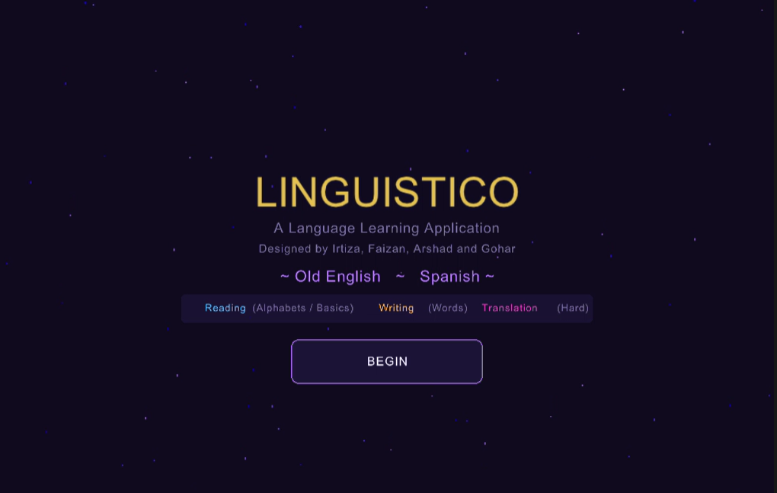

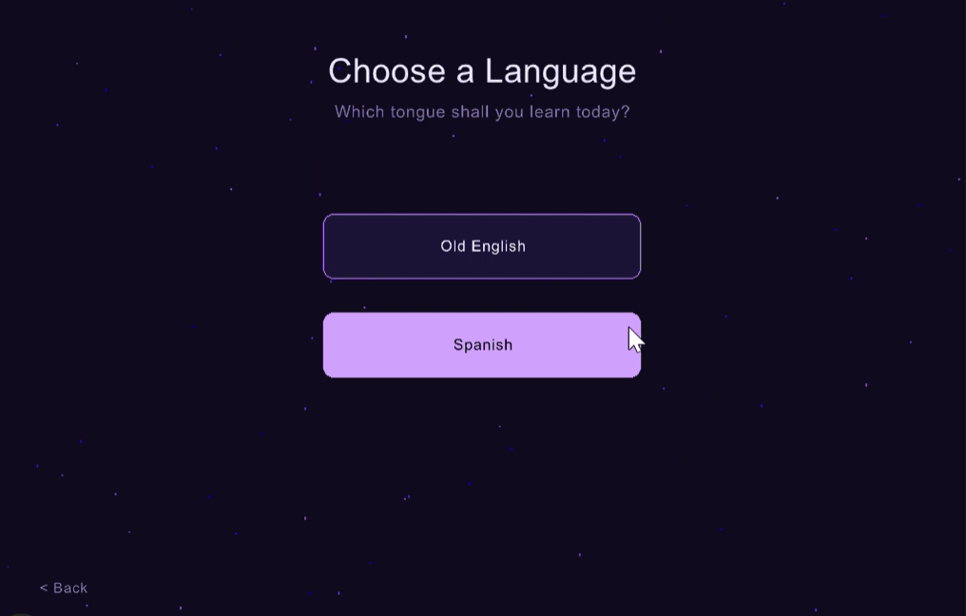

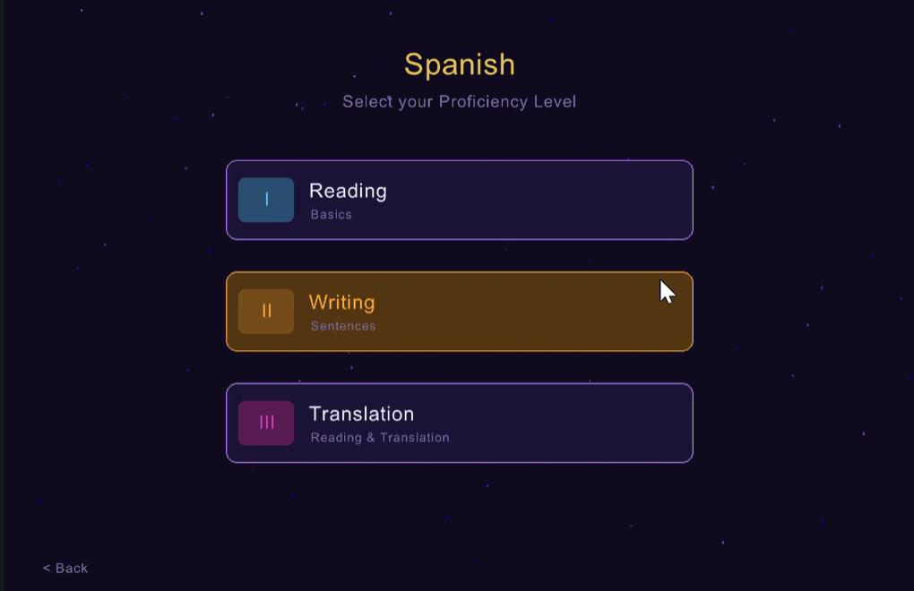

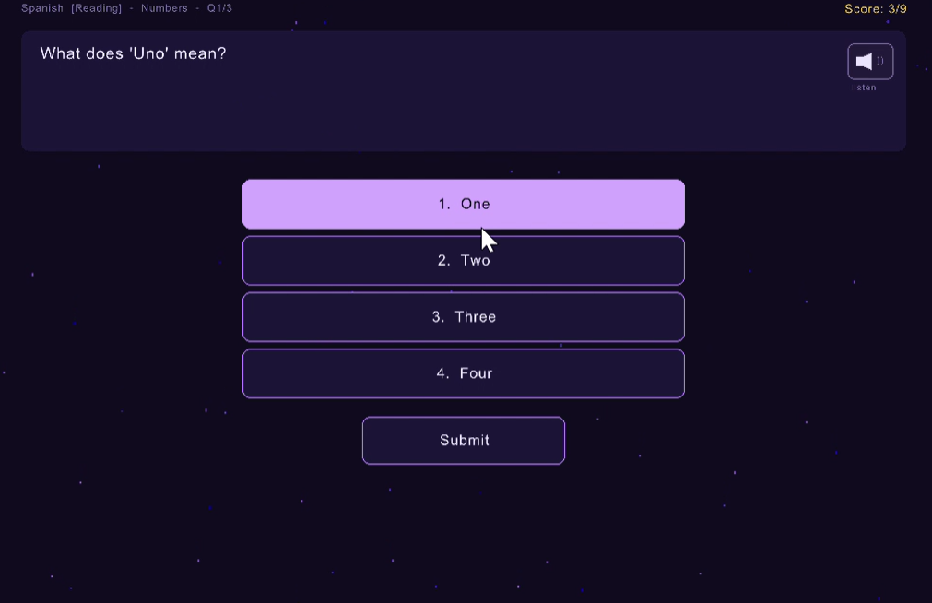

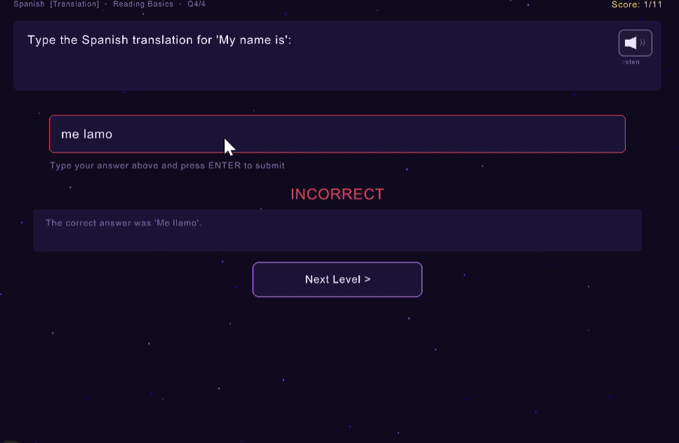

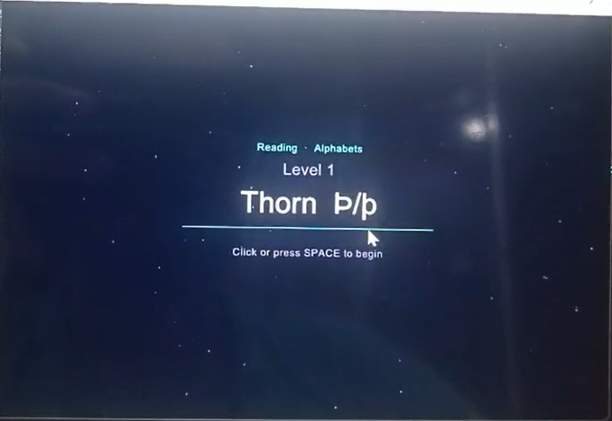

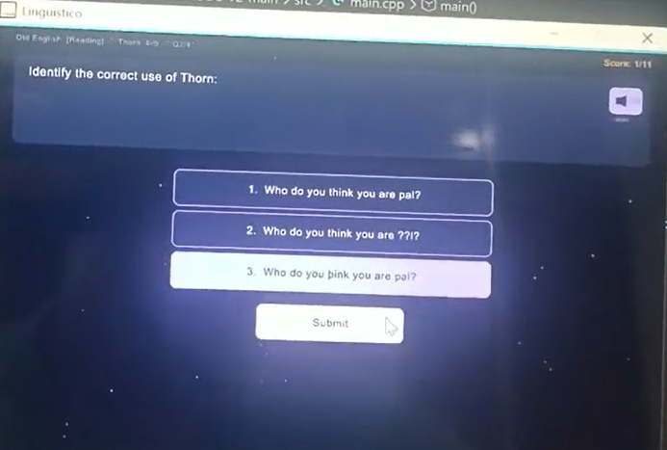

14. Team Contributions
Member | Role | Primary Responsibilities
Irtiza | Lead Developer | Core game level design, system skeletal structure, Implementation of languages, screen state machine
Faizan | Graphics Designer | System graphics, TTS integration, Implementation of raylib functionality, polishing of features
Arshad | Audio & Visual | Sound synthesis, discovery and implementation of system sound system
Gohar | GUI & Testing | Development of system UI, implementation of features, QA testing

15. Limitations & Future Work

Current Limitations
- Platform: Windows-only due to Win32 TTS and PowerShell dependency.
- No persistent progress: scores are not saved between sessions.
- Fixed font search path: LiberationSans.ttf must be co-located with the executable.
- No user accounts or leaderboards.

Potential Enhancements
- Cross-platform TTS using OpenAL or platform-agnostic speech libraries.
- Save/load progress to a local JSON or SQLite file.
- Additional languages: French, German, Arabic.
- Adaptive difficulty that adjusts based on the user's performance history.
- Animated mascot / character for encouragement feedback.
- Mobile port using Raylib's Android/iOS targets.

16. Conclusion
Linguistico successfully delivers an engaging, educational language-learning experience within a polished graphical environment. The project demonstrates effective use of Raylib for real-time UI rendering, creative use of Windows SAPI for speech synthesis without external SDKs, careful Unicode font engineering to support historical scripts, and a data-driven course architecture that makes it straightforward to add new languages and questions.
The team achieved all primary objectives: two fully developed language courses (Old English and Spanish) each with three proficiency tiers, a working typed-answer question format, dynamic TTS narration, and a professional visual presentation that goes well beyond a typical console-based project.

17. GitHub Link:

https://github.com/Kazmi-Irtiza/Code-of-Project-LINGUISTICO-With-Graphics-/tree/main

https://github.com/FaizanKhalid-Coder

End of Documentation — Linguistico Project — 2025

