Clusting Analysis Resilience Score on LGBTQ

Faizan Khalid Mohsin

August 3, 2019

## Data

## [1] 322 3

## Classes 'tbl_df', 'tbl' and 'data.frame': 322 obs. of 3 variables:  
## $ Close_Score : num 3.83 3 2.33 4.17 3 ...  
## $ Dependent_Score : num 3 3 2.83 3 2 ...  
## $ AttachmentAnxietyScore: num 3.5 3 2.5 4 3.67 ...

## Close_Score Dependent_Score AttachmentAnxietyScore  
## Min. :1.000 Min. :1.000 Min. :1.000   
## 1st Qu.:2.333 1st Qu.:1.833 1st Qu.:3.000   
## Median :3.000 Median :2.500 Median :3.667   
## Mean :3.082 Mean :2.541 Mean :3.585   
## 3rd Qu.:3.833 3rd Qu.:3.167 3rd Qu.:4.500   
## Max. :5.000 Max. :5.000 Max. :5.000   
## NA's :1 NA's :3

## [1] 319 3

## Classes 'tbl_df', 'tbl' and 'data.frame': 319 obs. of 3 variables:  
## $ Close_Score : num 3.83 3 2.33 4.17 3 ...  
## $ Dependent_Score : num 3 3 2.83 3 2 ...  
## $ AttachmentAnxietyScore: num 3.5 3 2.5 4 3.67 ...

## Clusting

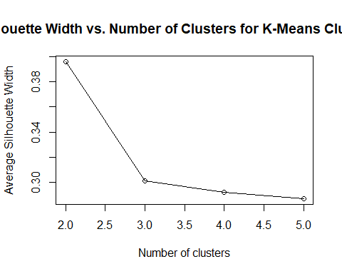

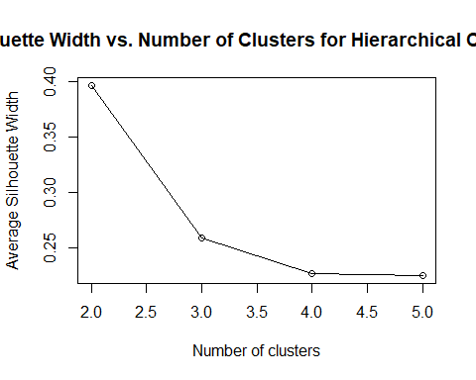

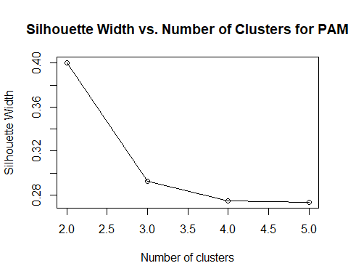

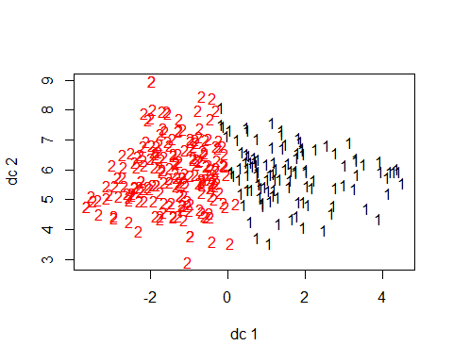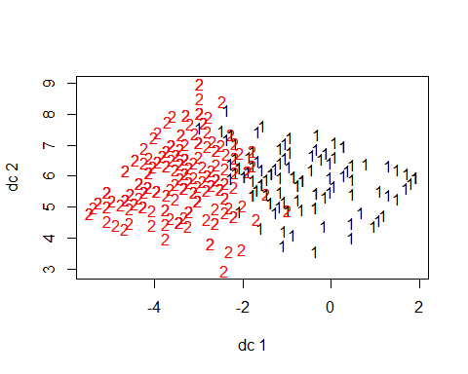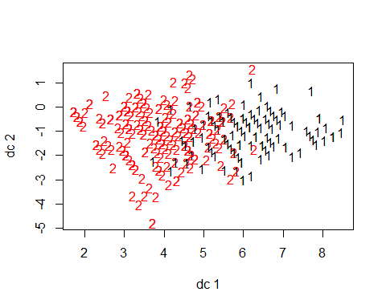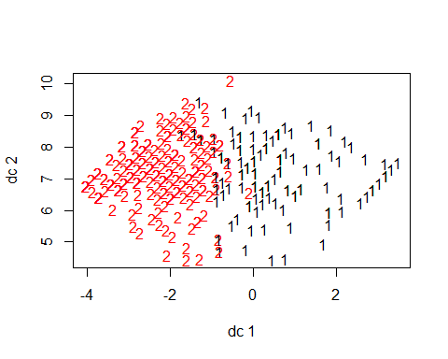

This has interesting pattern. For the characteristic: behavior levels, the data seems to be well divided into upper and lower halves at zero, with all the S/C being above zero and majority of C/S being below zero.

## List of 9  
## $ cluster : int [1:319] 2 1 1 2 2 2 1 2 3 3 ...  
## $ centers : num [1:3, 1:3] 3.84 3.4 1.95 3.54 2.38 ...  
## ..- attr(*, "dimnames")=List of 2  
## .. ..$ : chr [1:3] "1" "2" "3"  
## .. ..$ : chr [1:3] "Close_Score" "Dependent_Score" "AttachmentAnxietyScore"  
## $ totss : num 939  
## $ withinss : num [1:3] 148.4 140 92.2  
## $ tot.withinss: num 381  
## $ betweenss : num 559  
## $ size : int [1:3] 95 126 98  
## $ iter : int 3  
## $ ifault : int 0  
## - attr(*, "class")= chr "kmeans"

## K-means clustering with 3 clusters of sizes 95, 126, 98  
##   
## Cluster means:  
## Close_Score Dependent_Score AttachmentAnxietyScore  
## 1 3.842105 3.536842 2.328070  
## 2 3.398148 2.379630 4.034392  
## 3 1.945578 1.784014 4.188776  
##   
## Clustering vector:  
## [1] 2 1 1 2 2 2 1 2 3 3 2 2 1 1 2 1 1 2 1 1 2 1 2 3 2 1 3 2 1 3 1 2 2 1 3  
## [36] 1 2 2 2 1 2 2 3 3 2 1 2 2 1 2 3 3 3 1 3 3 1 2 3 3 3 2 1 3 2 1 1 1 3 2  
## [71] 2 2 3 3 2 2 1 1 2 1 2 3 2 3 2 1 2 1 2 2 3 3 2 3 2 3 1 2 3 3 2 2 1 1 1  
## [106] 1 1 3 2 1 1 2 2 3 3 1 3 1 3 1 3 2 2 3 3 2 2 3 3 1 1 1 2 1 1 1 3 1 2 2  
## [141] 3 3 2 2 3 3 3 1 3 2 2 2 2 2 3 1 3 1 1 3 3 2 1 2 1 3 2 2 2 1 3 3 1 3 1  
## [176] 1 3 3 3 2 2 3 2 3 2 2 2 3 2 1 3 1 3 3 2 3 1 3 2 2 2 3 1 3 3 3 1 3 1 3  
## [211] 3 1 2 2 3 3 3 3 3 2 1 3 1 2 2 3 1 2 3 1 2 1 2 2 1 1 1 2 2 3 1 2 2 1 1  
## [246] 2 2 3 3 3 2 1 1 3 2 1 3 1 3 2 2 3 1 2 1 2 1 3 1 2 1 3 2 2 2 2 1 1 2 3  
## [281] 2 2 2 1 1 1 3 2 3 3 2 2 2 2 2 2 3 3 2 2 3 2 1 2 2 2 2 2 2 1 1 3 2 1 3  
## [316] 2 1 2 1  
##   
## Within cluster sum of squares by cluster:  
## [1] 148.38889 139.99603 92.20125  
## (between_SS / total_SS = 59.5 %)  
##   
## Available components:  
##   
## [1] "cluster" "centers" "totss" "withinss"   
## [5] "tot.withinss" "betweenss" "size" "iter"   
## [9] "ifault"

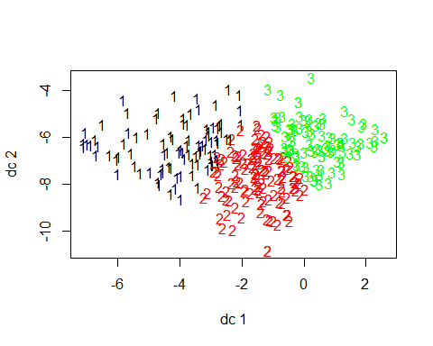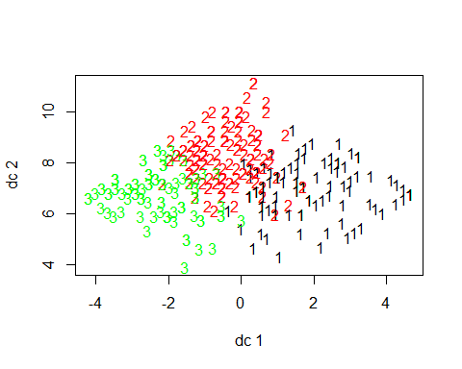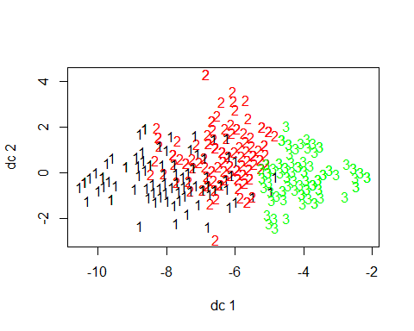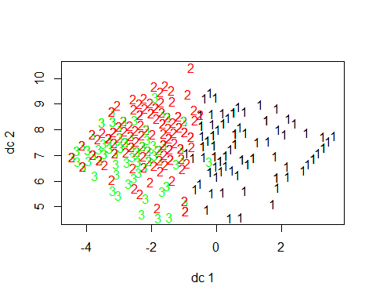

## Close_Score Dependent_Score AttachmentAnxietyScore  
## Close_Score 1.0000000 0.5321784 -0.3850990  
## Dependent_Score 0.5321784 1.0000000 -0.6053777  
## AttachmentAnxietyScore -0.3850990 -0.6053777 1.0000000

