Applied Bayesian Analysis Assignment 2

Faizan Khalid Mohsin

February 23, 2019

Table of Contents

# Question 1

<http://rmarkdown.rstudio.com>.

## Question 1 a:

Done in the attached paper by hand.

## Question 1 b:

# Data  
  
set.seed(25)  
nbig<-20000  
  
data = matrix( c( 1.13, 1.75, 2.30, 3.18,  
 1.20, 1.45, 2.15, 3.10,  
 1.00, 1.55 ,2.25, 3.28,  
 0.91, 1.64, 2.40, 3.35,  
 1.05, 1.60, 2.49, 3.12), nrow = 5, byrow = T)  
  
data = as.data.frame(data)  
colnames(data) = c("temp40", "temp60", "temp80", "temp100")  
attach(data)  
  
Y1<- mean(temp40)  
Y2<- mean(temp60)  
Y3<- mean(temp80)  
Y4<- mean(temp100)  
  
#MCMC Algorithm  
  
mu00<-0  
tau00<-1  
alp<-1  
beta<-1  
alp0<-1  
beta0<-1  
mu1<-rep(0,nbig)  
mu2<-rep(0,nbig)  
mu3<-rep(0,nbig)  
mu4<-rep(0,nbig)  
tau<-rep(0,nbig)  
mu0post1<-rep(0,nbig)   
tau0post1<-rep(0,nbig)   
mu0post2<-rep(0,nbig)  
tau0post2<-rep(0,nbig)  
mu0post3<-rep(0,nbig)   
tau0post3<-rep(0,nbig)  
mu0post4<-rep(0,nbig)   
tau0post4<-rep(0,nbig)   
mu0<-rep(0,nbig)  
tau0<-rep(0,nbig)  
mupost00<-rep(0,nbig)   
taupost00<-rep(0,nbig)   
betapost<-rep(0,nbig)  
betapost0<-rep(0,nbig)  
mu0[1]<-1   
mu1[1]<-0  
mu2[1]<-0  
mu3[1]<-0  
mu4[1]<-0  
tau[1]<-1  
tau0[1]<-1  
  
for(i in 2:nbig) {  
 mu0post1[i]<-(tau0[i-1]*mu0[i-1]+5*tau[i-1]*Y1)/(tau0[i-1]+5*tau[i-1])  
 tau0post1[i]<-tau0[i-1]+tau[i-1]*5  
 mu1[i]<-rnorm(1,mu0post1[i],sd=1/sqrt(tau0post1[i]))  
 mu0post2[i]<-(tau0[i-1]*mu0[i-1]+5*tau[i-1]*Y2)/(tau0[i-1]+5*tau[i-1])  
 tau0post2[i]<-tau0[i-1]+tau[i-1]*5  
 mu2[i]<-rnorm(1,mu0post2[i],sd=1/sqrt(tau0post2[i]))  
 mu0post3[i]<-(tau0[i-1]*mu0[i-1]+5*tau[i-1]*Y3)/(tau0[i-1]+5*tau[i-1])  
 tau0post3[i]<-tau0[i-1]+tau[i-1]*5  
 mu3[i]<-rnorm(1,mu0post3[i],sd=1/sqrt(tau0post3[i]))  
 mu0post4[i]<-(tau0[i-1]*mu0[i-1]+5*tau[i-1]*Y4)/(tau0[i-1]+5*tau[i-1])  
 tau0post4[i]<-tau0[i-1]+tau[i-1]*5  
 mu4[i]<-rnorm(1,mu0post4[i],sd=1/sqrt(tau0post4[i]))  
 mupost00[i]<-(4*tau0[i-1]*((mu1[i-1]+mu2[i-1]+mu3[i-1]+mu4[i-1])/4)+tau00*mu00)/(4*tau0[i-1]+tau00)  
 taupost00[i]<-4*tau0[i-1]+ tau00  
 mu0[i]<-rnorm(1,mupost00[i],1/sqrt(taupost00[i]))  
 alppost0<-alp0+(4/2)   
 betapost0[i]<-beta0+(1/2)*(sum((mu1[i]-mu0[i])^2)+sum((mu2[i]-mu0[i])^2)+  
 sum((mu3[i]-mu0[i])^2)+sum((mu4[i]-mu0[i])^2))  
 tau0[i]<-rgamma(1,alppost0,betapost0[i])  
 alppost<-alp+(5+5+5+5)/2   
 betapost[i]<- beta+(0.5*(sum((temp40-mu1[i])^2)+sum((temp60-mu2[i])^2)+  
 sum((temp80-mu3[i])^2)+sum((temp100-mu4[i])^2)))  
 tau[i]<-rgamma(1,alppost,betapost[i])   
}  
  
cbind(mu0,mu1,mu2,mu3,mu4,tau,tau0)[1:10,]

## mu0 mu1 mu2 mu3 mu4 tau tau0  
## [1,] 1.00000000 0.0000000 0.000000 0.000000 0.000000 1.000000 1.0000000  
## [2,] -0.67087848 0.9618526 1.073106 1.627497 2.969598 3.567329 0.1406228  
## [3,] -0.21803713 0.7974946 1.723503 2.438722 3.146576 7.909098 0.1382672  
## [4,] -0.08856949 1.2008003 1.477891 2.461938 3.439468 7.995753 0.2759665  
## [5,] 1.74787069 1.0746105 1.959628 2.051584 3.009483 4.157769 1.2478098  
## [6,] 2.19847692 0.8599432 1.453477 2.384100 3.335221 4.848577 0.5409701  
## [7,] 0.49204091 1.0647587 1.817526 2.134459 3.103938 7.224207 0.5538967  
## [8,] 0.98798373 1.0414805 1.628266 1.903217 3.223159 7.829289 0.6663553  
## [9,] 0.99478290 0.8430916 1.528940 2.620348 3.005581 7.833863 0.2846369  
## [10,] 1.67957313 0.9282185 1.471686 1.941989 3.366871 7.140161 1.0701806

## Question 1 c:

plot(density(mu1[-(1:5)]),type="l", xlab="mu", ylab="Posterior density ",  
cex=1.5, xlim=c(0,4), col="red", lty=1, main="Posterior distributions for Each temperature")  
lines(density(mu2[-(1:5)]), col="cyan",lty=1)  
lines(density(mu3[-(1:5)]),col="black",lty=1)  
lines(density(mu4[-(1:5)]),col="blue", lty=1)  
legend("topright", c("Temp 40", "Temp 60", "Temp 80", "Temp100"),lty=c(1, 1, 1,1), col=c("red","blue","green","black"),cex=0.5)

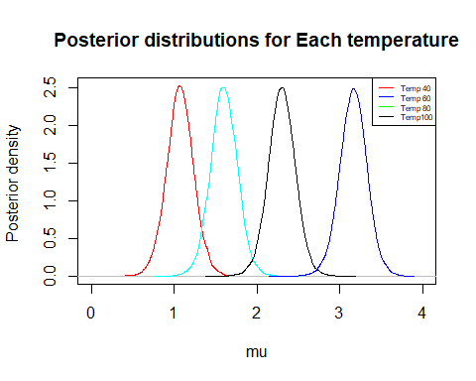

We now give summary statistics.

#some summary statistics   
#for temperature of 40  
temp1<-rnorm(nbig,mean=mu1,sd=1/sqrt(tau))  
mean(temp1)

## [1] 1.075937

sd(temp1)

## [1] 0.4081899

quantile(temp1, probs=seq(0,1,0.025)) # can use this for quantiles

## 0% 2.5% 5% 7.5% 10% 12.5%   
## -1.1881030 0.2735042 0.4093063 0.4954395 0.5623692 0.6164876   
## 15% 17.5% 20% 22.5% 25% 27.5%   
## 0.6626517 0.7047026 0.7431994 0.7795541 0.8121028 0.8431112   
## 30% 32.5% 35% 37.5% 40% 42.5%   
## 0.8721747 0.8989782 0.9270925 0.9536297 0.9789093 1.0031758   
## 45% 47.5% 50% 52.5% 55% 57.5%   
## 1.0280829 1.0542737 1.0776098 1.1017753 1.1270784 1.1522966   
## 60% 62.5% 65% 67.5% 70% 72.5%   
## 1.1768720 1.1998321 1.2244478 1.2517127 1.2795345 1.3090601   
## 75% 77.5% 80% 82.5% 85% 87.5%   
## 1.3409364 1.3741297 1.4096922 1.4452089 1.4866712 1.5288213   
## 90% 92.5% 95% 97.5% 100%   
## 1.5825283 1.6540241 1.7430060 1.8905469 2.8397865

#for temperature of 60  
temp2<-rnorm(nbig,mean=mu2,sd=1/sqrt(tau))  
mean(temp2)

## [1] 1.599299

sd(temp2)

## [1] 0.407251

quantile(temp2, probs=seq(0,1,0.025)) # can use this for quantiles

## 0% 2.5% 5% 7.5% 10% 12.5%   
## -0.9018925 0.8057017 0.9404629 1.0217177 1.0885434 1.1407553   
## 15% 17.5% 20% 22.5% 25% 27.5%   
## 1.1866114 1.2282171 1.2672095 1.3042119 1.3368791 1.3648965   
## 30% 32.5% 35% 37.5% 40% 42.5%   
## 1.3926090 1.4197036 1.4464276 1.4699231 1.4970850 1.5230949   
## 45% 47.5% 50% 52.5% 55% 57.5%   
## 1.5482864 1.5719386 1.5954392 1.6215553 1.6472966 1.6714743   
## 60% 62.5% 65% 67.5% 70% 72.5%   
## 1.6980285 1.7221561 1.7488720 1.7758051 1.8018586 1.8317326   
## 75% 77.5% 80% 82.5% 85% 87.5%   
## 1.8614844 1.8976021 1.9315419 1.9679328 2.0100466 2.0525874   
## 90% 92.5% 95% 97.5% 100%   
## 2.1086761 2.1765653 2.2696366 2.4221266 3.6349408

#for temperature of 80  
temp3<-rnorm(nbig,mean=mu3,sd=1/sqrt(tau))  
mean(temp3)

## [1] 2.298067

sd(temp3)

## [1] 0.4100596

quantile(temp3, probs=seq(0,1,0.025)) # can use this for quantiles

## 0% 2.5% 5% 7.5% 10% 12.5%   
## -0.1734029 1.4762093 1.6194603 1.7168903 1.7848460 1.8394244   
## 15% 17.5% 20% 22.5% 25% 27.5%   
## 1.8848909 1.9315313 1.9706710 2.0044349 2.0367474 2.0661966   
## 30% 32.5% 35% 37.5% 40% 42.5%   
## 2.0959162 2.1235632 2.1495094 2.1753845 2.2012886 2.2269243   
## 45% 47.5% 50% 52.5% 55% 57.5%   
## 2.2517509 2.2771972 2.3004862 2.3246684 2.3492710 2.3738857   
## 60% 62.5% 65% 67.5% 70% 72.5%   
## 2.4000962 2.4250823 2.4508861 2.4778945 2.5052257 2.5352723   
## 75% 77.5% 80% 82.5% 85% 87.5%   
## 2.5665385 2.5951755 2.6292515 2.6684601 2.7086424 2.7535407   
## 90% 92.5% 95% 97.5% 100%   
## 2.8096892 2.8715103 2.9561591 3.1040431 4.0449722

#for temperature of 100  
temp4<-rnorm(nbig,mean=mu4,sd=1/sqrt(tau))  
mean(temp4)

## [1] 3.165984

quantile(temp4, probs=seq(0,1,0.025)) # can use this for quantiles

## 0% 2.5% 5% 7.5% 10% 12.5% 15%   
## 0.8356794 2.3569307 2.5046330 2.5944238 2.6557061 2.7067012 2.7538854   
## 17.5% 20% 22.5% 25% 27.5% 30% 32.5%   
## 2.7968554 2.8350830 2.8692147 2.9007361 2.9330345 2.9631431 2.9915510   
## 35% 37.5% 40% 42.5% 45% 47.5% 50%   
## 3.0180532 3.0430122 3.0707183 3.0956220 3.1199232 3.1445478 3.1676430   
## 52.5% 55% 57.5% 60% 62.5% 65% 67.5%   
## 3.1927804 3.2174989 3.2418744 3.2686004 3.2948031 3.3214517 3.3485636   
## 70% 72.5% 75% 77.5% 80% 82.5% 85%   
## 3.3750916 3.4036304 3.4338766 3.4666124 3.5001802 3.5386364 3.5781617   
## 87.5% 90% 92.5% 95% 97.5% 100%   
## 3.6223528 3.6741157 3.7343435 3.8217921 3.9505292 5.0653461

sd(temp4)

## [1] 0.4071478

## Question 1 d:

What is the posterior distribution of the difference in number of cells grown at a temperature of 40 versus 80? What is the posterior probability that there will be more cells grown at a temperature of 40 versus 80?

Below we calculate the posterior distribution and probability.

Posterior probability will be 0, since temp3-temp1 is always less than 0 at all occasions, as indicated by the quantiles and the plot below

newmu<-mu1-mu4  
mean(temp1-temp3)

## [1] -1.22213

sd(temp1-temp3)

## [1] 0.5759653

quantile(temp1-temp3, probs=seq(0,1,0.025))

## 0% 2.5% 5% 7.5% 10% 12.5%   
## -4.03877161 -2.36003500 -2.16764043 -2.04007871 -1.94704866 -1.86734188   
## 15% 17.5% 20% 22.5% 25% 27.5%   
## -1.80317326 -1.74417089 -1.69316202 -1.64572156 -1.59937602 -1.55496531   
## 30% 32.5% 35% 37.5% 40% 42.5%   
## -1.51062791 -1.47206997 -1.43357653 -1.39568819 -1.35622523 -1.32117807   
## 45% 47.5% 50% 52.5% 55% 57.5%   
## -1.28843222 -1.25556285 -1.22109112 -1.18818651 -1.15139648 -1.11640377   
## 60% 62.5% 65% 67.5% 70% 72.5%   
## -1.08078435 -1.04330689 -1.00711812 -0.97026889 -0.93329153 -0.89189007   
## 75% 77.5% 80% 82.5% 85% 87.5%   
## -0.85098015 -0.80512530 -0.75434778 -0.70148875 -0.64090741 -0.57990318   
## 90% 92.5% 95% 97.5% 100%   
## -0.50300421 -0.41192743 -0.27819896 -0.06210936 2.35986813

plot(density(temp1-temp3),type="l", xlab="mu difference", ylab="Posterior density ", cex=1.5, xlim=c(-4,4), col="blue", lty=1, main="Posterior distributions for difference in temp 40 vs 80")

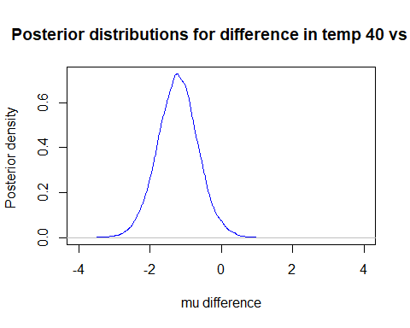

# Question 2

## Question 2 a

smokeDat=read.csv("SmokeAgeDeath.csv")  
library(R2OpenBUGS)

## Warning: package 'R2OpenBUGS' was built under R version 3.4.4

library(coda)

## Warning: package 'coda' was built under R version 3.4.4

#Code for OpenBUGS model given below  
cat("  
model{  
 for(i in 1:20)  
 {  
 #smoke age death pyears   
   
 death[i]~dpois(lam[i])  
 log(lam[i]) <- log(pyears[i]) + beta0 + beta.s[smoke[i]] + beta.c[age[i]] + b[i]   
 b[i] ~dnorm(0,tau)  
 b.adj[i] <- b[i] - mean(b[])   
 }  
 for(is in 1:4){  
 beta.s[is]~dnorm(0,tau.s)  
 beta.s.adj[is] <- beta.s[is] -mean(beta.s[])   
 }  
 for(ic in 1:5){  
 beta.c[ic]~dnorm(0,tau.c)  
 beta.c.adj[ic] <- beta.c[ic] - mean(beta.c[])  
 }  
 # Note: total person-years per categories is less than 115,000  
 # ln(115000) ~ = 11.65....  
 # so rate has to be bigger than 1/115,000 and log(rate) > -11.65...   
 # so log( base rate) should be between about -12 and 12.  
 # 1/12/12 is about .00694  
 beta0 ~ dnorm(0, .00694)   
 beta0.adj <- beta0 + mean(b[]) + mean(beta.s[])+ mean(beta.c[])  
 # for the <extra poisson variation> ...   
 # assume bounded by very big number... say 1000 times...   
 # so log(1000) is about 2.3*4 which is about 9.2  
 std ~ dunif(0, 9)  
 tau <- 1/std/std  
 # for the relative risk between groups... a very large number would be 100 times,   
 # so, log(100) is about 2.3*2 or about 4.6  
 # also, note that 1/5/5 is 0.04  
 #   
 std.s ~dunif(0, 5)  
 tau.s <- 1/std.s/std.s  
 std.c ~ dunif(0,5)   
 tau.c <- 1/std.c/std.c  
 beta.o~dnorm(0, .04)  
 }", file="smokemod.txt")  
  
#defining parameters and data for the bugs function  
  
params=c("beta.s.adj", "std.s", "beta.c.adj", "std.c", "beta0.adj", "std")  
attach(smokeDat)  
  
bug.dat=list("smoke","age","death", "pyears")  
init.fun=function(){list(  
 beta.s=rnorm(4), std.s=runif(1,1,2),  
 beta.c=rnorm(5), std.c=runif(1,1,2),   
 std=runif(1,1,2), beta0=rnorm(1),  
 b=rnorm(20,0,.1))}  
  
#using openBUGS to run our model, this code also gives the posterior which we need for 2a in OpenBUGS  
  
smokeBug0=bugs(bug.dat, init.fun, params, model.file="smokemod.txt",  
 n.chains=5, n.iter=8000, n.burnin=1000, debug=TRUE #for production  
 # n.chains=5, n.iter=6000, n.burnin=1000, debug=TRUE #for testing  
)

openBUGS Results output showing the posterior distributions:

library(knitr)  
results = read.csv("question2a_results.csv")  
kable(results, caption = "Summary Statistics")

Summary Statistics

|  |  |  |  |  |  |  |
| --- | --- | --- | --- | --- | --- | --- |
| X | mean | sd | val2.5pc | median | val97.5pc | sample |
| beta.c.adj[1] | -1.34600 | 0.24290 | -1.69100 | -1.33700 | -1.0070 | 35000 |
| beta.c.adj[2] | -0.72810 | 0.20150 | -1.01300 | -0.71950 | -0.4425 | 35000 |
| beta.c.adj[3] | -0.02599 | 0.16030 | -0.27570 | -0.02343 | 0.2166 | 35000 |
| beta.c.adj[4] | 0.69470 | 0.18180 | 0.44330 | 0.68340 | 0.9175 | 35000 |
| beta.c.adj[5] | 1.40600 | 0.12360 | 1.20800 | 1.40400 | 1.6000 | 35000 |
| beta.s.adj[1] | -0.43050 | 0.31510 | -0.64100 | -0.46010 | -0.2773 | 35000 |
| beta.s.adj[2] | -0.53190 | 0.11560 | -0.73930 | -0.53460 | -0.3289 | 35000 |
| beta.s.adj[3] | 0.05386 | 0.20450 | -0.21570 | 0.06957 | 0.3238 | 35000 |
| beta.s.adj[4] | 0.90860 | 0.25420 | 0.69020 | 0.92740 | 1.1540 | 35000 |
| beta0.adj | -7.37400 | 0.07059 | -7.51300 | -7.37300 | -7.2400 | 35000 |
| deviance | 102.20000 | 4.35500 | 95.67000 | 101.50000 | 112.5000 | 35000 |
| std | 0.12080 | 0.35690 | 0.00356 | 0.07111 | 3.4030 | 35000 |
| std.c | 1.72100 | 0.89100 | 0.71550 | 1.43600 | 4.1400 | 35000 |
| std.s | 1.41600 | 0.97450 | 0.43360 | 1.03600 | 4.2980 | 35000 |

#Deviance Information  
DevianceInformation = read.csv("DevianceInformation.csv")  
kable(DevianceInformation, caption = "Deviance Information")

Deviance Information

|  |  |  |  |  |
| --- | --- | --- | --- | --- |
| X | Dbar | Dhat | DIC | pD |
| death | 102.2 | 92.66 | 111.7 | 9.544 |
| total | 102.2 | 92.66 | 111.7 | 9.544 |

The above plots show the convergence in the chains after 8000 iterations

#boxplots for smoking categories  
  
boxplot(data.frame( (smokeBug0$sims.list)["beta.s.adj"]),  
 xlab="beta.s.adj")

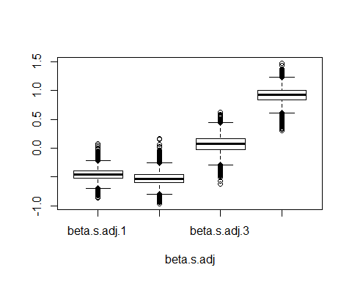

#boxplots for age categories  
  
boxplot(data.frame( (smokeBug0$sims.list)["beta.c.adj"]),  
 xlab="beta.c.adj")

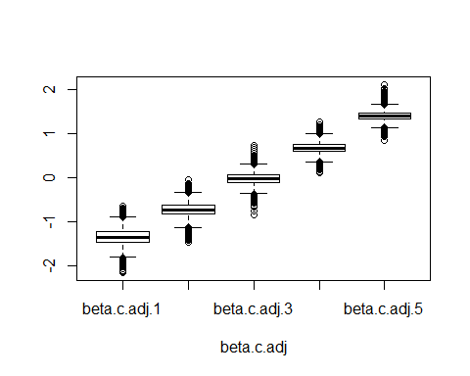

## Question 2 b.

The following plots show that our model converges.

Trace plots have been shown in the output given above that shows the convergence in chains after 8000 iterations.

The autocorrelation functions plots are given below.

# The following plots show that our model converges  
#autocorrelation functions given below  
#trace plots have been shown in the output given above that shows the convergence in chains after 8000 iterations  
acf(smokeBug0$sims.array[,1,"beta.s.adj[1]"])

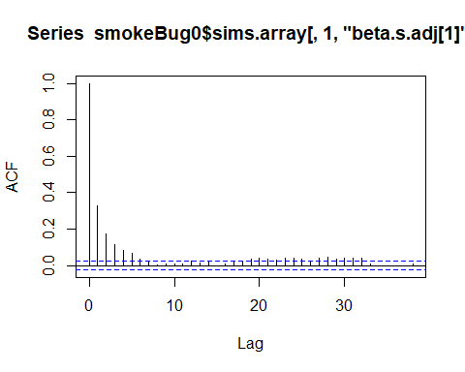

After 10 lags the plot seems to have converged. We observe the same for age which converges twice as #fast as shown below

#After 10 lags the plot seems to have converged. We observe the same for age which converges twice as #fast as shown below  
acf(smokeBug0$sims.array[,1,"beta.c.adj[1]"])

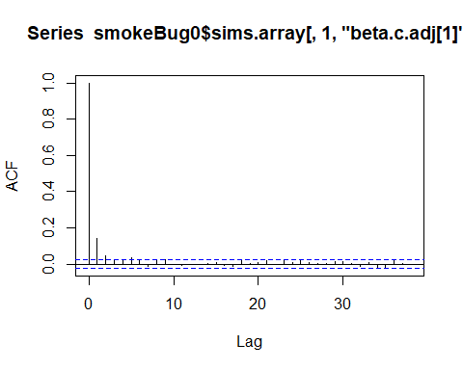

acf(smokeBug0$sims.array[,1,"beta0.adj"])

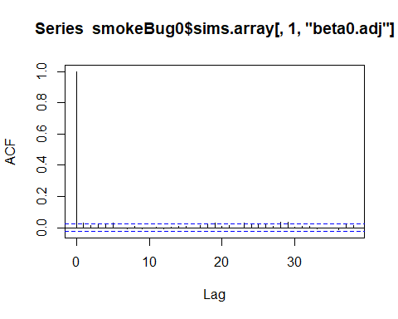

## Question 2 c.

risk20<-smokeBug0$sims.list$beta.s.adj[,4]-smokeBug0$sims.list$beta.s.adj[,1]  
mean(risk20)

## [1] 1.380155

exp(mean(risk20))

## [1] 3.975519

The above shows those who smoke >20 cigarettes per day versus nonsmoker have approximately 4 times (=3.98) the risk. We take the exponential in the last line since the model gives us the log of the risks.

quantile(exp(risk20), c(.025, .975)) # gives the 95% Cis for above risk

## 2.5% 97.5%   
## 2.842539 5.443937

# Question 3

## Question 3 a

R-code given below for defining data parameters, model and priors

library(R2OpenBUGS)  
  
diabetes = read.csv("DiabetesDrugEffect.csv")  
attach(diabetes)  
  
## Model 1  
  
cat("  
model{  
 for( i in 1:12){  
 diff[i] ~ dnorm(mu[i], Sediff[i])  
 mu[i] ~ dnorm(theta, sd)  
 }  
 theta ~ dnorm(0, .1) # so, sd =5. exp(5) ~ 148 which is huge  
 sd ~ dnorm(0, .1)   
 }  
 ", file="diabetesMod3.txt")  
   
bugM3.dat=list( "diff", "Sediff") # what variable you need in the model  
  
initM3.fun=function(){ list( theta=rnorm(1) ,  
 sd = rnorm(1),   
 mu = rnorm(1)  
   
 ) }  
  
   
paramsM3=c("mu", "theta", "sd")  
 ### what variables you want to monitor

#### Could change the code below...  
diabetesBaseM3=bugs(bugM3.dat, initM3.fun, paramsM3, model.file="diabetesMod3.txt",  
 n.chains=3, n.iter=3000, n.burnin=500,  
 n.thin=1 , debug=TRUE  
 )  
  
print(diabetesBaseM3,dig=3)  
  
  
SArray= diabetesBaseM3$sims.array  
vname=attr(SArray,"dimnames")[3][[1]]  
chainL=attr(SArray,"dim")[1][[1]]  
for(i in 1:length(vname)){   
 nn=vname[i]  
 plot(density(SArray[,,nn]), main=nn)  
 xnul=locator(1)   
 acf( SArray[,1,nn], main=nn) #note: this is only for 1st chain  
 xnul=locator(1)  
 matplot(1:chainL,SArray[,,nn], main=nn,xlab="index",type="l")  
 xnul=locator(1)  
}

## Model 2  
  
cat("  
model{  
 for( i in 1:12){  
 diff[i] ~ dnorm(theta, Sediff[i] + sd)  
 }  
 theta ~ dnorm(0, .1)   
 sd ~ dnorm(0, .1)   
 }  
 ", file="diabetesMod2.txt")  
   
bugM3.dat=list( "diff", "Sediff") # what variable you need in the model  
  
initM2.fun=function(){ list( theta=rnorm(1) ,  
 sd = rnorm(1)  
 ) }  
  
   
paramsM2=c( "theta", "sd")  
 ### what variables you want to monitor

#### Could change the code below...  
diabetesBaseM2=bugs(bugM3.dat, initM2.fun, paramsM2, model.file="diabetesMod2.txt",  
 n.chains=3, n.iter=3000, n.burnin=500,  
 n.thin=1 , debug=TRUE  
 )  
  
print(diabetesBaseM2,dig=3)  
  
SArray= diabetesBaseM2$sims.array  
vname=attr(SArray,"dimnames")[3][[1]]  
chainL=attr(SArray,"dim")[1][[1]]  
for(i in 1:length(vname)){   
 nn=vname[i]  
 plot(density(SArray[,,nn]), main=nn)  
 xnul=locator(1)   
 acf( SArray[,1,nn], main=nn) #note: this is only for 1st chain  
 xnul=locator(1)  
 matplot(1:chainL,SArray[,,nn], main=nn,xlab="index",type="l")  
 xnul=locator(1)  
}