Linear Regression on a Time Series Dataset
Topic: Linear Regression
Dataset: Monthly Airline Passengers (Time Series)
Learning Outcomes
1. Load and explore a real-world time series dataset.
2. Convert a time series into a supervised learning problem for regression.
3. Train and evaluate simple and multiple linear regression models.
4. Reflect on the limitations of linear regression for time series data.

Summary of Findings:

Task: Data Loading & Exploration

Initial Data Format:
The raw dataset was loaded with all data in a single column, where each cell contained both month and passenger count in a comma-separated format (e.g., "1949-01",112).

Preprocessing Steps:
- Split the single column into two columns using comma as delimiter
- Renamed columns to 'Month' and 'Passengers'
- Removed the header row and quotation marks
- Converted Month to datetime and set as index
- Converted Passengers to numeric values
Final Structure:

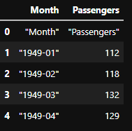

Key Observations:

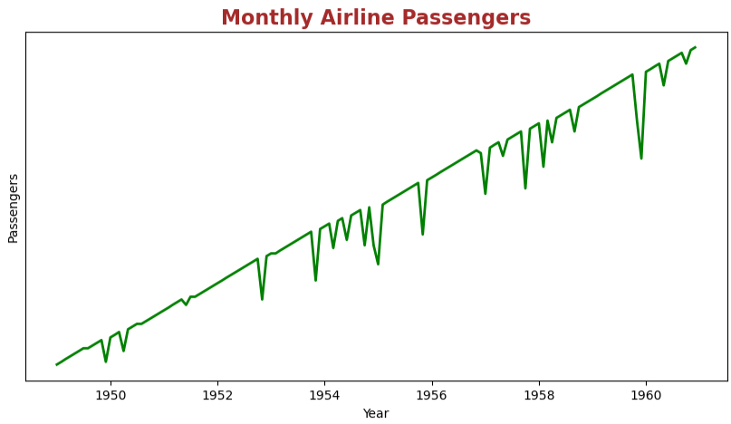
- Upward trend: passenger numbers increased steadily from 1949–1960
- Seasonal pattern: peaks in summer months, troughs in winter
- Predictable Pattern: The trend is so regular that future values can be accurately predicted using a simple linear equation without needing complex machine learning models.

Task: Time Series to Supervised Learning
The dataset was transformed into a supervised learning format by adding:
- A numeric time index 't' (1 to 144)
- Lag features: Passengers_lag1 (previous month) and Passengers_lag12 (same month previous year)
- Rows with NaN values were removed, resulting in 144 complete records

Model Comparison:
Model | Features Used | MSE
Baseline Linear Regression | t (time index only) | 5447.16
Multiple Linear Regression | t, Passengers_lag1, Passengers_lag12 | 1214.61

Key Finding
The multiple linear regression model with lag features significantly outperformed the baseline model, reducing the Mean Squared Error (MSE) from 5447.16 to 1214.61 (approximately 78% reduction). This demonstrates that incorporating historical passenger data (especially the same month from the previous year) greatly improves predictive accuracy.

Limitations of Linear Regression for Time Series
While linear regression with lag features provides a reasonable baseline, it has several limitations:
- Linear Assumption: Linear regression assumes linear relationships, which may not capture complex seasonal patterns
- Stationarity Issues: Linear regression models typically assume stationary data, while this time series exhibits trends and seasonality
- No Autocorrelation Handling: The model doesn't account for autocorrelation in residuals, which may violate model assumptions
- Limited Complexity: Linear models cannot capture non-linear patterns that more sophisticated models (like ARIMA or LSTM) might handle better

