**SYNOPSIS**

**“LOGIN LOGOUT APPLICATION”**

ACKNOWLEDGEMENT

**Keep away from people who try to belittle your ambitions. Small people always do that, but the really great make you feel that you too, can become great.**

I take this opportunity to express my sincere thanks and deep gratitude to all those people who extended their wholehearted co-operation and have helped me in completing this project successfully.

First of all, I would like to thank **Mr. Sunil Bhutani, Director, EME Technologies** for creating opportunities to undertake me in the esteemed organization.

Special thanks to **Mrs. Shashi Bhutani** Project Manager for all the help and guidance extended to me by her in every stage during my training. Her inspiring suggestions and timely guidance enabled me to perceive the various aspects of the project in a new light.

I also want to thank my teammates, friends and staff members of BTECH department that have shared their needs and experiences with me.

My report will remain incomplete if I do not make a mention about my parents who expended all moral and financial support to me. I would like to special thanks to my parents.

In all I found a congenial work environment in **EME Technologies** and this completion of the project will mark a new beginning for me in the coming days.

**Name-**

**B.TECH 8th sem.**

# 

**INTRODUCTION**

**LOGIN LOGOUT APPLICATION**

**LOGIN LOGOUT APPLICATION is basically a type of registration form and the main function of this type of registratiob form is to differentiate between MANAGER AND EMPLOYEE OF A COMPANY.**

**PURPOSE: -**

The purpose of this document is to give a detailed description of the requirements for the “LOGIN LOGOUT APPLICATION”. It will illustrate the purpose and complete declaration for this application. It will also explain system constraints, interface and interactions with other external applications. It give accurate information about brief working of this application.

**Objectives:-**

The main Objective of this project is to provide a solution to differentiate between humans and machines in any registration interface.

**Privacy:-**

Privacy can be kept by secure login using password.

**Practicality:-**

The system is stable and can be operated with average intelligence.

**Efficiency: -**

There should be balance amongst various factors like accuracy, comprehensiveness on one hand and response timeliness of the system on the other hand.

**Cost:-**

It is desirable to aim for the system with a minimum cost subject to the condition that it must satisfy the entire requirement.

**Flexibility:-**

The system should be modifiable depending on the changing needs of the user. Such modifications should entail extensive reconstructing. It should also be portable to different computer systems.

**Security:-**

This is very important aspect requiring rigorous designing of database including hardware reliability, fallback procedures and physical security of data.

**LANGUAGE USED:**

**JAVA:Sat**

**17**

**2012**

The whole project code is created using eclipse in Java. Java is a computer programming language that is concurrent, class-based, object-oriented, and specifically designed to have as few implementation dependencies as possible. It is intended to let application developers "write once, run anywhere" (WORA), meaning that code that runs on one platform does not need to be recompiled to run on another. Java applications are typically compiled to bytecode (class file) that can run on any Java virtual machine (JVM) regardless of computer architecture. Java is, as of 2014, one of the most popular programming languages in use, particularly for client-server web applications, with a reported 9 million developers.[10][11] Java was originally developed by James Gosling at Sun Microsystems (which has since merged into Oracle Corporation) and released in 1995 as a core component of Sun Microsystems' Java platform. The language derives much of its syntax from C and C++, but it has fewer low-level facilities than either of them.

**Eclipse:**

Eclipse is an integrated development environment (IDE) for developing primarily with Java, but also with other languages, in particular PHP, C/C++, and HTML5.[3] It is also an application platform framework for Java desktop applications and others. The Eclipse IDE is written in Java and can run on Windows, OS X, Linux, Solaris and other platforms supporting a compatible JVM.

The Eclipse Platform allows applications to be developed from a set of modular software components called modules. Applications based on the Eclipse

Platform (including the Eclipse IDE itself) can be extended by third party developers. The Eclipse Team actively support the product and seek future suggestions from the wider community.

**JDBC Connector:**

Java database connectivity (JDBC) is the JavaSoft specification of a standard application programming interface (API) that allows Java programs to access database management systems. The JDBC API consists of a set of interfaces and classes written in the Java programming language.

Using these standard interfaces and classes, programmers can write applications that connect to databases, send queries written in structured query language (SQL), and process the results.

The JDBC API is consistent with the style of the core Java interfaces and classes, such as java.lang and java.awt.

**INTRODUCTION TO MYSQL SERVER**

The MySQL server provides a database management system with querying and connectivity capabilities, as well as the ability to have excellent data structure and integration with many different platforms. It can handle large databases reliably and quickly in high-demanding production environments. The MySQL server also provides rich function such as its connectivity, speed, and security that make it suitable for accessing databases.

SQL stands for “Structured Query Language” and can be pronounced as “SQL” or “sequel – (Structured English Query Language)”. It is a query language used for accessing and modifying information in the database. IBM first developed SQL in 1970s. Also it is an ANSI/ISO standard. It has become a Standard Universal Language used by most of the relational database management systems (RDBMS). Some of the RDBMS systems are: Oracle, Microsoft SQL

server, Sybase etc. Most of these have provided their own implementation thus enhancing it's feature and making it a powerful tool.

Few functions of SQL are:

* store data
* modify data
* retrieve data
* modify data
* delete data
* create tables and other database objects
* delete data

**SCREENSHOTS**:

**1.**

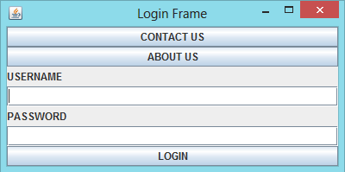

**2.**

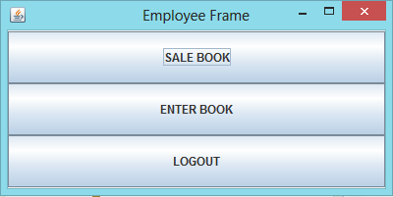

**3.**

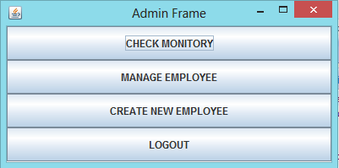

**BIBLIOGRAPHY:-**

1) [www.google.com](http://www.google.com)

2) [www.wikipedia.org](http://www.wikipedia.org)

3) [www.w3school.com/](http://www.w3school.com/)

4) [www.devguru.com/](http://www.devguru.com/)

5) [www.w3.org/](http://www.w3.org/)