**SYNOPSIS ON**

**“CAREER CONSTRUCTOR APPLICATION”**

ACKNOWLEDGEMENT

**Keep away from people who try to belittle your ambitions. Small people always do that, but the really great make you feel that you too, can become great.**

I take this opportunity to express my sincere thanks and deep gratitude to all those people who extended their wholehearted co-operation and have helped me in completing this project successfully.

First of all, I would like to thank **Mr. Sunil Bhutani, Director, EME Technologies** for creating opportunities to undertake me in the esteemed organization.

Special thanks to **Mrs. Shashi Bhutani** Project Manager for all the help and guidance extended to me by her in every stage during my training. Her inspiring suggestions and timely guidance enabled me to perceive the various aspects of the project in a new light.

I also want to thank my teammates, friends and staff members of BTECH department that have shared their needs and experiences with me.

My report will remain incomplete if I do not make a mention about my parents who expended all moral and financial support to me. I would like to special thanks to my parents.

In all I found a congenial work environment in **EME Technologies** and this completion of the project will mark a new beginning for me in the coming days.

**Name- EME**

**B.TECH 8th sem.**

**INTRODUCTION**

CAREER CONSTRUCTOR App basically allows students to make there resume easily sitting at home with a single click of mouse. We have connected our app with the live server so that it can directly fetch samples uploaded by admin on the server under various technologies. Admin on one side can add or delete templates, upload templates. The students can view and edit there resume. We have also incorporated auto email module in our project for providing users resume through email. In future we are also going to incorporate auto SMS module so that students will get new information on their phone. The app will be provided as a proper installer. This app will provide direct interaction platform for the students.

**FRONT END**

**Java** is a programming language originally developed by James Gosling at Sun Microsystems (which is now a subsidiary of Oracle Corporation) and released in 1995 as a core component of Sun Microsystems' Java platform. The language derives much of its syntax from C and C++ but has a simpler object model and fewer low-level facilities. Java applications are typically compiled to bytecode (class file) that can run on any Java Virtual Machine (JVM) regardless of computer architecture. Java is a general-purpose, concurrent, class-based, object-oriented language that is specifically designed to have as few implementation dependencies as possible. It is intended to let application developers "write once, run anywhere". Java is currently one of the most popular programming languages in use, and is widely used from application software to web applications.

The original and reference implementation Java compilers, virtual machines, and class libraries were developed by Sun from 1995. As of May 2007, in compliance with the specifications of the Java Community Process, Sun relicensed most of its Java technologies under the GNU General Public License. Others have also developed alternative implementations of these Sun technologies, such as the GNU Compiler for Java, GNU Classpath, and Dalvik.

**BACK END**

**MYSQL:**MySQL is currently the most popular open source database server in existence. On top of that, it is very commonly used in conjunction with PHP scripts to create powerful and dynamic server-side applications.MySQL has been criticized in the past for not supporting all the features of other popular and more expensive Database Management Systems. However, MySQL continues to improve with each release (currently version 5), and it has become widely popular with individuals and businesses of many different sizes.A database is a structure that comes in two flavors: a flat database and a relational database. A relational database is much more oriented to the human mind and is often preferred over the gabble-de-gook flat databases that are just stored on hard drives like a text file. MySQL is a relational database.In a relational structured database there are tables that store data. The columns define which kinds of information will be stored in the table. An individual column must be created for each type of data you wish to store (i.e. Age, Weight, and Height).On the other hand, a row contains the actual values for these specified columns. Each row will have 1 value for each and every column. For example a table with columns (Name, Age, Weight-lbs) could have a row with the values (Bob, 65, 165). This will tell about the person Bob with his age and weight.

**REQUIREMENT SPECIFICATIONS**

**HARDWARE:**

* Processor Pentium-II or higher
* Processor Speed 533 MHZ
* Hard Disk Space 20 GB (min.)
* Ram Memory 32 MB (64 MB recommended)

**SOFTWARE:**

* **NetBeansIDE 7.3**
* **Isetup5.5.4**
* **Launch4j-3.4-win32**
* **Window Scheduler**
* **Wamp Server for Database design**

**SYSTEM DESIGN**

System Design is the solution to the creation of a new system. This is the important aspect made up of several steps. The complete, efficient and successful system should provide the following in succession: -

* From where should we start
* Where we have to go
* Where should we stop

If the project is to be successful, we will need answer these question. The answer of these questions is designing of the multi-application. A systematic manner will be followed so as to achieve beneficial result at the end. It involves starting with a vague idea and ultimately developing it up into a useful system. The design phase is transition from a user oriented to a document oriented to the programmers. Software report can be broken into a series of steps starting with the basic ideas and ending with the finished project.

The steps for the successful project are as follows: -

We should define problem completely and the goals should be known before our destination

In the next step, we should specify inputs and outputs of our interest

Next, we should design our programs of user friendly nature and always provide a way to the user to read back the origin if he/she find any complex problem at any stage

We should know the function of each and every program which will leads us to or helps us to read at the specified goal.

Then we write these individual programs which later on joining solve our problem

Next step involve then testing of these programs and correction – if necessary

At last, linking all the programs in a well-specified manner and combining in the form of a menu, submenu etc. will be our defined problem.

Out of these defined steps, few of the major steps will respect to Project **“**CAREER CONSTRUCTOR Application”

**OBJECTIVE**

This project is based on the JAVA Technology. The main objective of this project is to develop a CAREER CONSTRUCTOR APP. In other words we can say that our project has the following objectives:-

* Reduce time consumption
* Reduce error scope
* All system managements are automated
* Database management
* No paper work requirement

**LANGUAGE USED:**

**JAVA:Sat**

**17**

**2012**

The whole project code is created using eclipse in Java. Java is a computer programming language that is concurrent, class-based, object-oriented, and specifically designed to have as few implementation dependencies as possible. It is intended to let application developers "write once, run anywhere" (WORA), meaning that code that runs on one platform does not need to be recompiled to run on another. Java applications are typically compiled to bytecode (class file) that can run on any Java virtual machine (JVM) regardless of computer architecture. Java is, as of 2014, one of the most popular programming languages in use, particularly for client-server web applications, with a reported 9 million developers.[10][11] Java was originally developed by James Gosling at Sun Microsystems (which has since merged into Oracle Corporation) and released in 1995 as a core component of Sun Microsystems' Java platform. The language derives much of its syntax from C and C++, but it has fewer low-level facilities than either of them.

**Eclipse:**

Eclipse is an integrated development environment (IDE) for developing primarily with Java, but also with other languages, in particular PHP, C/C++, and HTML5.[3] It is also an application platform framework for Java desktop applications and others. The Eclipse IDE is written in Java and can run on Windows, OS X, Linux, Solaris and other platforms supporting a compatible JVM.

The Eclipse Platform allows applications to be developed from a set of modular software components called modules. Applications based on the Eclipse

Platform (including the Eclipse IDE itself) can be extended by third party developers. The Eclipse Team actively support the product and seek future suggestions from the wider community.

**JDBC Connector:**

Java database connectivity (JDBC) is the JavaSoft specification of a standard application programming interface (API) that allows Java programs to access database management systems. The JDBC API consists of a set of interfaces and classes written in the Java programming language.

Using these standard interfaces and classes, programmers can write applications that connect to databases, send queries written in structured query language (SQL), and process the results.

The JDBC API is consistent with the style of the core Java interfaces and classes, such as java.lang and java.awt.

**INTRODUCTION TO MYSQL SERVER**

The MySQL server provides a database management system with querying and connectivity capabilities, as well as the ability to have excellent data structure and integration with many different platforms. It can handle large databases reliably and quickly in high-demanding production environments. The MySQL server also provides rich function such as its connectivity, speed, and security that make it suitable for accessing databases.

SQL stands for “Structured Query Language” and can be pronounced as “SQL” or “sequel – (Structured English Query Language)”. It is a query language used for accessing and modifying information in the database. IBM first developed SQL in 1970s. Also it is an ANSI/ISO standard. It has become a Standard Universal Language used by most of the relational database management systems (RDBMS). Some of the RDBMS systems are: Oracle, Microsoft SQL

server, Sybase etc. Most of these have provided their own implementation thus enhancing it's feature and making it a powerful tool.

Few functions of SQL are:

* store data
* modify data
* retrieve data
* modify data
* delete data

SCREENSHOTS:

1.

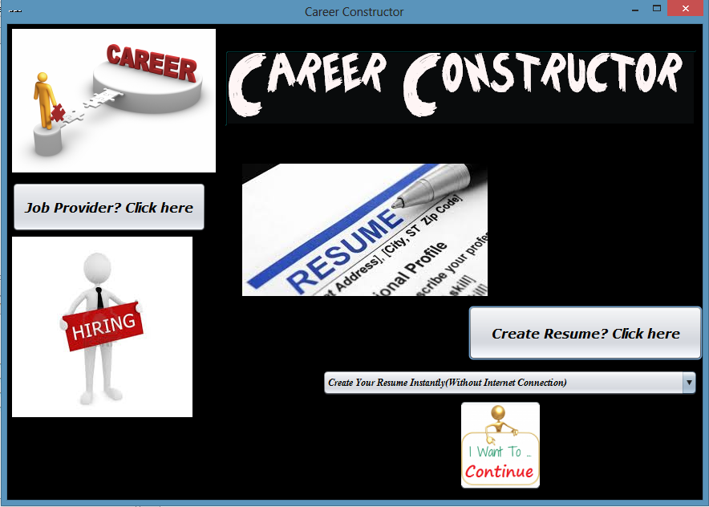

2.

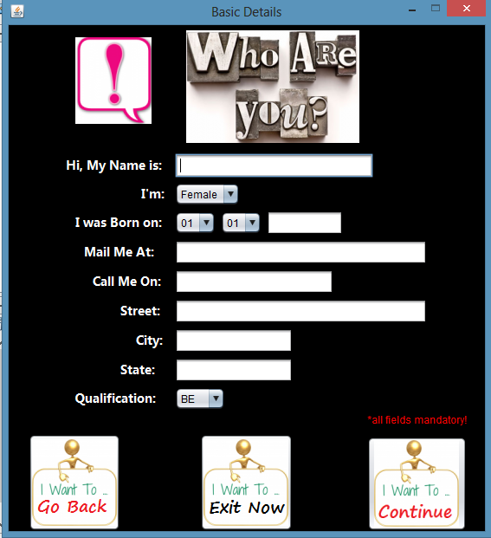

3.

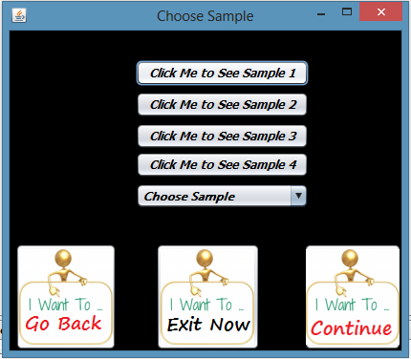

4.

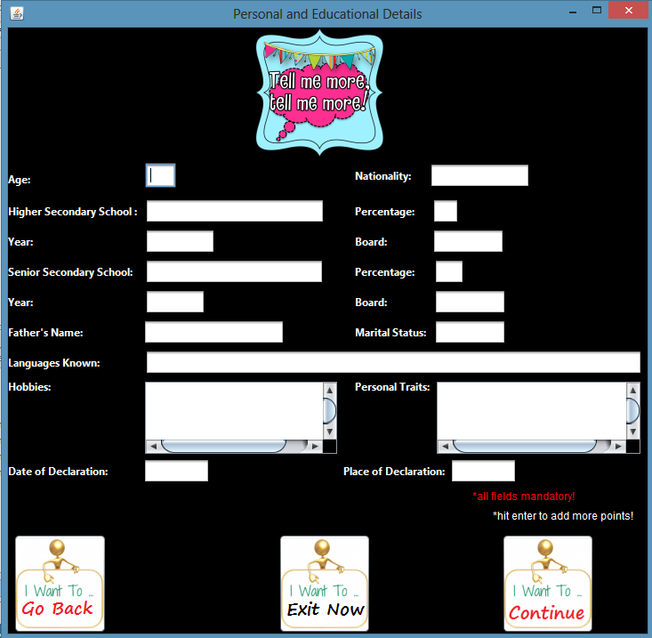

5.

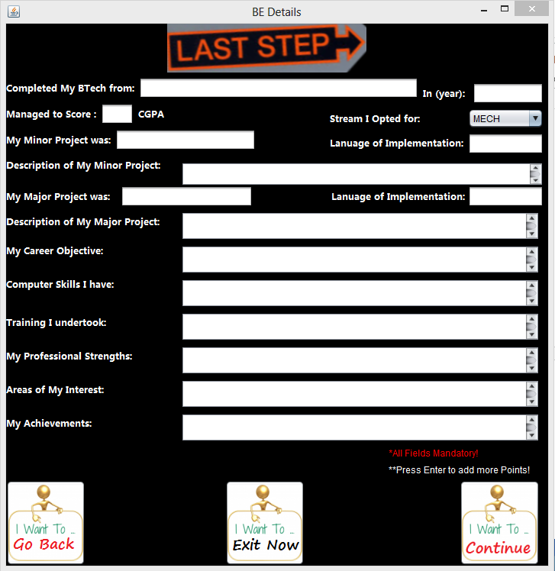

6.

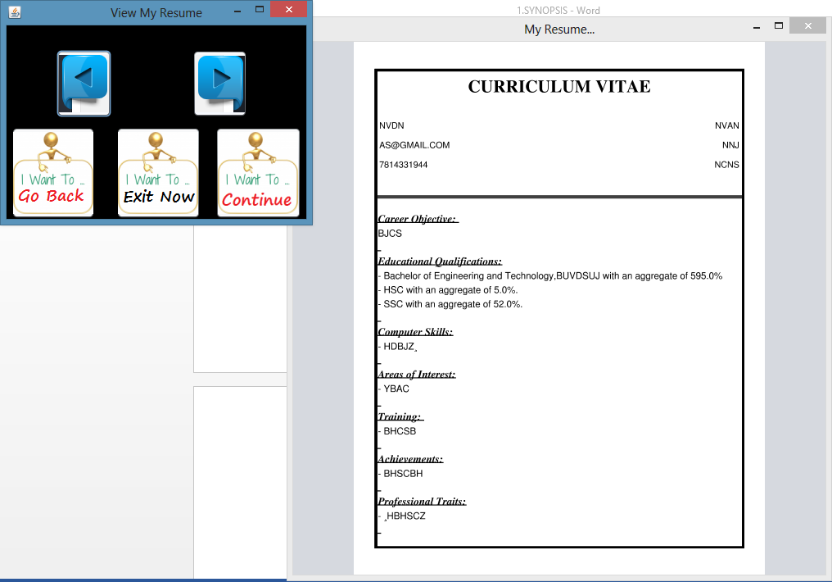

7.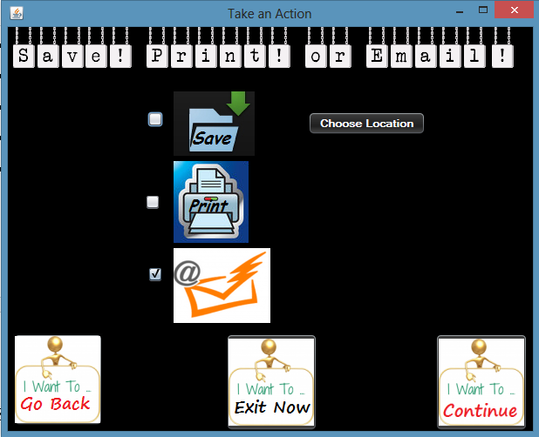

**BIBLIOGRAPHY:-**

1) [www.google.com](http://www.google.com)

2) [www.wikipedia.org](http://www.wikipedia.org)

3) [www.w3school.com/](http://www.w3school.com/)

4) [www.devguru.com/](http://www.devguru.com/)

5) [www.w3.org/](http://www.w3.org/)