





By EME

# CSE 5th Semester

***Project Objective:***

The main objective of the project is to create a career constructor software. Career constructor is divided into two major parts.

First one is resume builder, where the user, first can choose a resume sample that is viewed using the concept of PdfRenderer. After choosing the desired sample, the user is required to fill in his details, all basic and academic details, that are represented in a pdf format using I Text, for editing and making a pdf sample. After finally reviwing his pdf, the user is given three choices, to save the document or to email it to himself or to get it printed by a printer. The user can choose one or more frm these choices and the desired chosen option will be carried out.

Second part is, the application of database and SQL server. While forming the resume, the user has an option to register the values in a database. And the companies can choose candidates with apt qualifications. Here the company representatives are asked to fill in information on basis of which the candidates can be chosen. After choosing the candidates, these are represented in a jTable.

The program is small sized and written in java using netbeans software and finally it is wrapped and made an application using an installer. With the help of installer, anyone can download and install this software.

“CAREER CONSTRUCTOR” is the perfect solution if the user wants to create resume or the company wants to search for apt and qualified candidates.

***Contents:***

**Organization Profile: Page 3**

**Project Overview: Page 4**

**Tools used: Page 5**

**About the Technology: java Page 8**

**Source Codes of all tools: Page 17**

**Screen Shots of the project: Page 34**

**Bibliography: Page 41**

***Organization Profile:***

EME GROUP was established in 2006 by dedicated team of faculty members who are contributing their knowledge in Research, Industry and Teaching. EME Group is a fastest growing group has founded various Institutes under its umbrella and consists:

• ENGINEERING MADE EASY: It provides coaching for Engineering Entrance Exams like: IES / GATE / PSU

• EME TECHNOLOGIES: It provides 6 Weeks / 6 Months Industrial Training to B-Tech / Diploma / MCA / BCA students

EME Group is software Development & Training Centre, managed by a team of highly qualified software & hardware professionals. They provide trusted and expert training for a few IT companies to their utmost satisfaction. Also provide coaching for exams such as GATE, IES and PSU, full study material and regular updates.

The institute’s objectives is to empower the future computer Professionals by providing them decent work atmosphere, individual attention, creating confidence in them by encouraging them take-up the Project on their own, right from selection of topic until its implementation, under the supervision and guidance of experienced and expert faculty.

**EME-Overview:**

The “EMETECHNOLOGIES”, Mohali was formally known as “ZOOM IT”, Mohali in 7 Phase Industrial Area. EMETECHNOLOGIES are Offshore Outsourcing Consultants with a leading edge technology focus on delivering the best and most cost-effective solutions to their clients in various areas of web development services and solutions.

The team at EMETECHNOLOGIES consists of over 30 highly skilled professionals associated with Information Technology. EMETECHNOLOGIES delivers total solutions for software development and maintenance needs, serving companies from the smallest of start-ups to the largest of the Global 2000. We specialize in offshore software development and web applications.

At EMETECHNOLOGIES a talented group of designers and interface engineers are masters at effectively conveying a consistent corporate message and brand while concentrating on ensuring a pleasant and useful user experience. They help in effectively market the company by utilizing their skills in web strategy, creative interface design, corporate branding and logo design, online marketing

***Project Overview:***

|  |  |  |
| --- | --- | --- |
|  | **Name of the Project** | **Career Constructor** |
|  | **Objective/ Vision** | This project is an application that can be accessed throughout the web. This system can be used to create a resume sample, then to save, email or print the created resume. It can also be used by companies to find qualified candidates based on their academic results |
|  | **Users of the System** | 1. Students. 2. Companies. |
|  | **Functional Requirements** | i. Student is able to choose his qualification and then choose one sample according to his abilities.  ii. Student will be able to store his data in the live server that can be used by companies for recruitments. |
|  | **Non-functional requirements** | 1. Better component design to get better performance at peak time. 2. Flexible service based architecture will be highly desirable for future extension. |
|  | **Optional features** | 1. The project can be used to email the resume to the user. |
|  | **User interface priorities** | A. Professional look and feel.  B. Use of Netbeans 8.0 with all type of GUI. |
|  | **Team Size** | 2 |
|  | **Other important issues** | 1. Automated email firing 2. Pdf Viewing 3. Editing pdf 4. Installer 5. Live Server for database |
|  | **Technologies to be used** | **WINDOWS 7, Netbeans 8, Live Server for database, JavaScript** |

***Tools used in the Project:***

* ***Java(Netbeans)***
* ***PDF renderer***
* ***iText***
* ***Automated Email***
* ***JDBC Connector***
* ***Live Server(db4free)***
* ***Installer***

***Java:***

The whole project code is created using netbeans in Java. Java is a computer programming language that is concurrent, class-based, object-oriented, and specifically designed to have as few implementation dependencies as possible. It is intended to let application developers "write once, run anywhere" (WORA), meaning that code that runs on one platform does not need to be recompiled to run on another. Java applications are typically compiled to bytecode (class file) that can run on any Java virtual machine (JVM) regardless of computer architecture. Java is, as of 2014, one of the most popular programming languages in use, particularly for client-server web applications, with a reported 9 million developers.[10][11] Java was originally developed by James Gosling at Sun Microsystems (which has since merged into Oracle Corporation) and released in 1995 as a core component of Sun Microsystems' Java platform. The language derives much of its syntax from C and C++, but it has fewer low-level facilities than either of them.

***Netbeans:***

NetBeans is an integrated development environment (IDE) for developing primarily with Java, but also with other languages, in particular PHP, C/C++, and HTML5.[3] It is also an application platform framework for Java desktop applications and others.The NetBeans IDE is written in Java and can run on Windows, OS X, Linux, Solaris and other platforms supporting a compatible JVM.

The NetBeans Platform allows applications to be developed from a set of modular software components called modules. Applications based on the NetBeans Platform (including the NetBeans IDE itself) can be extended by third party developers.The NetBeans Team actively support the product and seek future suggestions from the wider community.

***PDF Renderer:***

Sun has released a new open-source project as part of SwingLabs: PDF Renderer, "a 100% Java PDF Renderer and Viewer." PDF Renderer can parse the Portable Document Format (PDF) from a file and display it, as an AWT image, in a panel, or using any Graphics2D implementation. It has been released under the LGPL license, the same license used by the rest of SwingLabs.

***iText:***

iText is an open source library for creating and manipulating PDF files in Java. It was written by Bruno Lowagie, Paulo Soares, and others. iText has a well established, mature codebase maintained by a large development team with stable Y-O-Y commits. Using the COCOMO model, it took an estimated 250 man-years of effort starting with its first commit in November, 2000.

As of version 5.0.0 (released Dec 7, 2009) iText is distributed under the Affero General Public License version 3. Previous versions of iText (Java up to 4.2.1 and C# up to 4.1.6) were distributed under the Mozilla Public License or the LGPL. iText is also available through a proprietary license, distributed by iText Software Corp. iText® is a registered trademark by 1T3XT BVBA.

By mid 2013 iText (Java) and iTextSharp (.NET) had been downloaded from SourceForge alone over 5 million times. In October 2013 downloads of iText from SourceForge were around 3,000 per week while iTextSharp downloads were around 4,000 per week.

***Automated Email:***

Automated mail is a business tool that makes it possible to process large volumes of mail with relative ease. Some companies make use of equipment and personnel to handle mail processing on this scale, while other companies outsource these functions to vendors who focus specifically on handling direct mail campaigns, regular distribution of mail pieces to clients, and other ongoing projects. The point of automated mail is to process the mail quickly and efficiently, thus reducing the expense associated with the creation and distribution of each unit.

***JDBC Connector:***

Java database connectivity (JDBC) is the JavaSoft specification of a standard application programming interface (API) that allows Java programs to access database management systems. The JDBC API consists of a set of interfaces and classes written in the Java programming language.

Using these standard interfaces and classes, programmers can write applications that connect to databases, send queries written in structured query language (SQL), and process the results.

The JDBC API is consistent with the style of the core Java interfaces and classes, such as java.lang and java.awt.

***Live Server(db4free)***

db4free.net provides a testing service for the latest - sometimes even development - version of the MySQL Server. You can easily create an account for free and test your applications, for example to make sure that they still work after a MySQL version update. db4free.net is also a good resource for education and to make yourself familiar with new features that were introduced in new versions.

db4free.net aims to always provide either the latest production release or the latest development release. db4free.net's MySQL server will be updated very soon after a new version is released, usually on the same day or very soon after.To access your data in a convenient way, db4free.net also provides an up-to-date version of phpMyAdmin. phpMyAdmin will also be updated very frequently, so you always get the very latest.

***Installer***

Installer is a program that is used to create a software that can be used to install any java project. Installer is a software that can be downloaded on any computer, irrespective of the computer platform. The project can be run after being installed by the installer. Any file to be used along with the project, can be attached to the installer while creating it. JDK is also attached to the installer in case any computer does not have the required jdk.

***About the Technology: JAVA***

Java is a programming language originally developed by James Gosling at Sun Microsystems (which is now a subsidiary of Oracle Corporation) and released in 1995 as a core component of Sun Microsystems' Java platform. The language derives much of its syntax from C and C++ but has a simpler object model and fewer low-level facilities. Java applications are typically compiled to bytecode (class file) that can run on any Java Virtual Machine (JVM) regardless of computer architecture. Java is a general-purpose, concurrent, class-based, object-oriented language that is specifically designed to have as few implementation dependencies as possible. It is intended to let application developers "write once, run anywhere". Java is currently one of the most popular programming languages in use, and is widely used from application software to web applications.

The original and reference implementation Java compilers, virtual machines, and class libraries were developed by Sun from 1995. As of May 2007, in compliance with the specifications of the Java Community Process, Sun relicensed most of its Java technologies under the GNU General Public License. Others have also developed alternative implementations of these Sun technologies, such as the GNU Compiler for Java, GNU Classpath, and Dalvik.

***Getting Started With Java***

When you create a new computer program, you go through a multistepprocess. The process involves three important tools:

Compiler: A compiler translates your code into computer-friendly(human-unfriendly) instructions.

Virtual machine: A virtual machine steps through the computer-friendly instructions.

Application programming interface: An application programming interface contains useful prewritten code.

***Java Programming Toolset***

To write Java programs, you need these tools :

* You need a Java compiler.
* You need a Java virtual machine.
* You need the Java API.
* You need the Java API documentation.
* You also need some less exotic tools:
* You need an editor to compose your Java programs.

When you come right down to it, a computer program is a big bunch of text. So to write a computer program, you need an editor — a tool for creating text documents. An editor is a lot like Microsoft Word, or like any other word processing program. The big difference is that an editor adds no formatting to your text — no bold, no italic, no distinctions among fonts. Computer programs have no formatting whatsoever. They have nothing except plain old letters, numbers, and other familiar keyboard characters.

You need a way to issue commands.

You need a way to say things like “compile this program” and “run the Java virtual machine.”Every computer provides ways of issuing commands. (You can double click icons or type verbose commands in a Run dialog box.) But when you use your computer’s facilities, you jump from one window to another. You open one window to read Java documentation, another window to edit a Java program, and a third window to start up the Java compiler. The process can be very tedious.

In the best of all possible worlds, you do all your program editing, documentation reading, and command issuing through one nice interface. This interface is called an integrated development environment (IDE).

A typical IDE divides your screen’s work area into several panes — one pane for editing programs, another pane for listing the names of programs, a third pane for issuing commands, and other panes to help you compose and test programs. You can arrange the panes for quick access. Better yet, if you change the information in one pane, the IDE automatically updates the information in all the other panes.

***Java Development Kit***

The Java Development Kit (JDK) is a Sun Microsystems product aimed at Java developers. Since the introduction of Java, it has been by far the most widely used Java SDK. On 17 November 2006, Sun announced that it would be released under the GNU General Public License (GPL), thus making it free software. This happened in large part on 8 May 2007; Sun contributed the source code to the Open JDK.



JDK contents :

The JDK has as its primary components a collection of programming tools, including:

* java – the loader for Java applications. This tool is an interpreter and can interpret the class files generated by the javac compiler. Now a single launcher is used for both development and deployment. The old deployment launcher, jre, no longer comes with Sun JDK.
* javac – the compiler, which converts source code into Java bytecode
* jar – the archiver, which packages related class libraries into a single JAR file. This tool also helps manage JAR files.
* javadoc – the documentation generator, which automatically generates documentation from source code comments
* jdb – the debugger
* jps – the process status tool, which displays process information for current Java processes
* javap – the class file disassembler
* appletviewer – this tool can be used to run and debug Java applets without a web browser.
* javah – the C header and stub generator, used to write native methods
* javaws – the Java Web Start launcher for JNLP applications
* extcheck – a utility which can detect JAR-file conflicts.
* apt – the annotation-processing tool
* jhat – (experimental) Java heap analysis tool
* jstack – (experimental) utility which prints Java stack traces of Java threads
* jstat – (experimental) Java Virtual Machine statistics monitoring tool
* jstatd – (experimental) jstat daemon
* jinfo – (experimental) This utility gets configuration information from a running Java process or crash dump.
* jmap – (experimental) This utility outputs the memory map for Java and can print shared object memory maps or heap memory details of a given process or core dump.
* idlj – the IDL-to-Java compiler. This utility generates Java bindings from a given IDL file.
* policytool – the policy creation and management tool, which can determine policy for a Java runtime, specifying which permissions are available for code from various sources
* VisualVM – visual tool integrating several commandline JDK tools and lightweight performance and memory profiling capabilities
* wsimport – generates portable JAX-WS artifacts for invoking a web service.
* jrunscript – Java command-line script shell.

The JDK also comes with a complete Java Runtime Environment, usually called a private runtime. It consists of a Java Virtual Machine and all of the class libraries present in the production environment, as well as additional libraries only useful to developers, such as the internationalization libraries and the IDL libraries.

Copies of the JDK also include a wide selection of example programs demonstrating the use of almost all portions of the Java API.

***Java (Software Platform)***

An edition of the Java platform is the name for a bundle of related programs, or platform, from Sun which allow for developing and running programs written in the Java programming language. The platform is not specific to any one processor or operating system, but rather an execution engine (called a virtualmachine) and a compiler with a set of libraries that are implemented for various hardware and operating systems so that Java programs can run identically on all of them.

* Java Card: refers to a technology that allows small Java-based applications (applets) to be run securely on smart cards and similar small memory footprint devices.
* Java ME (Micro Edition): Specifies several different sets of libraries (known as profiles) for devices which are sufficiently limited that supplying the full set of Java libraries would take up unacceptably large amounts of storage.
* Java SE (Standard Edition): For general purpose use on desktop PCs, servers and similar devices.
* Java EE (Enterprise Edition): Java SE plus various APIs useful for multi-tier client–server enterprise applications.

As of September 2009, the current version of the Java Platform is specified as either 1.6.0 or 6 (both refer to the same version). Version 6 is the product version, while 1.6.0 is the developer version.

The Java Platform consists of several programs, each of which provides a distinct portion of its overall capabilities. For example, the Java compiler, which converts Java source code into Java bytecode (an intermediate language for the Java Virtual Machine (JVM)), is provided as part of the Java Development Kit (JDK). The Java Runtime Environment (JRE), complementing the JVM with a just-in-time (JIT) compiler, converts intermediate bytecode into native machine code on the fly. Also supplied are extensive libraries, pre-compiled in which are several other components, some available only in certain editions.

The essential components in the platform are the Java language compiler, the libraries, and the runtime environment in which Java intermediate byte code "executes" according to the rules laid out in the virtual machine specification.

### Java Virtual Machine

The heart of the Java Platform is the concept of a "virtual machine" that executes Java byte code programs. This byte code is the same no matter what hardware or operating system the program is running under. There is a JIT compiler within the Java Virtual Machine, or JVM. The JIT compiler translates the Java byte code into native processor instructions at run-time and caches the native code in memory during execution.

***Java Byte code:***

The use of bytecode as an intermediate language permits Java programs to run on any platform that has a virtual machine available. The use of a JIT compiler means that Java applications, after a short delay during loading and once they have "warmed up" by being all or mostly JIT-compiled, tend to run about as fast as native programs. Since JRE version 1.2, Sun's JVM implementation has included a just-in-time compiler instead of an interpreter.

Although Java programs are platform independent, the code of the Java Virtual Machine (JVM) that execute these programs is not; every supported operating platform has its own JVM.

### Class libraries

In most modern operating systems, a large body of reusable code is provided to simplify the programmer's job. This code is typically provided as a set of dynamically loadable librariesthat applications can call at runtime. Because the Java Platform is not dependent on any specific operating system, applications cannot rely on any of the pre-existing OS libraries. Instead, the Java Platform provides a comprehensive set of its own standard class libraries containing much of the same reusable functions commonly found in modern operating systems.

The Java class libraries serve three purposes within the Java Platform. First, like other standard code libraries, the Java libraries provide the programmer a well-known set of functions to perform common tasks, such as maintaining lists of items or performing complex string parsing. Second, the class libraries provide an abstract interface to tasks that would normally depend heavily on the hardware and operating system. Tasks such as network access and file access are often heavily intertwined with the distinctive implementations of each platform. The Java java.net and java.io libraries implement an abstraction layer in native OS code, then provide a standard interface for the Java applications to perform those tasks. Finally, when some underlying platform does not support all of the features a Java application expects, the class libraries work to gracefully handle the absent components, either by emulation to provide a substitute, or at least by providing a consistent way to check for the presence of a specific feature. The Android OS is using Java class libraries which are open source for anyone to use.

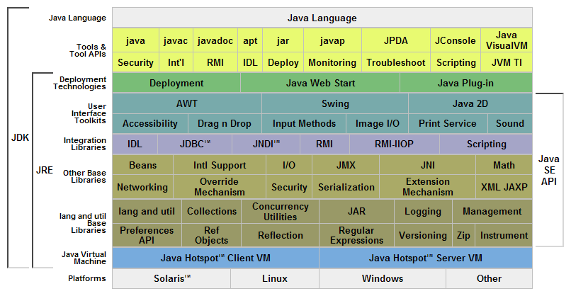

JAVA Platform diagram from Sun

***Execution environment***

Programs intended to run on a JVM must be compiled into a standardized portable binary format, which typically comes in the form of .class files. A program may consist of many classes in different files. For easier distribution of large programs, multiple class files may be packaged together in a .jar file (short for Java archive).

The JVM runtime executes .class or .jar files, emulating the JVM instruction set by interpreting it, or using a just-in-time compiler (JIT) such as Sun's HotSpot. JIT compiling, not interpreting, is used in most JVMs today to achieve greater speed. Ahead-of-time compilers that enable the developer to precompile class files into native code for a particular platforms also exist.Like most virtual machines, the Java Virtual Machine has a stack-based architecture akin to a microcontroller/microprocessor. However, the JVM also has low-level support for Java-like classes and methods, which amounts to a highly idiosyncratic memory model and capability-based architecture.The JVM, which is the instance of the 'JRE' (Java Runtime Environment), comes into action when a Java program is executed. When execution is complete, this instance is garbage collected. JIT is the part of the JVM that is used to speed up the execution time. JIT compiles parts of the byte code that have similar functionality at the same time, and hence reduces the amount of time needed for compilation.

***Source code for a Java Program***

package GUI;

import java.awt.Color;

import java.awt.Toolkit;

import logic.SetConnections;

public class CareerConstructor extends javax.swing.JFrame

{

public static int resume;

public CareerConstructor()

{

initComponents();

this.getContentPane().setBackground(new Color(0,0,0));

this.setLocationRelativeTo(null);

setIcon();

}

private void resumActionPerformed(java.awt.event.ActionEvent evt) {

p1.setVisible(true);

//p1.setBackground(new Color(23,190,190));

}

private void searchActionPerformed(java.awt.event.ActionEvent evt) {

this.dispose();

new Search1().setVisible(true);

}

private void jButton1ActionPerformed(java.awt.event.ActionEvent evt) {

resume = combo.getSelectedIndex();

if(new CareerConstructor().resume==1)

new SetConnections();

new BasicInfo().setVisible(true);

this.dispose();

}

private void comboActionPerformed(java.awt.event.ActionEvent evt) {

// TODO add your handling code here:

}

public static void main(String args[]) {

/* Set the Nimbus look and feel */

//<editor-fold defaultstate="collapsed" desc=" Look and feel setting code (optional) ">

/* If Nimbus (introduced in Java SE 6) is not available, stay with the default look and feel.

* For details see http://download.oracle.com/javase/tutorial/uiswing/lookandfeel/plaf.html

*/

try {

for (javax.swing.UIManager.LookAndFeelInfo info : javax.swing.UIManager.getInstalledLookAndFeels()) {

if ("Nimbus".equals(info.getName())) {

javax.swing.UIManager.setLookAndFeel(info.getClassName());

break;

}

}

} catch (ClassNotFoundException ex) {

java.util.logging.Logger.getLogger(CareerConstructor.class.getName()).log(java.util.logging.Level.SEVERE, null, ex);

} catch (InstantiationException ex) {

java.util.logging.Logger.getLogger(CareerConstructor.class.getName()).log(java.util.logging.Level.SEVERE, null, ex);

} catch (IllegalAccessException ex) {

java.util.logging.Logger.getLogger(CareerConstructor.class.getName()).log(java.util.logging.Level.SEVERE, null, ex);

} catch (javax.swing.UnsupportedLookAndFeelException ex) {

java.util.logging.Logger.getLogger(CareerConstructor.class.getName()).log(java.util.logging.Level.SEVERE, null, ex);

}

//</editor-fold>

/* Create and display the form */

java.awt.EventQueue.invokeLater(new Runnable() {

public void run() {

new CareerConstructor().setVisible(true);

}

});

}

// Variables declaration - do not modify

private javax.swing.JComboBox combo;

private javax.swing.JButton jButton1;

private javax.swing.JLabel jLabel1;

private javax.swing.JLabel jLabel4;

private javax.swing.JLabel jLabel5;

private javax.swing.JLabel jLabel6;

private javax.swing.JPanel p1;

private javax.swing.JButton resum;

private javax.swing.JButton search;

// End of variables declaration

private void setIcon() {

p1.setVisible(false);

setIconImage(Toolkit.getDefaultToolkit().getImage(getClass().getResource("abcd.jpg")));

p1.setBackground(new Color(0,0,0));

// this.getContentPane().setBackground(new Color(23,190,190));

}

}

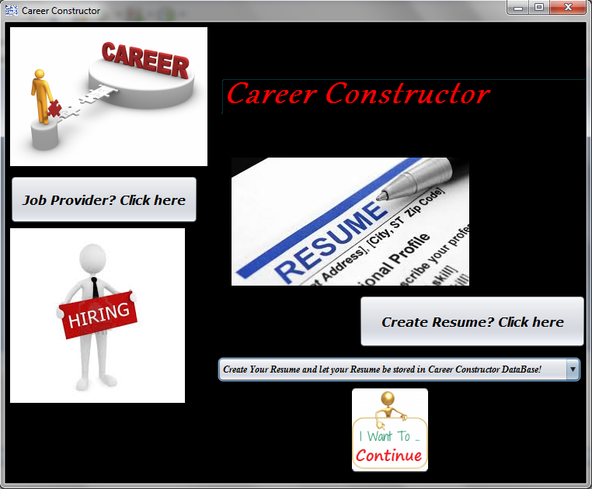

***PDF renderer***

Sun has released a new open-source project as part of SwingLabs: PDF Renderer, "a 100% Java PDF Renderer and Viewer." PDF Renderer can parse the Portable Document Format (PDF) from a file and display it, as an AWT image, in a panel, or using any Graphics2D implementation. It has been released under the LGPL license, the same license used by the rest of SwingLabs.

In this project , the pdf renderer is used for one basic operation, that is to view the pdf files. The documents can be viewed in a pdf format even if the computer does not have any software to view pdf format files like adobe reader.

***Source code for a PDF renderer***

import com.sun.pdfview.PDFFile;

import com.sun.pdfview.PDFPage;

import com.sun.pdfview.PagePanel;

import java.io.\*;

import java.nio.ByteBuffer;

import java.nio.channels.FileChannel;

import javax.swing.\*;

/\*\*

\* An example of using the PagePanel class to show PDFs. For more advanced

\* usage including navigation and zooming, look ad the

\* com.sun.pdfview.PDFViewer class.

\*

\* -AT-author joshua.marinacci@sun-DOT-com

\*/

public class Main {

public static void setup() throws IOException {

//set up the frame and panel

JFrame frame = new JFrame("PDF Test");

frame.setDefaultCloseOperation(JFrame.EXIT_ON_CLOSE);

PagePanel panel = new PagePanel();

frame.add(panel);

frame.pack();

frame.setVisible(true);

//load a pdf from a byte buffer

File file = new File("Amityform.pdf");

RandomAccessFile raf = new RandomAccessFile(file, "r");

FileChannel channel = raf.getChannel();

ByteBuffer buf = channel.map(FileChannel.MapMode.READ_ONLY,

0, channel.size());

PDFFile pdffile = new PDFFile(buf);

// show the first page

PDFPage page = pdffile.getPage(0);

panel.showPage(page);

}

public static void main(final String[] args) {

SwingUtilities.invokeLater(new Runnable() {

public void run() {

try {⁞

Main.setup();

} catch (IOException ex) {

ex.printStackTrace();

}

}

});

}

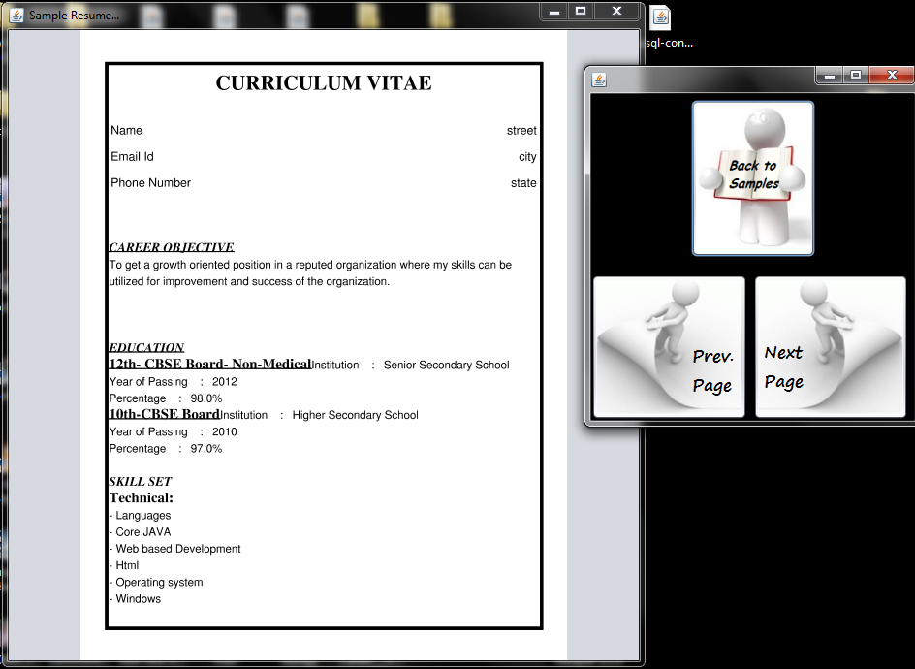}

***iText:***

iText is a PDF library that allows you to CREATE, ADAPT, INSPECT and MAINTAIN documents in the Portable Document Format (PDF):

* Generate documents and reports based on data from an XML file or a database
* Create maps and books, exploiting numerous interactive features available in PDF
* Add bookmarks, page numbers, watermarks, and other features to existing PDF documents
* Split or concatenate pages from existing PDF files
* Fill out interactive forms
* Serve dynamically generated or manipulated PDF documents to a web browser
* Legally binding digital signatures
* Tagged PDF
* iText is used by Java, .NET, Android and GAE developers to enhance their applications with PDF functionality.

In this project, itext is used for generation of pdf document. The four samples of each of three categories are created using iText. The forms, the writing done on pdf document, the merging of text, addition of line separators and rectangular boxes is all done using iText library. The after the user has entered its details, the same pdf samples are changed according to the values provided by the user. The modification and manipulation of the pdf is also done using iText library.

***Source code for iText***

package resume;

import GUI.BE;

import GUI.Basic;

import GUI.BasicInfo;

import com.itextpdf.text.BaseColor;

import com.itextpdf.text.Chunk;

import com.itextpdf.text.Document;

import com.itextpdf.text.DocumentException;

import com.itextpdf.text.Element;

import com.itextpdf.text.Font;

import com.itextpdf.text.List;

import com.itextpdf.text.ListItem;

import com.itextpdf.text.PageSize;

import com.itextpdf.text.Paragraph;

import com.itextpdf.text.Rectangle;

import com.itextpdf.text.pdf.PdfPCell;

import com.itextpdf.text.pdf.PdfPTable;

import com.itextpdf.text.pdf.PdfWriter;

import com.itextpdf.text.pdf.draw.LineSeparator;

import java.io.FileOutputStream;

import java.io.IOException;

import java.sql.Connection;

import java.sql.DriverManager;

import java.sql.PreparedStatement;

import java.sql.SQLException;

import java.util.logging.Level;

import java.util.logging.Logger;

import javax.swing.JOptionPane;

import static GUI.View.RESULT;

public class BE1 {

Connection con=null;

PreparedStatement preparedStatement=null;

BE be=new BE();

Basic b= new Basic();

BasicInfo i= new BasicInfo();

public static FileOutputStream fo;

public static PdfWriter writer;

public void create() throws DocumentException,IOException{

RESULT= System.getProperty("java.io.tmpdir")+"0112422vsabl.pdf";

// step 1

Document document = new Document();

// step 2

fo= new FileOutputStream(RESULT);

writer=PdfWriter.getInstance(document,fo );

document.setPageSize(PageSize.LETTER);

document.setMargins(36, 36, 36, 36);

document.setMarginMirroring(false);

// step 3

document.open();

// step 4

Rectangle rect= new Rectangle(33, 40, 580, 750); //Page Border

rect.setBorder(Rectangle.BOX);

rect.setBorderWidth(4);

rect.setBorderColor(BaseColor.BLACK);

document.add(rect);

Font font = new Font(Font.FontFamily.TIMES_ROMAN, 26, Font.BOLD, BaseColor.BLACK);

Paragraph title= new Paragraph("CURRICULUM VITAE\n\n",font);

title.setAlignment(Element.ALIGN_CENTER);

document.add(title);

Font f1= new Font (Font.FontFamily.UNDEFINED, 13, Font.NORMAL, BaseColor.BLACK);

Paragraph info= new Paragraph(name+"\n\n"+email+"\n\n"+phone_num,f1);

Paragraph addr= new Paragraph(street+"\n\n"+city+"\n\n"+state,f1);

PdfPTable table = new PdfPTable(2); //to left align info and right align addr

table.setWidthPercentage(100);

table.spacingAfter();

PdfPCell cell = new PdfPCell(info);

cell.setHorizontalAlignment(Element.ALIGN_LEFT);

cell.disableBorderSide(Rectangle.BOX);

cell.setExtraParagraphSpace(1.5f);

table.addCell(cell);

cell = new PdfPCell(addr);

cell.setHorizontalAlignment(Element.ALIGN_RIGHT);

cell.disableBorderSide(Rectangle.BOX);

cell.setExtraParagraphSpace(1.5f);

table.addCell(cell);

document.add(table);

document.add(new Chunk("\n"));

document.add(new LineSeparator(5f,100,BaseColor.DARK_GRAY,Element.ALIGN_CENTER,-1f));

Font heading= new Font (Font.FontFamily.TIMES_ROMAN, 16, Font.BOLDITALIC, BaseColor.BLACK);

Chunk subhd= new Chunk("Career Objective: ",heading);

subhd.setUnderline(1.5f, 0f);

document.add(subhd); //subheading

Font content= new Font (Font.FontFamily.HELVETICA, 14, Font.NORMAL, BaseColor.BLACK);

Paragraph cntnt= new Paragraph(career_objective,content);

document.add(cntnt); //content

subhd= new Chunk("\nEducational Qualifications:",heading);

subhd.setUnderline(1.5f, 0f);

//Chunk c1= new Chunk("Master of Engineering and Technology,"+univ_me+" with an aggregate of "+me_cgpa+"%",content);

Chunk c2= new Chunk("Bachelor of Engineering and Technology,"+univ_be+" with an aggregate of "+be_cgpa+"%",content);

Chunk c3= new Chunk("HSC with an aggregate of "+hss_percent+"%.",content);

Chunk c4= new Chunk("SSC with an aggregate of "+sss_percent+"%.",content);

List unorderedList = new List(List.UNORDERED);

//unorderedList.add(new ListItem(c1));

unorderedList.add(new ListItem(c2));

unorderedList.add(new ListItem(c3));

unorderedList.add(new ListItem(c4));

document.add(subhd);

document.add(unorderedList);

Chunk subhd1= new Chunk("\nComputer Skills:",heading);

subhd1.setUnderline(1.5f, 0f);

unorderedList = new List(List.UNORDERED);

for (String comp_skill : comp_skills) {

unorderedList.add(new ListItem(new Chunk(comp_skill, content)));

}

document.add(subhd1);

document.add(unorderedList);

subhd= new Chunk("\nAreas of Interest:",heading);

subhd.setUnderline(1.5f, 0f);

unorderedList = new List(List.UNORDERED);

for (String area_interest1 : area_interest) {

unorderedList.add(new ListItem(new Chunk(area_interest1, content)));

}

document.add(subhd);

document.add(unorderedList);

subhd= new Chunk("\nTraining: ",heading);

subhd.setUnderline(1.5f, 0f);

unorderedList = new List(List.UNORDERED);

for (String training1 : training) {

unorderedList.add(new ListItem(new Chunk(training1, content)));

}

document.add(subhd);

document.add(unorderedList);

document.add(rect);

subhd= new Chunk("\nAchievements:",heading);

subhd.setUnderline(1.5f, 0f);

unorderedList = new List(List.UNORDERED);

for(int i=0;i<awards.length;i++)

unorderedList.add(new ListItem(new Chunk(awards[i],content)));

document.add(subhd);

document.add(unorderedList);

subhd= new Chunk("\nProfessional Traits:",heading);

subhd.setUnderline(1.5f, 0f);

unorderedList = new List(List.UNORDERED);

for(int i=0;i<prof_traits.length;i++)

unorderedList.add(new ListItem(new Chunk(prof_traits[i],content)));

document.add(subhd);

document.add(unorderedList);

subhd= new Chunk("\nAcademic Projects:",heading);

subhd.setUnderline(1.5f, 0f);

document.add(subhd);

subhd= new Chunk("\nProject1: "+min_proj,heading);

subhd.setUnderline(1.5f, 0f);

cntnt = new Paragraph("Language of implementation : "+min_proj_tech,content);

document.add(subhd);

document.add(cntnt);

subhd= new Chunk("Project Description:",heading);

subhd.setUnderline(1.5f, 0f);

cntnt = new Paragraph(des_min,content);

document.add(rect);

document.add(subhd);

document.add(cntnt);

subhd= new Chunk("\nProject2: "+maj_proj,heading);

subhd.setUnderline(1.5f, 0f);

cntnt = new Paragraph("Language of implementation : "+maj_proj_tech,content);

document.add(subhd);

document.add(cntnt);

subhd= new Chunk("Project Description:",heading);

cntnt = new Paragraph(des_maj,content);

subhd.setUnderline(1.5f, 0f);

document.add(subhd);

document.add(cntnt);

subhd= new Chunk("\nPersonal Profile:",heading);

subhd.setUnderline(1.5f, 0f);

document.add(subhd);

cntnt= new Paragraph("Name : "+name+"\nFather's Name : "+f_name+"\nDate of Birth : "+date+"-"+month+"-"+year+"\nGender : "+gender+"\nMarital Status : "+mar_status+"\nNationality :  "+nationality+"\nPermanent Address : "+street+","+city+","+state+"\nContact Number : "+phone_num,content);

document.add(cntnt);

subhd= new Chunk("\nDeclaration:",heading);

subhd.setUnderline(1.5f, 0f);

document.add(subhd);

cntnt =new Paragraph("I hereby declare that the above-mentioned information is correct up to my knowledge and I bear the responsibility for the correctness of the above-mentioned particulars.\nDate : "+date_declaration+"\nPlace : "+place_declaration,content);

document.add(cntnt);

document.add(rect);

document.close();

}

}

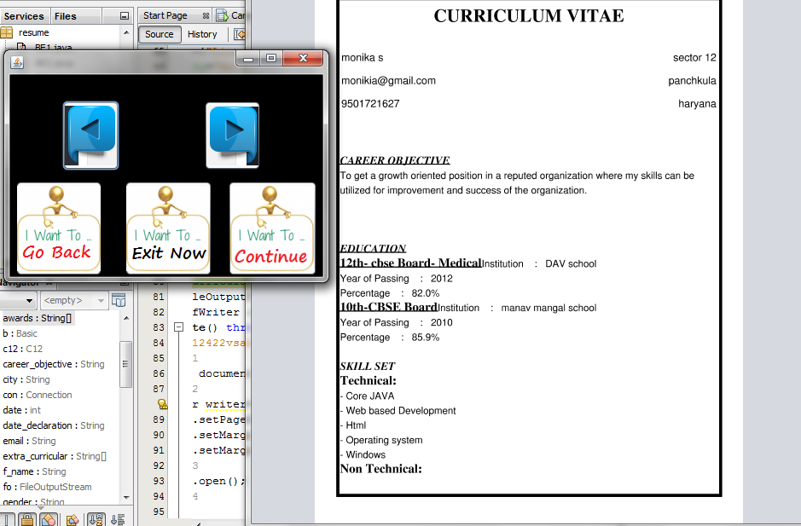

***Automated Email:***

Automated email is used in the project while the user wants to email his resume to either himself or any company, he gets to privilege to send it through our website. After creating the resume, the user gets three options, one of which is email, for the user to email its resume. The other part of this project where automated email is being used is, after searching for the qualified candidate for his company, the job provider can email the candidates and contact them through our project only.

***Source code for Automated Email:***

*package logic;*

*import java.util.Properties;*

*import javax.activation.DataHandler;*

*import javax.activation.DataSource;*

*import javax.activation.FileDataSource;*

*import javax.mail.BodyPart;*

*import javax.mail.Message;*

*import javax.mail.Multipart;*

*import javax.mail.PasswordAuthentication;*

*import javax.mail.Session;*

*import javax.mail.Transport;*

*import javax.mail.internet.InternetAddress;*

*import javax.mail.internet.MimeBodyPart;*

*import javax.mail.internet.MimeMessage;*

*import javax.mail.internet.MimeMultipart;*

*import static GUI.View.RESULT;*

*/\*\**

*\**

*\* @author Muddassir Iqbal*

*\*/*

*public class Email extends javax.mail.Authenticator {*

*String attachment;*

*private String mailhost ="smtp.gmail.com"; //SMTP Host/Email for Gmail*

*private String mailhost1 ="smtp.mail.yahoo.com";*

*private String user="careerconstructor@yahoo.com"; //Gmail username*

*private String password="Sakshi24"; //Gmail Password*

*private Session session; //To establish a session*

*public Email() {*

*// Create properties for Gmail server*

*Properties props = new Properties();*

*props.setProperty("mail.transport.protocol", "smtp"); //Protocol*

*props.setProperty("mail.smtp.host", mailhost); //Host Name*

*props.setProperty("mail.smtp.host", mailhost1);*

*props.put("mail.smtp.auth", "true"); //SMTP Authentication*

*props.put("mail.smtp.port", "465"); //SMTP port number*

*props.put("mail.smtp.socketFactory.port", "465");*

*props.put("mail.smtp.socketFactory.class","javax.net.ssl.SSLSocketFactory"); //SSL Socket setting*

*props.put("mail.smtp.starttls.enable","true"); //Start TLS Authentication*

*props.put("mail.smtp.debug", "true"); //Debugging*

*//props.put("mail.smtp.socketFactory.fallback", "false");*

*//props.setProperty("mail.smtp.quitwait", "false");*

*//session=Session.getDefaultInstance(props, this);*

*session = Session.getInstance(props, this); //Get instance*

*}*

*@Override*

*protected PasswordAuthentication getPasswordAuthentication(){*

*return new PasswordAuthentication(user, password);*

*}*

*public void sendMail(String recipients) throws Exception{*

*Message message = new MimeMessage(session);*

*String subject="Resume by Career Constructor";*

*String body= "Kindly Download your Resume created by Career Constructor.\n\nWith Regards ";*

*// Mail with Attachment*

*String sender="careerconstructor@yahoo.com";*

*message.setFrom(new InternetAddress(sender)); // Set From: header field of the header.*

*message.setSubject(subject); // Set Subject: header field*

*BodyPart messageBodyPart = new MimeBodyPart(); // Create the message part*

*messageBodyPart.setContent(body, "text/html"); // Now set the actual message*

*Multipart multipart = new MimeMultipart(); // Create a multipart message*

*multipart.addBodyPart(messageBodyPart); // Set text message part*

*// Part two is attachment*

*attachment = RESULT;*

*messageBodyPart = new MimeBodyPart();*

*DataSource source = new FileDataSource(attachment);*

*messageBodyPart.setDataHandler(new DataHandler(source));*

*// Extracting filename out of file path*

*int i = attachment.lastIndexOf('\\');*

*String file = attachment.substring(i+1);*

*messageBodyPart.setFileName(file);*

*multipart.addBodyPart(messageBodyPart);*

*message.setContent(multipart); // Set the complete message parts*

*message.setRecipient(Message.RecipientType.TO, new InternetAddress(recipients));*

*//Set the recepients*

*Transport.send(message); // Sending mail*

*}*

*}*

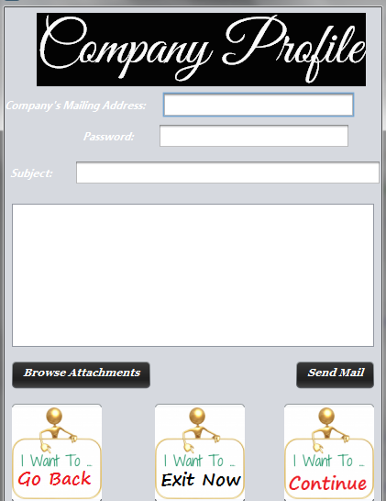

***Source Code for JDBC Connector:***

package logic;

import java.sql.Connection;

import java.sql.DriverManager;

import java.sql.PreparedStatement;

/**

*

* @author om

*/

public class SetConnections {

Connection con=null;

PreparedStatement preparedStatement=null;

public SetConnections()

{

try

{

Class.forName("com.mysql.jdbc.Driver");

con= DriverManager.getConnection("jdbc:mysql://db4free.net:3306/dbresume","sakshi24","Sakshi24");

}

catch(Exception e)

{

e.printStackTrace();

}

}

}

***Source code for Entering values into a live server:***

public void insert()

{

try

{

preparedStatement=con.prepareStatement("insert into resume1(name,qualification,phone_num,email_id,date,month,year,gender,street,state,city) values(?,?,?,?,?,?,?,?,?,?,?)");

preparedStatement.setObject(1, n.getText());

preparedStatement.setObject(2, q.getSelectedItem().toString());

preparedStatement.setObject(3, nm.getText());

preparedStatement.setObject(4, e.getText());

preparedStatement.setObject(5, d.getSelectedItem().toString());

preparedStatement.setObject(6, m.getSelectedItem().toString());

preparedStatement.setObject(7, y.getText());

preparedStatement.setObject(8, g.getSelectedItem().toString());

preparedStatement.setObject(9, s.getText());

preparedStatement.setObject(10, c.getText());

preparedStatement.setObject(11, st.getText());

preparedStatement.executeUpdate();

}

catch(Exception e)

{

JOptionPane.showMessageDialog(null, e.toString(), "Try Again!",

JOptionPane.ERROR_MESSAGE);

}

}

***Updating of Values:***

public void update2() throws SQLException

{

preparedStatement=con.prepareStatement("update resume1 set min_proj=?,desc_min=?,maj_proj=?,maj_proj_tech=?,desc_maj=?,career_obj=?,comp_skills=?,proff_traits=?,area_interest=?,awards=?,grad_degree=?,grad_year=?,grad_univ=?,grad_cgpa=?,mba_univ=?,mba_year=?,mba_cgpa=?,mba_specialisation=? order by s_no desc limit 1");

preparedStatement.setObject(1, minp.getText());

preparedStatement.setObject(2, desn.getText());

preparedStatement.setObject(3, majp.getText());

preparedStatement.setObject(4, majt.getText());

preparedStatement.setObject(5, desj.getText());

preparedStatement.setObject(6, cro.getText());

preparedStatement.setObject(7, csk.getText());

preparedStatement.setObject(8, pt.getText());

preparedStatement.setObject(9, ai.getText());

preparedStatement.setObject(10, aw.getText());

preparedStatement.setObject(11, gd.getText());

preparedStatement.setObject(12, gy.getText());

preparedStatement.setObject(13, gu.getText());

preparedStatement.setObject(14, gc.getText());

preparedStatement.setObject(15, mu.getText());

preparedStatement.setObject(16, my.getText());

preparedStatement.setObject(17, mc.getText());

preparedStatement.setObject(18, ms.getText());

preparedStatement.executeUpdate();

}

***For Searching Values in a db and displaying them in jTable:***

public void search_c1() throws SQLException {

this.Hss_marks = hss_marks.getText();

this.Sss_marks = sss_marks.getText();

this.Sss_stream=sss_stream.getEditor().toString();

final JFrame frame = new JFrame();

frame.setDefaultCloseOperation(JFrame.EXIT_ON_CLOSE);

Vector<String> columnNames = new Vector<String>();

columnNames.add("Name");

columnNames.add("Age");

columnNames.add("Gender");

columnNames.add("E-Mail ID");

columnNames.add("Phone Number");

columnNames.add("SSS Marks");

columnNames.add("HSS Marks");

columnNames.add("");

String query =("select name,age,gender,email_id,phone_num, hss_percent, sss_percent from resume1 where qualification='Class 12' and hss_percent>='"+ Hss_marks +"'" + "and sss_percent>='" + Sss_marks +"'"+ "and sss_stream ='"+ Sss_stream +"'");

try {

conn = DriverManager.getConnection(DB_URL, USER, PASS);

stmt = conn.createStatement();

ResultSet rs = stmt.executeQuery(query);

while (rs.next()) {

Vector<String> vstring = new Vector<String>();

vstring.add(rs.getString("name"));

vstring.add(rs.getString("age"));

vstring.add(rs.getString("gender"));

vstring.add(rs.getString("email_id"));

vstring.add(rs.getString("phone_num"));

vstring.add(rs.getString("sss_percent"));

vstring.add(rs.getString("hss_percent"));

vstring.add("Contact Applicant");

data.add(vstring);

}

} catch (SQLException e) {

e.printStackTrace();

} finally {

if (stmt != null) {

try {

stmt.close();

} catch (SQLException ex) {

}

}

}

final JTable table;

table = new JTable(data, columnNames)

{

public boolean isCellEditable(int rowIndex, int colIndex) {

return false; //Disallow the editing of any cell

}

};

table.setCellSelectionEnabled(true);

ListSelectionModel cellSelectionModel = table.getSelectionModel();

cellSelectionModel.setSelectionMode(ListSelectionModel.SINGLE_SELECTION);

cellSelectionModel.addListSelectionListener(new ListSelectionListener() {

public void valueChanged(ListSelectionEvent e) {

int[] selectedRow = table.getSelectedRows();

for (int i = 0; i < selectedRow.length; i++) {

Email = (String) table.getValueAt(selectedRow[i],3);

}

frame.dispose();new Contact().setVisible(true);

System.out.println("Selected: " + Email);

}

public boolean isCellEditable(int rowIndex, int mColIndex) {

return false;

}

});

frame.add(new JScrollPane(table));

frame.setSize(500, 700);

frame.setVisible(true);

}

***Installer:***

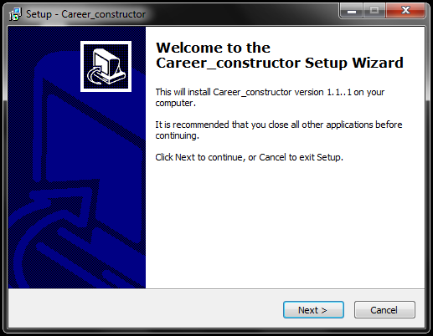

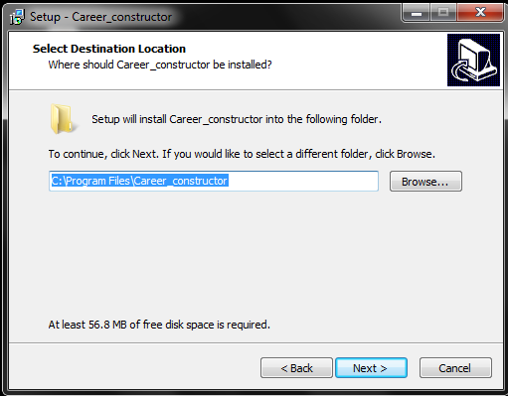

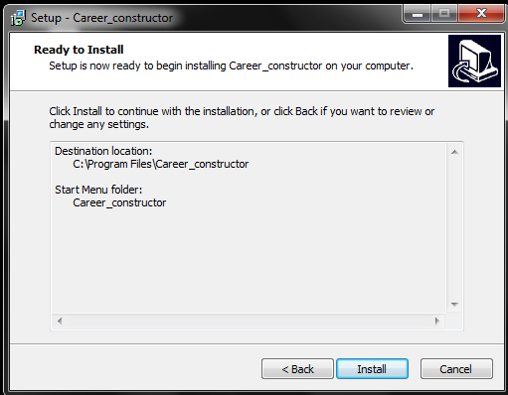

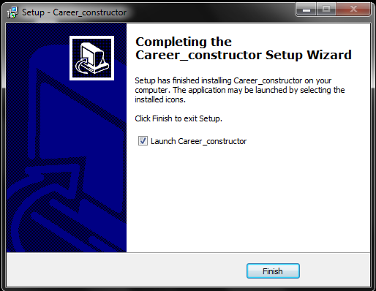

***Screen Shots of the Project***

The user can choose one of the two options: Create Resume or Job Provider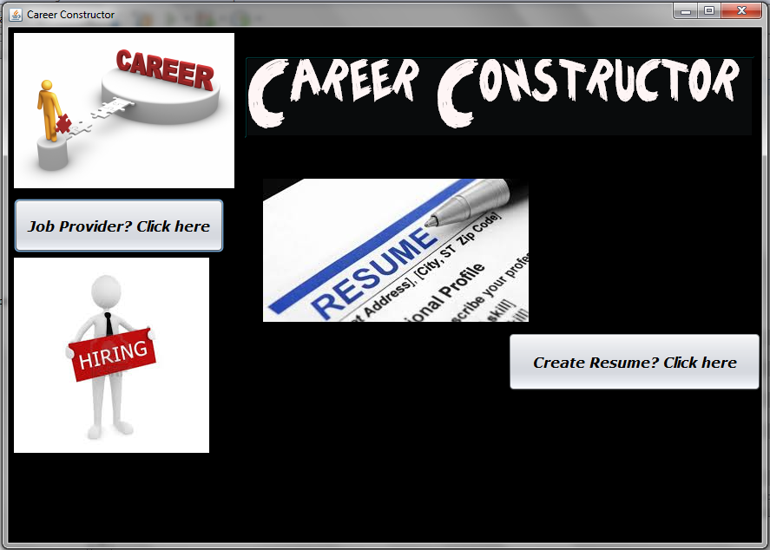

Here the user is asked to fill in his basic details and choose his qualification.

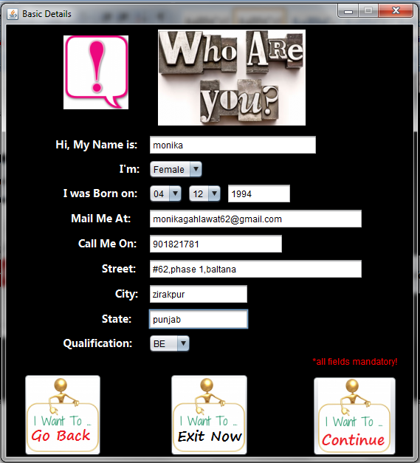

In this jFrame, the user can view any of the four samples and then choose one desired sample to create his resume.

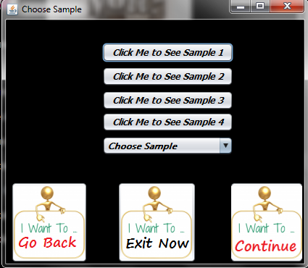

The resume samples can be viewed in a pdf format using pdf renderer.

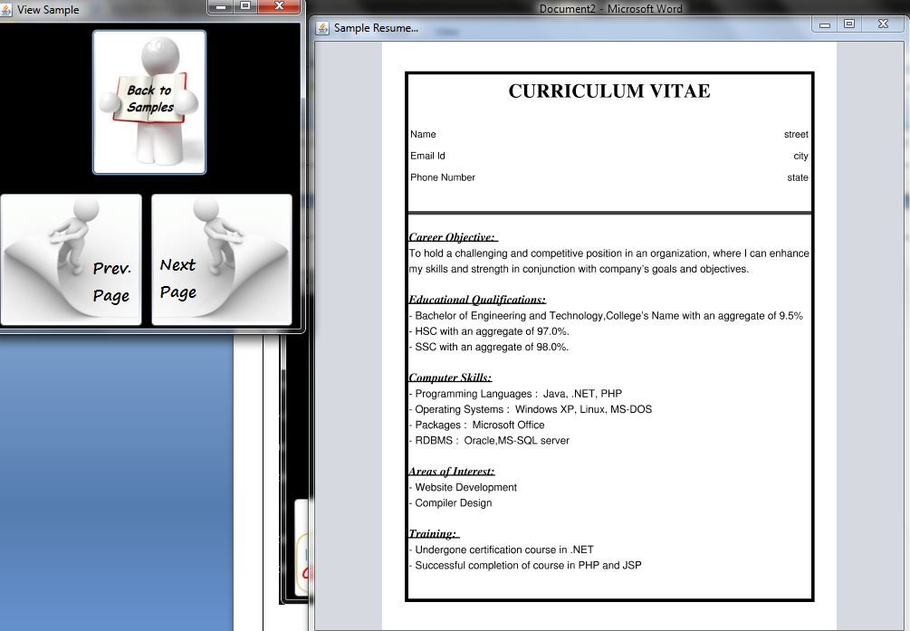

Next, the user is asked to fill in other important details.

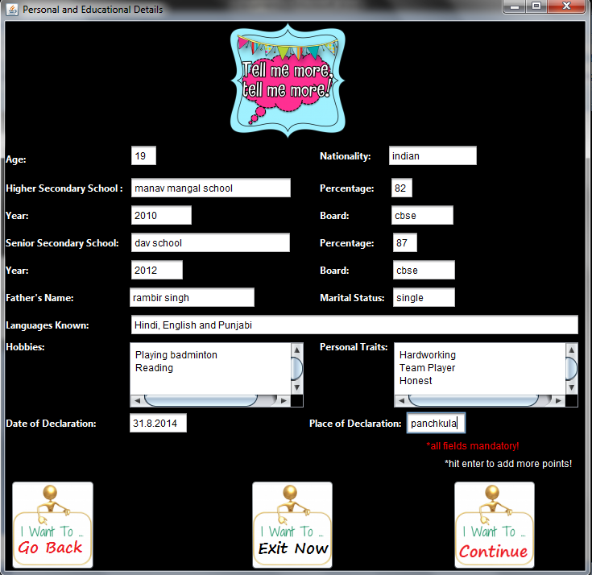

In the last step, the user is asked to fill in his required qualifications and other important details.

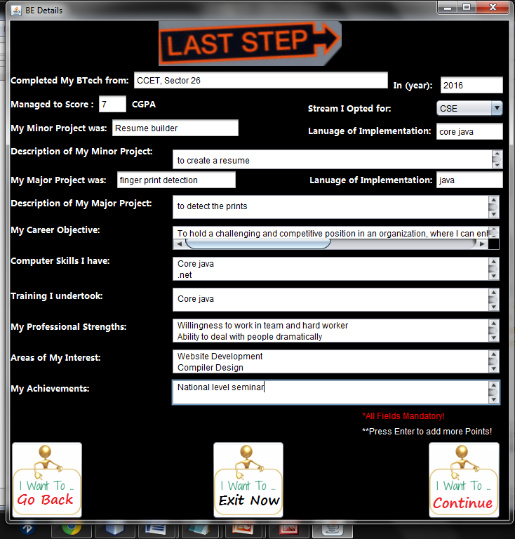

The user can view his created resume.

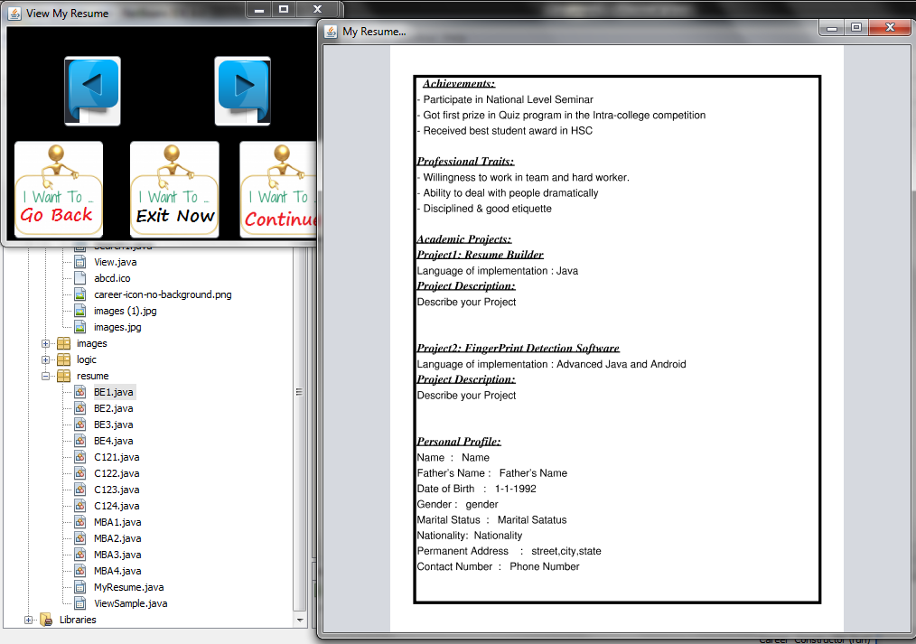

And in the last step, the user can choose whether he wants to save, print or email his document.

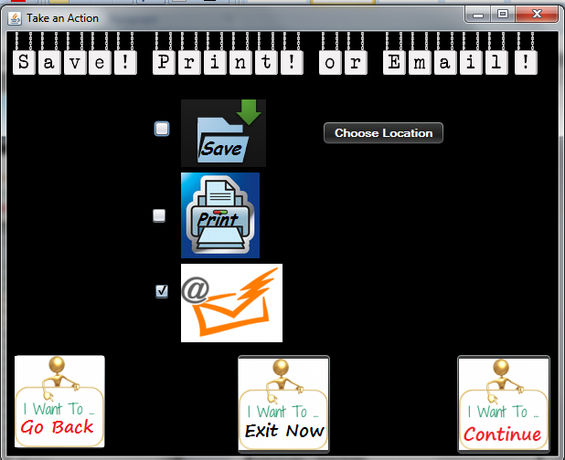

If the user decides to check on the second part of project, in the first screen he is asked to choose on what criteria he wishes to categorize the candidates.

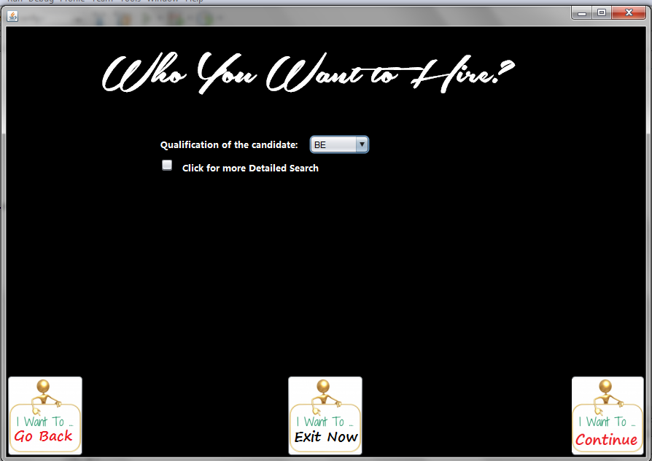

The desired candidates are displayed that fulfill the criterion.

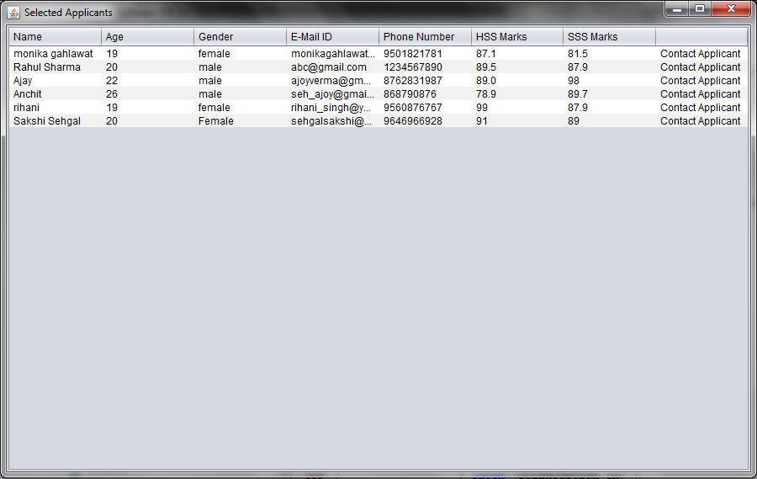

And if the job provider wishes, he can contact the candidates via email

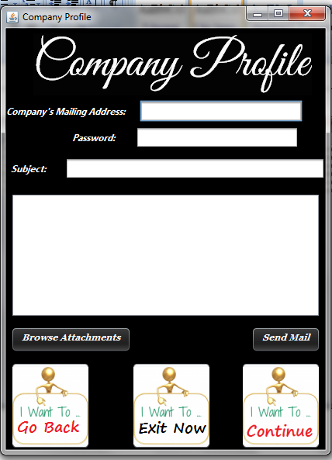

***Bibliography***

***Internet:***

• http://wikipedia.org/

• http://www.google.co.in/

• http://www.roseindia.net/

• http://www.mkyong.com

• http://forums.techarena.in

• http://www.w3schools.com

• http://websequencediagrams.com

• http://www.freejavaguide.com/

• http://www.buildingjavaprograms.com

• http://www.kodejava.org

• http://learnjava.awardspace.com

• http://www.javaworld.com

• www.javabeginner.com/

• www.webdeveloper.com

• www.slideshare.net

• www.webdesigners-directory.com/webdesignskill/JAVA

***Books:***

• Complete Reference for java(j2ee) By Herbert Schildt

• Thinking In Java By Bruce Eckel

• Java in a nutshell By David Flanagan

• Java Programming Language By Ken Arnold, James Gosling, David Holmes

• Head First Java By Kathy Sierra, Bert Bates

• Programming with Java By E Balagurusamy

• Beginning JSP Web Development By Casey Kochmer

• More Servlets and Java-Server Pages By Marty Hall

• Core Web Programming By Marty Hall and Larry Brown