SUSHANT BHOSLE
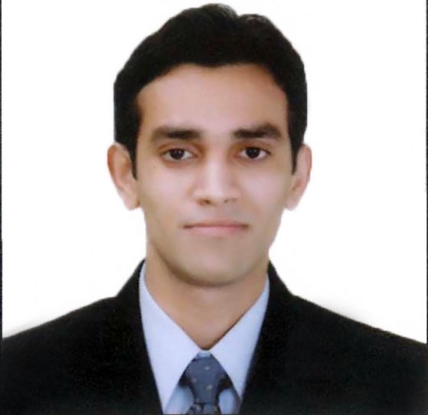
Address: Budhiram Society, Vivekanand Nagar, Vakola Bridge,
Santacruz (East) Mumbai-400055.
Mobile: +91 9930424592 • Email: sushantbhosle13@gmail.com • DOB: May 13,1986

OBJECTIVE

Seeking an innovative and a challenging position which will maximize opportunities to implement my knowledge and full utilization of my capabilities that will not only enrich my skills & satisfy my urge for learning but also lead to overall development of organization.

SUMMARY

- Team Member in Cash Operations of Treasury & Security Services in J.P.Morgan Services India Pvt Ltd.
- MBA in Finance from Mumbai University.
- Summer Internship in Corporate Finance from Reliance Infrastructure Ltd.
- Bachelor in Physics from R.D.National College.

ACADEMIC CREDENTIALS

Degree | Institution/University | Year of Passing | Percentage
M.M.S (Finance) | Mumbai University | 2011 | 72
B.Sc (Physics) | R.D.National College | 2007 | 54
H.S.C | St.Mary’s Junior College | 2004 | 55
S.S.C | St.Anthony’s High School | 2002 | 68

SKILL SET

Office tools | MS Word, MS Excel, MS Powerpoint, MS Access.
Platform & Language | Windows , Linux & C++
Relevant Subjects | Advanced Financial Management, Security Analysis and Portfolio Management, International Finance, Mergers and Acquisition, Strategic Cost Management, International Business , Financial Accounting, International Business.

EXTRA CURRICULAR ACTIVITIES & ACHIEVEMENTS

- Participated in several Inter-College B-school events.

- Recipient of Gold Card for Outstanding Regularity and Punctuality in Degree College.

- Co-ordinator of My India My Kartavya Initiative.

- Participated in STAR MOVIES OSCAR QUIZ 2011.

HOBBIES & INTERESTS

- Watching English Movies.
- Listening Music.
- Watching Sports and Playing Outdoor Games.
Signed
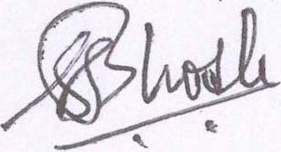
SUSHANT BHOSLE

