**Project**

**MAC Spoofing Tool**

**CS4061**

**Ethical Hacking Concepts and Practices**

**Submitted by:** Faizan Pervaz

**Roll number:** 20I-0565

**Date:** 09-03-2024

**Table of Contents**

• **Introduction** 3

• **CodeStructure** 3

• **Usage Instructions** 3

• **Summary** 3

• **References** 3

# **Introduction**

# The MAC Address Spoofing Tool is a Python script designed to provide a graphical user interface (GUI) for manipulating MAC addresses on Linux systems. It allows users to perform various tasks such as displaying developer information, viewing and changing MAC addresses, scanning the network for devices, assigning random MAC addresses, and resetting to the original MAC address.

# **Code Structure**

The code is organized into several functions, each serving a specific purpose:

1. **load_mac_vendor_mappings(xml_file):**
   * Loads MAC address vendor mappings from an XML file into a dictionary.
   * I have taken the database of mac address from cisco and used them for mac address spoofing.
2. def load_mac_vendor_mappings(xml_file):
3. try:
4. tree = ET.parse(xml_file)
5. root = tree.getroot()
6. namespace = root.tag.split('}')[0] + '}'
7. for mapping in root.findall(namespace + 'VendorMapping'):
8. mac_prefix = mapping.attrib['mac_prefix']
9. vendor_name = mapping.attrib['vendor_name']
10. mac_addresses_full[mac_prefix] = vendor_name
11. except Exception as e:
12. print(f"Error loading MAC address vendor mappings: {e}")
13. **my_info_show():**
    * Displays developer information including name, roll number, degree, campus, course, and current date and time.
14. def my_info_show():
15. info = """
16. Faizan Pervaz
17. 20i-0565
18. CS B
19. BS Computer Science
20. ISB Campus
21. Ethical Hacking
22. Date and Time: {}
23. """.format(datetime.now().strftime('%Y-%m-%d %H:%M:%S'))
24. tk.messagebox.showinfo("Developer Information", info)
25. **network_info_cmd():**
    * Determines the appropriate command (**ifconfig** or **ip addr**) for retrieving network interface information based on availability.
26. def network_info_cmd():
27. if 'ifconfig' in subprocess.getoutput('which ifconfig'):
28. return 'ifconfig'
29. elif 'ip' in subprocess.getoutput('which ip'):
30. return 'ip addr'
31. else:
32. raise OSError("Neither 'ifconfig' nor 'ip' found on the system.")
33. **display_current_mac():**
    * Retrieves and displays the current MAC address of the system.
34. def display_current_mac():
35. try:
36. command = network_info_cmd()
37. output = subprocess.check_output(command.split()).decode('utf-8')
38. if command == 'ifconfig':
39. mac_address = re.search(r"ether (\S+)", output).group(1)
40. else:  # 'ip addr' command output parsing
41. mac_address = re.search(r"link/ether (\S+)", output).group(1)
42. tk.messagebox.showinfo("MAC Address", f"MAC Address: {mac_address}")
43. except subprocess.CalledProcessError as e:
44. tk.messagebox.showerror("Error", f"An error occurred while trying to get MAC address: {e}")
45. except Exception as e:
46. tk.messagebox.showerror("Error", f"An unexpected error occurred: {e}")
47. **get_original_mac(interface):**
    * Retrieves the original MAC address of a specified network interface.
48. def get_original_mac(interface):
49. try:
50. command = network_info_cmd()
51. output = subprocess.check_output(command.split()).decode('utf-8')
52. if command == 'ifconfig':
53. match = re.search(r"ether (\S+)", output)
54. else:  # 'ip addr' command output parsing
55. match = re.search(r"link/ether (\S+)", output)
57. if match:
58. return match.group(1)
59. else:
60. tk.messagebox.showerror("Error", "MAC address not found.")
61. except subprocess.CalledProcessError as e:
62. tk.messagebox.showerror("Error", f"An error occurred while trying to get original MAC address: {e}")
63. except Exception as e:
64. tk.messagebox.showerror("Error", f"An unexpected error occurred: {e}")
65. **change_mac_linux(interface, new_mac):**
    * Changes the MAC address of a specified network interface on Linux systems.
66. def change_mac_linux(interface, new_mac):
67. try:
68. # Store the original MAC address before making any changes
69. if interface not in original_mac_addresses:
70. original_mac_addresses[interface] = get_original_mac(interface)
71. # Change the MAC address
72. command_down = ["sudo", "ifconfig", interface, "down"]
73. subprocess.run(command_down, check=True)
75. command_change = ["sudo", "ifconfig", interface, "hw", "ether", new_mac]
76. subprocess.run(command_change, check=True)
78. command_up = ["sudo", "ifconfig", interface, "up"]
79. subprocess.run(command_up, check=True)
81. tk.messagebox.showinfo("Success", "MAC address has been changed successfully.")
82. except subprocess.CalledProcessError as e:
83. tk.messagebox.showerror("Error", f"An error occurred while trying to change MAC address: {e}")
84. except Exception as e:
85. tk.messagebox.showerror("Error", f"An unexpected error occurred: {e}")
86. **apply_random_mac_address():**
    * Assigns a randomly generated MAC address to a specified network interface.
87. def apply_random_mac_address():
88. interface = simpledialog.askstring("Interface", "Enter the network interface name (e.g., wlan0):")
89. if interface:
90. random_mac = ':'.join(['{:02x}'.format(random.randint(0x00, 0xff)) for _ in range(6)])
91. change_mac_linux(interface, random_mac)
92. **reset_to_original_mac():**
    * Resets the MAC address of a specified network interface to its original value.
93. def reset_to_original_mac():
94. interface = simpledialog.askstring("Interface", "Enter the network interface name (e.g., wlan0):")
95. if interface:
96. if interface in original_mac_addresses:
97. original_mac = original_mac_addresses[interface]
98. change_mac_linux(interface, original_mac)
99. else:
100. tk.messagebox.showinfo("Info", "Original MAC address not found. No changes made.")
101. **select_and_change_mac():**
     * Allows the user to select a MAC address from a list and change it on the specified network interface.
102. def select_and_change_mac():
103. def on_select(evt):
104. # Check if there is a selection first to prevent IndexError
105. if not lb.curselection():
106. tk.messagebox.showerror("Error", "No MAC address selected.")
107. return
108. index = int(lb.curselection()[0])
109. selected_mac = list(filtered_mac_addresses.keys())[index]
110. vendor_name = filtered_mac_addresses[selected_mac]
111. interface = simpledialog.askstring("Interface", "Enter the network interface name (e.g., wlan0):")
112. if interface:
113. change_mac_linux(interface, selected_mac)
114. tk.messagebox.showinfo("MAC Address Changed", f"MAC address has been changed to {selected_mac} ({vendor_name})")
115. top.destroy()
116. def on_search():
117. search_text = search_entry.get().lower()
118. filtered_mac_addresses.clear()
119. for mac, vendor in mac_addresses_full.items():
120. if search_text in vendor.lower():
121. filtered_mac_addresses[mac] = vendor
122. update_listbox()
123. def update_listbox():
124. lb.delete(0, tk.END)
125. for mac, vendor in filtered_mac_addresses.items():
126. lb.insert(tk.END, f"{mac} - {vendor}")
127. top = Toplevel()
128. top.title("Select MAC Address")
129. search_frame = tk.Frame(top)
130. search_frame.pack(fill=tk.X)
131. search_label = tk.Label(search_frame, text="Search Vendor Name:")
132. search_label.pack(side=tk.LEFT, padx=(5, 0))
133. search_entry = tk.Entry(search_frame)
134. search_entry.pack(side=tk.LEFT, padx=5, fill=tk.X, expand=True)
135. search_button = tk.Button(search_frame, text="Search", command=on_search)
136. search_button.pack(side=tk.LEFT, padx=(0, 5))
137. lb = Listbox(top, width=50, height=20)
138. lb.pack(padx=5, pady=5, fill=tk.BOTH, expand=True)
139. scrollbar = Scrollbar(top, orient=tk.VERTICAL)
140. scrollbar.config(command=lb.yview)
141. scrollbar.pack(side=tk.RIGHT, fill=tk.Y)
142. filtered_mac_addresses = mac_addresses_full.copy()
143. update_listbox()
144. lb.bind('<<ListboxSelect>>', on_select)
145. **scan_network(network_cidr):**
     * Scans the network for devices using ARP requests and returns their MAC addresses.
146. def scan_network(network_cidr):
147. """
148. Scans the network for devices using ARP requests and attempts to resolve their hostnames.
149. :param network_cidr: The network CIDR notation (e.g., '192.168.1.0/24') to scan.
150. """
151. packet = Ether(dst="ff:ff:ff:ff:ff:ff")/ARP(pdst=network_cidr)
152. result, _ = srp(packet, timeout=3, verbose=0)
154. mac_addresses = []
155. for _, received in result:
156. mac_addresses.append(received.hwsrc)
157. return mac_addresses
158. **scan_network_and_display():**
     * Scans the network for devices and displays their MAC addresses in a listbox.
159. def scan_network_and_display():
160. try:
161. local_ip = socket.gethostbyname(socket.gethostname())
162. network_cidr = '.'.join(local_ip.split('.')[:3]) + '.0/24'
163. except Exception:
164. network_cidr = '192.168.1.0/24'  # Fallback CIDR, change as needed
165. mac_addresses = scan_network(network_cidr)
166. # Display the results in a listbox
167. top = Toplevel()
168. top.title("Scanned MAC Addresses")
169. lb = Listbox(top, width=50, height=20)
170. lb.pack(padx=5, pady=5, fill=tk.BOTH, expand=True)
171. scrollbar = Scrollbar(top, orient=tk.VERTICAL)
172. scrollbar.config(command=lb.yview)
173. scrollbar.pack(side=tk.RIGHT, fill=tk.Y)
174. for mac in mac_addresses:
175. lb.insert(tk.END, mac)
176. lb.config(yscrollcommand=scrollbar.set)
178. **display_welcome_screen() & second_screen():**
     * Displays a welcome screen with a background image.
     * Displays the main interface of the MAC Address Spoofing Tool.
179. def display_welcome_screen():
180. welcome_root = tk.Tk()
181. welcome_root.title("Welcome to MAC Address Spoofing Tool")
182. welcome_root.geometry("800x600")
183. welcome_root.resizable(False, False)
184. background_image = Image.open("hacker.jpeg")
185. background_image = background_image.resize((800, 600))
186. background_photo = ImageTk.PhotoImage(background_image)
188. background_label = tk.Label(welcome_root, image=background_photo)
189. background_label.place(x=0, y=0, relwidth=1, relheight=1)
191. welcome_frame = tk.Frame(welcome_root, bg="#ffffff", bd=5)
192. welcome_frame.place(relx=0.5, rely=0.5, anchor='center')
193. welcome_label = tk.Label(welcome_frame, text="Welcome to MAC Address Spoofing Tool", font=("Arial", 18), bg="#ffffff")
194. welcome_label.pack(pady=(20, 30))
195. continue_button = tk.Button(welcome_frame, text="Continue", command=welcome_root.destroy, font=('Arial', 14), padx=15, pady=8)
196. continue_button.pack()
197. welcome_root.mainloop()
198. def second_screen():
199. display_welcome_screen()
200. root = tk.Tk()
201. root.title("MAC Address Spoofing Tool")
202. root.geometry("800x600")
203. root.resizable(False, False)
204. load_mac_vendor_mappings("vendorMacs.xml")
206. background_image = Image.open("hacker.jpeg")
207. background_image = background_image.resize((800, 600))
208. background_photo = ImageTk.PhotoImage(background_image)
209. background_label = tk.Label(root, image=background_photo)
210. background_label.place(x=0, y=0, relwidth=1, relheight=1)
211. frame = tk.Frame(root, bg="#ffffff", bd=5)
212. frame.place(relx=0.5, rely=0.5, anchor='center')
213. title_label = tk.Label(frame, text="MAC Address Spoofing Tool", font=("Arial", 18), bg="#ffffff")
214. title_label.pack(pady=(20, 30))
215. button_font = ('Arial', 14)
216. left_buttons_frame = tk.Frame(frame, bg="#ffffff")
217. left_buttons_frame.pack(side=tk.LEFT, padx=20)
218. right_buttons_frame = tk.Frame(frame, bg="#ffffff")
219. right_buttons_frame.pack(side=tk.RIGHT, padx=20)
220. tk.Button(left_buttons_frame, text="Display Developer Info", command=my_info_show, font=button_font, padx=15, pady=8).pack(fill=tk.X, pady=10)
221. tk.Button(left_buttons_frame, text="Display Current MAC", command=display_current_mac, font=button_font, padx=15, pady=8).pack(fill=tk.X, pady=10)
222. tk.Button(left_buttons_frame, text="Change MAC From Manufacturer", command=select_and_change_mac, font=button_font, padx=15, pady=8).pack(fill=tk.X, pady=10)
223. tk.Button(right_buttons_frame, text="Network Scanning", command=scan_network_and_display, font=button_font, padx=15, pady=8).pack(fill=tk.X, pady=10)
224. tk.Button(right_buttons_frame, text="Assign Random MAC Address", command=apply_random_mac_address, font=button_font, padx=15, pady=8).pack(fill=tk.X, pady=10)
225. tk.Button(right_buttons_frame, text="Reset to Original MAC Address", command=reset_to_original_mac, font=button_font, padx=15, pady=8).pack(fill=tk.X, pady=10)
226. root.mainloop()

# **Usage Instructions**

1. Ensure Python and required dependencies (Tkinter, scapy, etc.) are installed.
2. Run the script in a Python environment.
3. Follow the on-screen instructions:
   * Use the buttons to perform various tasks such as displaying developer information, viewing current MAC address, changing MAC address, scanning the network, assigning random MAC address, and resetting to original MAC address.
   * Enter interface names when prompted.
   * Use the search functionality to filter MAC addresses.
   * Click the "Continue" button on the welcome screen to access the main interface.

# **Summary**

The MAC Address Spoofing Tool offers a convenient solution for managing MAC addresses on Linux systems, empowering users to enhance network security and privacy through effective MAC address manipulation.

Overall, the project provides a valuable tool for cybersecurity enthusiasts, network administrators, and individuals seeking to protect their privacy in network environments.

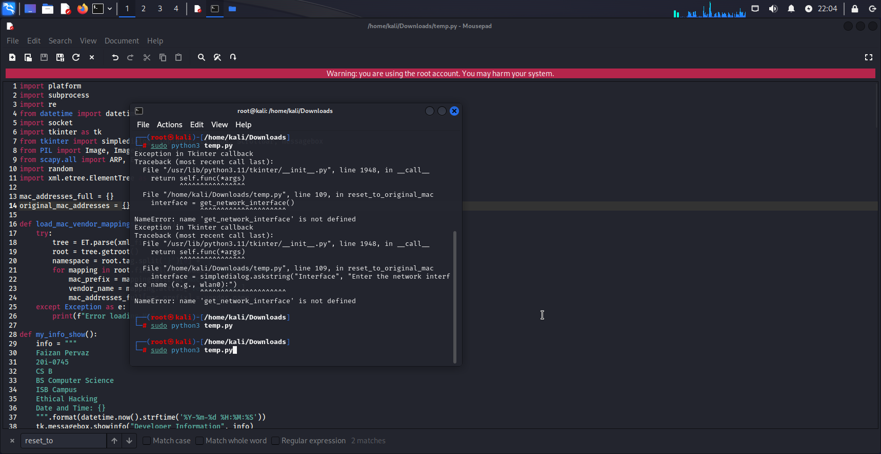

# **References**

* <https://devtools360.com/en/macaddress/vendorMacs.xml>
* <https://dnschecker.org/mac-lookup.php>
* <https://maclookup.app/>