
Ahsan khan | Faizan Ullah
Abstract
Crypto Currency data mosaic, sourcing data from well known sources. Providing insights and charts to showcase trends
Data Mosaic
Data Engineering
24280044 | 23030015
Contents
Contribution Details 2
Overview: 3
Data Collection Process: 3
Initial Observations: 4
Reddit: 4
Kaggle: 5
AI Product preposition: 7
Terms of Service & Privacy Considerations. 7
Multiple Data Sources: Benefits & Conflicts 8
Visualizations (Optional). 9
Reddit: 9
Kaggle Datasets: 9
Yahoo (“Close” statistics): 10
Google Trends: 10
Yahoo: 11

Contribution Details
Project Overview:
- Extracted cryptocurrency data from Reddit, Google Trends, Kaggle, and Yahoo.
- Tasks included data extraction, cleaning, exploratory analysis, visualization, coding, and report writing.
Division of Responsibilities:
- Data Extraction:
  - Ahsan Khan: Reddit & Kaggle
  - Faizan Ullah: Google Trends & Yahoo
- Data Cleaning & Integration:
  - Collaboratively cleaned and merged all datasets to maintain consistency.
- Exploratory Analysis & Visualization:
  - Jointly analysed data to uncover key trends and insights.
  - Worked together to design and refine visualizations.
- Coding & Peer Review:
  - Both members developed initial code for all four data pipelines.
  - Exchanged code for peer review, formatting and to ensure quality and mutual understanding.
- Report Writing:
  - Shared the effort equally in drafting and finalizing the project report.
Conclusion:
- Our balanced approach and collaborative efforts ensured equal contribution across all aspects of the project.

Overview:
We selected cryptocurrency as our topic because it is currently a hot discussion area in both technology and finance. Relevant data is often available, making it accessible for analysis and modelling. Machine learning models can be used to predict trends and help in investment decision-making.
Expected Data: We anticipated to find metrics like:
- Historical price data
  - Daily prices, trade volumes, market capitalization).
- User interest or sentiment:
  - Reddit posts discussing particular coins, public opinion).
- Search trends:
  - Indicating popularity or public curiosity over time via google trends

Data Collection Process:
We collected data from three main sources:
- Reddit
  - API: Created an API application on Reddit.
  - Library: Used the praw Python library to handle data extraction.
  - Sample Size: Fetched 100 posts, adhering to the required sample size and respecting rate limits.
- Public Datasets (Kaggle)
  - Datasets:
    - Dataset 1
    - Dataset 2
  - Access: Downloaded manually from Kaggle for offline analysis with Pandas, furthermore, we wrote a script to automate processing of dataset 2 source from kaggle.
  - Challenges: [Insert any specific obstacles you faced (e.g., data cleaning, large file sizes, etc.)]
- Yahoo API
  - Tickers: BTC-USD, ETH-USD, DOGE-USD, SOL-USD, BNB-USD.
  - Timeframe: Gathered 2 years of historical data (daily prices, volumes, etc.).
  - Process: Used Python’s data fetching libraries (e.g., yfinance) to download and then analyze with Pandas.
- Google Trends
  - Library: pytrends was used to fetch interest over time data for keywords like “Bitcoin” and “Crypto.”
  - Timeframes: Divided into monthly segments from [October 2024 to January 2025] due to rate limit constraints.
Challenges Encountered:
- API rate limits on Reddit, leading us to moderate our requests.
- API rate limits on Google with 429 error, leading us to pivot to other data source, like yahoo.
  - HTTP 429 Rate Limit Error: Google often blocked large requests, so we spaced out requests with a 3-minute sleep (time.sleep(180)).
  - Partial Data: Couldn’t collect all months in one go; had to break into smaller intervals.
  - Needed to clean/merge monthly CSV files afterward.
- Incomplete or inconsistent data in certain Kaggle files.
- Terms of Service (TOS) constraints: We had to ensure we respect usage limits and privacy guidelines.

Initial Observations:

Reddit:
- File: crypto_reddit_data.csv
- Shape: 100 rows × 6 columns
Observations:
- There are 40 non-null entries under “Post Text,” indicating many posts might be link-only or have no body text.
- Dates are stored as object. We may want to convert them to a proper datetime type for time-based analysis.
- No missing values in Title, Author, or Subreddit, but do note that “Post Text” has only 40 non-null values.
Snippet:
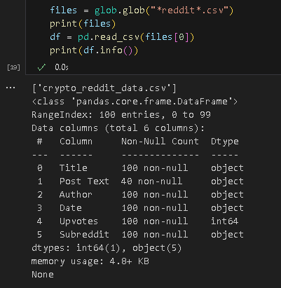

Kaggle:
- Files: Multiple CSVs (e.g., "crypto_coin1.csv", "crypto_coin2.csv", etc.), concatenated into merged_df.
- Shape: 37,082 rows × 10 columns (after merging).
Observations:
- All columns have 37,082 non-null entries, indicating no immediate NaNs.
- Dates are stored as object; converting to a proper datetime type is recommended.
- Typical float columns for numeric metrics; potential for deeper EDA, such as computing average close prices, total marketcap by date, etc.

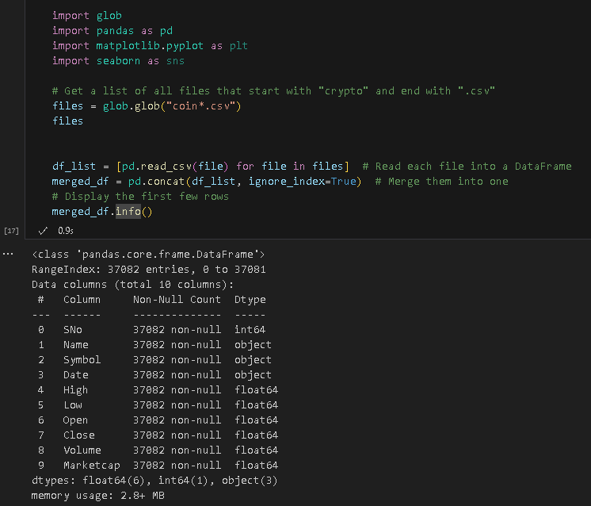

Google Trends:
- Files: For each month in November 2024 through January 2025, we have CSV files named like crypto_trends_november_2024.csv, crypto_trends_december_2024.csv, crypto_trends_january_2025.csv, etc.
- Shape: Each file typically has ~45 rows × ~4 columns (depending on the requested timeframe). When merged with the Reddit file (in the screenshot), the combined DataFrame shows 145 entries × 10 columns.
Observations:
- Some columns overlap with the Reddit dataset (Title, Post Text, etc.) even though they are not relevant to Google Trends. This suggests we merged all CSVs into one DataFrame. In practice, we might prefer separate DataFrames or carefully join on date/time or a common key.
- The isPartial column is often True or False; partial data might skew averages if we’re doing monthly comparisons.
- Rate limit (HTTP 429) caused partial coverage: we only successfully retrieved half-month data for each month.

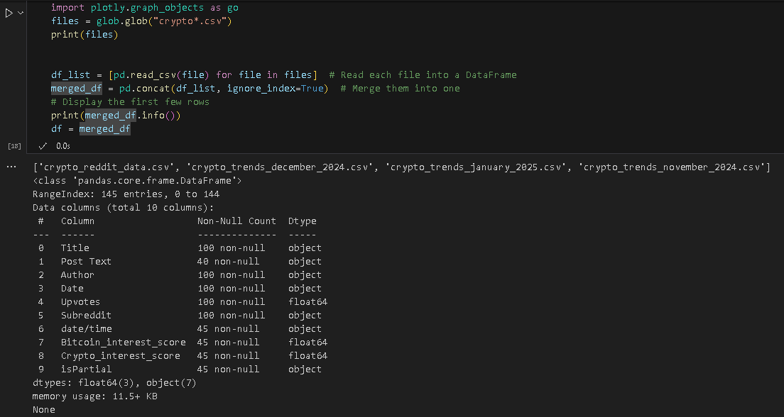

AI Product preposition:
Our goal is to develop an AI/ML model that can:
- Forecast Cryptocurrency Prices: Integrate historical price data with social media sentiment (Reddit) and global interest (Google Trends).
- Provide Investment Insights: A dashboard or platform that highlights correlations as if high Reddit activity or Google Trends spikes correlate with price swings.

Terms of Service & Privacy Considerations.
- Reddit:
  - Must not collect or store personally identifiable information.
  - Rate limits for API calls must be respected.
- Google:
  - Rate-limiting encountered (429 error) required us to split requests.
  - Must not redistribute raw user-generated or user-specific data in a way that violates Google’s TOS.
- GDPR Compliance:
  - Anonymize or exclude any personal data (especially from Reddit).
  - Retain only aggregated or publicly available information.

Multiple Data Sources: Benefits & Conflicts
Aspect | Helps Data Quality | Hinders Data Quality
Coverage & Completeness | Broader perspective, reduced data gaps. | Possible missing/incomplete data or differing data periods.
Validation & Reliability | Can cross-check info (e.g., Reddit vs. Google Trends). | Conflicting insights if sources don’t agree or have timing mismatches.
Richness & Diversity | Combines structured (Kaggle) & unstructured (Reddit). | Requires heavy preprocessing, more complex pipelines.
Different Data Formats | Varied perspectives (API, CSV, JSON). | Data must be standardized (dates, naming conventions, etc.).
Timeframe Mismatch | Multiple intervals (monthly, daily) provide deeper view. | Misaligned timestamps can distort correlation or trend analysis.
Rate Limit Constraints | Slows data collection, ensures better compliance. | Potential for partial or incomplete data if time-limited.

Storing and Combining the Data
Relational Database:
- Separate tables (e.g., reddit_data, google_trends_data, kaggle_price_history) linked via date or cryptocurrency keyword.
- Joins: Data can be combined with queries for time-based or coin-based analyses.
Object-Based Storage – S3:
- CSV files in a well-structured hierarchy (dataset/raw/, dataset/processed/).
- Easy to share and version control, but may be less efficient for complex queries.
Potential NoSQL:
- Might store Reddit text data in a document store (e.g., MongoDB) for flexible indexing and text search.

Visualizations (Optional).

Reddit:
A scatter plot of total Reddit crypto-related upvotes aggregated every two hours, highlighting periods of intense user engagement
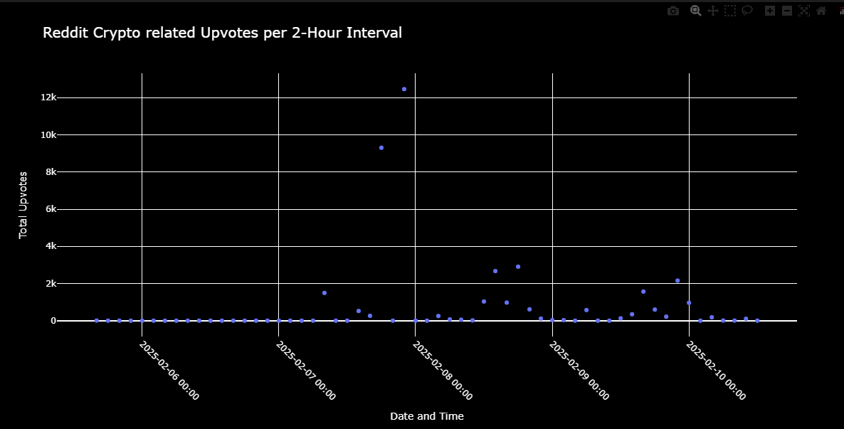

Kaggle Datasets:
A table displaying mean, minimum, and maximum daily price changes for various cryptocurrencies
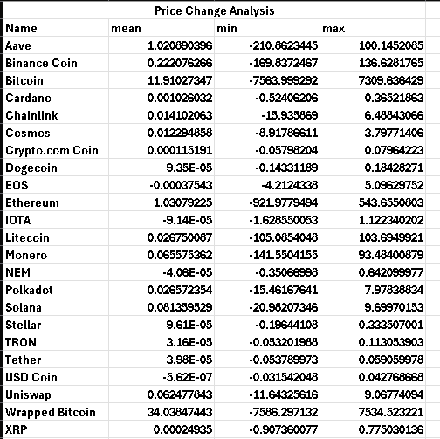
A table summarizing mean, minimum, and maximum volatility measures for each cryptocurrency.
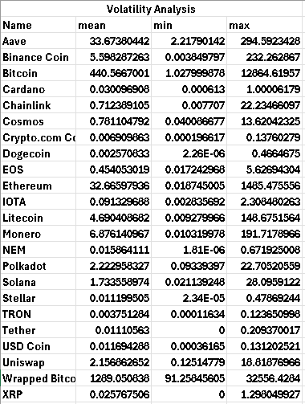

Yahoo (“Close” statistics):
A snapshot showing each ticker’s mean, minimum, and maximum prices over the queried timeframe.
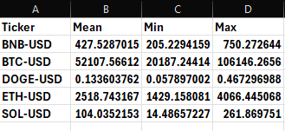

Google Trends:
Scatter plots indicating ‘Bitcoin’ and ‘Crypto’ interest scores over time, as fetched via pytrends
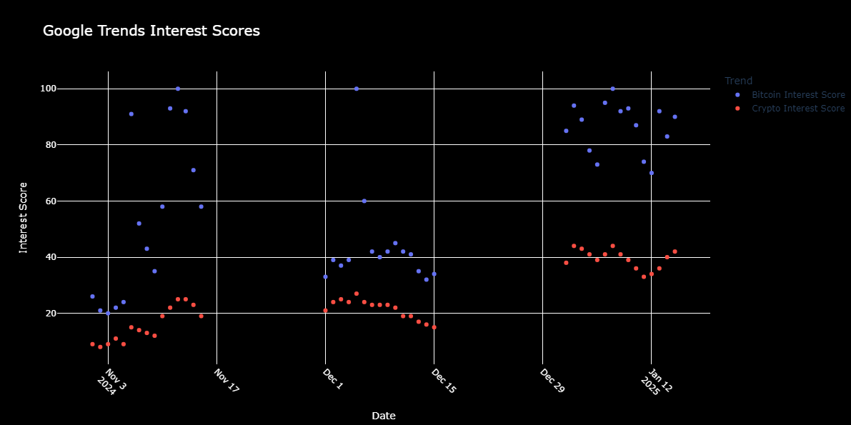

Yahoo:
A line chart comparing the 4-month average prices for multiple crypto tickers (BNB, BTC, DOGE, ETH, SOL)
