  - APPLIED ANALYTICS / FASHION & APPAREL

Exploratory Data Analysis & Visualization in Fashion Trends
  - Evidence-led EDA: seasonal demand, correlation, outliers and operational interpretation

ASSESSMENT | DELIVERABLE | EVIDENCE
Internship Week 3 | Word report + reproducible Python | U.S. Census Bureau / FRED

Research date: 6 November 2026 | Historical data release: 15 October 2026 | Last observed month: August 2026
Scope: The public dataset describes U.S. national retail clothing-store sales in millions of nominal U.S. dollars. It is not an Indian retailer’s point-of-sale system, product-level trend feed, or proprietary dataset. All forecasts are labeled separately from observed facts.

1. Executive research question
How can a junior analyst turn public apparel-retail observations into defensible evidence about demand patterns, seasonality, unusual events and relevant business decisions? This report demonstrates a complete pipeline using published clothing-store receipts. It distinguishes directly observed market behavior from inferred product preferences: national sales by month cannot show whether a specific style, textile, size or color is trending. A follow-up merchant test would require SKU-level transactions or search-interest data.

2. Dataset identification, authorization and integrity
The primary series is U.S. Census Bureau Monthly Retail Trade observations redistributed by the Federal Reserve Bank of St. Louis, “Retail Sales: Clothing Stores” (MRTSSM4481USN). Secondary context is “Retail Sales: Clothing and Clothing Accessory Stores” (MRTSSM448USN). Both are monthly, not seasonally adjusted (NSA), measured in millions of nominal U.S. dollars. A fixed October 15, 2026 release snapshot provides 92 clothing-store observations for January 2019–August 2026; the overlapping comparison series begins in January 2020. The raw source URLs, unit metadata, release context and a frozen machine-readable CSV are supplied with the GitHub project.
Data field | Cleaning / verification | Analytical role
date | Convert to monthly first-of-month timestamps; assert unique and continuous | Chronology / seasonality
clothing_stores_usd_million | Numeric; positive; check against published FRED entries | Primary target
clothing_accessory_stores_usd_million | Numeric; missing 2019 permitted; compare overlapping months only | Related market context
release/adjustment | Freeze vintage and mark NSA/nominal explicitly | Prevents false comparisons

3. Reproducible preprocessing and exploratory workflow
(1) Download or transcribe the FRED table into the controlled CSV and record observation vintage; (2) parse dates and numeric values; (3) sort chronologically; (4) assert no duplicate months and no missing months; (5) preserve the 2020 disruption instead of treating it as erroneous data; (6) compute year, calendar month, 12-month year-on-year (YoY) percent changes, annual means and deviation from annual mean; (7) create 2021–2025 calendar-month medians as a five-year seasonality reference; (8) use robust median-absolute-deviation (MAD) outlier scoring on YoY changes; (9) compute correlations only over overlapping dates; and (10) export tables, JSON findings and charts. The script is run with `python run_analysis.py` and verified with unit tests.

4. Summary statistics and the seasonal pattern
There are 92 monthly observations, with 0 missing values and 0 nonpositive clothing sales values. The average monthly clothing-store sales in complete 2021–2025 calendar years were $16,961 million. Median December sales were $24,904 million, compared with $13,118 million in February, a 1.90× ratio. That repeated seasonal gap supports earlier inventory and staffing preparation for holiday peaks; it does NOT quantify an individual store’s December uplift or establish which products will sell.
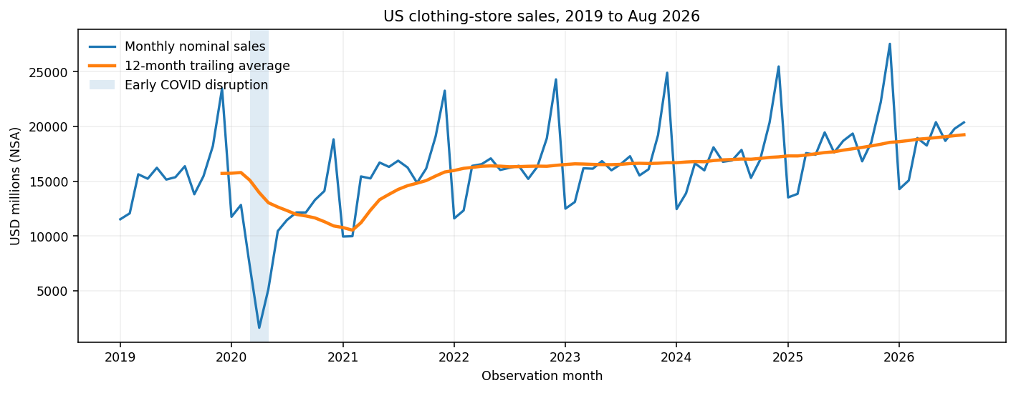
Figure 1. Line chart: historic monthly nominal US clothing-store receipts and trailing 12-month mean.
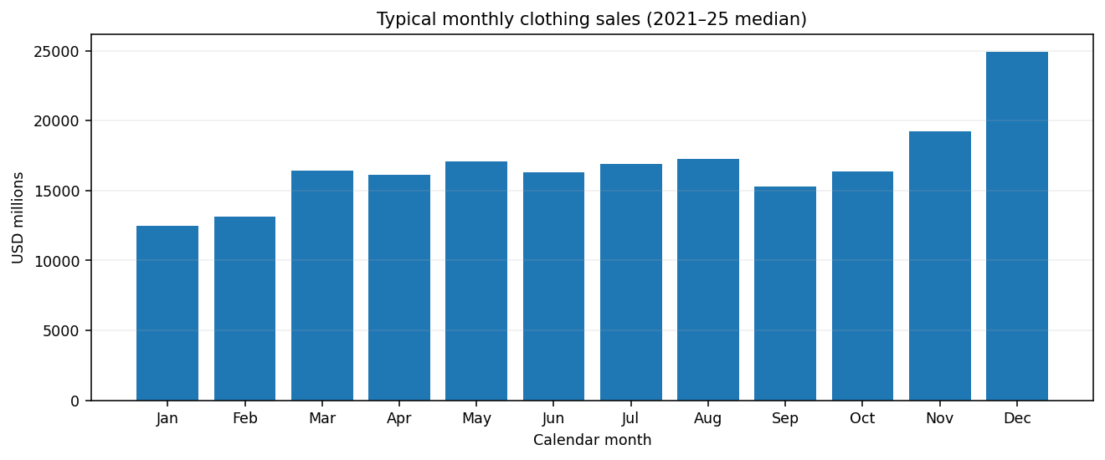
Figure 2. Bar graph: median monthly clothing-store receipts across 2021–2025; makes the December peak easily comparable.

5. Outliers, event context and distribution
An abnormal observation is not automatically an error. April 2020 recorded $1,642 million compared with $15,238 million one year earlier; the COVID disruption plausibly caused the structural break. The robust screening rule uses `abs((YoY – median(YoY)) / (1.4826 × MAD)) > 3.5`; it flags 16 highly unusual YoY observations, including collapse/reopening effects. These are retained and explicitly annotated. Removing them would conceal the volatility that forecasting methods must confront. Boxplots expose monthly spread by year and unusually high holiday months; the exact IQR whisker definition differs from the robust YoY screen.
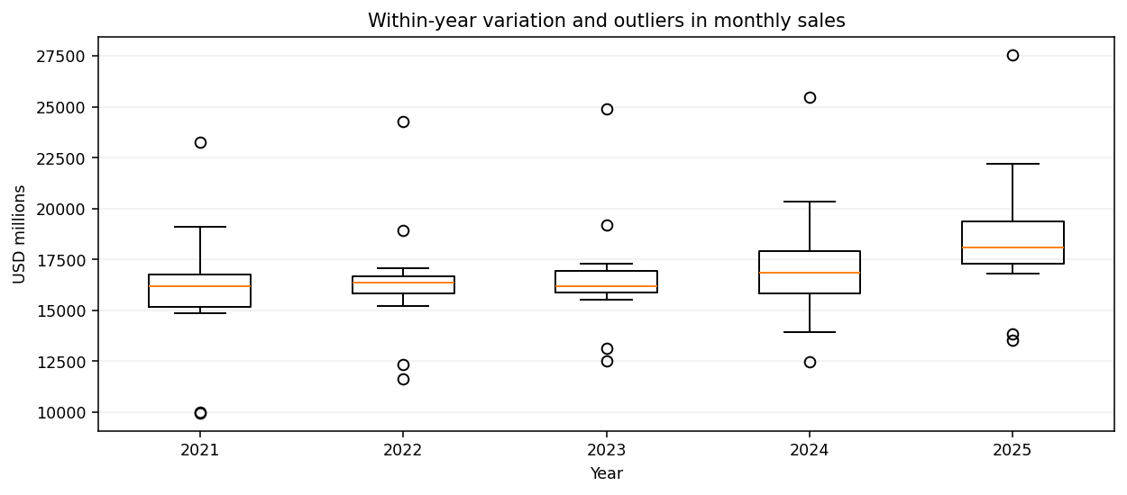
Figure 3. Boxplot: monthly dispersion, interquartile ranges and potential extremes for complete 2021–2025 years.

6. Correlation: useful context but not causation
Clothing stores versus the broader clothing-and-accessories series have Pearson correlation 0.986 in nominal monthly levels and 1.000 in YoY changes on the overlapping sample. This unusually strong relationship is expected because clothing stores are part of the broader series; it must NOT be described as independent external validation, a causal effect or proof that accessories drive clothing demand. For a genuine predictive driver study, add independent Google Trends interest, local weather, campaign timing and prices—aligned by month and available as of the forecast date—then test incremental predictive value in time-based splits.
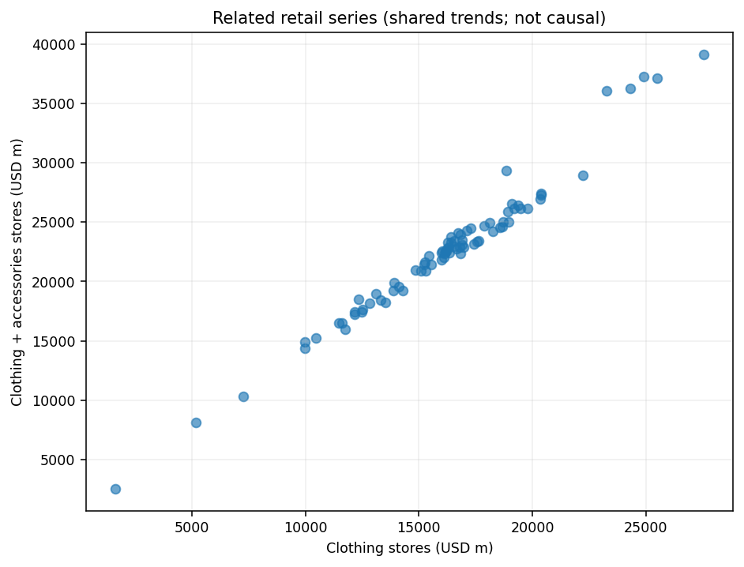
Figure 4. Scatterplot: overlapping related retail categories. Correlation is inflated by subset and common seasonal structure.

7. Pie chart: when proportions are and are not appropriate
A pie chart is appropriate for a small number of non-overlapping groups that sum to a defined whole. The next graphic divides combined revenue over the five complete years 2021–2025 into yearly portions. It must NOT be presented as market share by apparel category, nor used to compare incomplete 2026 against full years. Bar graphs are preferable for fine rank comparisons.
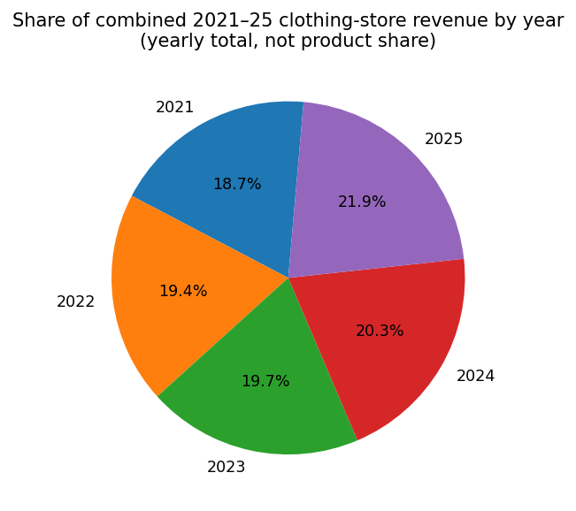
Figure 5. Properly defined whole: contribution of each complete calendar year to combined 2021–2025 nominal retail sales.

8. Decision framework and guardrails
Observed pattern | Potential fashion-sector decision | Follow-up validation
December median exceeds February | Schedule earlier holiday procurement; reserve labor and delivery capacity | Pilot against store-level sell-through and excess stock
2020 structural shock | Include contingency and exception scenarios | Review service level vs markdown cost during stress tests
Stable monthly seasonality | Create monthly planning cadence and promotional calendar | Verify same pattern in Indian/local channels
High related-series correlation | Use as contextual cross-check, not causal input | Add truly independent signal and retest

9. Challenges, precise solutions and residual risks
Specific obstacle | Mitigation and diagnostic | Residual limitation
National US series vs. Coimbatore retail | Clearly restrict external validity; propose validation with authorized local SKU sales | Cannot infer local tastes or fabric choices
NSA series and changing prices | Compare same calendar months; note nominal inflation; optionally deflate with CPI | Not an estimate of physical units sold
Pandemic regime break | Flag MAD extremes and annotate event; compare pre/post years | Model may still fail under future structural breaks
Related-series correlation inflation | Warn of overlap; evaluate independent leading indicators with lagging | Observed correlation cannot imply demand causation
Release revisions, partial 2026 | Freeze published snapshot/date; label latest Aug 2026; no full-year comparison | Later FRED vintages may differ
A visually persuasive but misleading pie | Define denominator, exclude overlapping groups, favor sorted bars | Proportions are descriptive only

10. Implementation and completion checklist
Day 1: license and source inventory; verify units, coverage and publication lag. Day 2: ingestion and schema/duplicate checks, report unresolved anomalies. Day 3: descriptive statistics, MAD and correlation diagnostics. Day 4: create accessible labeled charts; write a business implication and caveat for every figure. Day 5: peer review against raw FRED values, execute tests, archive charts/CSVs/report and record limitations. Acceptance: 92 continuous months; no missing primary values; five generated charts; six CSV/JSON output artifacts; successful automated tests; no fabricated local fashion trend claims.

Sources and replication
U.S. Census Bureau via FRED, Retail Sales: Clothing Stores (MRTSSM4481USN), https://fred.stlouisfed.org/data/MRTSSM4481USN. Companion series: MRTSSM448USN, https://fred.stlouisfed.org/data/MRTSSM448USN. Both accessed for the snapshot released 15 October 2026. Scripts and source file live in the companion GitHub project; run `python -m pip install -r requirements.txt`, then `python run_analysis.py`, then `python -m unittest discover -s tests -v`.

