  - APPLIED ANALYTICS / FASHION & APPAREL

Predictive Analytics & Forecasting in Fashion
  - Operationally usable forecasting framework with real-data backtests and robust safeguards

ASSESSMENT | DELIVERABLE | EVIDENCE
Internship Week 4 | Word report + reproducible Python | U.S. Census Bureau / FRED

Research date: 6 November 2026 | Historical data release: 15 October 2026 | Last observed month: August 2026
Scope: The public dataset describes U.S. national retail clothing-store sales in millions of nominal U.S. dollars. It is not an Indian retailer’s point-of-sale system, product-level trend feed, or proprietary dataset. All forecasts are labeled separately from observed facts.

1. Problem definition, target and decision
Fashion planning requires advance estimates of demand to prevent stockouts and dead stock. This report tests whether a junior analyst can forecast a public monthly clothing-retail market indicator using only information available before prediction time. The response variable is aggregate national U.S. clothing-store sales, in millions of nominal USD, published by the U.S. Census Bureau via FRED (MRTSSM4481USN); it is not item-level fashion demand, local purchase propensity or internal company revenue. The purpose is to teach model selection and evaluation under realistic constraints without proprietary data.

2. Acquisition, preprocessing and leakage controls
Import the fixed October 15, 2026 FRED table for January 2019–August 2026. Parse dates as calendar months, validate unique/continuous time index and positive values, preserve the 2020 pandemic shock as evidence, and retain all original monthly values in the project. The demonstration fits the regularized regression only on 2021 onward so extreme 2020 conditions do not dominate normal-seasonality coefficients. This is documented rather than hidden. Do not use future prices, later sales, hindsight features or random train/test shuffling.

3. Candidate models, rationale and parameters
Candidate | Definition and assumptions | Selection parameters
Seasonal naïve | Forecast month t from observed same month one year earlier; interpretable lower bar | 12-month lag
Seasonal trend | Last-year same-month observation + 0.5× its prior-year difference; floor at zero | Lag 12; lag 24; drift weight 0.5
Ridge + Fourier | Linear trend plus annual and semi-annual cyclic terms and Jan/Dec indicators; shrinkage helps small samples | Ridge α = 50, standardized features, two Fourier harmonics

Time-series decomposition, SARIMA and tree boosting are valid alternatives for later extensions. They are not claimed to outperform the tested baselines. ARIMA would need stationarity diagnostics and seasonal-order tuning; boosted trees risk overfitting with fewer than 100 monthly observations. The three implemented candidates emphasize explainability and reproducibility.

4. Validation protocol (chronological, not random)
Model comparisons use two expanding-window forecast origins: (A) train only on observations through December 2023 and forecast all 12 months of 2024; (B) train through December 2024 and forecast all 12 months of 2025. Each 12-month block is forecast at once, with no opportunity to peek at intervening true values. Candidate methods and the fixed ridge α and drift weight are predetermined. Choose the lowest pooled 2024–2025 WAPE, then evaluate that choice once on a separate January–August 2026 holdout trained only through December 2025. Only afterward refit using all data observed through August 2026 and generate a forward scenario.

5. Metrics and numerical results
WAPE = 100 × sum(|actual − predicted|) / sum(|actual|), computed over all observations in the test window. MAE = mean absolute error in USD millions. Bias = mean(predicted − actual), positive values indicate systematic overforecasting. WAPE aggregates scale but can obscure major month-to-month errors, so residual plots and bias are also evaluated.
Model | 2024–25 pooled WAPE | MAE (USD million) | Bias (USD million)
seasonal_trend | 4.72% | 844 | -735
seasonal_naive | 5.40% | 967 | -928
ridge_fourier | 8.94% | 1,599 | -670

Based solely on 2024–2025 validation, the selected method is **seasonal trend** (4.72% pooled WAPE). The sealed 2026 January–August holdout produced 2.66% WAPE, versus 5.69% for the seasonal-naïve benchmark. These are recorded outcomes on an observed public series, not a guarantee of future performance or a claim about local retailers.
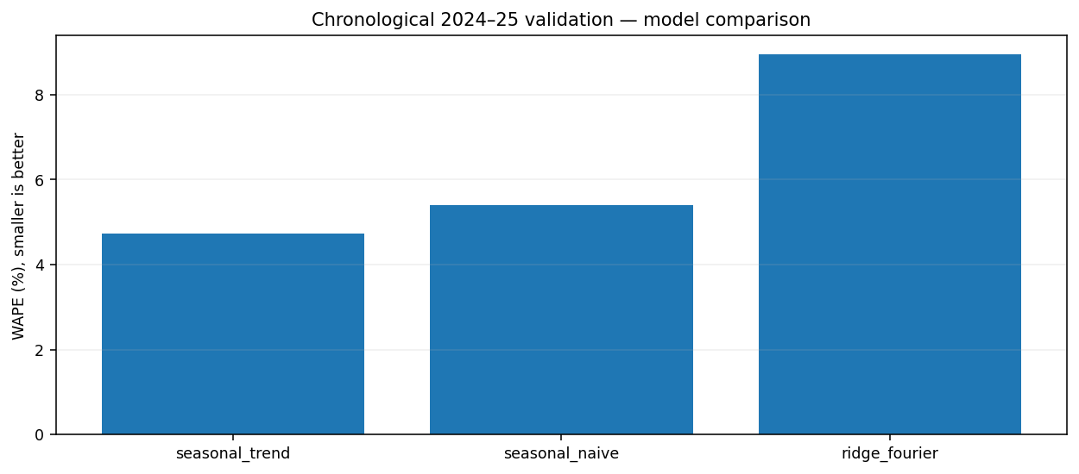
Figure 1. Fair comparison: two annual forecast-origin validation folds scored using WAPE.
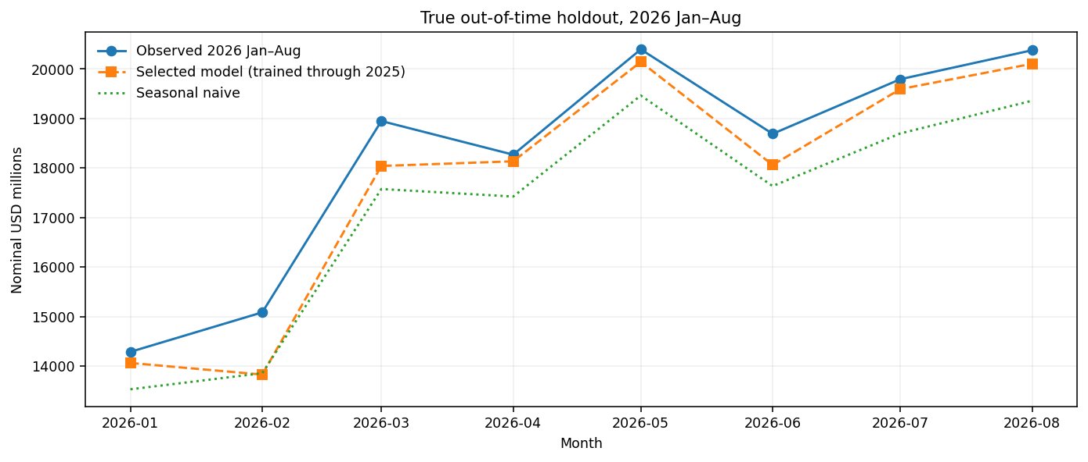
Figure 2. Untouched January–August 2026 observations versus predictions trained through December 2025.

6. Forward scenario: distinguish estimates from actuals
After selecting a model and evaluating it once on the separate holdout, the pipeline refits using observed history through August 2026 and forecasts September 2026–August 2027. It supplies point forecasts and a conservative ±10% stress range. Importantly, the range is NOT a formal 95% prediction interval: it comes from a descriptive holdout-error heuristic with just eight observations. Decisions should compare an optimistic, base and adverse scenario rather than commit production inventory directly from national-sales forecasts.
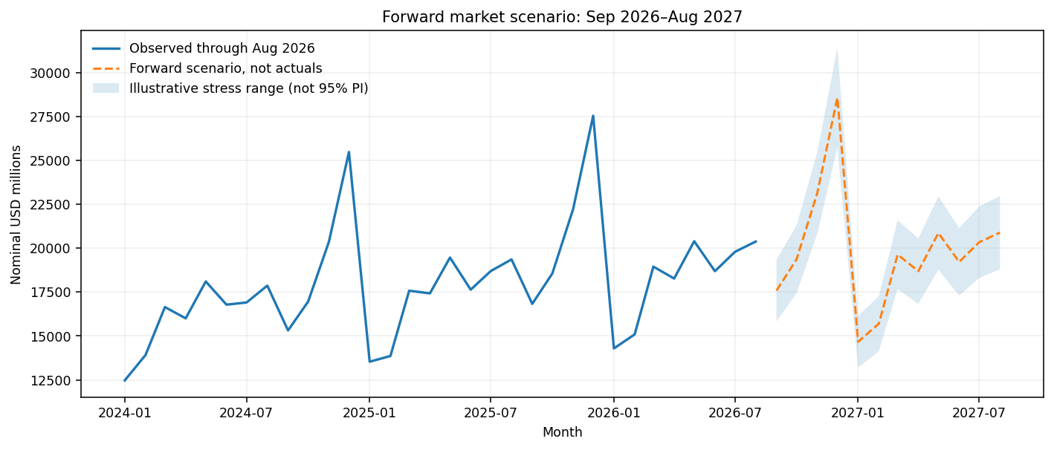
Figure 3. Explicit forward scenario, separated from known actual sales; shaded band is illustrative, not a calibrated 95% interval.

7. Implementation plan, training, validation and deployment
Stage | Work package and practical tool | Gate / artifact
1: Define | Agree prediction horizon, country and currency, unit economics | Target glossary, metric and acceptable error
2: Acquire | Snapshot FRED table; preserve source vintage and data dictionary | Row count and change log
3: Prepare | Enforce monthly regularity; impute only documented missing values | Integrity checks and exception CSV
4: Model | Build naive, fixed drift, regularized Fourier model | Versioned script and parameter record
5: Validate | 2024/2025 annual-origin folds; select model; test on sealed 2026 | WAPE/MAE/bias and chart
6: Forecast | Fit selected method on all observed months | 12-month point forecast and risk band
7: Pilot | Map macro indicator to authorized local category sales through a tested calibration layer | Pilot impact on in-stock rate and forecast bias
8: Monitor | Monthly refresh and sliding-origin recalibration with manager review | Drift alerts, owner and rollback procedure

8. Failure modes, specific handling and residual risk
Observed risk | Proposed control and evidence | Escalation
COVID-like break | Preserve incident dates; stress test forecast bias and compare against seasonal baseline | Human planner overrides while event persists
Data revised / missing releases | Source-vintage checkpoint; reject duplicate months and incomplete periods | Freeze last good model; alert data steward
National USD market not local unit demand | Do not equate USD million with pieces sold or Indian store demand | Pilot using retailer-approved local category records
December errors cost more than average | Review month-level error and bias; test weighted stockout costs | Override high-risk buying decisions
Feature leakage / tuning on test | Chronological fixed-origin folds; separate sealed 2026 evaluation | Rebuild if any post-origin variable enters features
Low confidence in 12-month scenario | Label simple stress band, not formal 95% PI; compare scenario cases | Limit automated ordering until calibrated PI passes checks
Ridge underfits structural nonlinearity | Retain seasonal baselines; compare new models only with predeclared CV | Roll back if WAPE or bias deteriorates

9. Examples of business decisions and expected output
For an apparel retailer, a monthly market demand index can guide the timing of capacity reviews and promotion windows. It cannot specify the number of black size-M T-shirts to purchase. In an authorized pilot, the analyst would collect local SKU-week orders, beginning inventory, delivery lead time and returns, construct size-aware demand targets, and compare base/stockout-sensitive error costs by SKU segment. Reorder points would then use locally measured demand and lead-time uncertainty; no national USD figure is directly converted into local item counts. Approved KPI targets should be set only after baseline measurement.

10. Ethical, financial and reproducibility considerations
Because the inputs are public aggregate data, the demonstration uses no personal customer records. A future retailer deployment must minimize customer identifiers, respect license terms, document data retention, avoid using sensitive traits for pricing discrimination, and store model versions and forecasts with timestamps. Key financial controls include deflating nominal spending when interpreting real consumption, treating national geographic transfer as uncertain, accounting for cost asymmetry, and preventing false confidence from a favorable test window. A junior analyst must show both success cases and failures to their supervisor.

11. Acceptance checklist and references
Pass conditions: source dates are 2019-01 through 2026-08 only; all 92 observed months are present; any prediction origin uses training dates strictly earlier than the test; three candidate methods run without credentials; WAPE, MAE and bias tables are generated; a separate 2026 holdout is untouched until selection; the forward scenario begins September 2026; generated artifacts include source CSV, five result files, three charts, a JSON findings file and unit tests. Reproduction: `python -m pip install -r requirements.txt`; `python run_analysis.py`; `python -m unittest discover -s tests -v`.
U.S. Census Bureau via Federal Reserve Bank of St. Louis, Retail Sales: Clothing Stores, FRED series MRTSSM4481USN, https://fred.stlouisfed.org/series/MRTSSM4481USN and table https://fred.stlouisfed.org/data/MRTSSM4481USN (historical snapshot released 15 October 2026). Source series notes emphasize monthly nominal U.S. dollars and not seasonally adjusted values. Model implementations and exact output metrics appear in the companion GitHub project.

