WEEK 5 / SUBMISSION REPORT / 09 NOV 2026

Data Quality Assessment & Error Handling in Apparel Data
Evidence-led controls for apparel transactions and public clothing-market time series
TECHNICAL METHOD • MEASURED EVIDENCE • DECISION CONTROLS
Audience: Internship evaluator and junior data-science analyst. Scope: offline reproducible work, using public data and clearly labelled synthetic examples. No proprietary business data.
The analysis does not imply observed outcomes for any employer or guarantee a particular evaluation grade.

Executive summary
Data errors become expensive when a duplicate invoice inflates sales, a returned garment is counted as demand, a missing price is assumed to be zero, or a pandemic shock is discarded as bad data. This report defines a reproducible control system across seven quality dimensions; validates an intentionally dirty apparel transaction sample; and tests the integrity of a real public clothing-sales time series. It explains both what can be established automatically and what still requires an accountable data steward.
Evidence set | Observed quality outcome | Interpretation
SYNTHETIC apparel transaction stress test | 163 input → 147 sales + 2 returns + 14 quarantine | Complete row conservation; only accepted lines enter business metrics.
REAL public clothing-sales time series | 92 monthly records; 0 missing target months; 16 YoY shock flags | Structurally complete monthly series; shocks require business review, not deletion.
Claim boundary | Validation is not ground-truth accuracy | No independent point-of-sale ledger or retailer confirmation is available.

Priority decision: permit downstream analysis only from accepted sales/returns and the validated monthly series. Maintain a quarantine queue and dated source snapshots. Do not automate price correction, consumer identity inference or inventory purchase orders on this evidence alone.

1 Data assets, grain and acquisition
- Stress-test source: 163 intentionally messy, fabricated apparel order-lines (`data/raw/synthetic_fashion_orders.csv`) with line identifiers, SKU, size, discount, price, quantity, timestamp, channel and return status. This demonstrates failure handling—not actual retailer revenue.
- External source: 92 dated observations (January 2019–August 2026) for U.S. Census retail sales at clothing stores, FRED series MRTSSM4481USN, in nominal USD millions, not seasonally adjusted. Frozen source vintage: 15 October 2026.
- Grain: one invoice line in the first input; one calendar month in the second. A collection count, sales order, unique garment and geographic macro-series are not interchangeable entities.
- Ingestion record: raw filename, SHA-256 digest, provider URL, source vintage, expected schema, units, UTC interpretation, transformation version and generated outputs.

2 Quality dimensions, operational formulas and decision gates
Dimension & definition | Measurement / source-specific gate | Why it matters
Completeness | 100 × nonblank required cells / total required cells; key financial fields must be 100% on accepted records | A blank price cannot support reliable sales value.
Validity | Pass rate under type, domain and range constraints: integer quantity, >0 price, discount in [0,1], parseable time | An unparseable date cannot enter weekly trends.
Uniqueness | Accepted invoice line IDs must be unique; exact source duplicates go to quarantine | Stops double counting; the order ID may legitimately repeat across different lines.
Consistency | Signed quantity vs return flag, standard category and size mapping, gross/net arithmetic | Prevents treating refunds as demand and mixing 5% with 0.05.
Integrity | Row conservation: accepted sales + returns + quarantined = raw; source checksum recorded | Every source record remains traceable and explainable.
Timeliness | Monthly vintage and expected calendar months; alert on late updates, without filling unseen months with zero | Delayed monthly releases must not be construed as missing retail demand.
Accuracy | Requires an independent trusted ledger, approved catalog or verified physical stock count | A format-valid price can still be factually wrong; accuracy is not proven here.

Formula example: 163 rows × 5 critical fields = 815 source cells. Three are blank, yielding 812/815 = 99.63% raw cell completeness. Accepted transaction rows contain 100% populated fields among those same five. This is a critical-field check, not proof that every other attribute is fully populated.

3 Applied transactional assessment and before/after results
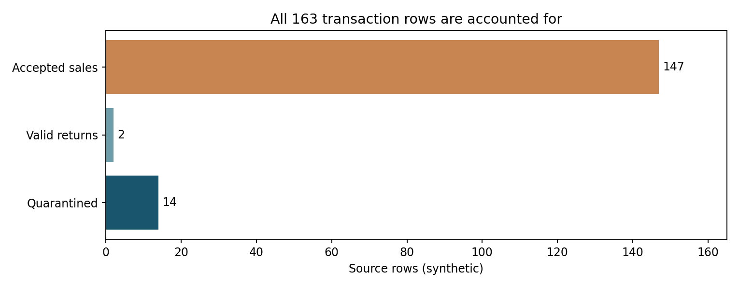
Figure 1. All 163 input rows are allocated exactly once. Synthetic observations only.
Measured check | Before | After / disposition
Critical-field populated rate | 99.63% | 100% across 149 accepted sales and returns
Source rows | 163 | 147 valid sales + 2 returns + 14 quarantined = 163
Exact duplicate source rows | 2 | 0 accepted; 2 quarantined
Unique accepted line IDs | Not guaranteed | Yes: no accepted collisions
Customer ID absent | 2 rows | Guest-coded; excluded from identified-customer features
Revenue labels | Potentially contaminated raw values | Synthetic gross INR 292,860; discounted net INR 268,664.55; 3 return units separately tracked

The 91.41% retention measure equals 149 accepted / 163 input lines. It is NOT a target to maximize at any cost: accepting false price entries would raise retention while degrading validity. Quarantine reasons can exceed the number of quarantined lines if a single record violates several rules.
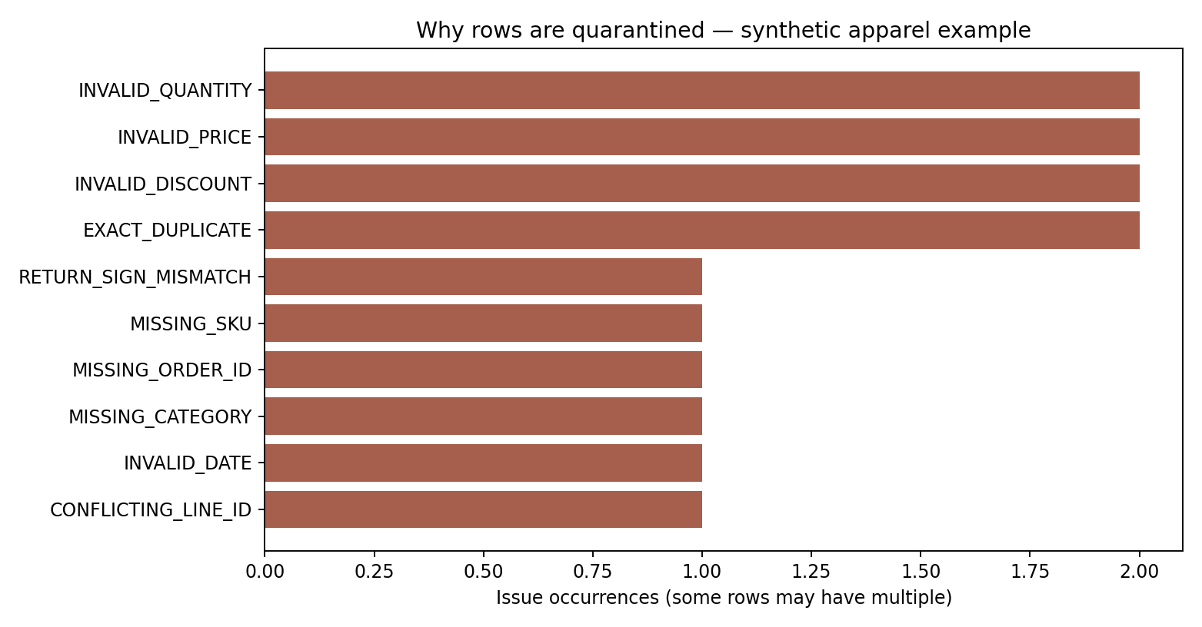
Figure 2. Measured reason counts for the transaction quarantine. Do not equate issue counts to distinct rows.

4 Worked error-correction examples (detector → treatment → proof)
Anomaly and concrete example | Correct action | Acceptance evidence
Discount 10, 10%, 0.10 | Normalize to decimal 0.10; reject 120% | Unit test confirms equivalence and upper bound
Unit price INR 1,299 / blank | Remove currency separator; reject unknown price | Parsed number 1299; no fabricated price
Order ID repeated with distinct line IDs | Keep lines; quarantine exact duplicates or conflicting line ID | Accepted line ID uniqueness; reconciliation total
Negative quantity with return flag | Isolate in returns ledger; reject mismatched sign | 2 accepted return lines / 3 units
Size "medium", "M", "MD" | Map to M; retain UNKNOWN when unsupported | Normalization is documented and auditable
Missing CustomerID | Use anonymous GUEST marker; exclude from identified-customer RFM | No pseudo-ID invented; 2 guest lines
Mixed timestamps / invalid date | Parse to UTC under stated assumption; quarantine unparseable date | No null accepted timestamps
Extreme order or sales value | Check domain and inventory context, seek source confirmation | No blanket winsorization of genuine demand

A more cautious imputation policy avoids converting uncertainty into fabricated sales: zero discount is permissible only where the input contract defines an empty promotion as no discount; missing prices and demand should remain unknown pending source review. For forecasting, past-only seasonal imputations may be tested on deliberately masked data, with imputation status recorded as a feature.

5 Observed public-data integrity and anomaly review
The frozen public FRED clothing-store series includes 92 contiguous monthly observations (2019-01 to 2026-08). It has 0 missing target months, 0 duplicated dates, 0 nonpositive/missing target values and 0 dates not on the first of a month. The optional accessory-store comparison column has 12 unavailable observations. That optional column is not imputed into the clothing-store target.
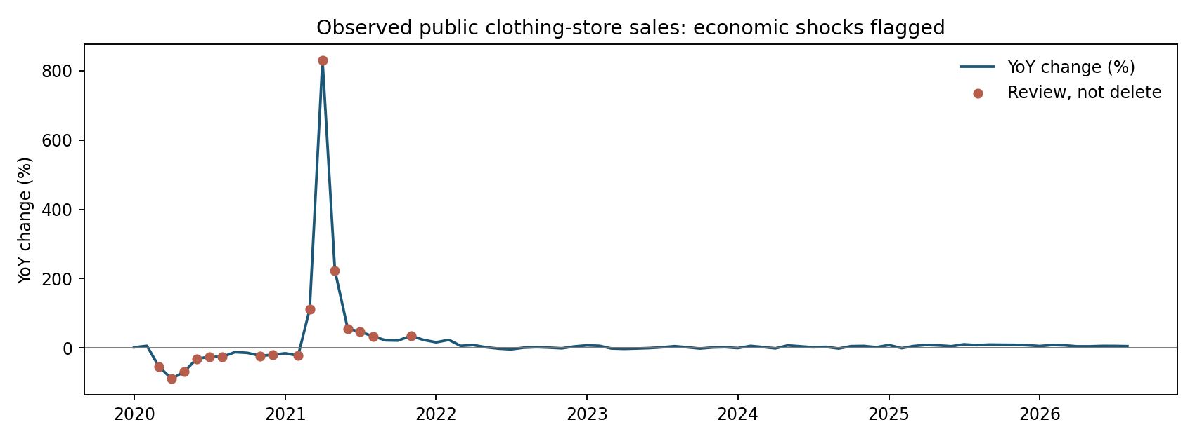
Figure 3. Historical year-over-year shocks are flagged by a robust median/MAD screen, not erased.
A median-absolute-deviation review flags 16 unusually large year-over-year movements. April 2020's observed clothing-store value is USD 1,642 million versus USD 15,238 million in April 2019—a genuine economic disruption candidate, not necessarily a file error. A reviewer should consult Census publication notes and preserve the underlying observation. For retrospective forecasts, records must be evaluated using the vintage available at each decision date; later revisions introduce look-ahead risk.

6 Specific challenges and the mitigation that actually resolves each
Missing ≠ zero. A missing month in a national market series signals absent observation or delayed release, not zero purchases. Block publication and backfill only from an authorized vintage; surface the missing-date list in the audit.
Duplicate ≠ repeat purchase. An order ID may contain multiple garment lines. Deduplicating only by order ID wrongly removes real sales; use invoice line as the business key and preserve raw evidence of duplicates for upstream reconciliation.
Valid ≠ accurate. A price of INR 1,299 can be syntactically valid yet stale or incorrect. Compare with an approved effective-dated price book if available, and require a merchandising owner to approve discrepancies.
Outlier ≠ typo. The 2020 clothing-store collapse is an authentic contextual stress event. Quarantining extreme events automatically would train an unrealistically smooth model. Review event logs and add shock indicators, not indiscriminate trimming.
Multiple units and tax conventions. One file may contain piece counts while another contains metres of fabric, price inclusive of GST, or currency converted at varied exchange rates. Establish schema-level unit and tax contracts before aggregation; never add unlike measures.
Identifiability and missing IDs. Guest purchases should not be stitched together as if they came from one person. Aggregate anonymously or seek appropriate consent; avoid inferring identities from browser or location traces.
Source revisions and geographic transfer. October 2026 U.S. values can later be revised and cannot verify Coimbatore SKU availability. Freeze vintage and avoid combining nominal USD market totals with INR store unit counts without an explicit bridge and local validation.
Operational overload. A quarantine that accumulates unresolved records becomes silent data loss. Give every issue an owner, severity, source row, age, resolution code and replay test; escalate failed critical financial fields within one business day.

7 Phased correction, owners, monitoring and release checklist
Phase | Action, accountable role and output | Gate to move forward
0 — Ingest | Analyst saves immutable raw files, checks hashes and locks source vintage | Recorded source ID, consent/licence and schema
1 — Profile | Analyst reports missingness, duplicate keys, range and cross-field violations | Automated row and constraint inventory complete
2 — Isolate | Data steward triages row-level quarantine and source-level anomalies | No rejected row silently dropped
3 — Correct | Merchandising/finance approves SKU, size, price and return classifications | Signed issue resolution + replay proof
4 — Validate | Analyst reruns tests, reconciles rows, checks drift vs last accepted run | 100% critical accepted fields, zero duplicate line IDs
5 — Monitor | Weekly exception aging and monthly source-vintage checks | Open exception register + accountable handover

Proposed alert thresholds for a future production system (targets, not measured achievements): 0 duplicate accepted keys; 100% critical field validity; 100% expected monthly target dates; no unowned critical-price exceptions after one business day; and review any new >3.5 robust-z time-series shocks before model release. Use rolling baselines rather than a fixed reject-rate target for seasonal spikes.

8 Reproducibility, tests and evidence pack
From `Week5_Apparel_Data_Quality/`, install requirements and run `python run_analysis.py` followed by `python -m unittest discover -s tests -v`. The current project runs 10 automated tests, including two deliberate corruptions of the monthly series to verify missing-month and duplicate-date detection. Generated outputs are reproducible without proprietary access.
- `outputs/quality_evidence.json`: metric definitions and measured results, including the explicit accuracy limitation.
- `outputs/retail_processed/quarantine.csv`: rejected source rows with reasons; `clean_sales.csv` and `returns.csv` preserve signed record semantics.
- `outputs/retail_issue_register.csv`: issue-level counts; `outputs/quality_control_matrix.csv`: operational release criteria.
- `outputs/fred_outlier_review.csv`: measured robust outlier flags for genuinely observed public values; figures reproduced in `assets/`.
Recommended evaluation drill: inject a second identical invoice line and one missing FRED month, rerun the gate, verify the respective failure, correct the source with documented approval, and rerun tests. This tests recovery—not merely a success path. Rejecting rows is not always fixing the upstream problem; effective data quality requires a closed-loop remedy.

Sources, provenance and scope
- U.S. Census Bureau via FRED, MRTSSM4481USN. https://fred.stlouisfed.org/series/MRTSSM4481USN (nominal monthly clothing-store retail sales; source vintage 2026-10-15).
- FRED ALFRED historical vintages. https://alfred.stlouisfed.org/series?seid=MRTSSM4481USN (revision tracking).
- UCI Online Retail. https://archive.ics.uci.edu/dataset/352/online+retail (retail returns/cancellations as contextual reference; not executed in this report).
- Week 2 repository. Week2_Fashion_Data_Preprocessing source transaction-cleaning script and originally generated 163-row synthetic fixture.
All dates, units, file names, exclusions and decision thresholds are documented in the companion repository. Historic statistical series are subject to revision after their frozen snapshot; re-run against the same supplied files for exact replication.

