WEEK 6 / SUBMISSION REPORT / 09 NOV 2026

Reporting, Evaluation & Presentation of Fashion Data Insights
Six-week synthesis: from external market signals to gated, testable business decisions
TECHNICAL METHOD • MEASURED EVIDENCE • DECISION CONTROLS
Audience: Internship evaluator and junior data-science analyst. Scope: offline reproducible work, using public data and clearly labelled synthetic examples. No proprietary business data.
The analysis does not imply observed outcomes for any employer or guarantee a particular evaluation grade.

Executive decision brief
This final report connects strategy, acquisition, exploratory analysis, modelling, data quality and communication into a single decision sequence. The recommendations are deliberately conditional: source integrity first, then a local test of seasonality, then a monitored forecast pilot, then ethical experimentation. The core finding is not that a real apparel business has already improved, but that the prior assignments now produce an auditable evidence chain that a junior analyst can explain and reproduce.
Headline evidence | Observed result / limitation
External India market context | World Bank internet use 43.41% (2020) to 70.00% (2025); does not measure fashion demand
Public catalog quality | 161 collections, 2,938 unique products reported; 3 missing images and 1 missing SEO summary
Synthetic transaction controls | 163 = 147 accepted sales + 2 returns + 14 quarantined; not genuine employer sales
Public fashion-sector seasonality | 92 real monthly U.S. clothing-store observations; December/February median factor 1.90 (2021–25)
Forecast model evaluation | 2024–25 backtest 4.72% WAPE; Jan–Aug 2026 held-out test 2.66% WAPE versus 5.69% seasonal-naïve

Recommendation: approve a controlled pilot, not automated SKU orders or measured return-on-investment claims. Business benefit depends on consented local data, category segmentation, inventory constraints and management approval. All numerical evidence is linked to accompanying CSV/JSON outputs and source snapshots.

1 An evidence chain across all six weeks
Stage | Evidence and analytical method | Decision consequence
W1 / Strategy | Joined six years of India internet-use and urban-share statistics; defined inventory and marketing questions | Macro context informs testable hypotheses, not causal conversions.
W2 / Acquisition | Collected public fashion catalog; validated schema, counts and missing metadata | Catalog remediation must precede campaign segmentation.
W3 / EDA | Explored public 2019–2026 clothing-sales series with trend, seasonal medians, correlations and MAD review | Use seasonal shape as a candidate prior; separate shock years.
W4 / Forecasting | Compared seasonal-naïve, seasonal-trend and Ridge; held out Jan–Aug 2026 | Require time-respecting tests, benchmark comparison and signed bias.
W5 / Quality | Reconciled synthetic invoice lines; validated public monthly integrity and exception triage | Only approved and traceable data enter dashboards or models.
W6 / Reporting | Recomputed test accuracy, mapped findings to decisions and owners | Communicate uncertainty, deployment gates and measurable follow-up.

Core distinction: the World Bank, apparel catalog and FRED/Census tables are observed public datasets; the dirty order-line fixture is synthetic; 2026 forecasting scores are historical backtest results; proposed local inventory and digital-marketing interventions remain untested scenarios.

2 Chart-led insight: the market has seasonality and shocks
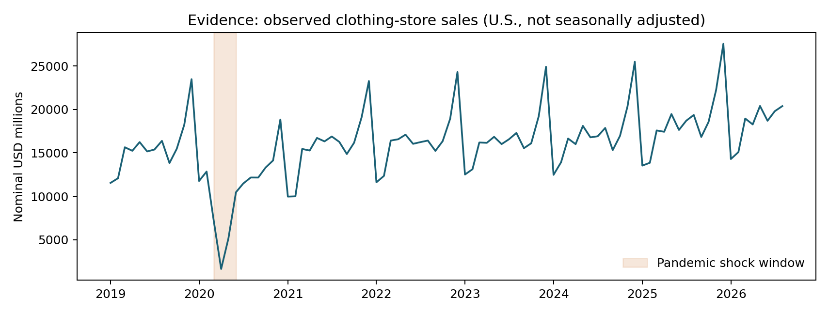
Figure 1. Real U.S. Census clothing-store monthly sales, frozen 15 Oct 2026. Shading flags a shock period.
The 2021–2025 December median is 1.90 times February's median. This supports a seasonal-hypothesis discussion, not an automatic 1.90 multiplier for an Indian retailer. Nominal USD aggregation, inflation, changing retail coverage and local climate/cultural calendars affect transferability. The 2020 disruption argues for event-aware interpretation rather than deleting outliers or fitting a single unbroken trend.
Specific decision example. A planner might compare the historical December/February relationship with two years of local SKU-level units before adjusting a buying calendar. If local peaks differ, the national proxy must be rejected. No inventory amount is recommended from the macro-series alone.

3 Predictive evaluation: benchmark, holdout, bias and failure cases
Week 4 used expanding-window selection folds for calendar 2024 and 2025, then evaluated the chosen method once on an eight-month January–August 2026 holdout. Weighted Absolute Percentage Error (WAPE) = Σ|actual − forecast| / Σactual × 100, well-defined for the positive sales series. The selected seasonal-trend forecast outperformed a 12-month seasonal-naïve baseline in this short historical test, but selection performance and holdout performance must not be conflated.
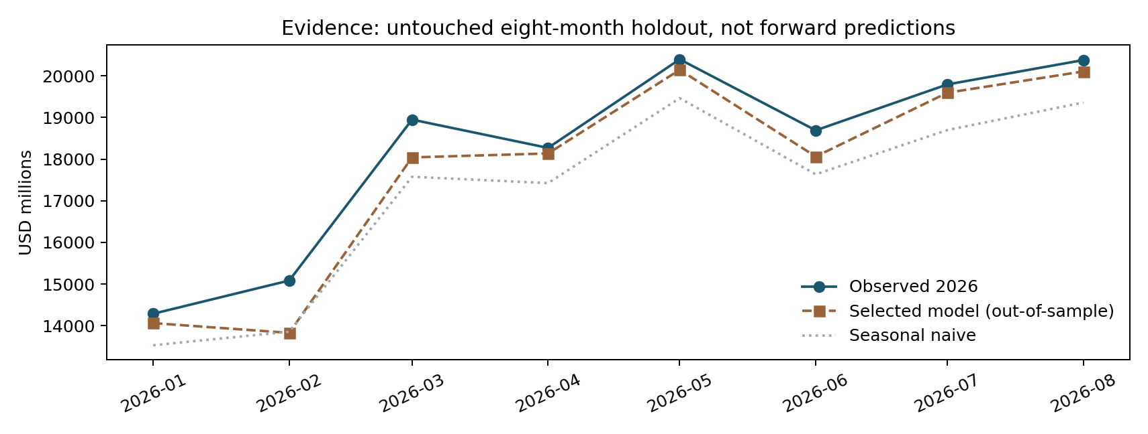
Figure 2. Held-out months with actual values and two pre-specified forecast methods.
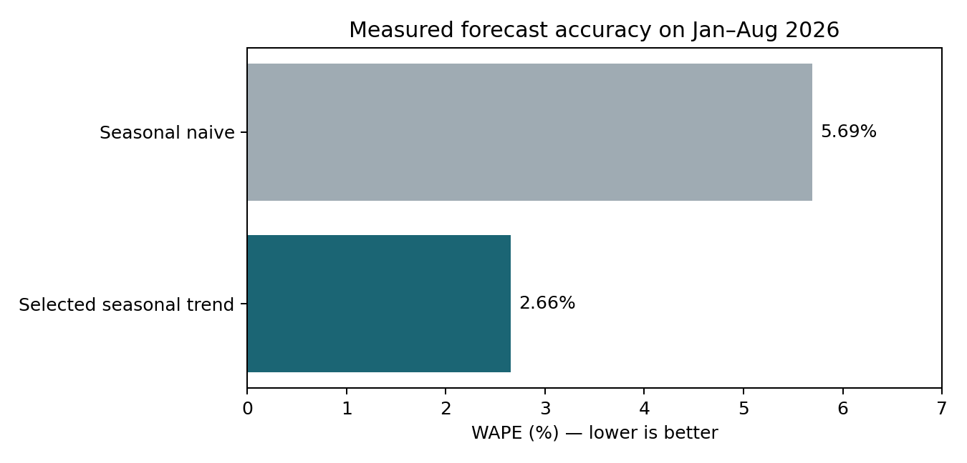
Figure 3. Recomputed error on exactly eight held-out months. Smaller WAPE is better.
Evaluation measure | Seasonal trend | Seasonal naive
Selection period WAPE, 2024–25 | 4.72% | 5.40%
Untouched Jan–Aug 2026 WAPE | 2.66% | 5.69%
2026 mean signed forecast error, USD million | −484.38 | −1,037.75
Held-out sample size | 8 months | 8 months

The selected forecast's largest absolute error was USD 1,256 million in 2026-02. Its negative average signed error suggests systematic underprediction on the holdout. This matters operationally: the forecast may understate purchase volume even while total WAPE looks relatively low. An inventory system needs costs of stockouts versus excess stock, not WAPE alone.
Not a calibrated probability claim. The previous Week 4 future interval was an illustrative stress band, not a statistically validated 95% prediction interval. No observed future forecast accuracy or profitable buying outcomes can be claimed until additional periods and local category data have been tested.

4 Evaluate data quality and the validity of each claim
The Week 5 demonstration accounted for every input line: 147 clean synthetic sales, two valid returns and 14 quarantine records. Its 91.41% retention is conditional on business rules; it cannot be treated as evidence of 91.41% factual accuracy. In the real public monthly series, 92 consecutive target months passed date continuity, uniqueness and positive-value checks. The last 12 optional accessory comparison observations were absent and must not be reported as zero.
Finding | Strength | Residual uncertainty / treatment
World Bank country trends | Published external macro indicators | No causal link from connectivity to fashion sales; require campaign experiment.
Public catalog audit | Real collection and category counts | Collection memberships overlap; resolve missing imagery via owner.
Transaction cleaning | Controlled dirty fixture with known defects | Synthetic data cannot reveal real enterprise error rates.
Seasonality EDA | 92 observed monthly market records | National nominal NSA, historical revisions and shock sensitivity.
Forecast backtest | Chronological, separate holdout and baseline | Small recent test window; monitor bias, data vintage and category performance.
Final strategic recommendation | Named owners, metrics and gates | ROI not yet observed; pilot with stop rules and privacy review.

5 Recommendations ranked by evidence strength and operational risk
Priority and owner | Next action | KPI and stop rule
1. Quality gate — Data steward | Enforce schema, source checksums, line-ID uniqueness, signed returns and exception aging | 100% valid critical fields; 0 accepted duplicate keys; stop on failed conservation
2. Catalog hygiene — Merchandising | Resolve 3 missing collection images and one missing SEO summary; review 2 collection counts exceeding distinct total | Evidence of corrected approved source, not generated placeholder
3. Forecast pilot — Planning | Build SKU/category time series with real calendar and stockout flags; repeat chronological validation | WAPE, bias, stockout and aged-stock vs naive; stop if performance unstable
4. Marketing experiment — Privacy + Marketing | Test a consent-based channel intervention with control group and predeclared outcomes | Incremental contribution and opt-out rate; stop for privacy or negative lift

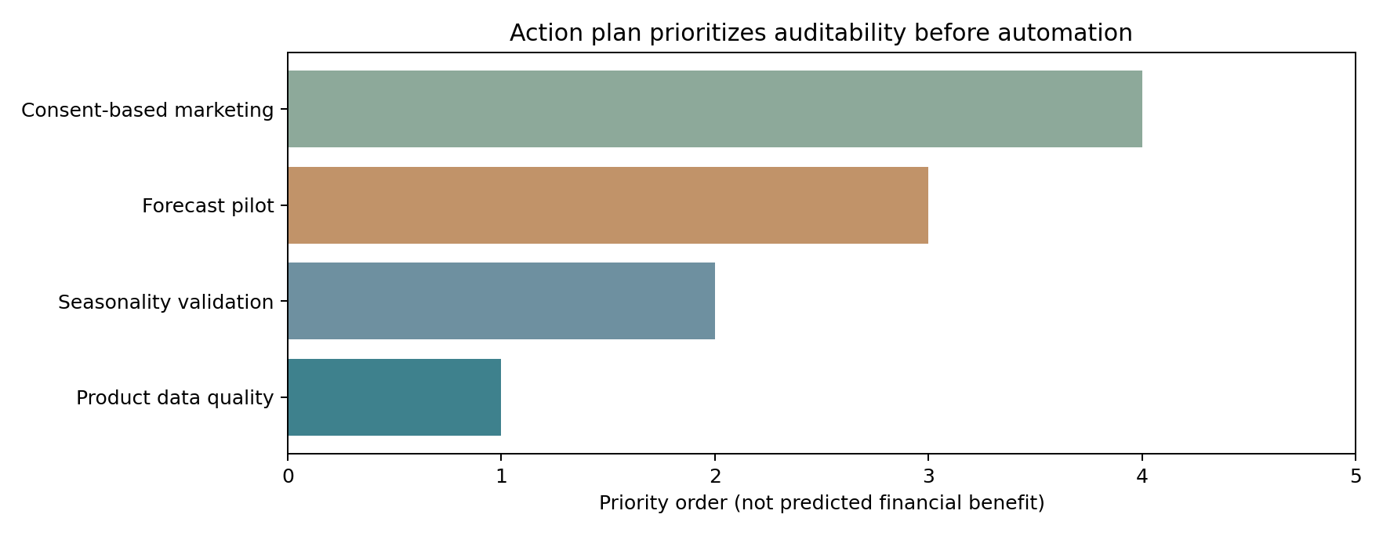
Figure 4. Priority sequencing is a governance plan, not a prediction of savings.

6 A phased six-week implementation and reporting rhythm
Window | Deliverable, resource and stakeholder | Go/no-go condition
Week A | Analyst builds lineage manifest, quality checks and a signed issue register | Documented critical data grain, currency, timezone and owners
Week B | Steward and merchandising owner correct approved catalog anomalies | No silent imputation or open critical identity conflicts
Week C | Analyst assembles local SKU-week history, lead times and stockout masks | Sufficient history and authorization to use data
Week D | Demand planner validates baseline versus candidates with rolling origins | Consistent improvement on held-out periods, monitored bias
Week E | Finance and merchandising simulate cost-sensitive replenishment | Robust under lead-time and margin assumptions
Week F | Leadership reviews accessible dashboard and opt-in pilot design | Sign-off on uncertainty, privacy, owner and rollback

Suggested RACI: analyst is Responsible for code and dashboards; data steward is Accountable for release quality; planners/merchandisers approve SKU corrections and stock decisions; privacy officer approves personal-data use; finance reviews incremental cost; internship supervisor signs off on interpretation. Archive every report version and the data vintage used.

7 Presentation design: three audiences, one consistent truth
Executive: one page. Lead with four decisions, one evidence table, forecast benchmark, risk controls and a requested approval. Name the geography and sample size in every headline.
Merchandising: operational appendix. Use exception owner lists, SKU aggregation grain, seasonal-category comparisons, stockout flags and cost assumptions. Avoid inferring actual stock from retail-sector revenue.
Technical evaluator: reproducibility. Lead with links to `run_analysis.py`, a fixed data snapshot, original charts, CSV outputs, test suite and verification commands. Distinguish source facts from simulated examples line by line.
Chart integrity. Include units, actual-vs-forecast legend, data source and period. Use bar charts with an interpretable zero, show model errors on identical date windows, annotate shock regimes, offer CSV equivalents and alt-text descriptions. Never silently truncate an axis to exaggerate differences.
Suggested 60-second opening: “We used public clothing-market statistics to measure seasonal patterns, then tested three forecast methods with chronological holdouts. On eight recent months, the selected method gave 2.66% WAPE versus 5.69% for a seasonal baseline. These are U.S. sector measures, so we recommend a controlled, privacy-reviewed local pilot—not an automatic buying decision.”

8 External factors, concrete ethics scenarios and safeguards
Realistic failure case | Why it threatens a decision | Mitigation / proof
Festival timing or heat in Tamil Nadu differs from the U.S. holiday calendar | National December peak may mislead local buying | Use local promotions, festival dates, regional weather; validate SKU-level uplift out-of-sample.
A model learns that one garment size sold less during past stockouts | Observed sales understate true demand; unfair size availability | Include stockout indicator; check service levels and errors by size; do not suppress uncommon sizes.
Customer IDs can be reidentified via joins | Unauthorized marketing or harm to privacy | Use consented aggregation, least-privilege access, deletion policy and documented legal basis.
Forecast improves WAPE but underpredicts peak demand | Inventory shortfall despite favorable score | Monitor signed bias, high-season errors, cost-weighted stockout risk and fallback baseline.
COVID-style market shock or later Census revision | Model confidence and charts become misleading | Version datasets, flag regime breaks, report a backtest by vintage, trigger manual review.

9 Review criteria, unresolved questions and next evidence needed
- Before executive adoption, obtain at least two complete years of authorized local SKU-week sell-through, returns, stockout status, current stock and supplier lead times; replace aggregate market proxies where feasible.
- Assess forecasting accuracy by category, size, seasonal window and channel; compare a simple baseline and maintain a human override audit trail.
- Test whether interventions improve incremental gross contribution and service level, rather than assuming that a lower WAPE automatically increases margin.
- Re-examine external economic factors (consumer income, weather, exchange rates, promotions and supply disruptions) using point-in-time data and a clearly specified causal or predictive hypothesis.
- For every dashboard revision, record whether values are observed, synthetically generated, backtested or projected, together with dataset vintage and known failure modes.

10 Reproduce all report figures and checks
From `Week6_Fashion_Insights_Final/`, install the requirements, run `python run_analysis.py`, and then `python -m unittest discover -s tests -v`. Nine tests pass on the supplied offline fixture. The code recomputes WAPE and bias directly from the eight January–August 2026 held-out rows and refuses a zero-denominator WAPE. This report is an integration product: to rebuild all earlier models, use each week’s original project rather than claiming the Week 6 script itself refits every model.

Sources, provenance and scope
- World Bank India indicators — Week 1 case study. Repository: Week1_External_Data_Case_Study/outputs/external_case_findings.json; scenario marketing calculations separately labelled hypothetical.
- Public fashion catalog — Week 2 case study. https://github.com/arturayupov/womens-fashion-catalog-open-data (MIT-licensed source snapshot 2026-10-18).
- U.S. Census Bureau via FRED, MRTSSM4481USN. https://fred.stlouisfed.org/series/MRTSSM4481USN (monthly clothing-store sales, nominal USD millions, vintage 2026-10-15).
- Week 3 & Week 4 evaluation artifacts. Repository: Week3_Fashion_Trend_EDA/outputs and Week4_Fashion_Forecasting/outputs (charts, forecasts and frozen 2026 holdout).
- Week 5 quality assessment. Repository: Week5_Apparel_Data_Quality/outputs/quality_evidence.json (independent checks and quarantine register).
All dates, units, file names, exclusions and decision thresholds are documented in the companion repository. Historic statistical series are subject to revision after their frozen snapshot; re-run against the same supplied files for exact replication.

Appendix: rapid evaluator verification checks
Claim to verify | Independent file and calculation
World Bank India internet usage change, 26.59 pp | Subtract 43.41 from 70.00 in data/reference/week1_external_indicators.json; macro indicator, not marketing lift.
Synthetic row reconciliation equals 100% | Review Week 2 audit: 147+2+14 = 163; no untraceable source rows.
Observed year-over-year seasonality ratio 1.90 | Read data/raw/fred_clothing_store_sales_2019_2026_08.csv; compare December/February medians for 2021–2025.
2026 holdout error is 2.66% versus 5.69% | Recalculate Σ absolute forecast error divided by Σ actual on eight rows of data/reference/untouched_2026_holdout.csv.
Forecast has negative signed bias | Average forecast − actual on the same eight months: −484.38 USD million.
Recommendations are untested | See outputs/prioritized_decision_plan.csv: proposed owner, validation and explicit stop rules.

Reviewer note: percentages in these tables may differ by a few hundredths if rounded intermediate values are used. The executable scripts compute from the original retained figures, and the scripts produce the CSV/JSON evidence alongside each chart.

