RESEARCH + IMPLEMENTATION BLUEPRINT

Fashion Data
Strategy & Business
Analysis
Connecting demand, inventory, trend signals and customer value
for apparel and textile businesses.

ASSIGNMENT | PERIOD | SUBMISSION
Junior Data Science Analyst — Week 1 | 13 Oct – 19 Oct 2026 | Revised 22 Oct 2026
Internship: Coimbatore, Tamil Nadu | 13 Oct – 24 Nov 2026 | Word report + code evidence

DOCUMENT PURPOSE
An independently executable six-week plan that identifies strategic questions, measurable KPIs, public data sources, modelling approaches, responsible-use safeguards, resources, and assessment criteria. The companion GitHub-ready project provides reproducible sample analyses using synthetic data—not claims about any employer.
Report version 1.1 | Expanded quantitative evidence | Prepared for academic evaluation | Public-data-first

Executive summary
Apparel businesses face a recurring tension: buying or making enough of the right product, size and colour while limiting unsold stock, markdowns and avoidable resource use. In 2026, the State of Fashion research highlights changing consumer preferences, trade volatility and AI-enabled operating improvements [1]. Tamil Nadu’s integrated textile and knitwear ecosystem makes these questions particularly relevant to a Coimbatore-centred learning case [2][3].
This report recommends starting with three practical decision systems: (1) size-level sales forecasting and reorder review, (2) early detection of apparel search-interest changes, and (3) permission-aware customer segmentation and campaign testing. A fourth, longer-horizon workstream connects return reasons, product attributes and traceability to circularity. The proposed first milestone is a reproducible proof of concept; not an enterprise data platform.
Because no internal company files are assumed available, the independent demonstration uses synthetic orders and sales, public research, downloadable Google Trends samples, and sources that are clearly marked as conditional or third-party licensed. Actual business improvements must be validated on authorised real data before decisions are automated.
PRIORITY | MANAGEMENT QUESTION | FIRST DECISION OUTPUT
01 Demand & stock | Which SKU / size is at risk of missing demand or becoming aged stock? | Weekly SKU demand scorecard and reorder review queue
02 Trend intelligence | Which garment types or colours show sustained emerging interest? | Trends watchlist, not an automatic buy signal
03 Customer growth | Who may benefit from useful, relevant outreach? | Aggregate customer groups and controlled campaign test
04 Circularity (phase 2) | Where are returns and material losses concentrated? | Reason-code quality checks and traceability checklist

Status: strategic plan plus demonstration only. No internal company access, live retailer forecast or claimed revenue improvement is assumed.

1. Sector context and business case

1.1 Why analytics matters in fashion
Fashion differs from generic retail because many variants of one style compete for constrained stock; collection life cycles are short; preferences change across seasons, occasions and regions; and unsold merchandise loses value as new assortments arrive. A useful data strategy must therefore operate at style–colour–size–channel–week granularity while preserving an aggregated view for managers.
The 2026 McKinsey/Business of Fashion outlook identifies technology adoption, shifting consumer priorities and trade uncertainty as strategic pressures [1]. For the regional context, the Tamil Nadu Department of Handlooms describes a substantial knitwear and garment industry around Tiruppur and an interlinked textile value chain [2]. A 2026 Tamil Nadu circular-textile pathway emphasises traceability, resource efficiency and better coordination along the chain [3]. These observations justify the business problem; they do not supply a measured baseline for a particular company.

1.2 Decision hierarchy
DECISION HORIZON | USE CASE | INFORMATION REQUIRED
Daily / weekly | Reallocate sizes, identify stockouts, launch small replenishment review | Available-to-sell units, sell-through, lead times, recent sales
Monthly | Adjust category allocation, discount depth and acquisition mix | Forecast errors, promotion effects, gross margin, incremental campaign lift
Seasonal / quarterly | Review assortment gaps, supplier exposure and waste-reduction actions | Historical cohort demand, return reasons, supplier data, traceability evidence

2. Objectives, hypotheses and research questions
OBJECTIVE / PRIORITY | TESTABLE BUSINESS QUESTION | HYPOTHESIS / DECISION RULE
A. Improve demand planning | Highest | Can a transparent SKU-level baseline forecast outperform or match naive recent-sales estimates on unseen weeks? | Use walk-forward tests. Promote only if error reduction is stable across categories and stockout artefacts are monitored.
B. Reduce inventory friction | Highest | Which SKUs need review given forecast demand, on-hand stock, lead time and service risk? | Rank reorder candidates; require human confirmation until costs and lead-time distributions are available.
C. Detect emerging trends | Medium | Do persistent search changes lead category demand by two to eight weeks? | Compare search indices with lagged category sales; retain a signal only when it beats a sales-only baseline.
D. Improve marketing efficiency | Medium | Do permission-aware RFM audiences respond better than undifferentiated campaigns? | Randomised holdout, report incremental conversions and gross contribution, not click-through alone.
E. Enable circularity | Longer term | Which product attributes or suppliers correlate with avoidable returns and waste? | Start with coded return reasons and credible material-provenance fields; do not infer sustainability from a marketing label.

Scope assumption: a hypothetical small/midsize apparel retailer or brand connected to the Tamil Nadu textile ecosystem. Manufacturer-only businesses can substitute finished-goods demand with purchase orders, fabric yield, defect rate and on-time-in-full shipments.

3. KPI framework: definitions, baselines and success gates
Every KPI needs a single formula, consistent reporting grain, a baseline period, a data steward and a response action. Proposed targets below are pilot thresholds, not measured current performance or guaranteed gains.
KPI | DEFINITION / UNIT | PILOT DECISION THRESHOLD
Data completeness | SKU–week rows with valid date, SKU, units and price / required SKU–week rows | At least 95% completeness; duplicate key below 1%; flag exceptions
Forecast WAPE | 100 × sum(|actual − forecast|) / sum(actual), for nonzero actual total; percent | Stretch goal: at least 10% relative WAPE reduction versus naive baseline on out-of-time test
In-stock rate | SKU–store–day observations with sellable stock / all eligible SKU–store–day observations | Target +3 percentage points only after reliable daily stock data exists
Sell-through | Net units sold / (opening units + received units) for defined cohort; percent | Track by collection and age; investigate slow movers, no universal target
Aged-stock share | Units (or value) older than locally chosen collection-age threshold / total units (or value) | Pilot goal: reduce aged-stock value 10% relative after matched cohort measurement
Return rate | Returned units / shipped units on aligned order cohort; percent | Report by reason and size; first objective is reliable reason coding
Incremental campaign lift | (Treatment conversion rate − control conversion rate) and gross margin lift | Run holdout test; scale only if lift exceeds noise and contribution covers spend
Attribution / cost | Customer acquisition cost = attributable acquisition spend / new customers | Secondary guardrail; never treat clicks or attributed ROAS as causal lift

WAPE is undefined when total actual demand is zero. Low-demand SKUs should be evaluated in aggregated groups as well as individually. Stockouts censor observed sales, so sales alone can understate true demand.

Target ownership and frequency
An analyst should issue weekly demand / data-quality scorecards and a monthly customer-learning summary. In a future company pilot, merchandising owns stock decisions, marketing owns campaign design, operations validates lead times, and an appointed data steward signs off on definitions. In the internship demonstration, the student plays the analyst and documents these roles without requiring company participation.

4. Data inventory: public-first and future company inputs
SOURCE / ACCESS | WHAT IT CONTRIBUTES | LIMITATION / SAFE USE
Google Trends / manual CSV export [4][5] | Relative search interest by term, date and geography; examples: cotton kurta, oversized T-shirt | Normalised 0–100, not search volume or direct purchase intent; time/location comparisons need care.
Tamil Nadu public textile sources [2][3] | Cluster background, value chain, circularity priorities and policy context | Sector context only; cannot substitute for local store transaction data.
Open-Meteo archive [6][7] | Past temperature or rainfall features to test weather-sensitive category hypotheses | Free service is non-commercial; check current terms and commercial licence before business deployment.
H&M Kaggle competition [8] | Fashion article metadata and time-stamped purchases for separate methodology experimentation | Account and rules acceptance required; large download, competition-specific licence; do not redistribute.
UCI Online Retail [9] | General transaction structure, cancellation handling and RFM teaching example | Not an apparel dataset; historic UK gift retailer; transfer learning only.
Locally generated synthetic CSVs | Complete offline reproducibility of forecast, reorder and customer-segmentation examples | Demonstrates code mechanics only; no commercial conclusions.
Future authorised company data / conditional | POS, e-commerce orders, stock snapshot, receipts, returns, promotions, cost and consent | Not accessible in this task; require permission, security, business definitions and privacy review.

Minimum analytical data schema
The recommended fact table key is (week_start, SKU, sales_channel, location) with `units_sold`, `units_returned`, `selling_price`, `promotion_flag`, `in_stock_exposure`, `beginning_inventory`, `receipts` and `inventory_on_hand`. A product dimension maps SKU to style, category, size, colour, fabric, season and supplier. Future marketing tables should contain pseudonymised customer IDs, consent flags, event timestamps and campaign costs, stored separately from directly identifying details.
Validation rules: reject negative non-return sales, invalid dates and impossible sizes; deduplicate the declared composite key; reconcile sales plus returns with order-line evidence; distinguish cancellations from fulfilled orders; store currency and tax treatment; flag impossible inventory balances; capture snapshot dates; and log missingness by channel and category. Use ISO dates and UTF-8 consistently.

5. Analytics and business-action design

5.1 Inventory optimisation and demand forecasting
- Prepare weekly item-level sales, stock availability, returns, promotions and any order cancellations. Split chronologically; retain the most recent 12 weeks for evaluation.
- Benchmark seasonal-naive (same period in prior cycle) or rolling-four-week mean against transparent candidates: 4/8-week blend, exponential smoothing or category pooling when sparse.
- Compare WAPE by category and by full portfolio; inspect systematic bias, high-demand items, promotions, newly launched styles and weeks with stockouts. Do not apply a random train/test split.
- Build a decision queue: reorder point = expected demand during supplier lead time + safety stock. Include minimum order quantity, supplier capacity, margin, obsolescence risk and return-adjusted demand as data becomes available.
- Human reviewer approves a small trial; track realised fill rate, stock value and forecast drift weekly. Stop automatic proposals if missing stock data or abnormal trends make the recommendation unreliable.
Action example: if a size is trending up but has limited sellable stock, review allocation and replenish cautiously; if an end-of-season style has weak sell-through and excess stock, test smaller markdowns before ordering more. Estimated lost sales should be treated as an assumption unless customer demand beyond stock limits can be observed.

5.2 Trends and assortment intelligence
Create a stable dictionary of apparel terms grouped by category, fit, fabric, colour and occasion; export comparable weekly Google Trends series for India or relevant cities [4][5]. Standardise geography and window before comparing terms. Apply four-week smoothing and track sustained changes rather than one-off spikes. Combine search indices with seasonality, holidays, weather (where terms allow) and product lead times. Back-test lag correlations on prior weeks and compare against a sales-only baseline before assigning a “watch” or “validate” status.
Output: a 10–20-term watchlist with direction, confidence, time window, source link and owner. Example question: does interest in cotton kurtas rise ahead of demand in a given region? The search index can generate an investigation; it cannot alone justify supplier orders or infer absolute market size.

5.3 Customer marketing and retention
With consented, authorised transaction records, compute recency, frequency and monetary value. Create understandable groups such as loyal repeat buyers, reactivation candidates and growth-potential buyers; test cross-selling or useful product information through channels customers have chosen. Use a randomised holdout and measure incremental conversions, attributable gross margin and opt-outs. Report results separately from platform-reported return on ad spend (ROAS), which can over-attribute sales. Avoid profiling protected or sensitive characteristics and do not purchase dubious identity datasets.

5.4 Returns, responsible sourcing and circularity
As a future extension, normalise return reasons (fit, quality, damaged, style mismatch), and link them to size guide, garment attributes and production batch when authorised. The 2026 Tamil Nadu circular-textile pathway calls attention to traceability and resource efficiency [3]. A responsible analytics objective is therefore verifiable lower waste and clearer provenance, not unsubstantiated sustainability scores.

6. Technical demonstration and honest interpretation
The companion GitHub-ready code repository contains reproducible Python, a README, two automated tests and generated CSV/PNG outputs. It creates 78 weekly periods for 16 imaginary SKUs and 520 imaginary customers; it does not download, scrape or reveal business records. The forecast evaluation uses the final 12 weeks, expands the training history one week at a time and excludes flagged stockout test weeks.
SYNTHETIC DEMONSTRATION MEASURE | OBSERVED OUTPUT | WHAT IT MEANS / DOES NOT MEAN
Four-week moving mean WAPE | 19.09% | Baseline error on fictional uncensored holdout sales only
4/8-week blend WAPE | 18.86% | A small synthetic difference; not proof of real-world superiority
Evaluated SKU–weeks | 153 | Eligible observations after excluding flagged test stockouts
Replenishment review list | 11 of 16 SKUs | Illustrative reorder screening with invented on-hand quantities
RFM customer coverage | 520 simulated customers | Demonstrates segmentation logic, not campaign uplift

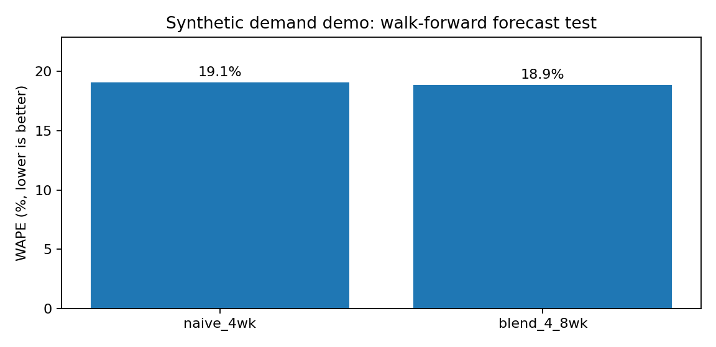
Figure 1. Forecast-model comparison on generated sample data (seed = 42). Both methods are tested on fictional sales only. Source: included Python project.
Interpretation: the blend edges the simple baseline on this seed, but the difference is small and neither passes the proposed 10% relative improvement threshold. A responsible project would retain the simpler baseline or continue testing rather than imply a demonstrated business gain. Past training-period stockouts can still depress observed demand; the example does not model price elasticity, supply constraints or causal promotions.

6.1 Worked case study: design and validation boundary
The following tables and figures are computed from the executable Python files accompanying this report. A deterministic seed creates 78 weekly observations per SKU for 16 fictional apparel SKUs (4 categories × 2 colours × 2 sizes), totalling 1,248 SKU-weeks, plus 2,374 fictional order records from 520 customers. All amounts are INR and all outcomes are SYNTHETIC; they are evidence that the analytical method runs, not evidence that a real brand earned or saved money.
Data-quality and exposure check: 34,131 units are marked as sold with a notional listed-price gross value of INR 51,174,969. 1,986 units are recorded as returned (5.8% of sold units), and 214 of 1,248 SKU-weeks (17.1%) are stockout-flagged. Listed-price gross value is NOT recognised/net revenue or margin: it is before returns and any realised discounts. Stockout-flagged sales are censored, not true demand.

6.2 Concrete category analysis: sales, stockouts and returns
Apparel category | Units sold | Listed-price gross value (INR) | Stockout SKU-weeks | Return-unit rate
ACTIVE | 6,173 | 9,253,327 | 55/312 | 5.99%
DENIM | 6,960 | 16,001,040 | 45/312 | 5.95%
KURTA | 8,312 | 15,784,488 | 62/312 | 5.50%
TSHIRT | 12,686 | 10,136,114 | 52/312 | 5.87%
Business interpretation: synthetic T-shirts contribute the most units (12,686), while denim generates high listed-price value because of its higher price point. Kurta shows the highest stockout-flagged SKU-weeks (62 out of 312). A merchandising analyst would investigate these categories first, but should not infer the cause of a stockout from this table alone; supplier delays, distribution, assortment and promotions require separate evidence.

6.3 Forecast experiment: actual calculations and cautious decisions
Experiment design: the last 12 calendar weeks are reserved as an out-of-time test; the model predicts each SKU-week only from preceding weeks. Forecast rows with stockout flags are excluded from the test because observed sales may understate demand. That leaves 153 evaluated SKU-weeks and 39 excluded test SKU-weeks. WAPE = 100 × SUM(|actual units − predicted units|) / SUM(actual units) over the included rows.
Category | Evaluated SKU-weeks | 4-week WAPE | 4/8-week blend WAPE | Change (pp)
ACTIVE | 33 | 21.18% | 20.99% | +0.19
DENIM | 42 | 23.24% | 22.74% | +0.49
KURTA | 39 | 16.94% | 16.27% | +0.67
TSHIRT | 39 | 17.03% | 17.26% | -0.23
Positive percentage-point change means the blend has lower error. Weighted across all evaluated rows, the four-week baseline WAPE is 19.09% and the four-/eight-week blend WAPE is 18.86%, an absolute difference of only 0.23 percentage points (about 1.2% relative reduction in error). The blend loses on T-shirts: 17.26% versus 17.03% baseline. A simple paired resampling of the 12 test weeks gives an illustrative 95% range of −0.36 to +0.83 percentage points for the blend improvement; it crosses zero. Therefore the result is not robust evidence to replace the baseline, and it is not a production claim.
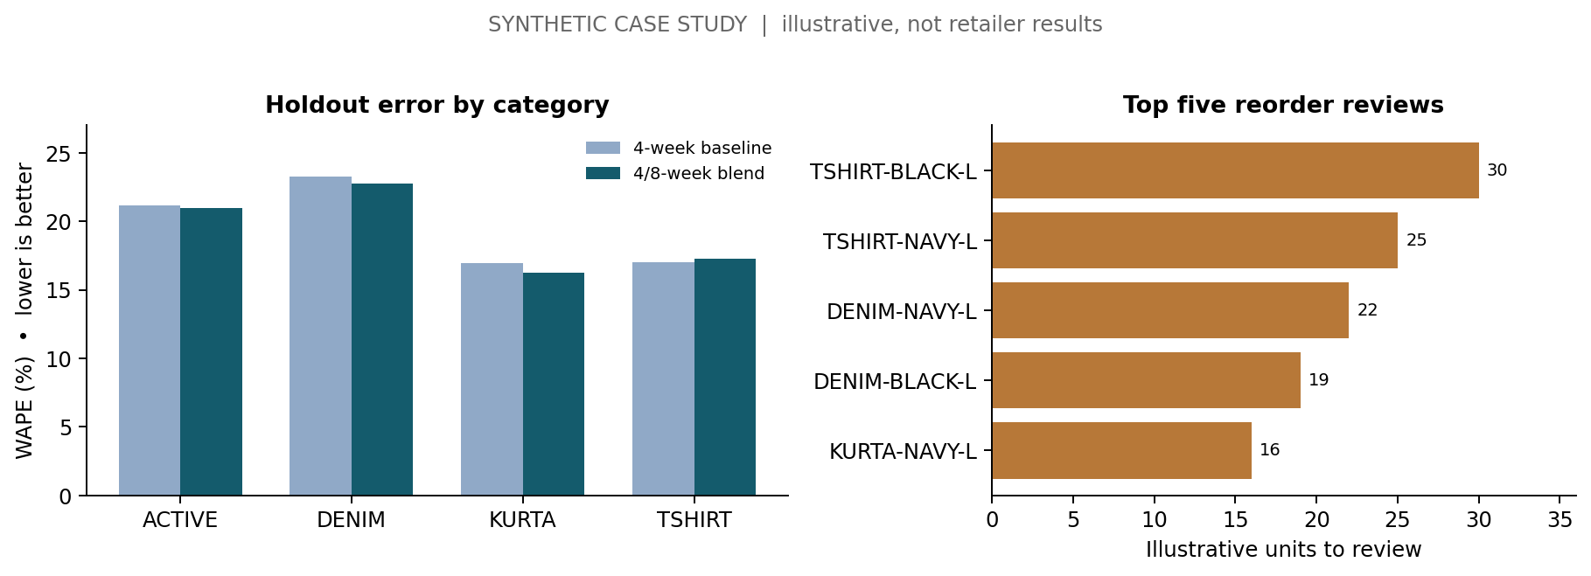
Figure 2. Forecast error by apparel category and prioritized replenishment reviews; all values synthetic.
Recommended decision: retain the four-week mean as a transparent champion until a longer external holdout shows consistent reduction in stockout-adjusted error by product family. Add promotion, price, calendar, returns, local weather and availability features only after establishing data provenance. A production dashboard would display SKU-week actuals, predictions, WAPE, bias and 80%/95% prediction intervals.

6.4 Inventory use case: worked reorder-point calculation
Rule (illustrative): reorder point = ceiling[2 × mean weekly units over 8 weeks + 1.65 × sample standard deviation of last 8 weeks × √2]. The two-week lead time and safety multiplier of 1.65 are assumed, not sourced from an actual supplier. Review units = MAX(0, reorder point − simulated on-hand). This does not include open purchase orders, shelf minimums, pack sizes, or desired order-up-to coverage.
SKU | 2-week reorder point | Demo on-hand | Units for human review
TSHIRT-BLACK-L | 79 | 49 | 30
TSHIRT-NAVY-L | 80 | 55 | 25
DENIM-NAVY-L | 58 | 36 | 22
DENIM-BLACK-L | 48 | 29 | 19
KURTA-NAVY-L | 60 | 44 | 16
Worked SKU example: TSHIRT-BLACK-L averages approximately 29.0 units/week. Two weeks of expected sales are about 58 units. Adding approximately 20 units of estimated safety stock gives a reorder point of 79 units after ceiling the unrounded underlying calculations. With 49 fictional units on hand, the review gap is 79 − 49 = 30 units. Across all 16 SKUs, 11 receive REVIEW flags, totalling 149 illustrative units; that total is NOT an authorised purchase recommendation or a proven stockout reduction.

6.5 Trend signal and marketing example
Illustrative seasonal hypothesis: synthetic Kurta weekly SKU-level units averaged 22.25 in August–September 2025 and 29.69 in October–November 2025, a descriptive increase of 33.4%. This fits a plausible festive-season hypothesis but does NOT establish causal demand growth: simulated promotions and stock availability differ by period. Before acting, compare equivalent weeks across at least two years and validate against Google Trends relative search indices, holiday dates, price and actual available-to-sell stock.
RFM audience | Customers | Share of customers | Synthetic spend share
Growth potential | 191 | 36.7% | 36.7%
Loyal | 97 | 18.7% | 29.3%
Occasional | 103 | 19.8% | 17.1%
Reactivation candidate | 129 | 24.8% | 17.0%
Decision example: prioritise opt-in, permission-respecting retention experiments for 129 fictional reactivation candidates rather than emailing all 520 customers indiscriminately. Assign a random holdout group and track incremental conversion and gross margin after campaign cost and returns. RFM is descriptive segmentation; it does not establish that an offer improves retention, revenue or lifetime value.

6.6 Reproducibility, limitations and evaluation checklist
Evidence chain: data/synthetic_weekly_sales.csv + data/synthetic_orders.csv → src/fashion_strategy_demo.py → outputs/walk_forward_predictions.csv / forecast_scores.csv / replenishment_suggestions.csv / rfm_segment_summary.csv → src/case_study_analysis.py → outputs/case_*.csv, case_study_summary.json, case_study_decisions.png → Week1_Fashion_Case_Study.ipynb → report tables. An evaluator can open the precomputed files without running code or reproduce them from the repository root.
Run: pip install -r requirements.txt; python src/fashion_strategy_demo.py; python src/case_study_analysis.py; python -m unittest discover -s tests -v. No business accounts, credentials or internal company datasets are required. Dependencies, sample data, generated outputs and tests are included at the root of the linked GitHub repository.
Validity gates: (1) verify unique SKU × week keys; (2) remove no rows without explanation; (3) protect time-series ordering; (4) distinguish stockout-censored observed sales from latent demand; (5) retain baseline if change is within error uncertainty; (6) obtain real point-in-time inventory and product costs before making purchase decisions; (7) run controlled consented marketing tests before claiming incremental results. The case study is suitable as a training demonstration, not as statistical proof of a real apparel strategy.

7. Six-week implementation roadmap and resource plan
The roadmap aligns with the six-week internship period beginning Tuesday, 13 October 2026. Since the submission window ends on 24 November, technical work is staged through 23 November with a final review/upload checkpoint on 24 November. Actual assignment completion is not asserted by this plan.
WEEK / DATES | WORK PACKAGE | OUTPUT + ACCEPTANCE GATE
1 | 13–19 Oct | Research 2026 sector trends, frame decisions and assumptions; document public sources; define KPI dictionary. | Strategy DOCX, question matrix, risk list and repository outline; evaluator can follow the plan.
2 | 20–26 Oct | Acquire allowed public samples; create synthetic schema and validations; document source permissions. | Data dictionary + clean example CSVs; completeness and schema checks pass.
3 | 27 Oct–2 Nov | Establish demand baselines, walk-forward tests, stockout flags and indicative reorder queue. | Forecast error table, code, method note and human-review rubric.
4 | 3–9 Nov | Compare Google Trends terms by stable windows; explore external features and leakage. | Trend watchlist and a documented sales-only comparison; no “prediction” based solely on searches.
5 | 10–16 Nov | Perform synthetic RFM and plan a privacy-aware marketing experiment. | Customer group summary, randomised holdout design and contribution metric.
6 | 17–23 Nov | Integrate charts, examine limitations, test scripts and prepare final explanation. | Readable GitHub repository, validated outputs, final report and assessment checklist.
Close | 24 Nov | Check filenames, document length and upload requirements. | Word document uploaded to internship portal; real public GitHub URL supplied if required.

Resources, effort and budget assumptions
Personnel: one junior analyst/student for approximately 8–10 hours per week (48–60 hours across six weeks), with no compulsory company reviewer. Technology: Python 3, pandas, NumPy, Matplotlib, Word-compatible DOCX tools, a free GitHub repository and locally generated CSVs. Baseline software cost is ₹0 for permitted educational use on an existing computer; electricity, device, network, and any chosen paid services are excluded. H&M data access is optional and subject to rules. Live commercial uses of an API or data feed require a separate licence and budget check.
Dependencies: internet access for public reading/CSV exports, computer with Python, and permission to publish code. If optional sites are unavailable, use included synthetic files. To move from demonstration to real operations, the organisation would need to provide transaction and stock data, define replenishment authority, and authorise data governance.

Decision gates
GATE | PASS CONDITIONS | IF NOT MET
Data ready | Key schema validates; sources and licences recorded; no personal identifiers exposed | Use synthetic schema and document gap; do not make operational recommendations
Forecast ready | Out-of-time error, stockout exclusions and category performance reported | Keep transparent baseline; review data and additional history
Pilot ready | Human owner, inventory and cost data, review trail and monitoring exist | Restrict output to educational ranking only
Marketing ready | Consent and opt-out workflows; randomised control and contribution metric | Do not send campaigns or make causal claims

8. Risks, mitigations and ethical safeguards
CHALLENGE | POTENTIAL FAILURE | MITIGATION / OWNER
Data gaps and silos | Missing sizes or transactions produce inaccurate demand | Validate grain, log missingness; analyst pauses unreliable segments
Stockout censoring | Observed sales understate actual desire to buy | Use stock availability/exposure; skip censored validation points; operations review
Cold-start styles | New SKUs lack historical demand | Borrow category and similar-style priors; lower confidence and order smaller
Changing season and promotions | Historic relationship breaks during festival or markdown | Rolling backtests, drift alerts and event annotations; merchandising review
Selection / leakage bias | Future promotions used to predict past sales or test tuned repeatedly | Time-based splits, frozen holdout, timestamped feature availability
Misinterpreting search interest | Normalised Trends score confused with total shoppers | Attribute source, compare same windows; treat as leading hypothesis [5]
Customer privacy and fairness | Unconsented tracking or discriminatory targeting | Minimise/pseudonymise data; opt-out and retention controls; marketing steward
Confounded campaigns | Attributed ROAS mistaken for incremental sales | Randomised control, incremental gross contribution and uncertainty interval
Source licensing / costs | Competition data or non-commercial API used beyond permission | Document terms; use synthetic fallback; procure commercial permissions [7][8]
Unverified sustainability claims | “Green” labels imply evidence that does not exist | Collect traceability proof; show missing values; avoid unsupported scores

9. Evaluation, deliverables and conclusion

Evaluator-facing completion checklist
EXPECTED DELIVERABLE | PROOF INCLUDED OR PLANNED
Detailed Word-format strategy, >200 words | This DOCX: sector rationale, objectives, analytics logic, governance and roadmap
Business questions and KPIs | Sections 2 and 3: explicit decisions, metric formulas and tentative gates
External research and data sources | Section 4 and sources [1]–[9], including access and licence caveats
Inventory, forecasting and marketing analysis | Section 5: decision framework, validation plan and limitations
Executable technical evidence | Companion Python code, synthetic CSV, result charts, README and passing tests
Action plan, resources and mitigation | Sections 7 and 8, including dated phases, effort and contingencies
Submission description of at least 200 words | Companion Submission_Description.txt ready to paste
GitHub URL for technical internship | Repository files prepared; user must publish to GitHub to obtain genuine live URL

Conclusion. The recommended strategy is intentionally modest in technology but ambitious in decision clarity: unify product-level definitions, measure forecast and stock outcomes, treat trend data as contextual evidence, and test marketing actions incrementally. Its value lies in connecting repeatable measurement to operational choices while keeping methodological uncertainty visible. A public-data-first demonstration can be completed independently; a real business rollout should occur only after data access, ownership and decision rights are established.

References and access notes
Source review date: 15 October 2026. Source titles and URLs are supplied for evaluator verification; external pages may change. Background figures on older government pages should not be represented as October 2026 market observations.
[1] McKinsey & The Business of Fashion (17 Nov 2025). The State of Fashion 2026: When the Rules Change. Global industry outlook. View original source
[2] Government of Tamil Nadu, Department of Handlooms. Textile sector background, knitwear / garment ecosystem and Tiruppur context. View original source
[3] Government of Tamil Nadu / Tamil Nadu Green Climate Company (2026). Reweaving the Circular Transition: A Pathway for Sustainable Circular Textiles in Tamil Nadu. View original source
[4] Google Trends Help. Export, embed and cite Trends data; export is available as CSV. View original source
[5] Google Trends Help. FAQ on normalised relative search-interest indices (0–100). View original source
[6] Open-Meteo. Historical Weather API data documentation. View original source
[7] Open-Meteo. Terms and licence distinction between educational/non-commercial free API and commercial use. View original source
[8] H&M / Kaggle. Personalized Fashion Recommendations dataset; sign-in, competition terms and file sizes apply. View original source
[9] UCI Machine Learning Repository. Online Retail benchmark: non-fashion transactional dataset for methods practice. View original source

Appendix A. Transition from demonstration to a real pilot
An independent demonstration becomes a real decision-support tool only after the organisation supplies permissioned data and identifies a person responsible for the outputs. The following handover checks prevent a prototype from being mistaken for operational automation.
REPLACE OR APPROVE | CONDITION FOR REAL-WORLD USE
Synthetic demand and on-hand | Load authorised SKU–store–day sales, returns, stock and product master data; reconcile inventory movements.
Lead-time assumptions | Use verified supplier lead-time history, minimum order quantities, purchase costs and review cycles.
Source licences and consent | Document permitted data uses, retention limits, customer contact choices and commercial feed terms.
Performance thresholds | Set a real baseline, evaluate the next 8–12 weeks out of time and record gross-margin / availability trade-offs.
Human ownership | Assign business approvers; keep an audit log and disable any decision automation on data-quality failure.

Reproducibility: run the repository command in README.md and compare outputs/kpi_summary.json with the technical-demonstration values in Section 6. A different random seed will change all synthetic outcomes.

Appendix B. Verified External-Data Integration Case Study
Purpose. This appendix responds directly to the Week 1 assessment request for concrete examples of how independently obtained external sources contribute to fashion-sector decisions. The analysis uses observed World Bank data, not fabricated statistics. A fashion campaign scenario is clearly identified as hypothetical.

B1. Business decision and two public datasets
Decision question: Should a Coimbatore-based apparel retailer prioritise a small mobile-first digital marketing experiment, and which performance measurements would validate that choice? These indicators provide national channel context, not local proof of demand. They must not be treated as causal predictors of sales.
Actual source | Business relevance | Join key & granularity
World Bank • IT.NET.USER.ZS | India: individuals using the internet (% population) | Annual share; country IND; 2020–2025
World Bank • SP.URB.TOTL.IN.ZS | India: urban population (% population) | Annual share; country IND; 2020–2025
Source endpoints (official API, reviewed October 2026):
https://api.worldbank.org/v2/country/IND/indicator/IT.NET.USER.ZS?format=json
https://api.worldbank.org/v2/country/IND/indicator/SP.URB.TOTL.IN.ZS?format=json
Acquisition and provenance: the saved CSV contains the 12 observed indicator values (6 annual records per source), World Bank series IDs, source URLs and source-update metadata. The source API reported a last-update date of 13 July 2026. The accompanying Python code offers an optional --refresh mode that downloads both series in JSON format and updates the snapshot; the default mode uses the audit-ready CSV offline.

B2. Executable cleaning, merging and verification
- Step 1 — Identify and download the two indicator series for country code IND, 2020–2025. Use the year and indicator identifiers returned by the World Bank rather than relying on column order.
- Step 2 — Parse year to integer, percentage values to numeric and country codes to uppercase; filter to valid years; reject missing, invalid (outside 0–100%), or duplicate country-year-indicator observations.
- Step 3 — Pivot each series into a column and match on the composite key (country, year). The code asserts exactly six matched years with complete measurements, and writes outputs/joined_india_external_market_indicators.csv.
- Step 4 — Calculate observed changes in percentage points, not percentage growth, chart the two series, and document the difference between national digital access and fashion purchase conversion.
- Step 5 — Formulate a reversible marketing pilot, instrument web sessions and completed orders, and scale only after permissioned store data validate incremental results.

B3. Results of the real-data join
World Bank indicator | 2020 observed | 2025 observed
Internet users (% population) | 43.41% | 70.00%
Urban population (% population) | 34.13% | 35.69%
Calculation: Internet-user share difference = 70.00 − 43.40544313 = +26.59 percentage points (rounded); urban-population share difference = 35.68915577 − 34.12867261 = +1.56 percentage points. The joined dataset has six annual observations and no duplicate or unmatched keys. These are descriptive demographic changes, not measured growth in fashion demand.
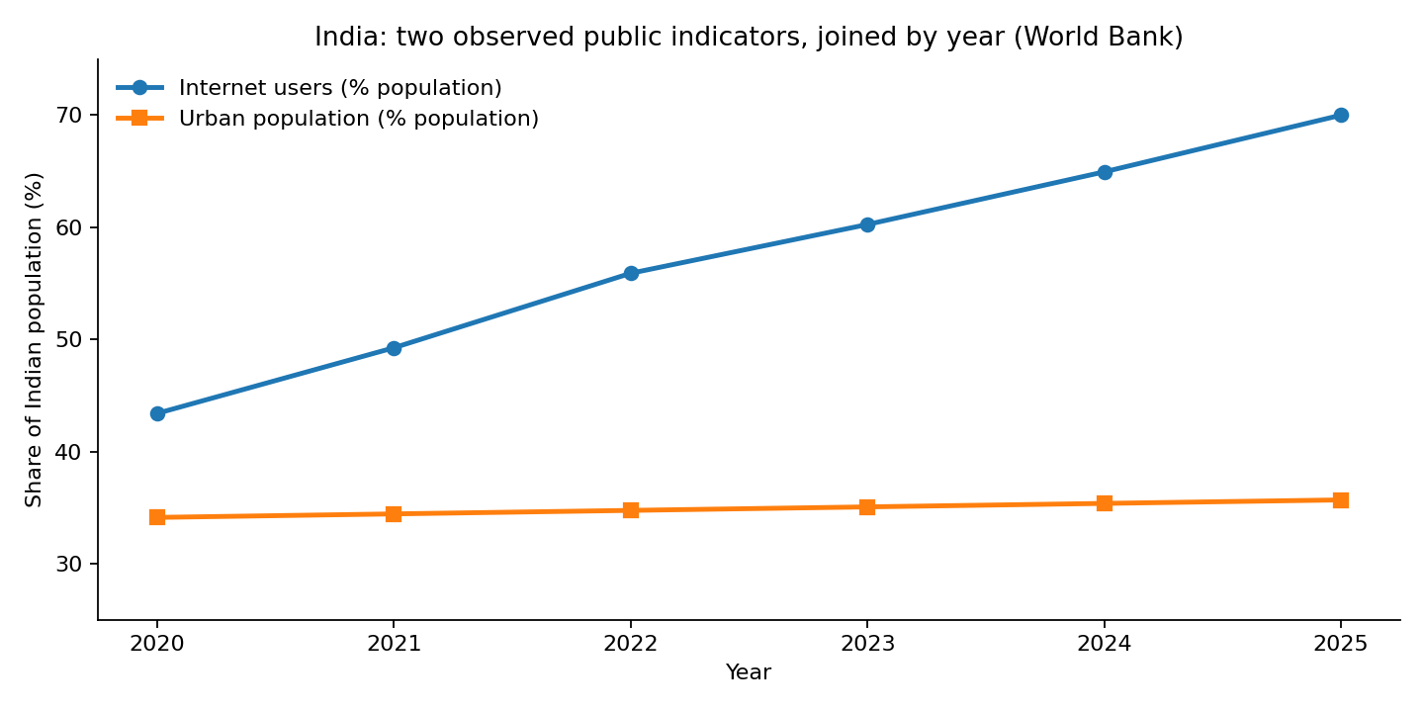
Figure B1. India public internet-use and urban-share indicators, 2020–2025. Source: World Bank; cleaned and joined by country and year.

B4. Explicit worked fashion-marketing scenario
A retailer may use the national internet-access trend as justification to TEST a mobile-friendly sales journey, not as a measured predictor of regional clothing demand. The following are illustrative planning assumptions invented for this case, not reported campaign outcomes: 20,000 ad impressions, 2.5% click-through rate, 4% post-click purchase conversion, ₹1,800 order value and ₹12,000 campaign spend.
KPI | Reproducible formula | Illustrative outcome
Website clicks | 20,000 × 2.5% | 500 clicks
Orders | 500 × 4% | 20 orders
Attributed gross revenue | 20 × ₹1,800 | ₹36,000
Gross-revenue ROAS | ₹36,000 ÷ ₹12,000 | 3.0×
Recommended pilot: compare mobile-optimised landing pages against a documented control within the same geography and measurement window. Record eligible exposure, consented sessions, paid orders, return-adjusted revenue, margin, acquisition cost and weekly confidence intervals. Do not infer incremental lift from a simple before/after comparison; use randomised allocation where feasible. Stop or revise if conversion or contribution margin underperforms the pre-registered benchmark.

B5. Limitations and reproducibility evidence
- Geographical mismatch: World Bank India-wide percentages do not identify Coimbatore shopper behaviour, fashion purchasing power or local Internet access.
- Ecological fallacy: two national percentages cannot be multiplied to estimate urban Internet users; the data contain no individual-level joint distribution.
- Time mismatch: annual 2020–2025 indicators are contextual and cannot improve a weekly 2026 SKU-demand forecast without further matching, backtesting and proper lag structure.
- Scenario validity: the marketing calculations are a planning illustration; no actual campaign, incrementality or return on advertising spend has been measured.
- Re-run instructions: pip install pandas matplotlib; python src/worldbank_market_integration.py; python -m unittest discover -s tests -v. Add --refresh to retrieve new API values if network access is available.
Files in the GitHub external case-study folder: data/external/worldbank_india_2020_2025.csv (source snapshot), src/worldbank_market_integration.py (source retrieval, quality checks, join, chart and scenario), outputs/joined_india_external_market_indicators.csv, outputs/external_case_findings.json, outputs/worldbank_india_2020_2025.png and tests/test_worldbank_integration.py (5 passing automated tests).

