**TASK ANALYSIS**

The primary user identified is the restaurant owner. Other could be the customer that would want to din in rather than delivery. The restaurant owner would be the stakeholder that would want to run his/her business even in the pandemic.

**LIST OF TASKS:**

**PRIMARY ACTOR (RESTURANT ADMIN):**

1. Registration / Login:
2. Registration for admin
3. Registration for restaurant.
4. Retrieve guest list
5. Edit profile
6. Admin profile
7. Restaurant profile.

**SECONDARY ACTOR (CUSTOMER):**

1. Scan QR Code.
2. Fill form for reservation.
3. Contact us.

**SCENARIO 1**

Due to **COVID** because anyone can be affected by coronavirus when not taking safety precautions. There is still smart lockdown in cities, restaurants are still open for dine in but for limited time. People start to rush into restaurants at different times and crowd throngs the restaurants which is then difficult for restaurants to manage them especially in COVID times. Customers need to wait for long hours for their turn and the time they are waiting for the restaurant timings are closed. So, Restaurant owner need a virtual platform where he manage all the government policies (cannot gather huge crowd, maintain social distancing between the tables) and maintain SOP’S in restaurant.

**Solution:** We need to create a platform where restaurants and customers are connected with one another to take care of the above issue.

**Steps for the User Perspective:**

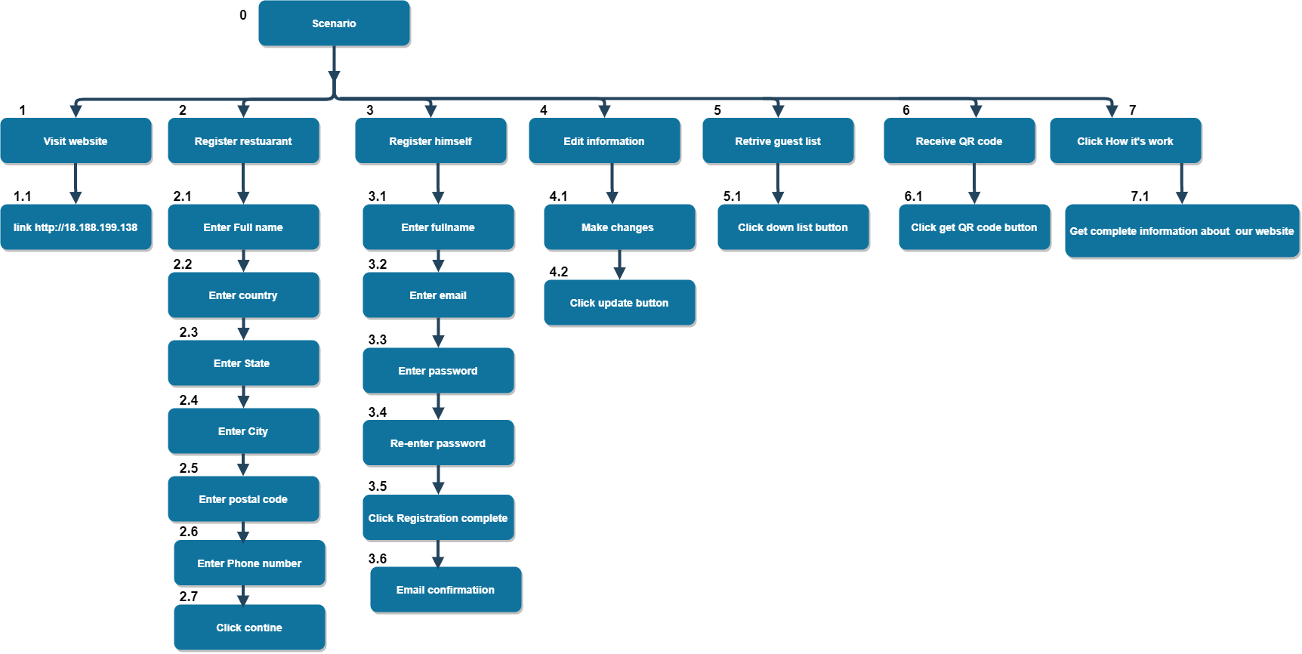

Hierarchical view of steps fig #1.

**Explanation:**

In the fig 1. Our primary stakeholders (Restaurant proprietor, administrator) need to enroll on our site first. At that point, he enrolls himself as the owner of the restaurant. After registration, he got a QR code that is unique, for this he can insert the QR code into a different platform like (Website, socializing app). If later he needs to change any information about the company he can change by simply click on edit information. He would now be able to see the list of guest who applies for the reservation and send an email to the guest for reservation is possible or not.

**SCENARIO 2**

**Due to Covid** the user cannot make reservations personally or reach out to the restaurant, a platform from which the restaurant and the customer interact with each other must be enforced. As covid can infect many people, therefor the customer would not want to dine in such a restaurant which does not ensure safety of others. The users must confirm and accept to follow the SOPs for themselves and encourage others as well. People start to rush into restaurants at different times and crowd through the restaurants which would be difficult to manage as social distancing is a must.

**Solution:** We need to create a platform where restaurants and customers are connected with one another to take care of the above issue.

**Steps for the User Perspective:**

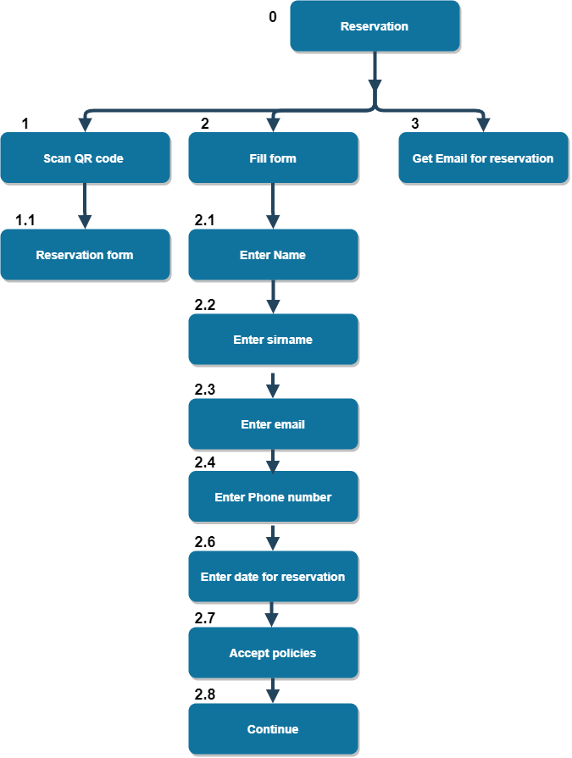Hierarchical view of steps fig #2

**Explanation:**

In the fig 1.Our secondary stakeholders (User), He need to scan QR code for reservation. And then the form will appear after fill up the form .He got email from restaurant for reservation