**USER ANALYSIS**

**Stakeholders:**

* **Primary stakeholder (Restaurant owner, Admin):** The Admin who manage all the guest and reservation of the restaurant.

**Goals:**

**.** Register Restaurant.

·         Register/login.

·         Retrieve Guest list.

·         Provide customers with space available.

·         Download brochure.

**Personas:**

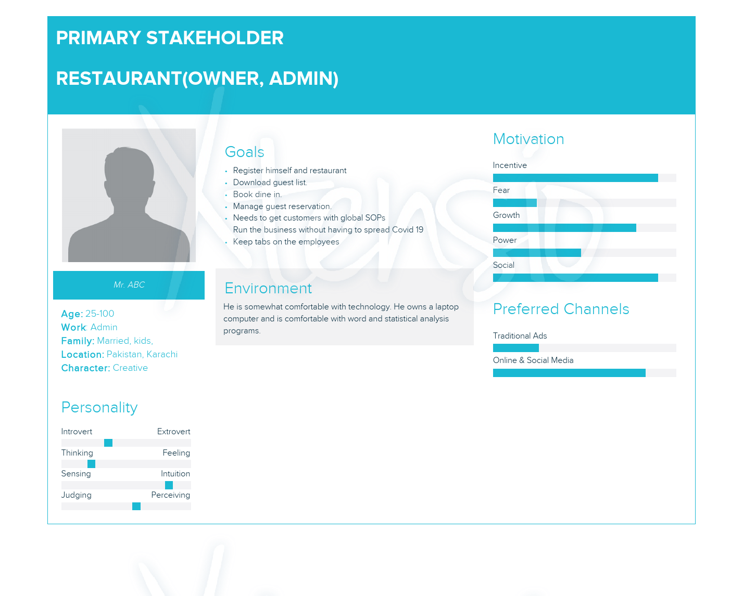

* **Secondary stakeholder (Guest):** The guest who fill form for the reservation of dine in

**Goals:**

**.** Fill provided form.

·         Scan QR code

·         Receive confirmation

**Persona:**

