# **Conceptual Design**

## Use cases identified

**Restaurant Owner:**

* **Register restaurant:** The restaurant owner would register the restaurant and they would be able to proceed to the next step.
* **Retrieve guests list**: the owner would be able to access the guest list generated by the system when the users would fill in their reservations.
* **Download brochure**: the brochure would have details of the restaurant with the links, QR code and the restaurant details. Restaurant owner can also hang this on their place
* **Receive QR code:** the QR would be generated by the system for the restaurant owner.

**Customer:**

* **Fills Form:** the customer will fill the form providing the details of the reservation such as name and other details.
* **Scan QR Code:** user can scan the QR code to receive the details of restaurant and also for confirmation.
* **Receive Emails:** the user will also receive the email for the confirmation of their reservation.

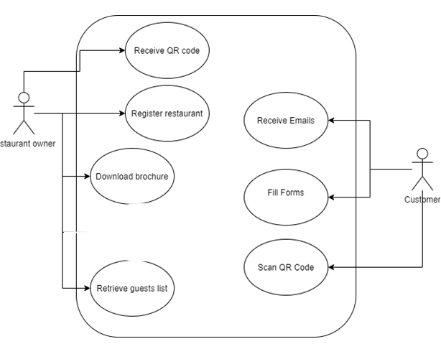

## Metaphors

**Login:**

Text boxes, input field, password field, forget password link.

**Register:**

Input fields, text fields, number fields

Dropdown is another alternative for selecting the country.

**Main page:**

The main page has buttons from which the user would be able to click and navigate to the different functionality.

The button would be to get the QR code to retrieve the guest list how the application works. The main page would also have the guest link from which the guests would fill the details for their reservation which would be used to generate guests list or QR code.

The alternative that could be used is to give a button for filling the form instead of link but link is better as the user that would want to fill the form could be anytime or anywhere so the form that would open should be independent.

**Guest form:**

The input fields for name, full name, email and phone would be provided to the user from which he/she would fill out the form. Another would be a confirmation radio button for which the user would click or select to confirm he/she doesn’t show any symptoms or COVID or he is not currently infected.

**Scan QR code:**

The QR code generated would be downloaded as a pdf file so that the user would have the details and can scan the QR code. The options for this would be to click on a button or a link to get the QR code or the user can scan the QR code from any QR scanner and show it to the restaurant for confirmation.

**Guest List:**

The guest list would be generated and received by the restaurant owner. This options for this would be the owner can have an excel sheet generated or the result of reservation would be showed on a grid view.

## Content diagram:

