# Heuristic Evaluation & Prototype Revision #1:

**Executive Summary:**

For this report, we conducted heuristic evaluations of **CORONA FORM** Heuristic evaluations allow us to analyze the usability and functionality of the site in a standardized way. We performed individual heuristic evaluations and then met together to discuss and combine our results. The system was evaluated and ranked according to user testing heuristics and severity rating scale of 0-3. After discussing our noted usability issues, we prioritized our findings by severity and developed the following series of findings and recommendation.

**Introduction:**

Due to COVID, restaurants are still open for dine in but for limited time. People start to rush into restaurants at different times and crowd throngs the restaurants which is then difficult for restaurants to manage them especially in COVID times. Customers need to wait for long hours for their turn .Thus, by utilizing technology we overcome the problem (crowd and sops maintenance).

**Focus of Evaluation:**

To first start off, we narrowed down what site UI screen. We wanted to evaluate. Looking at the site’s main functions, we focused on evaluating **CORONA FORM** ability to create better and customize screens. We also considered our client’s request by making UI.

**Methods:**

Heuristic evaluations allow us to better understand our client’s system, quickly identify minor and major usability issues, and alert the client to usability issues they may be unaware of. By conducting both individual and group heuristic evaluations, we can ensure that we provide a thorough evaluation of the site. After evaluating the site, we combined and discussed our results and developed a series of findings and recommendations.

## Evaluation Process:

Each group member and class fellow conducted an individual heuristic evaluation of CORONA. While performing the evaluations, each member took notes on the site’s usability successes and failures and ranked the severity of each noted usability finding (see Appendix). For our severity scale, we provide user evaluation material at http://13.59.214.225/

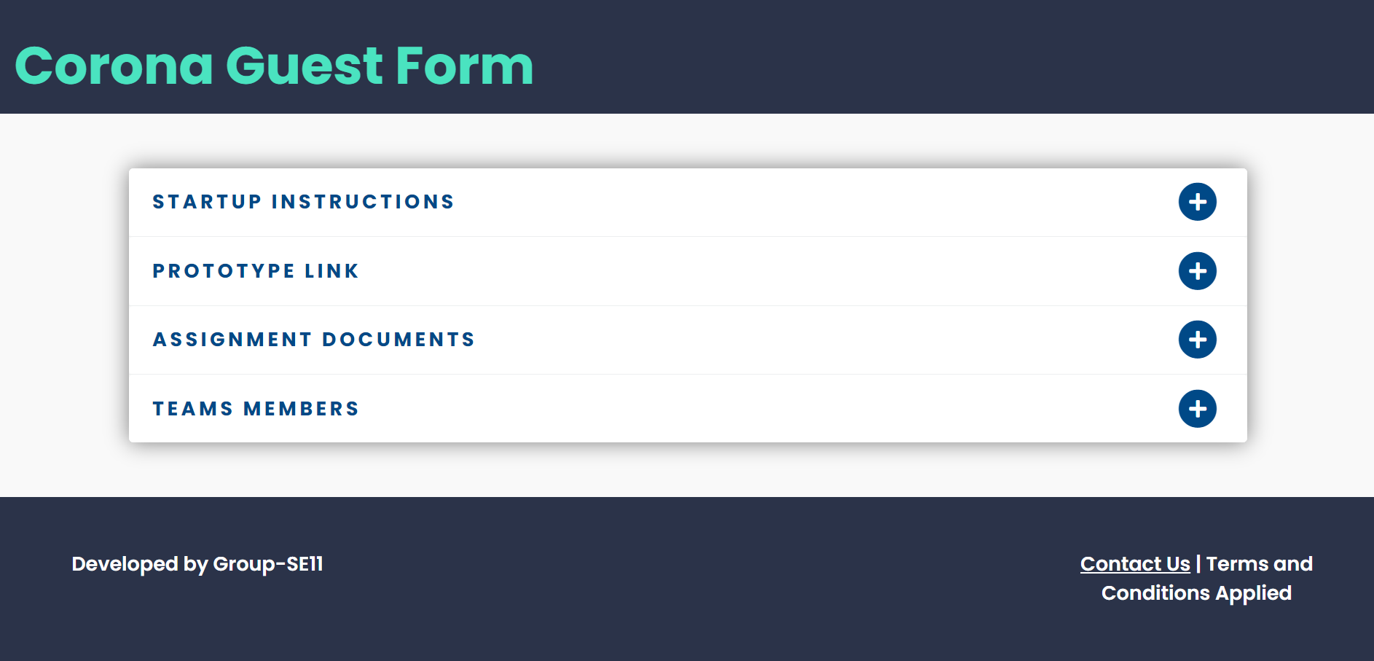

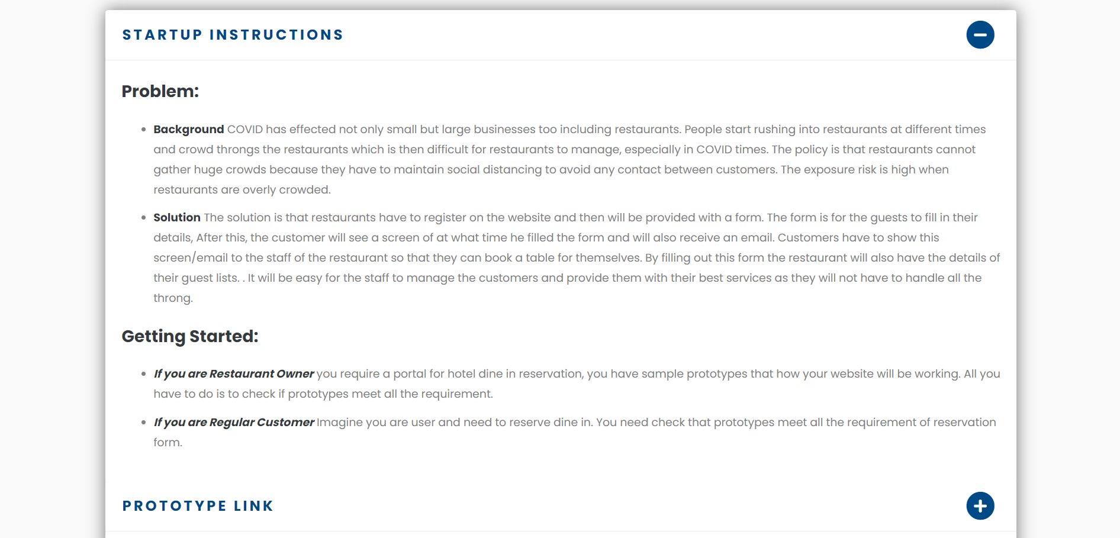

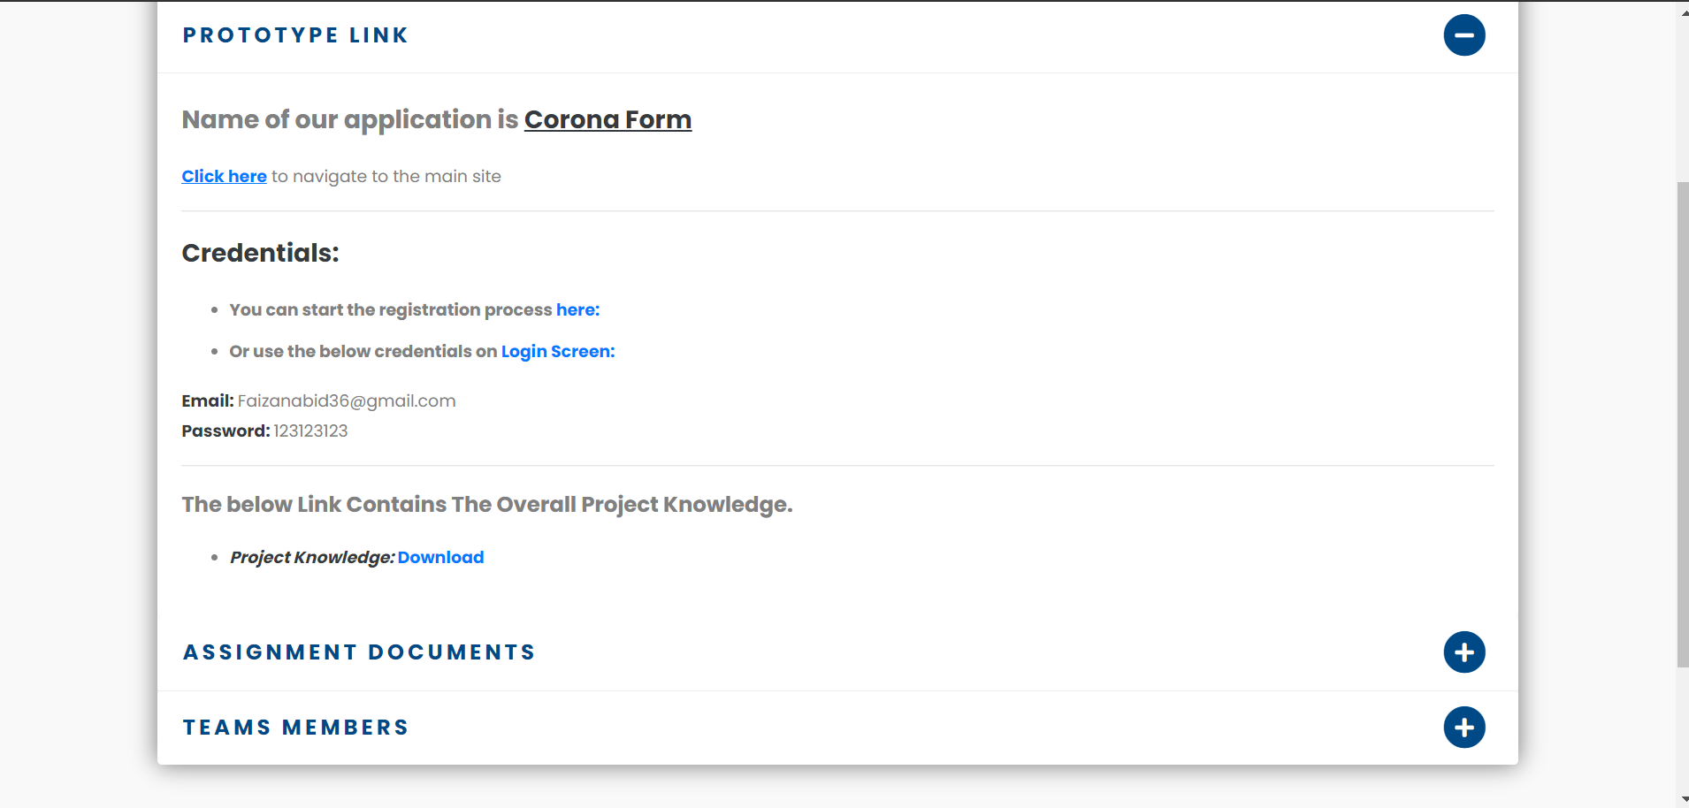

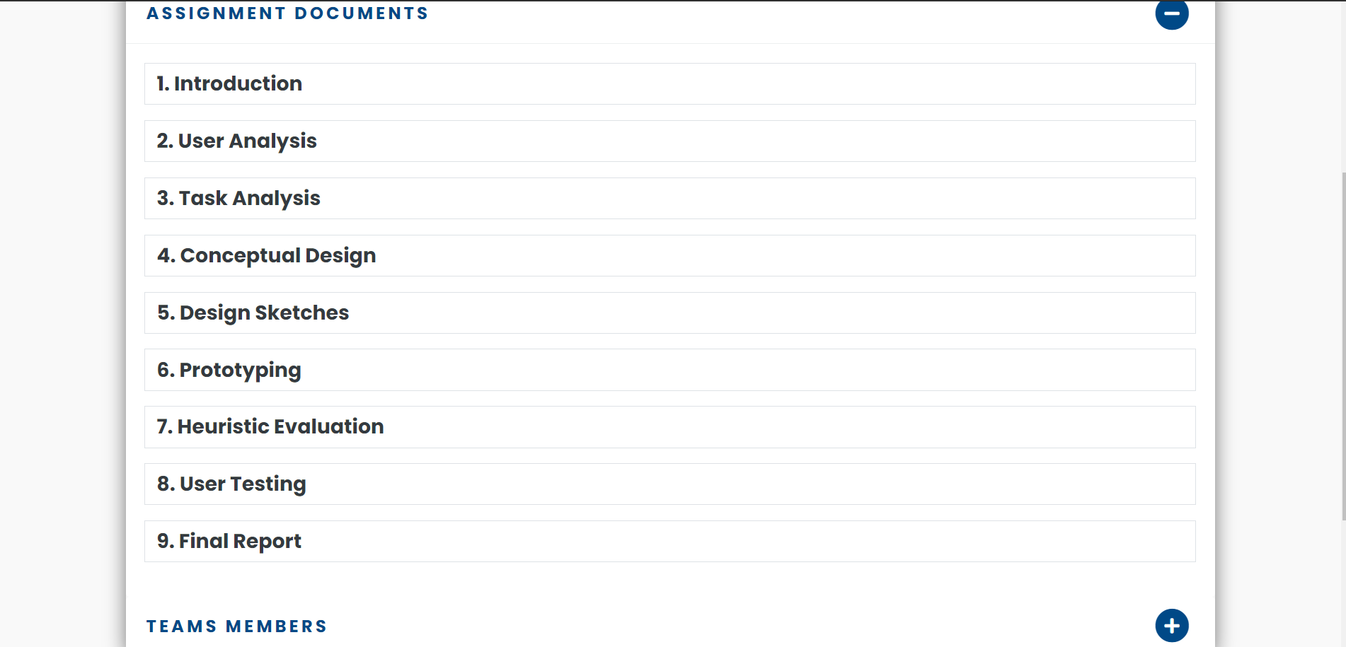

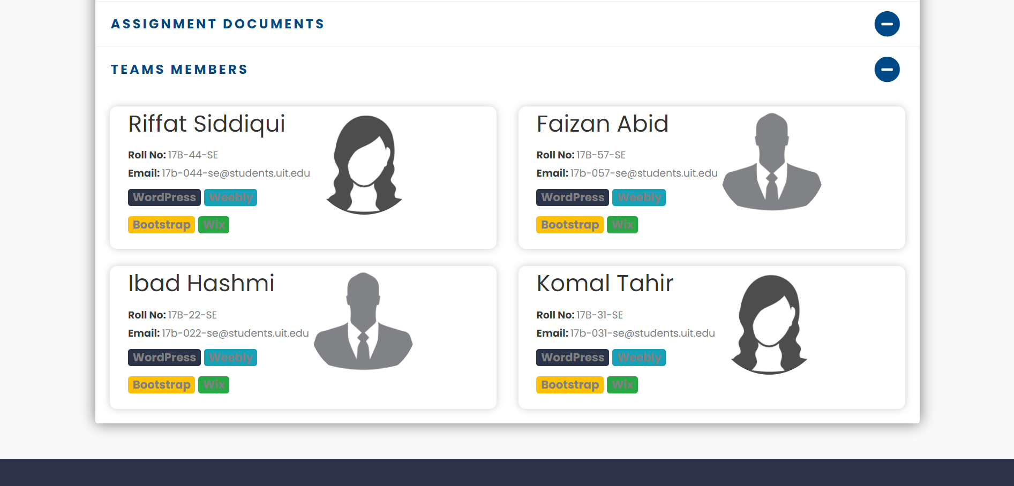

Then we create a Google form for evaluation.

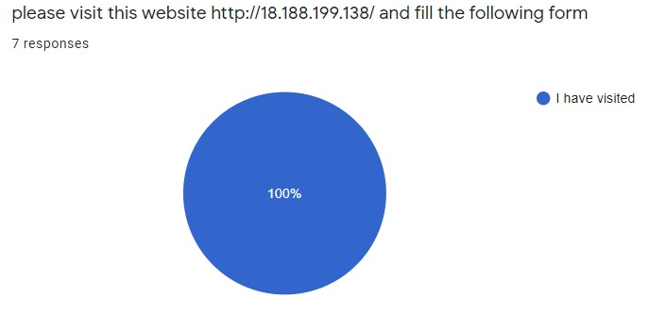

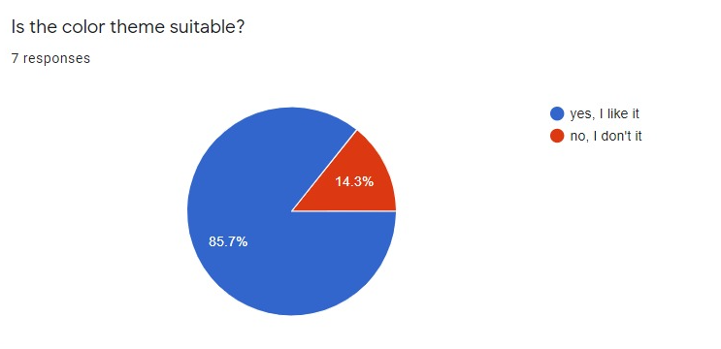

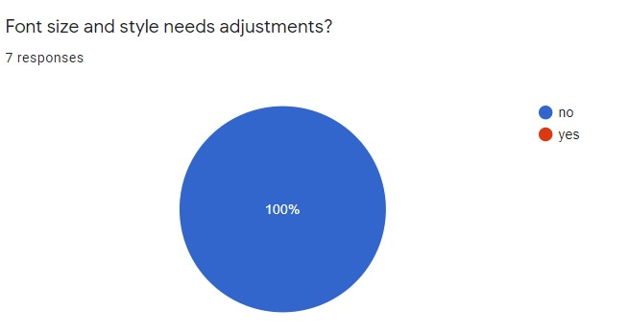

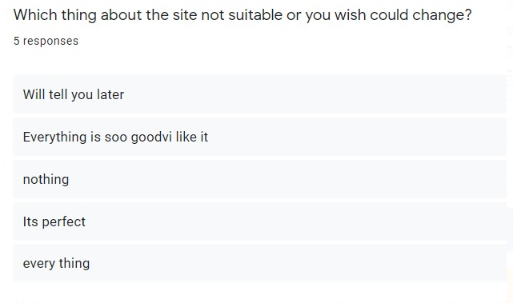

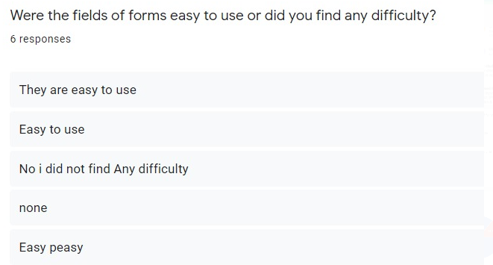

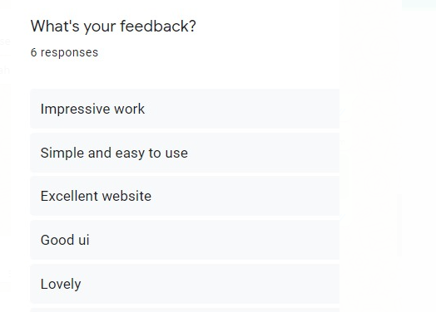

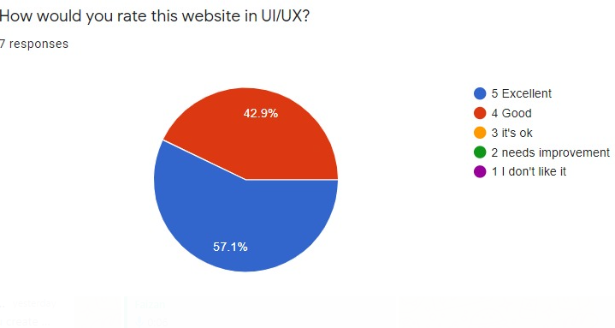After the Google form evaluation we provide check list for further detail about our UI/UX design. Then we figure out most common issue. They are facing with 4/5 user.

### **Website Name: Corona Form**

Website URL: s http://13.59.214.225/

|  |  |  |
| --- | --- | --- |
| **Heuristic** | **Rating**  **(1,2,3)** | **Comments** |

Appearance/Aesthetics – First impression is important – it can make the difference between users staying or leaving your site.

|  |  |  |  |
| --- | --- | --- | --- |
| Primary goal/purpose is clear |  | 3 | Easy to understand. |
| Clean, simple design |  | 3 | Simple and user-friendly UI. |
| Consistent design |  | 2 | Back button missing on registration/login screen. |
| Text and colors are consistent |  | 3 | Yes, they are consistent. |
| Icons are universally understood |  | 3 | Yes, icons are easily understandable. |
| Images are meaningful and serve a purpose |  | 3 | Yes, images are meaningful and serve a purpose. |

Content – Users are at your site for the content – make it easy for them to find and use your site.

|  |  |  |  |
| --- | --- | --- | --- |
| Major headings are easy to understand | 2 |  | Ambiguous heading on registration/login screen. |
| Easy to scan | 3 |  | Yes, scanning QR code. |
| Minimal text/information presented |  |  | Yes, long and descriptive texts are prevented |
| Clear terminology, no jargon | 2 |  | Yes, terminologies are clear. |
| Links are clear and follow conventions | 2 |  | Back button missing on registration/login screen. |
| Help is available on every page | 2 |  | Help documentation is missing. |
| Important content is above the fold | 2 |  | At some point It was missing. |

Navigation – Makes getting around your site easy and takes out the guess work of a user’s visit.

|  |  |  |  |
| --- | --- | --- | --- |
| Consistent Navigation | 3 |  | Back button missing on registration/login screen. |
| Consistent way to return Home | 3 |  | Yes, consistent way to return home page. |
| Limited number of buttons & links | 3 |  | Yes, there are limited button and links. |

Efficiency/Functionality – Following basic rules will keep user frustration to a minimum.

|  |  |  |  |
| --- | --- | --- | --- |
| Website loads quickly | 3 |  | Yes, perfect navigation. |
| Custom 404 errors | 3 |  | Yes, 404 error available. |
| Error messages are meaningful | 3 |  | Yes, validations are perfect. |
| Login is in upper right corner of page | 3 |  | Yes, login button is upper right corner of page. |
| Login is easy to find | 2 |  | We cannot find login button on registration screen. |
| No broken Links | 3 |  | Yes, no broken buttons. |
| User knows if they are logged in/out | 3 |  | Yes, Name of login person is available. |

### Findings and Recommendations:

**Finding 1:**

There is a lack of a customization tutorial for first-time users

**Recommendation:**

We recommend implementing a tutorial to help first-time users understand the customization process and reduce task complexity and confusion.

**Severity:** 2

**Finding 2:**

Use of inconsistent links.

**Recommendation:**

We recommend to use proper back button on every page.

**Severity**: 3

**Finding 3:**

Login button is missing.

**Recommendation:**

We recommend to use login button on registration page. User have to go home page first then go to login button.

**Severity**: 3

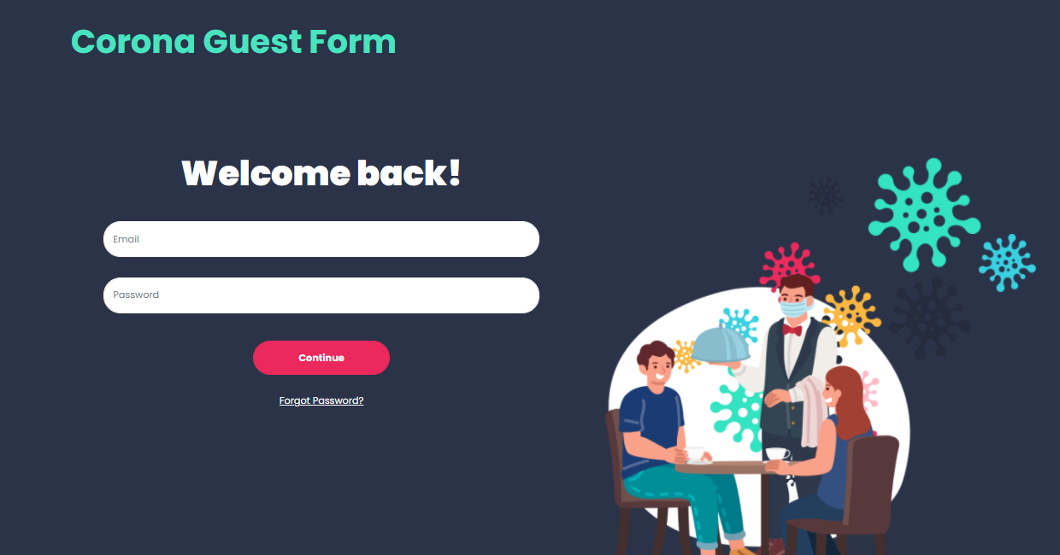

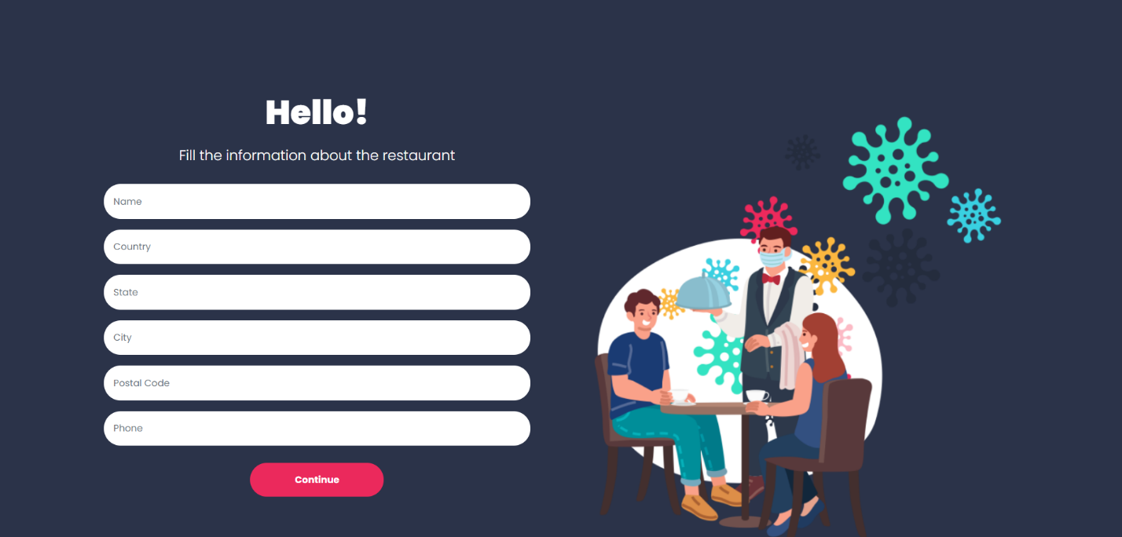

**Conclusion**:

By conducting heuristic evaluations, we were able to analyze the site’s usability, functionality, and design in a standardized structure. Overall, we did not find any major or critical issues of the site but did identify a few areas where links and navigation and basic help could improve in to maximize their user experience and usability. These areas lie in the heuristics of help documentation, visibility of system status, and aesthetic design. We provided recommendations of implementing a tutorial for first-time users, improving the visibility of the site’s photo editing features, highlighting selected features to show users what they have selected, making help documentation easier to find, and improving the site’s design to minimize distraction.