# PROTOTYPING-

## PAPER BASED

**Restaurant (Owner, Admin) perspective:**

* **REGISTRATION / LOGIN:**

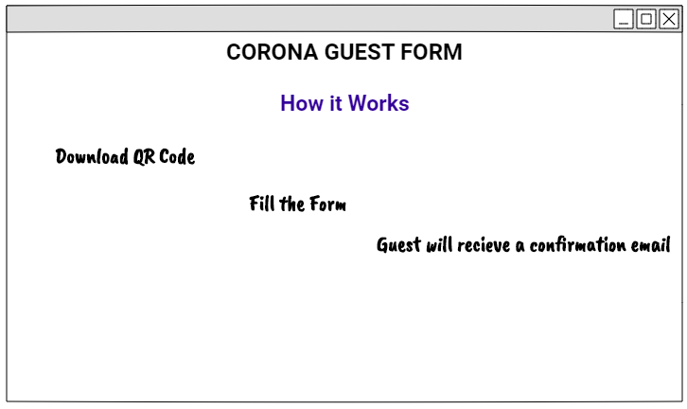

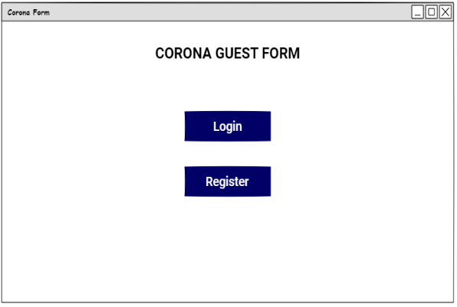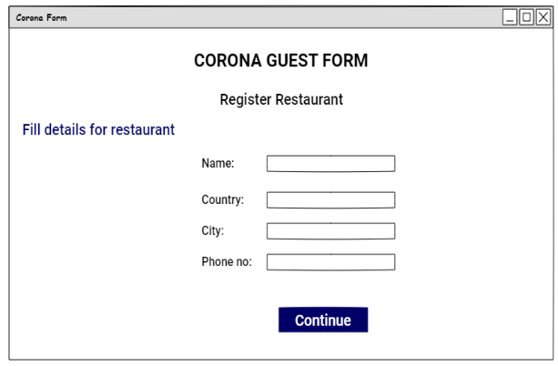

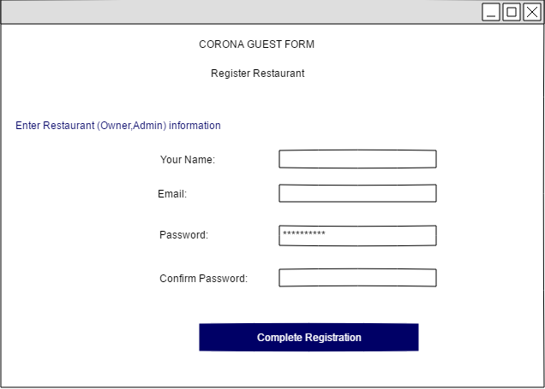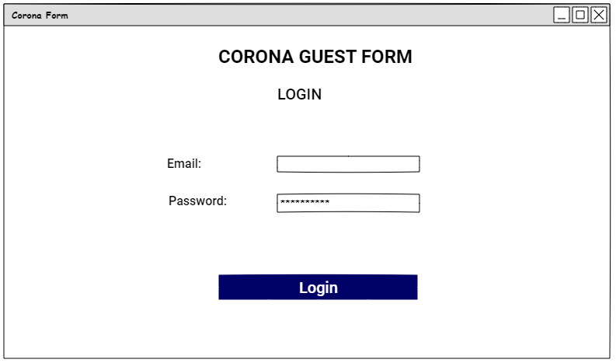

* **MAIN SCREEN AFTER REGISTRATION/LOGIN:**

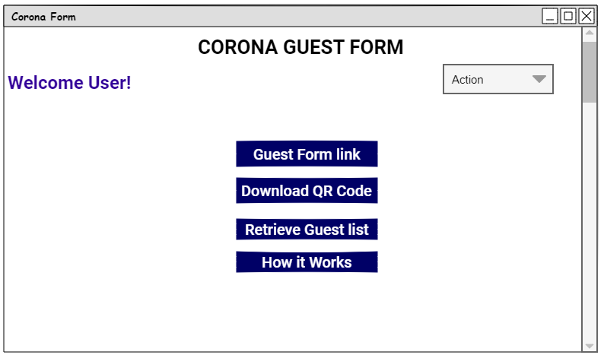

* **Edit detail for restaurant:**

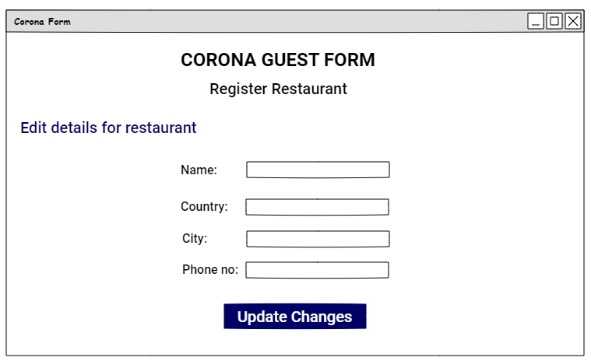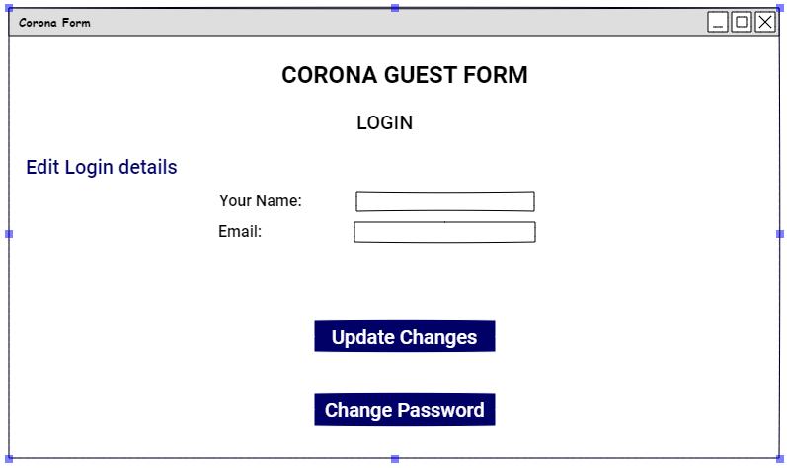

**Customer’s perspective:**

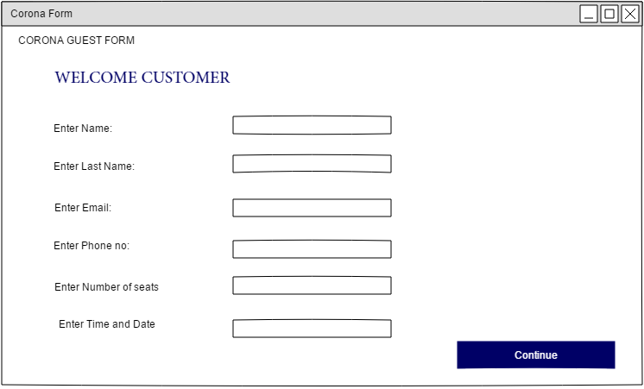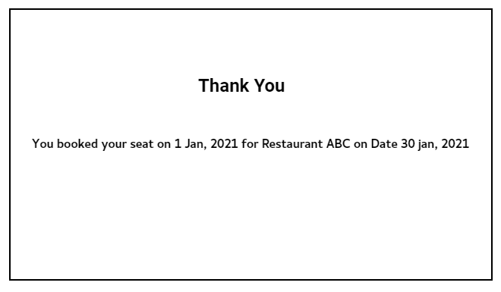

**EXECUTIVE SUMMARY:**

Due to COVID, restaurants are still open for dine in but for limited time. People start to rush into restaurants at different times and crowd throngs the restaurants which is then difficult for restaurants to manage them especially in COVID times. Customers need to wait for long hours for their turn .Thus, by utilizing technology we overcome the problem (crowd and sops maintenance).

**SCOPE:**

Scope of this project is to build a website for reservation tables for restaurant. User can allowed to take reservation quickly and easily. These reservation are under user’s control. The user can choose reservation as per their preference of location and time. The restaurant admin doesn’t need to maintain a guest book anymore. Admin can simply reply to the user by email. This method also makes it easy to change the status of reservation. Time management become simple.

**OUR STAKEHOLDERS:**

* + **Primary stakeholder (Restaurant owner, Admin):**

The Admin who manages all the guest and reservation of the restaurant.

* + **Secondary stakeholder (Guest):**

The guest who fills form for the reservation of dine in

**TOTAL USECASE:**

1.  **Restaurant owners:**

* Register Restaurant.
* Register/login.
* Retrieve Guest list.
* Provide customers with space available.
* Download brochure.
* Receive QR code.

2.  **Customers:**

* Fill provided form by restaurants.
* Scan QR code.
* Receive confirmation email.

**TASK:**

* Imagine you are restaurant owner and need a website for hotel dine in reservation so, you have a sample prototypes that how your website working. Now you have to check that prototypes meet all the requirement.
* Imagine you are user and need to reserve dine in. You need check that prototypes meet all the requirement of reservation form.

**GOAL:**

* Register your restaurant in our system.
* Fill the form of user reservation.

**PARTICIPANT PROFILES:**

Participant which are involve in prototype testing.

|  |  |  |  |  |  |
| --- | --- | --- | --- | --- | --- |
| **Users** | **Age** | **Gender** | **Education** | **Occupation** | **Place** |
| User 1 | 21 | Male | Undergraduate | Freelancer | Online meeting |
| User 2 | 24 | Female | Masters | Web developer | Online meeting |
| User 3 | 20 | Male | Undergraduate | Web developer | Online meeting |

**RESULTS:**

As the result of the paper-based prototypes, we clear lot of confusion that we are facing and get lot off feedback which may help to build the interface more clearly and efficiently.

**SUMMARY OF INSIGHTS:**

* **FEED BACK:**
* User like the general look of our website.
* User found attractive to fill the reservation form by QR code.
* This software easily to maintain SOPs in restaurant by just filling form by customer.
* **GENERAL SUGGESTIONS:**
* User want another way to contact other than the reservation process for some user felt that was too big of a first step.
* Guest list must be on excel sheet for easily maintenance.
* **USER EXPERIENCE SUGGESTIONS:**
* User suggested having a better explanation of the website in the banner of the homepage.
* Final after filling form must show no. of seats book with restaurant name, address on email that user receive.
* “How it’s work” section must contain all possible steps customer and restaurant admin.
* Customer form must contain, policies for COVID and user have to confirm that policies otherwise no further process.

# PROTOTYPING

## COMPUTER BASED

* **WEBSITE LOOK:**

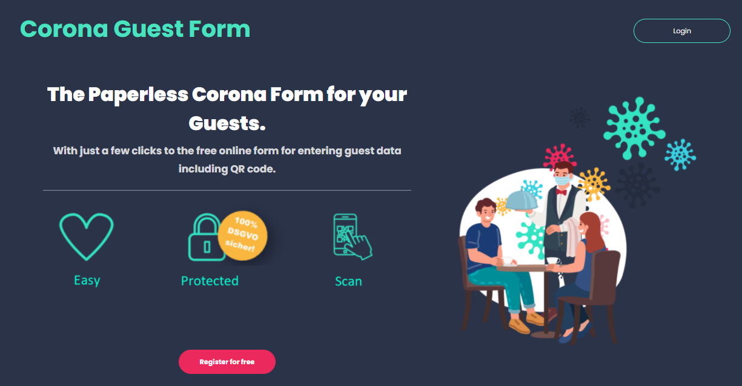

**Restaurant (Owner, Admin) perspective:**

* **REGISTRATION / LOGIN:**

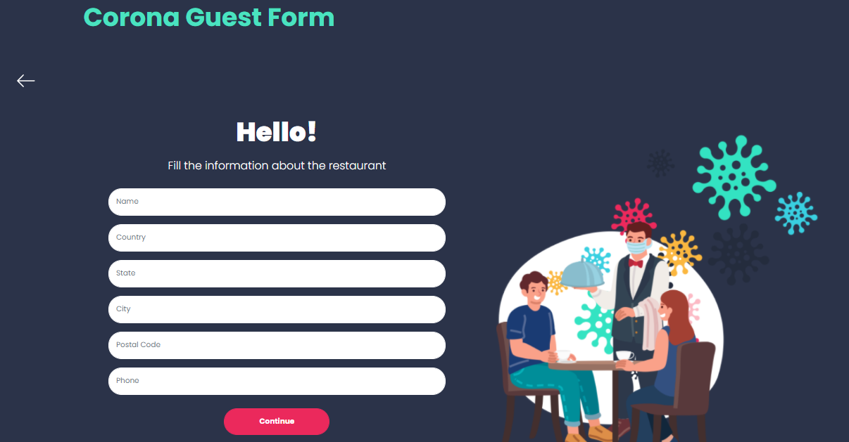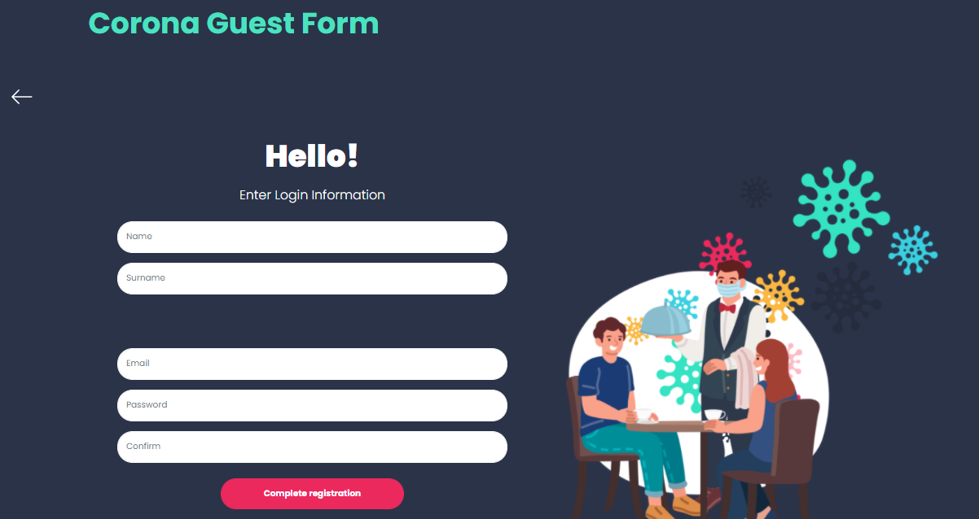

**MAIN SCREEN AFTER REGISTRATION/LOGIN:**

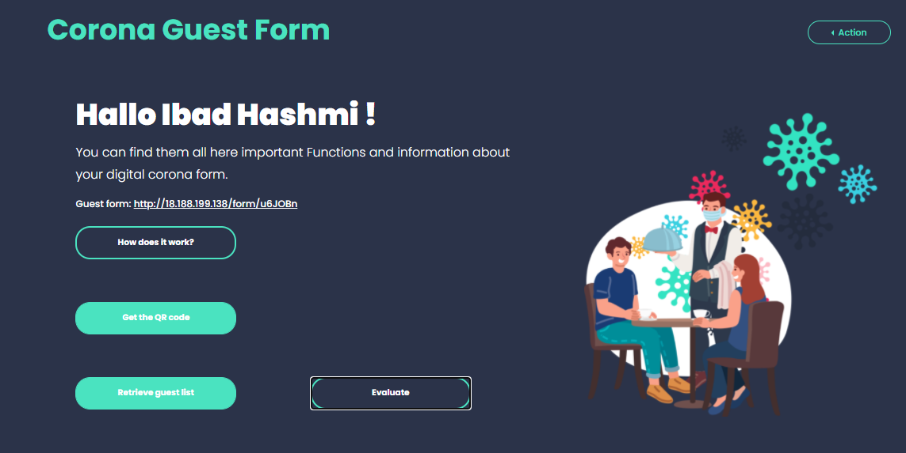

* **Edit detail for restaurant:**

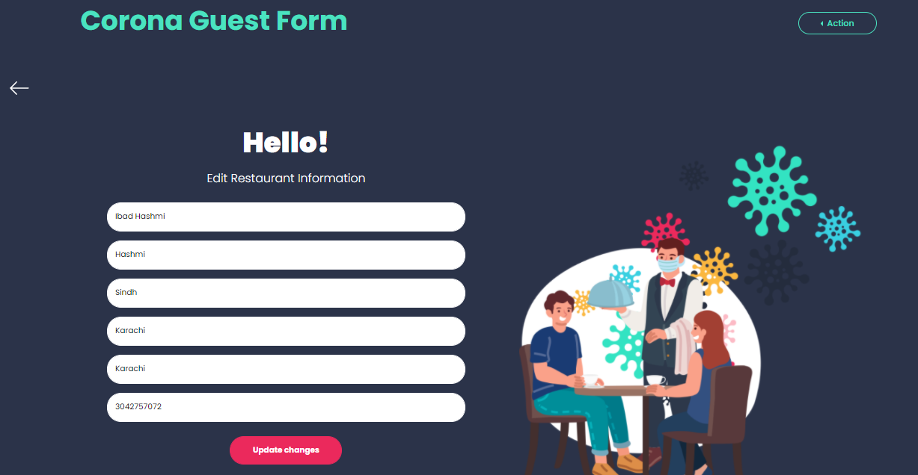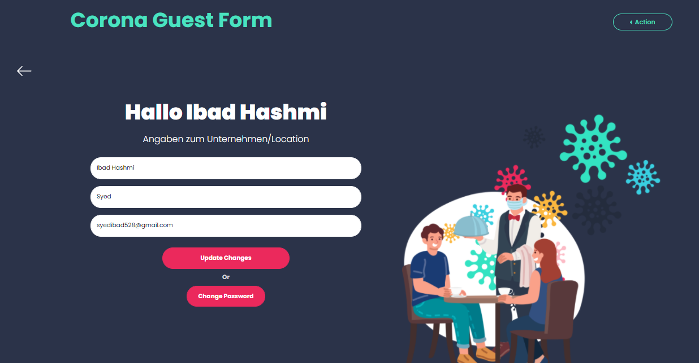

* **GUEST LIST:** 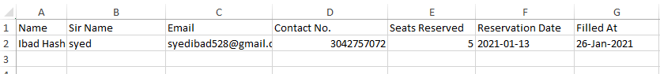
* **HOW IT’S WORK SECTION:**

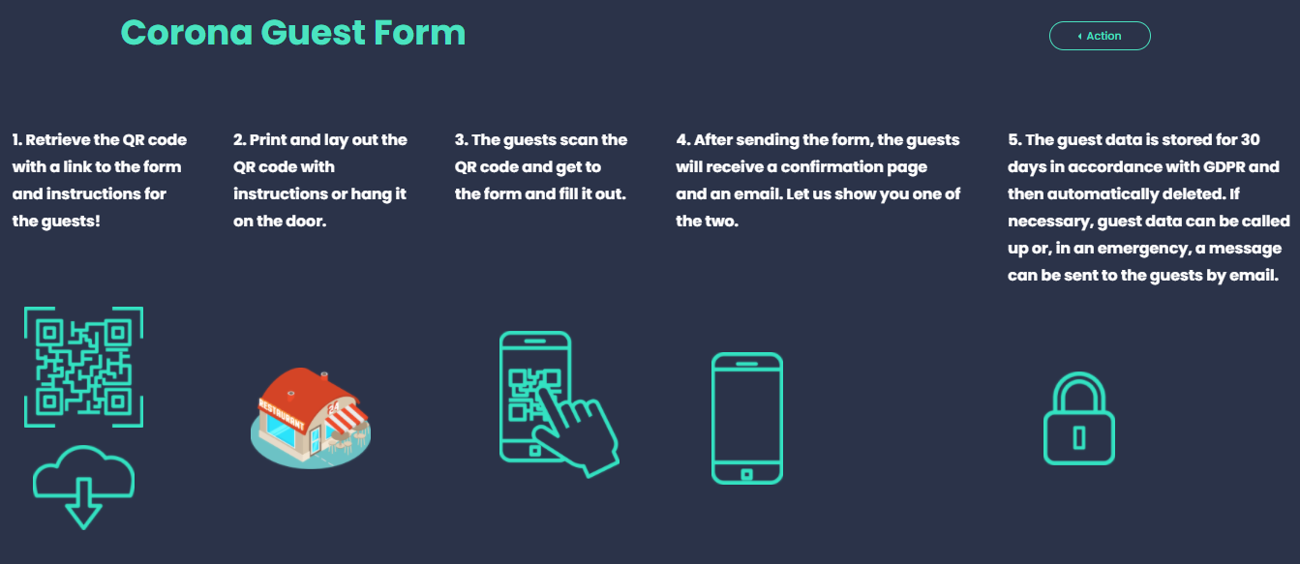

**Customer’s perspective:**

* **QR CODE FOR SPECIFIC RESTAURANT:**

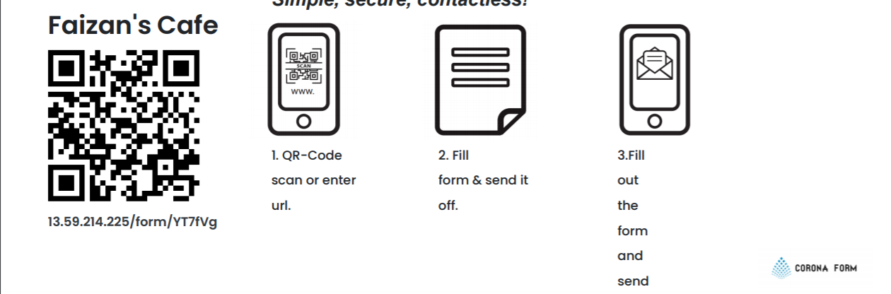

* **QR CODE FOR SPECIFIC RESTAURANT:**

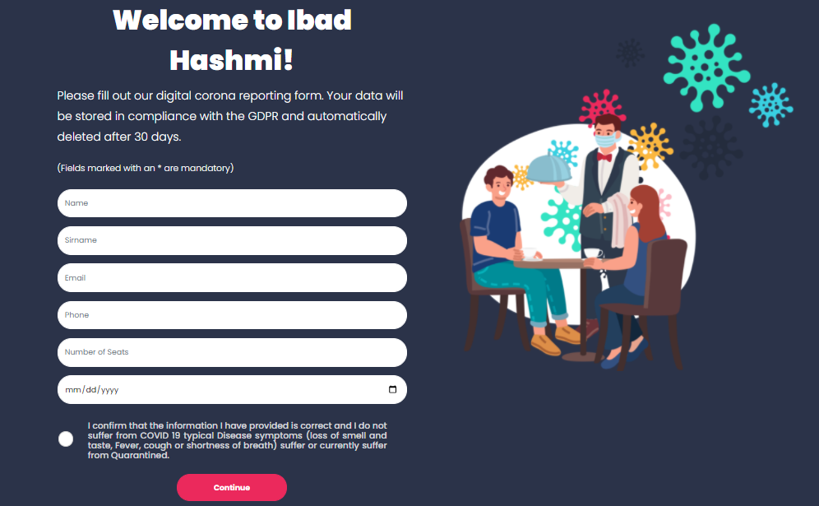

* **EMAIL RECEIVED AFTER FORM FILL BY USER:**

