# Task and User Analysis

## User Analysis

### **Stakeholders:**

* **Primary stakeholder (Restaurant owner, Admin):**

The Admin who manages all the guest and reservation of the restaurant.

**Goals:**

* + - Register Restaurant.
    - Register/login.
    - Retrieve Guest list.
    - Provide customers with space available.
    - Download brochure.

**Personas:**

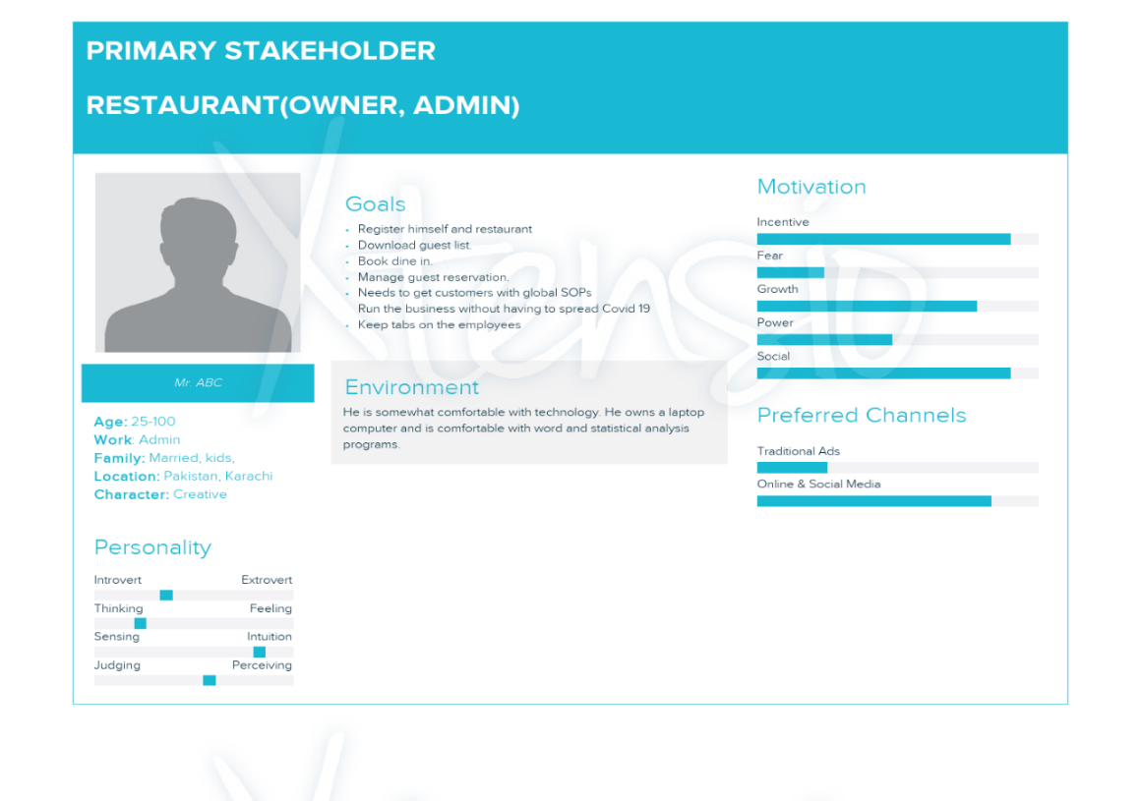

* **Secondary stakeholder (Guest):**

The guest who fills form for the reservation of dine in

**Goals:**

* + - Fill provided form.
    - Scan QR code
    - Receive confirmation

**Persona:**

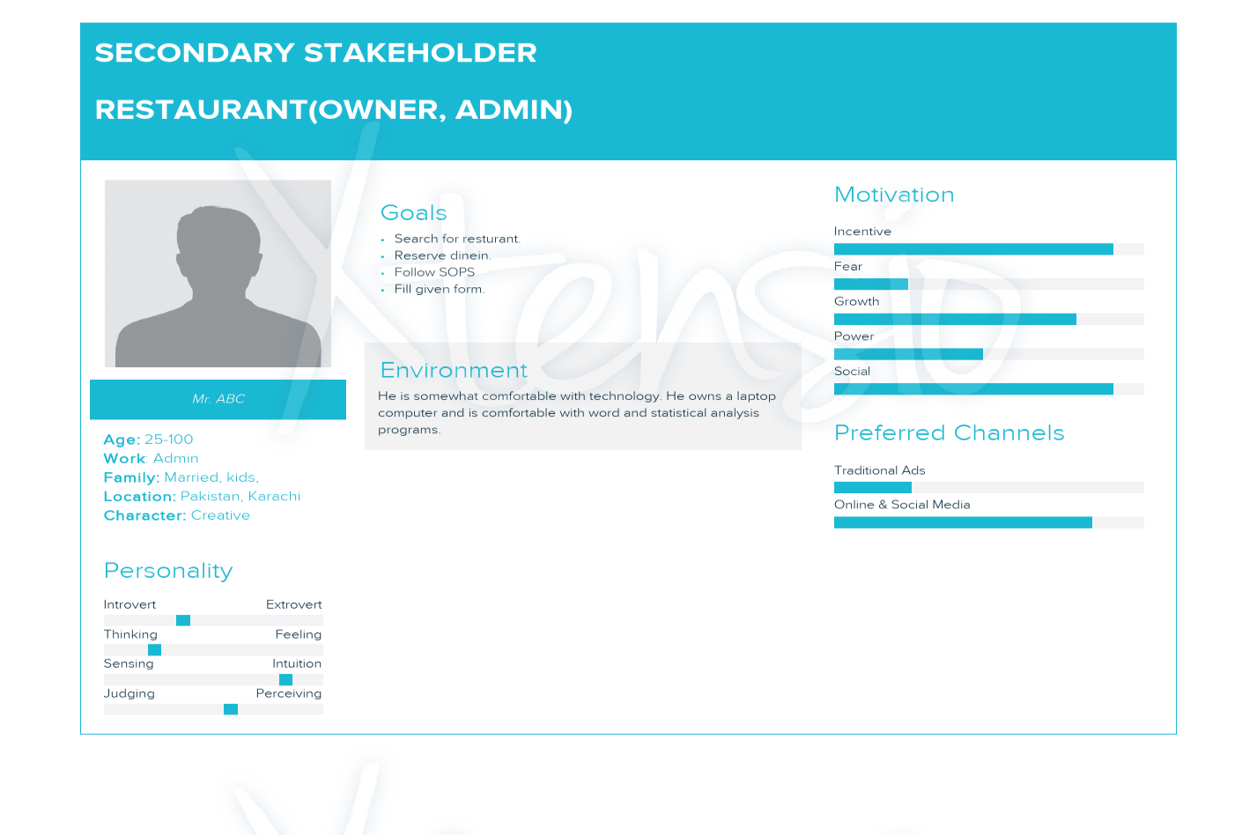

## TASK ANALYSIS

The primary user identified is the restaurant owner. Other could be the customer that would want to din in rather than delivery. The restaurant owner would be the stakeholder that would want to run his/her business even in the pandemic.

### LIST OF TASKS:

**PRIMARY ACTOR (RESTURANT ADMIN):**

1. Registration / Login:
2. Registration for admin
3. Registration for restaurant.
4. Retrieve guest list
5. Edit profile
6. Admin profile
7. Restaurant profile.

**SECONDARY ACTOR (CUSTOMER):**

1. Scan QR Code.
2. Fill form for reservation.
3. Contact us.

### **TASK SCENARIO-1**

Due to **COVID** because anyone can be affected by coronavirus when not taking safety precautions. There is still smart lockdown in cities, restaurants are still open for dine in but for limited time. People start to rush into restaurants at different times and crowd throngs the restaurants which is then difficult for restaurants to manage them especially in COVID times. Customers need to wait for long hours for their turn and the time they are waiting for the restaurant timings are closed. So, Restaurant owner need a virtual platform where he manage all the government policies (cannot gather huge crowd, maintain social distancing between the tables) and maintain SOP’S in restaurant.

**Solution:** We need to create a platform where restaurants and customers are connected with one another to take care of the above issue.

**Steps for the User Perspective:**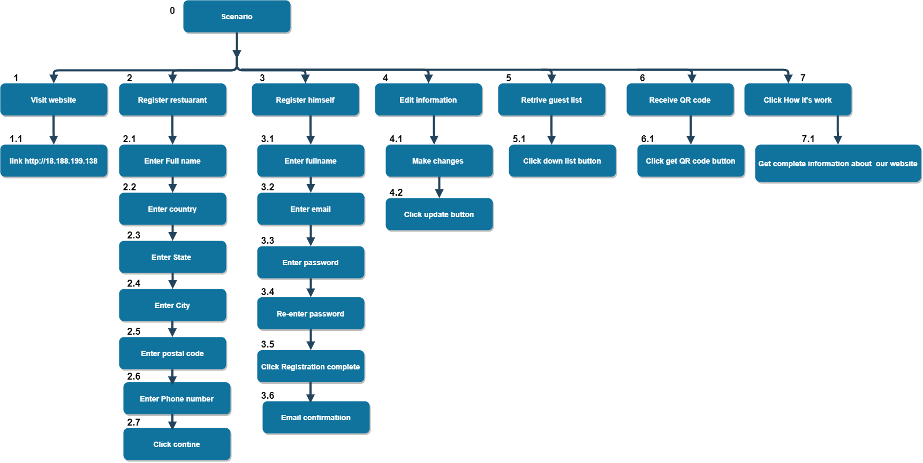

Hierarchical view of steps fig #1.

**Explanation:**

In the fig 1. Our primary stakeholders (Restaurant proprietor, administrator) need to enroll on our site first. At that point, he enrolls himself as the owner of the restaurant. After registration, he got a QR code that is unique, for this he can insert the QR code into a different platform like (Website, socializing app). If later he needs to change any information about the company he can change by simply click on edit information. He would now be able to see the list of guest who applies for the reservation and send an email to the guest for reservation is possible or not.

### **TASK SCENARIO-2**

Due to Covid the user cannot make reservations personally or reach out to the restaurant, a platform from which the restaurant and the customer interact with each other must be enforced. As covid can infect many people, therefor the customer would not want to dine in such a restaurant which does not ensure safety of others. The users must confirm and accept to follow the SOPs for themselves and encourage others as well. People start to rush into restaurants at different times and crowd through the restaurants which would be difficult to manage as social distancing is a must.

**Solution:** We need to create a platform where restaurants and customers are connected with one another to take care of the above issue.

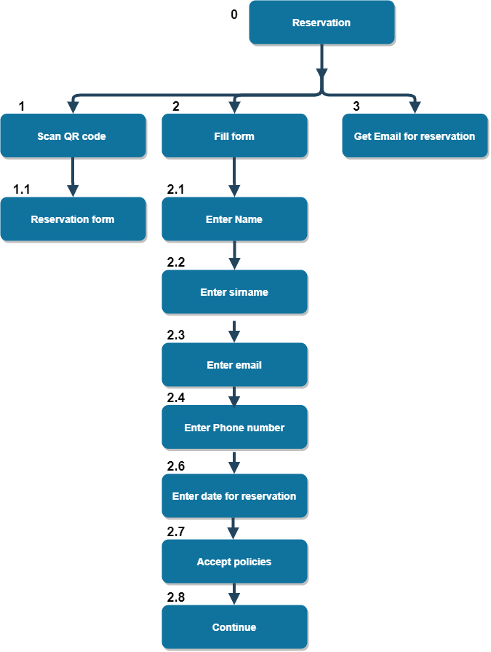**Steps for the User Perspective:**

Hierarchical view of steps fig #2

**Explanation:**

In the fig 1. Our secondary stakeholders (User), He need to scan QR code for reservation. And then the form will appear after fill up the form. He got email from restaurant for reservation.

## Usability Requirements:

Some usability requirements that apply in our application are:

* **Usability:**

The system is easy to understand and every design is well suited for its purpose. The processes of the application system is automated. The system is supportive and provides guide to the Restaurant owner on how the QR code works and where to download it

* **Performance:**

The system is robust and provide an interrupt and error free communication to user. The system response to the owner when he/she downloads the form.

* **Reliability:**

The application provides a reliable solution to customers so that they can reserve their table before entering the restaurant and they will not have to wait.

* **Security:**

The application is secure and the customer’s data will not be shared with any other except the owner of the restaurant where his data is saved for reservations. The data customer provides is confidential as their data will be stored in compliance with the GDPR and automatically deleted after 30 days.

* **Efficiency:**

The resources used for this is system to be made is efficient. We have achieved Optimum efficiency in our system. In downloading the QR code there will be no delay as well.

* **Storage:**

Customer’s data is stored in database for only 30 days and it will be deleted after then. There will be no risk of losing data as well because restaurant owner can download the guest list which is in excel sheet and it cannot be deleted by its own, so guest record will be saved every time owner download the list.

* **Reusable:**

The form owner download or can retrieve from the QR code can be reused by customers. Owner can also put that form in their restaurants door or put it on websites so it is easily accessible for them and portable too.

* **Environmental:**

The system is eco-friendly as no use of paper and in corona times it is specially not right to interact with people so online form is available for customers to book their reservations.

* **Manageability:**

It is easy for restaurants to manage the customers and not create crowd.

* **Supportability:**

This system is remotely accessible for customers as they can fill the form anywhere and any time