M. C. E Society's
Allana Institute of Management Sciences, Pune
Synopsis on
Cine Circuit
Online Movie Ticket Booking System
Mini Project
By
Faizan Khan
MCA – I
Roll No. --
Academic Year 2025-26
Guide Name
Mehdi Gafri
ABSTRACT
The Cine Circuit is a production-grade, full-stack web-based Online Movie Ticket Booking System designed to provide a seamless platform for users to browse movies, view showtimes, select seats, and book tickets online. The system serves four distinct user roles — Viewers (general users), Organizers (movie creators), Theatrers (theatre owners), and Administrators — each with dedicated dashboards and role-specific functionalities.
The platform eliminates physical box-office queues by enabling online seat selection and payment through an integrated Razorpay payment gateway. Secure authentication uses JWT in httpOnly cookies and bcrypt password hashing. Automated HTML email notifications are sent for OTP verification, booking confirmation, cancellations, password resets, organizer approvals, and maintenance alerts — 17 distinct email templates in total.
Cine Circuit is built with React.js 19 (Vite) and Tailwind CSS on the frontend, Node.js + Express.js on the backend, and MongoDB Atlas as the cloud database. Media is managed via Cloudinary, and the app is deployed on Vercel (frontend) and Render (backend). Advanced capabilities include an AI-powered movie recommendation engine, maintenance mode with user notifications, bug reporting with media attachments, SEO optimization with JSON-LD schemas, Progressive Web App (PWA) support, automated cron jobs for movie status updates, visitor tracking, Swagger API documentation, and a comprehensive analytics dashboard.
Introduction
Cine Circuit is a comprehensive full-stack web application that automates and digitizes the movie ticket booking process. Traditional systems require physical visits to a box office, which is time-consuming and inconvenient. Cine Circuit solves this by providing an intuitive platform where users can register, browse movies, select seats interactively, make payments, and receive tickets — all online.
The system supports four roles: Viewers browse and book tickets; Organizers create and manage shows, upload posters/trailers, manage cast and hashtags, and submit verification documents; Theatrers manage venue details, allotted shows, ticket distribution, and sales analytics; Administrators oversee the entire platform — verifying shows/organizers/theatres, managing genres and languages, viewing analytics, and controlling maintenance mode.
Objectives of the Project
The primary objective is to design and develop a full-stack, production-grade Online Movie Ticket Booking System that covers the entire lifecycle from movie creation and show scheduling to seat selection, payment, ticket delivery, and post-show reviews.
Specific Objectives:
- Provide a multi-role online platform (Viewer, Organizer, Theatrer, Admin) with JWT-based secure authentication.
- Enable OTP-based email verification, password reset, and rate-limited profile updates (30-day cooldowns).
- Integrate Razorpay payment gateway with atomic seat locking to prevent double-booking race conditions.
- Allow Organizers to create shows with posters, trailers, cast, hashtags, genre, language, and ticket categories.
- Allow Theatrers to manage allotted shows, distribute tickets, view sales analytics, and update show timings.
- Provide Admins with full platform control: verify shows/organizers/theatres, manage genres/languages, and view dashboards.
- Deliver 17 automated HTML email notifications covering all major platform events.
- Implement an AI-powered movie recommendation engine using genre and sub-genre preferences.
- Support SEO with react-helmet-async, JSON-LD schemas, dynamic sitemap.xml, and robots.txt.
- Provide PWA support visitor tracking swagger api docs automated cron jobs for movie status updated
10
Modules
Module 1: User Authentication & Account Management
Handles registration, OTP email verification, login, logout, password reset, and profile updates (picture, username, phone, password) with rate-limiting cooldowns for all four user roles.
Module 2: Movie & Show Management
Organizers create shows with full metadata — title, tagline, genre, sub-genre, language, release date, cast, director, producer, writers, budget, poster, trailer, and hashtags. Show status is auto-managed (Upcoming → Released → Expired) by cron jobs.
Module 3: Ticket Booking & Seat Selection
Viewers browse shows, pick a theatre and date, select ticket count per category (Standard/Premium/VIP/Family/Loyalty), and proceed to checkout with live availability checks.
Module 4: Payment & Order Processing
Razorpay order creation with a pre-payment DB check, atomic findOneAndUpdate on verification, QR-code ticket generation, email confirmation, and cancellation with seat release.
Module 5: Theatre Management
Theatrers register their venue, get admin approval, receive show allotments, distribute tickets to buyers, view per-show revenue, and update show timings — with email notifications to affected ticket holders.
Module 6: Organizer Verification & Profiles
Organizers submit comprehensive professional profiles (role, experience, projects, awards, social media) and role-specific forms (Director/Producer × Fresher/Experienced).
Admin reviews with approval/rejection and up to 3 attempts before lockout.
Module 7: Admin Dashboard & Control Panel
Admins manage users, verify organizers/theatres/shows, perform CRUD on genres, sub-genres and languages, delete comments, view analytics charts, toggle maintenance mode, and handle bug reports.
Module 8: AI Movie Recommendation Engine
A public genre-based recommendation system: user selects genre → sub-genres shown → user selects sub-genre → top-8 most-liked matching movies returned.
Module 9: Email Notification System
17 HTML email templates auto-sent for: OTP, booking confirmation, payment failure, ticket PDF, password reset, profile updates (name/phone/image/password), organizer approval/rejection, theatre approval/rejection, maintenance alert, bug report submission/resolution.
Module 10: Bug Reporting System
Logged-in users submit bug reports (title, description, up to 5 images + 2 videos). Auto-generates a unique BUG-XXXXXX ID. Admins filter by status, update with notes, and trigger resolution emails.
Module 11: Rating, Review & Engagement
Viewers post star ratings (1-5) and text reviews (purchase required), post/delete comments (max 500 chars), like/dislike movies, add to wishlist, and receive a review-prompt popup 3 hours after a show ends.
Module 12: SEO, PWA & Performance
React Helmet meta tags + JSON-LD Movie schema per movie page, dynamic sitemap.xml endpoint, robots.txt, PWA manifest + service worker, lazy-loaded routes, cookie consent banner, visitor tracking, and mobile-blocker for screens < 768px.
Scope and Functionality of Each Module
Authentication & Account Management
- OTP auto-expires in 2 minutes; resend cooldown enforced
- JWT stored in httpOnly cookie; bcrypt password hashing (10 salt rounds)
- Role-based access: Viewer / Organizer / Theatrer / Administrator
- Update cooldowns: profile image & username & password (30 days), phone (7 days)
- Last login timestamp array tracked per user
Movie & Show Management
- Show metadata: title, tagline, genre, sub-genre, language, cast, hashtags, budget
- Poster (max 100MB) and trailer upload to Cloudinary
- Cron job runs every 6 hours: Upcoming → Released → Expired auto-transition
- Admin verification gate before show goes live on platform
- Custom messages per show for announcements
Ticket Booking & Payment
- Ticket categories: Standard, Premium, VIP, Family, Loyalty
- Fresh DB re-check before Razorpay order creation (prevents overselling)
- Atomic findOneAndUpdate on payment verification (prevents race conditions)
- QR code embedded in ticket; PDF generated and emailed to user
- Cancellation workflow: seat released, refund initiated, email sent
Theatre & Organizer Management
- Theatre registration → Admin approval (Pending/Approved/Rejected workflow)
- Show allotment system: Organizer allots theatre → Theatre sees it in dashboard
- Organizer profile: up to 3 verification attempts; lockout after 3 failures
- Director/Producer × Fresher/Experienced sub-forms with word-limited fields
- Theatre sales analytics: revenue per show, payment status, unsold tickets
Admin Panel & Bug Reports
- CRUD operations on Genre, Sub-Genre, Language
- User lists: verified/unverified users, organizers, and theatres
- Analytics dashboard with booking and revenue charts
- Maintenance mode: custom message, end time, optional mass email to all users
- Bug reports: paginated list, status filter, media preview, admin notes
Technology Used
A System Requirement Specification (SRS) outlines the essential hardware and software requirements for the development, deployment, and operation of Cine Circuit.
Hardware Requirements
- Processor: Intel Core i3 / AMD Ryzen 3 or above
- RAM: Minimum 8 GB
- Storage: Minimum 100 GB (SSD preferred)
- Internet Connection: Required (cloud-based system)
Software Requirements
- Operating System: Windows 10/11 or Linux (Ubuntu)
- Runtime: Node.js v20.x
- Frontend: React.js v19 + Vite 6 + Tailwind CSS v4 + Redux Toolkit
- Backend: Node.js + Express.js v4
- Database: MongoDB (MongoDB Atlas cloud) via Mongoose v8
- Authentication: JSON Web Tokens (JWT) + bcrypt (httpOnly cookies)
- Payment: Razorpay SDK
- Media Storage: Cloudinary (images, videos, PDFs)
- Email: Nodemailer (SMTP)
- File Upload: express-fileupload (10MB images / 100MB video)
- Rate Limiting: express-rate-limit (5 auth attempts / 200 general per 15 min)
- Scheduled Jobs: node-cron (every 6 hours for movie status updates)
- Visitor Tracking: express-visitor-counter
- API Documentation: Swagger UI (swagger-jsdoc + swagger-ui-express)
- SEO: react-helmet-async + JSON-LD + dynamic sitemap.xml
- PWA: Web App Manifest + Service Worker
- Animations: GSAP + Swiper.js
- Forms: React Hook Form
- Deployment: Vercel (frontend) + Render (backend)
- Version Control: Git + GitHub
- Browser: Google Chrome / Mozilla Firefox
System Diagrams
Use Case Diagram
Cine Circuit — System Boundary
Viewer
Organizer
Theatrer
Admin
Register / Login
Browse Movies
Search Shows
Select & Book Seats
Make Payment (Razorpay)
View / Download Ticket
Like / Dislike Movie
Post Comments & Reviews
Add to Wishlist
AI Movie Recommendations
Submit Bug Report
Create Show
Upload Poster/Trailer
Manage Cast & Tags
Create Ticket Slots
Allot Theatre
Submit Org Verification
Distribute Tickets
View Total Sales
Update Show Timings
Verify Shows/Org/Theatres
Manage Genre/Language
Figure 1: Use Case Diagram — Cine Circuit (4 Actors)
Activity Diagram — Ticket Booking Flow
User Registers / Logs In
Browse Movies & Shows
Select Show, Date & Theatre
Choose Number of Tickets
Seats Available?
No
Show Error / Try Again
Yes
Proceed to Razorpay
Payment Success?
Yes
Generate Ticket + QR
Send Booking Email
No
Payment Failed Email
Show Ticket Page
Option: Cancel Ticket
Seat Released + Refund
Figure 2: Activity Diagram — Full Ticket Booking & Cancellation Process
Sequence Diagram — Booking Interaction
er
Us
Bro
wser
Backend
MongoDB
Razorpay
Select show + seats
POST /Make-Payment
Check seat availability
Seats OK (return data)
Create Razorpay Order
Order ID returned
Return order details
Open payment modal
Payment token (success)
POST /Verify-Payment
Atomic seat lock + save
Booking saved OK
Email: Booking Confirmation
Ticket data + 200 OK
Render Ticket + QR Code
Figure 3: Sequence Diagram — User
→
Browser
→
Backend
→
MongoDB
→
Razorpay
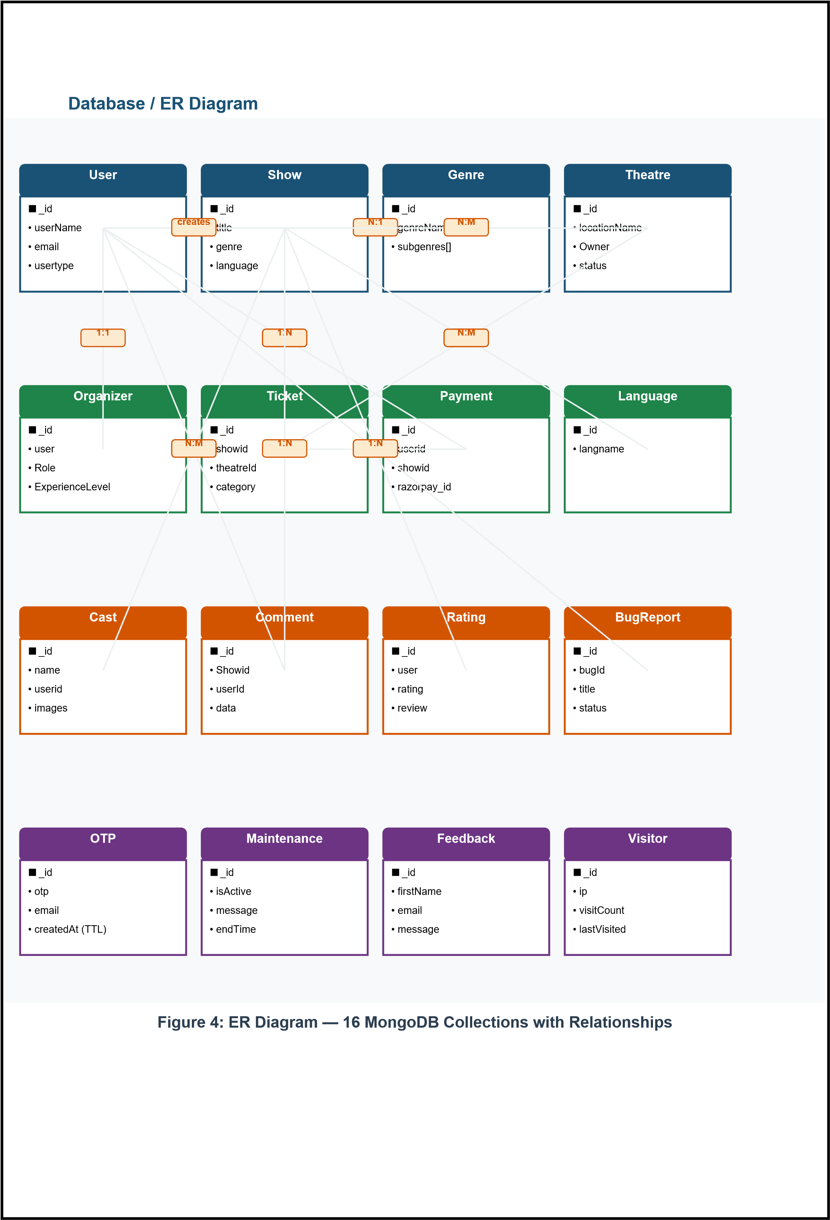
Limitations of the Proposed System
- No native mobile app (web-based only; PWA partial offline support included).
- Seat selection is count-based, not individual interactive seat map.
- AI recommendation uses genre-based filtering only, not collaborative filtering.
- Seat availability uses DB-level atomic operations, not WebSocket real-time sync.
- Refund initiation is manual; automatic bank refund not implemented.
- JWT stored in localStorage on client side (XSS risk — BUG-2 noted for future fix).
- UI is English-only; no multi-language interface support.
- Chat module is a placeholder; real-time messaging not yet implemented.
Conclusion
Cine Circuit successfully demonstrates the design and development of a full-stack, production-grade Online Movie Ticket Booking System. By integrating modern technologies — React.js, Node.js, MongoDB Atlas, Razorpay, and Cloudinary — the project delivers a real-world applicable solution covering the complete lifecycle from movie creation to ticket delivery.
The platform supports four user roles, 79 REST API endpoints, 26 database models, 17 automated email templates, and 12 major feature modules. Advanced features like AI movie recommendations, automated cron jobs, maintenance mode, SEO with JSON-LD schemas, PWA support, visitor tracking, and a Swagger-documented API make Cine Circuit a comprehensive, scalable, and production-ready system.
This project provided valuable hands-on experience in full-stack web development, RESTful API design, database modeling with MongoDB, cloud deployment, secure authentication, payment gateway integration, and software engineering best practices — reflecting practical implementation of academic concepts and readiness for industry-level development.
Student Name : Faizan Khan
Student Mobile Number : 9011575978
E-mail Id : FaizanKhan901152@gmail.com
Permanent Address : lane no 32 near alfall masjid bhagyoday nagar pune

