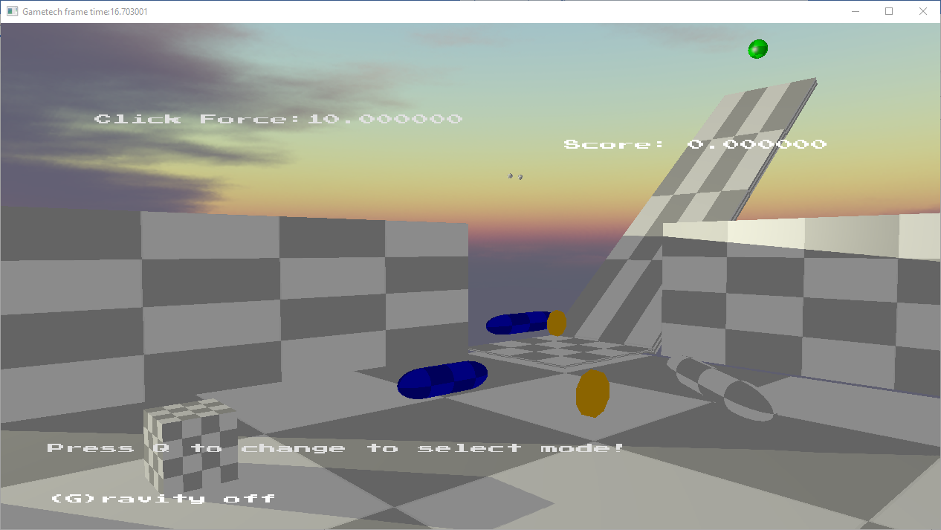

Blue Capsules are triggerable on clicking.

To push swing capsule left click, set force and then apply force with right click.

To Spin blue other capsule click on it.

Two Stateful cube objects acting as barrier.

Collectable coins.

Ball Interacts with everything.

AABB AABB – bouncing floor at the end of the ramp (high coeff of restitution)

Sphere Capsule (also contains sphere sphere)

Sphere OBB Ramp, Sphere AABB base floor

Ball rolls due to friction.

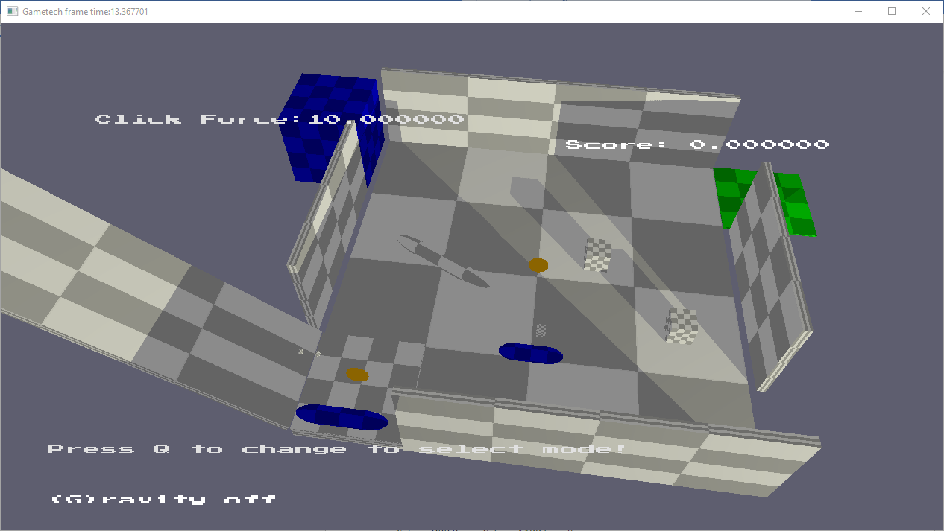

Go to the green side exit to win, fall out fron any other side or bounce off high and you loose.

Press I to spawn cube for AABB Capsule interaction testing.

Click on blue spring box to activate it.

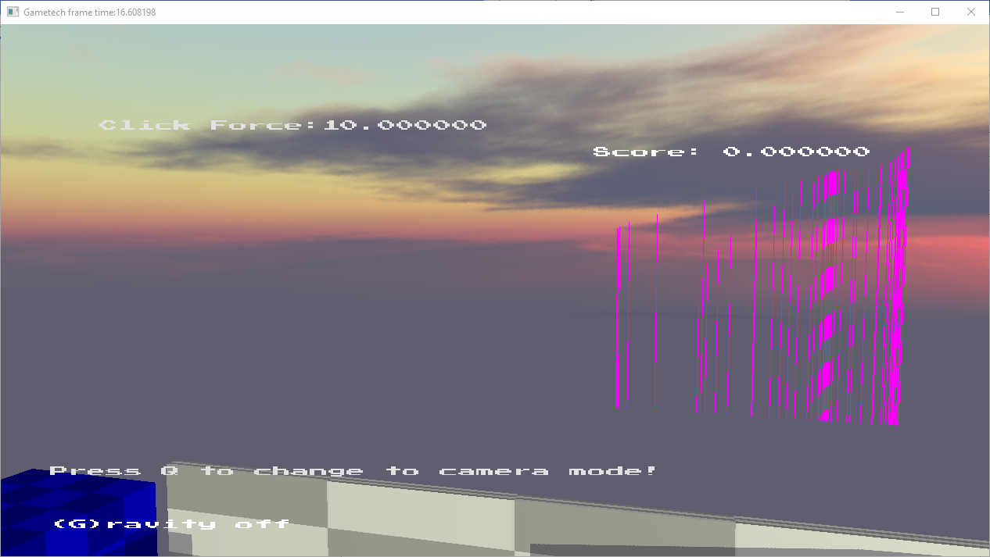

Press p to activate plane play mode and p to turn it off

Ray vs plan interaction

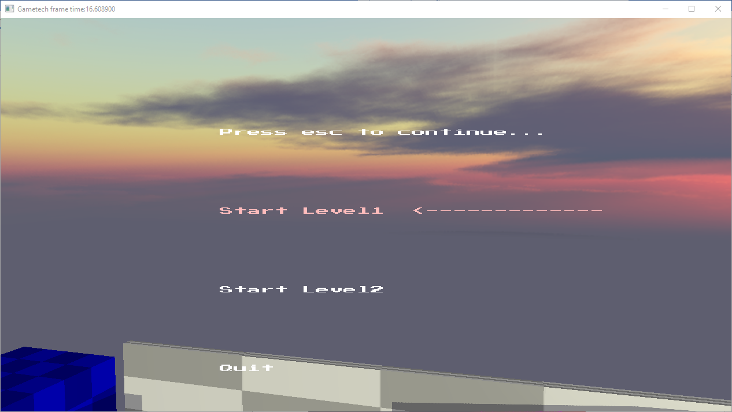

Pushdown automata menu.

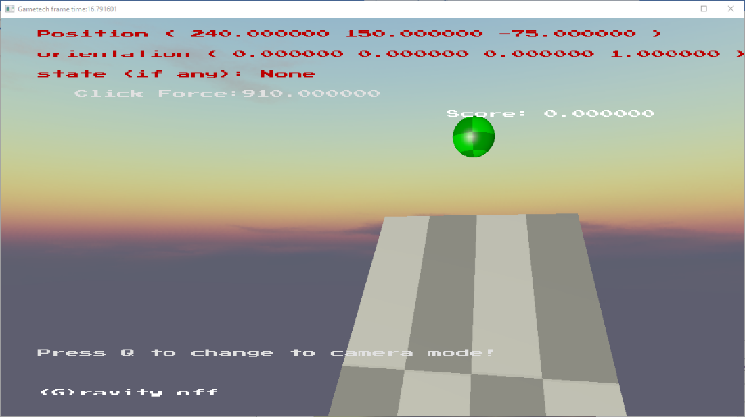

Left click for debug info on objects

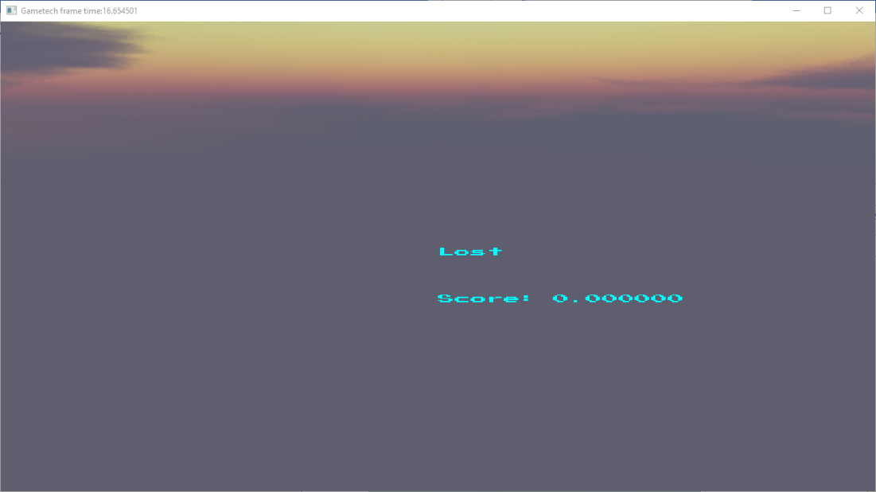

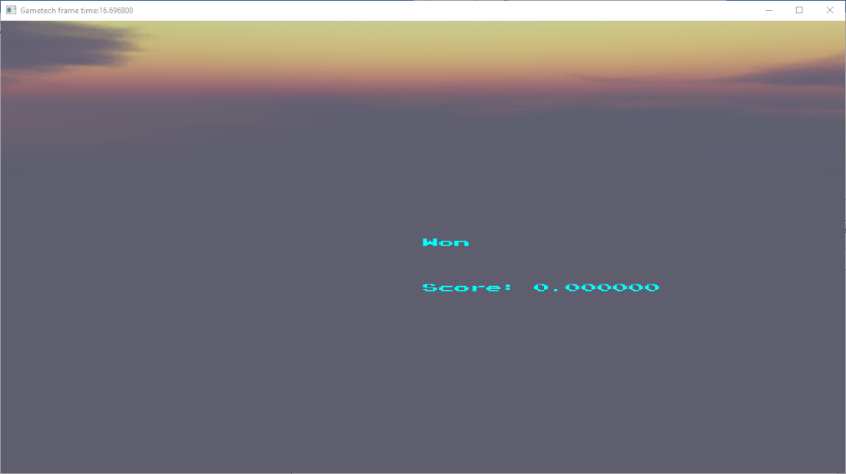

Grid-based pathfinding (AI)