NAME:FAIZAN Ali

CMS: 462013

ASSIGNMENT 01

SEC -A

1. **Write a C++ program to display factors of a number using for loops.**

#include<iostream>

using namespace std;

int main(){

int x;

cout<<"enter a number\n";

cin>>x;

for(int count=1;count<=x;count++){

if(x%count==0){

cout<<count<<"is a factor OF "<<x<<endl;

}

}

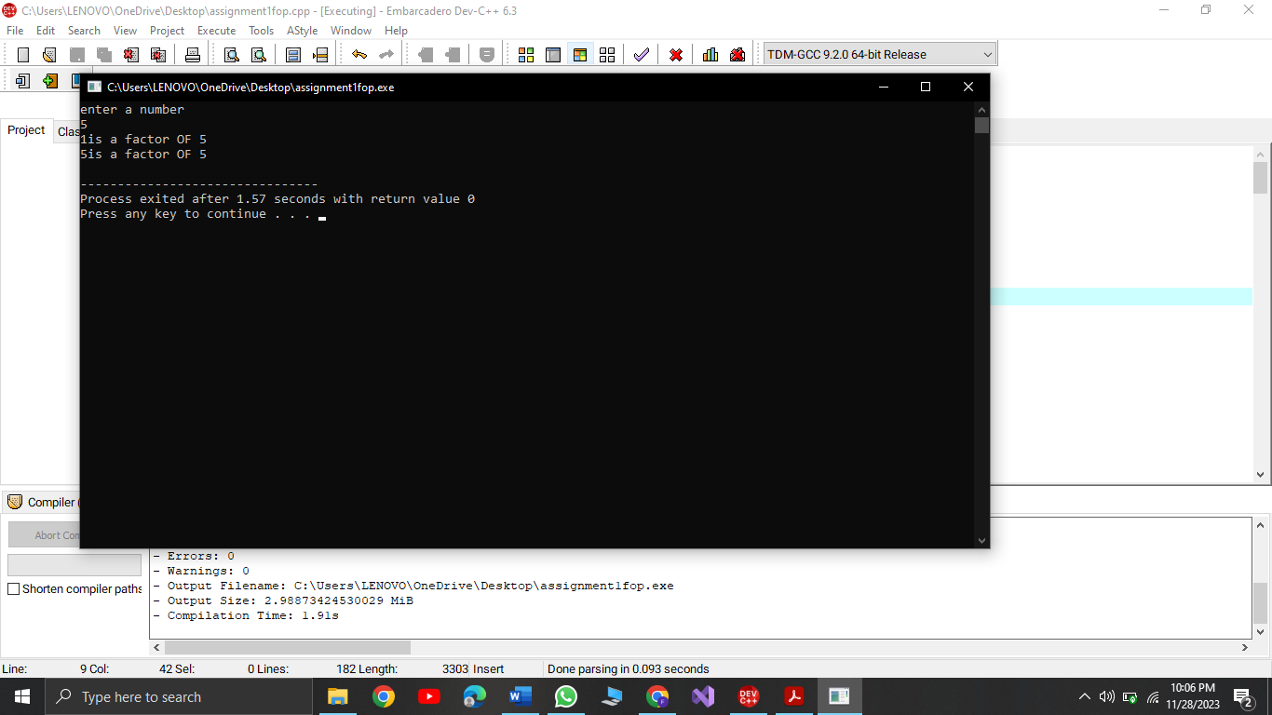

1. **Write output to the following code.**

X is 5 and y is 10

**3.Write a C++ program, take an integer value from user and check if it’s greater than 10 and less than equal to 20. Print 1 if yes and print 0 if no. Use appropriate datatype for output.**

cout<<"task3\n";

int x;

bool rangeofnum;

cout<<"enter a number\n";

cin>>x;

if(x>10&&x<=20){

rangeofnum=true;

}

else{

rangeofnum=false;

}

cout<<rangeofnum;

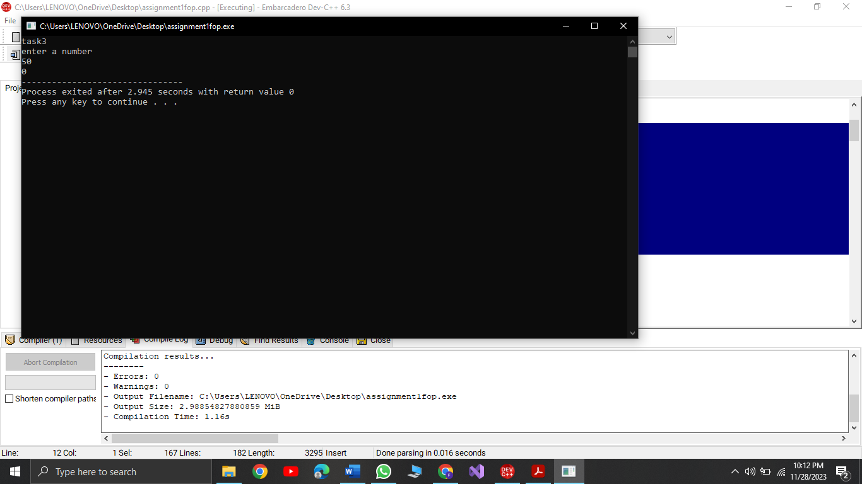

1. **Write a C++ program that uses a while loop to find the largest prime number less than a given positive integer N. Your program should take the value of N as input from the user and then find the largest prime number less than or equal to N. You are not allowed to use any library or pre-existing functions to check for prime numbers.**

int n,x,y;

bool flag;

cout<<"enter a number\n";

cin>>n;

x=n;

while(x>1){

y=x-1;

while(y>1){

if(x%y==0){

flag=false;

break;

}

else {

y--;

flag=true;

}

}

if (flag){

cout<<"largest prime no is "<<x;

break;

}

else{

x--;

}

}

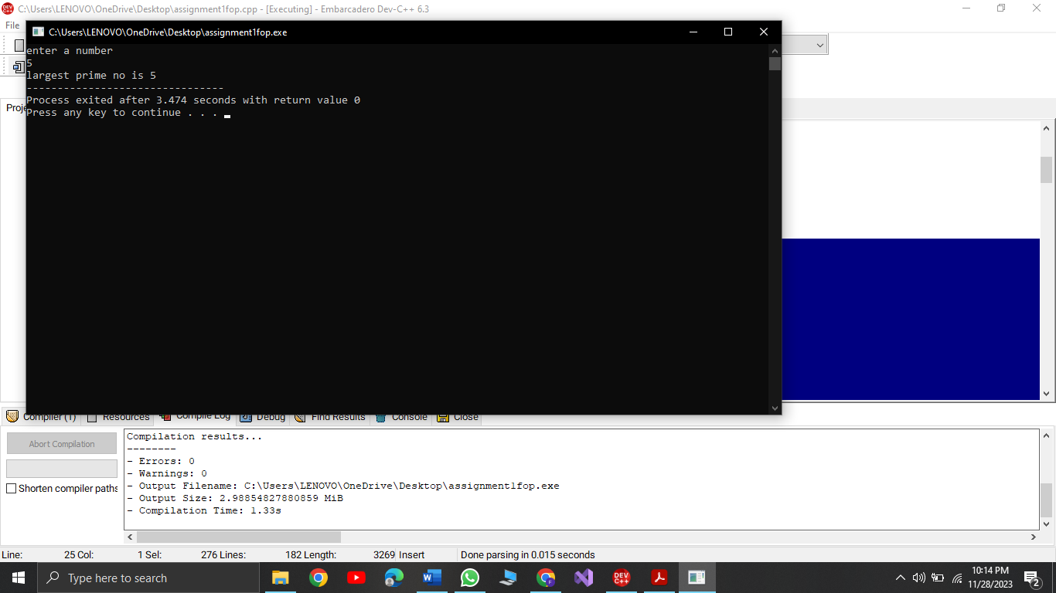

1. **Write a C++ program, take two string as input from user and check if both strings are equal or not. If they are equal make them unequal by rotating string. e.g., Hello is turned into olleH etc.**

string var1,var2;

string rotatestring="";

cout<<"enter two strings\n";

cin>>var1>>var2;

if(var1==var2){

cout<<"strings are equal\n";

for(int x=var1.length();x>=0;x--){

rotatestring+=var1[x];

}

cout<<"reversed string is"<<rotatestring<<endl;

}

else{

cout<<"the two strings are not equal\n";

}

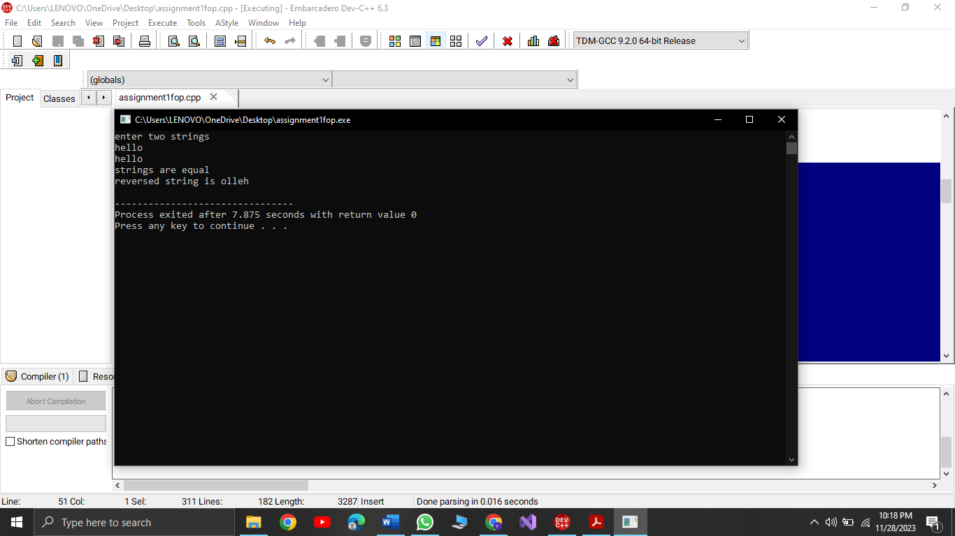

1. **Perform division in C++ without / using for loops. You can use / only to display the final results. Your dividend must be greater than divisor.**

int x, y, z=0;

cout<<"Enter a dividend."<<endl;

cin>>x;

cout<<"Enter a divisor."<<endl;

cin>>y;

if(x<y) {

cout<<"The dividend must be greater than the divisor."<<endl;

}

else if (x>0 && y>0) {

for (int x;x>=y; x--) {

if (x%y==0) {

z=z+1;

}

}

}

cout<<z;

1. **Write a C++program for a string which may contain lowercase and uppercase characters. The task is to remove all duplicate characters from the string and find the resultant string**

int y;

string var1;

cout<<"enter a string\n";

cin>>var1;

for(int i=0;i<var1.length();i++ ){

for(int j=0;j<var1.length();j++){

if(i!=j){

if(var1[i]==var1[j]){

var1[j]=var1[j+1];

var1[j+1]=' ';

}

}

}

}

cout<<var1;

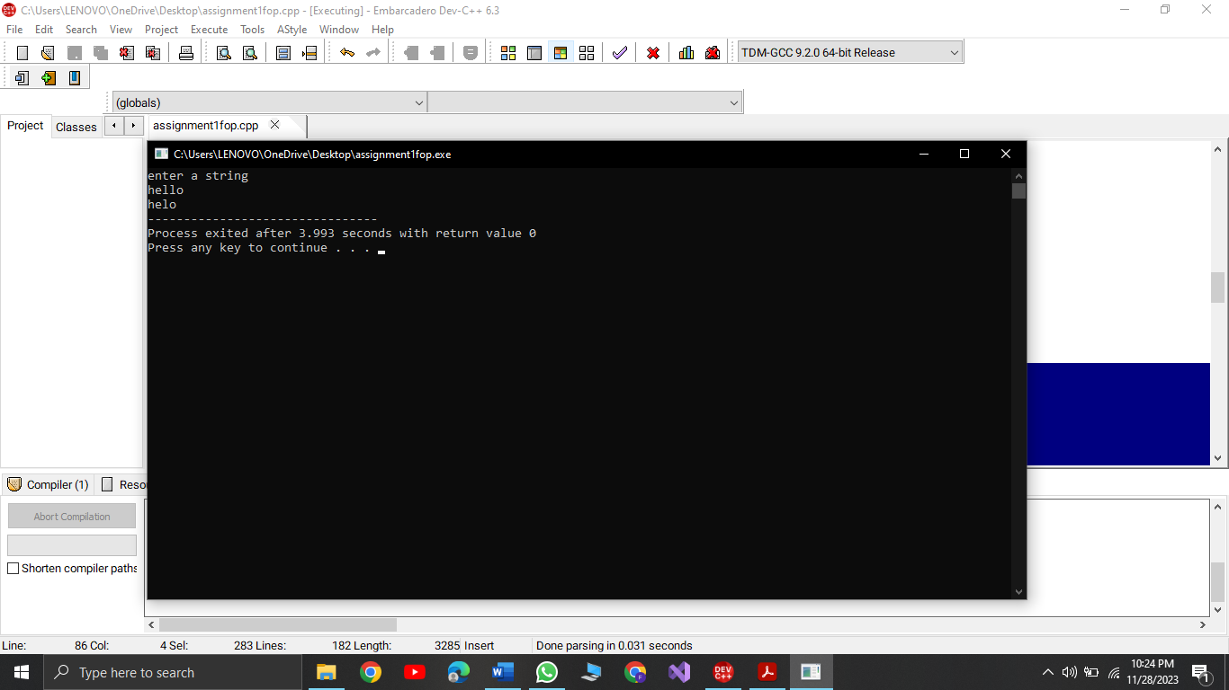

**8.Suppose an integer array a[5] = {1,2,3,4,5}. Add more elements to it and display them in C++.**

cout<<"task 8\n";

int arr[5] = {1, 2, 3, 4, 5};

cout << "Initial Array: \n";

for (int i = 0; i < 5; ++i) {

cout << arr[i] << " ";

}

int extra_elements[] = {6, 7, 8, 9, 10};

int newSize = 10;

int *newArray = new int[newSize];

for (int i = 0; i < 5; ++i) {

newArray[i] = arr[i];

}

for (int i = 0; i < 5; ++i) {

newArray[i + 5] = extra_elements[i];

}

cout << "\nNew Array: ";

for (int i = 0; i < newSize; ++i) {

cout << newArray[i] << " ";

}

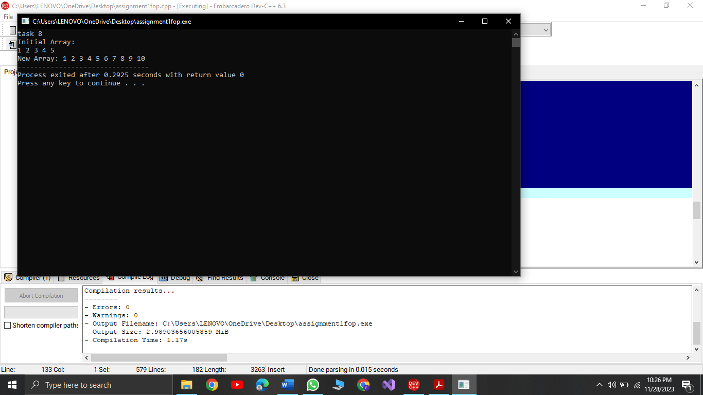

9.

**Given an integer array and an integer X. Find if there’s a triplet in the array which sums up to the given integer X.**

int num,x,sum;

int arr[num];

cout<<"enter size of array\n";

cin>>num;

for (int i=0; i<num;i++){

cout<<"enter element into array\n";

cin>>arr[i];

}

cout<<endl;

cout<<"please enter the number for triplet \n";

cin>>x;

for(int j=0;j<num;j++){

for (int i=j+1;i<num;i++){

for (int b=j+1;b<num;b++){

sum=arr[i]+arr[j]+arr[b];

if (sum==x){

cout<<arr[i]<<" "<<arr[j]<<" "<<arr[b]<<endl;

}

}

}

}

10**. Implement Bubble Sort on an array of 6 integers.**

int arr[6];

cout << "Enter the array of 6 integers\n";

for (int i = 0; i < 6; i++){

cin >> arr[i];

}

for (int e = 0; e <= 6; e++)

{

for (int j = 0; j < 4;j++)

{

if (arr[j] > arr[j + 1])

{

int temp; temp = arr[j];

arr[j] = arr[j + 1]; arr[j + 1] = temp;}}

}

cout << "The sorted array is :" << endl;

for (int k = 0;k < 6;k++)

{cout<< arr[k]<<endl;

}

