**NAME: FAIZAN ALI**

**CLASS:ME-15**

**SECTION A**

**LAB MANUAL 04**

**HOMETASK**

#include<iostream>

using namespace std;

int main(){

cout<<"task 1\n";

for (int x=0; x<=150; x++ ){

if(x%10==0){

continue;

}

cout<<x<<endl;

}

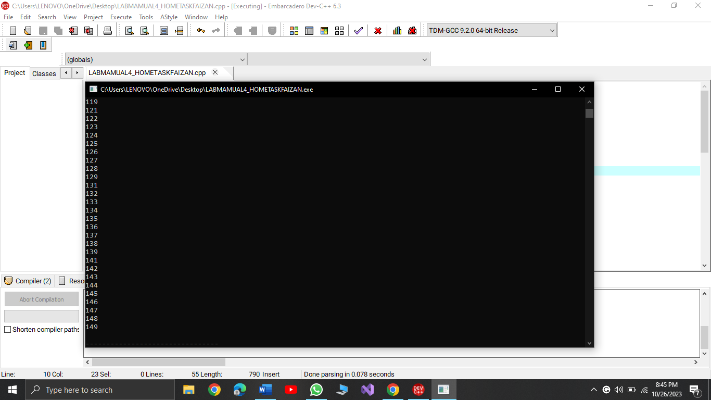

cout<<"task 2\n";

int x;

int sum=0;

cout<<"enter a number\n";

cin>>x;

while (x>0){

int digit = x % 10;

sum =sum + digit;

x/= 10;

}

cout << "Sum of digits: " << sum << endl;

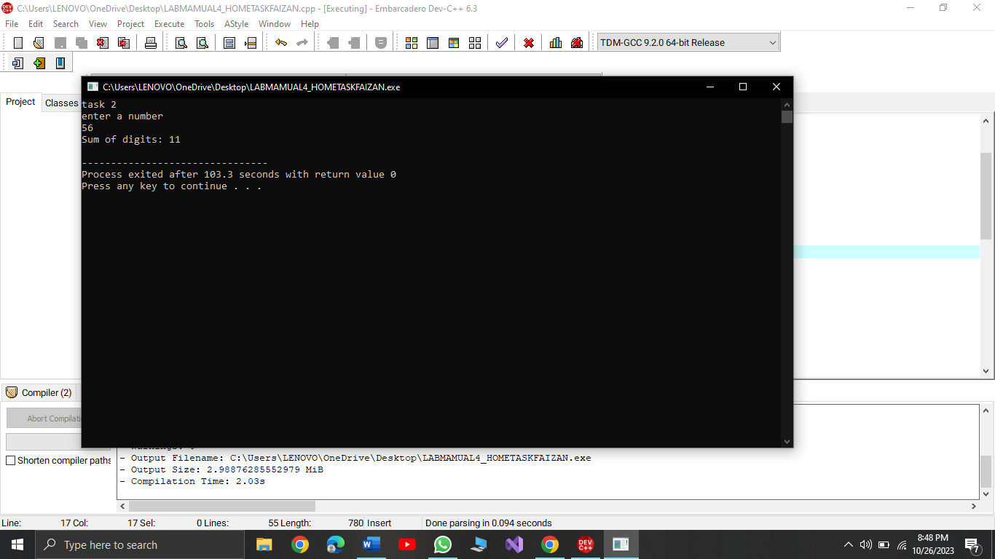

cout<<"task 3\n";

int a;

cout<<"enter the number to check if prime or not\n";

cin>>a;

bool isPrime = true;

for(int b =2 ;b<a ; b++){

if(a%b==0){

isPrime = false;

}

}

if (isPrime){

cout<<"number prime\n";

}

else{

cout<<"not prime\n";

}

