**NAME :FAIZAN ALI**

**CLASS:ME-15**

**SECTION:A**

**CMS:462013**

**LAB MANUAL 5**

#include<iostream>

#include <cmath>

using namespace std ;

int main(){

int x=1;

do {

cout<<"enter a number\n";

cin>>x;

}

while(x>0);

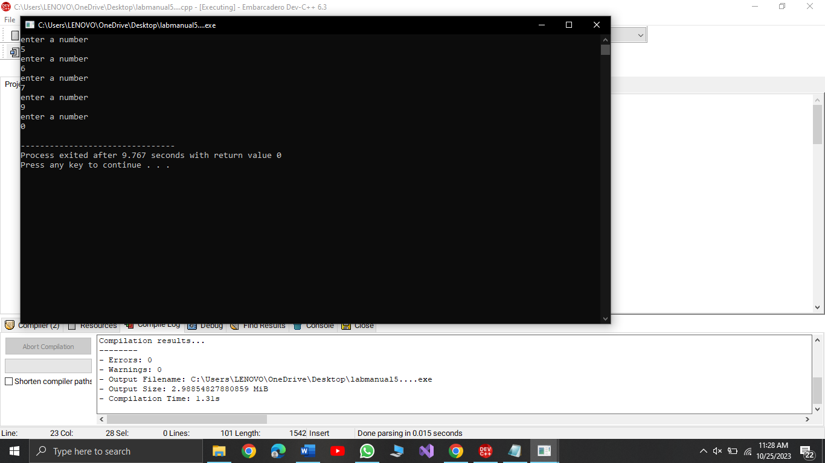

cout<<"task 2\n";

int x,y,res;

char opera;

char option;

do{

cout<<"enter a first number\n";

cin>>x;

cout<<"enter the operator\n";

cin>>opera;

cout<<"enter a second number\n";

cin>>y;

switch(opera){

case'-':res=x-y;

break;

case'+':res=x+y;

break;

case'*':res=x*y;

break;

case'/':res=x/y;

break;

}

cout<<"result is\n"<<res<<endl;

cout<<"enter y if use calculator again and n if not again\n";

cin>>option;

}

while(option=='y');

cout<<"the end\n";

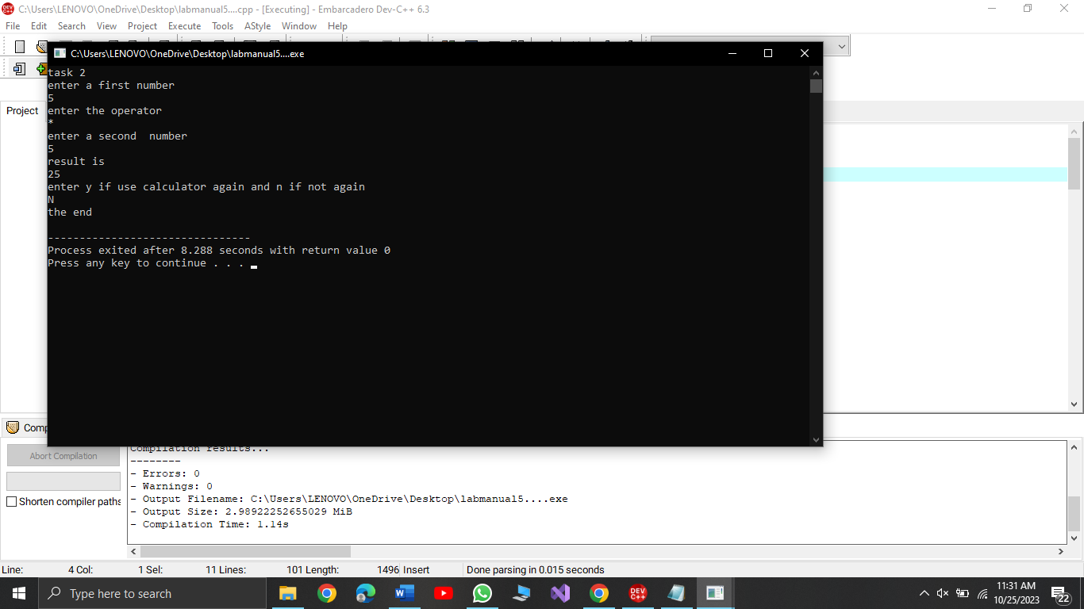

cout<<"task 3a)\n";

int sum=0;

int x=2;

while(x<=100){

if(x%2==0) {

sum=sum+x;

x++;

} else{

x++;

}

}

cout<<"sum is \n"<<sum;

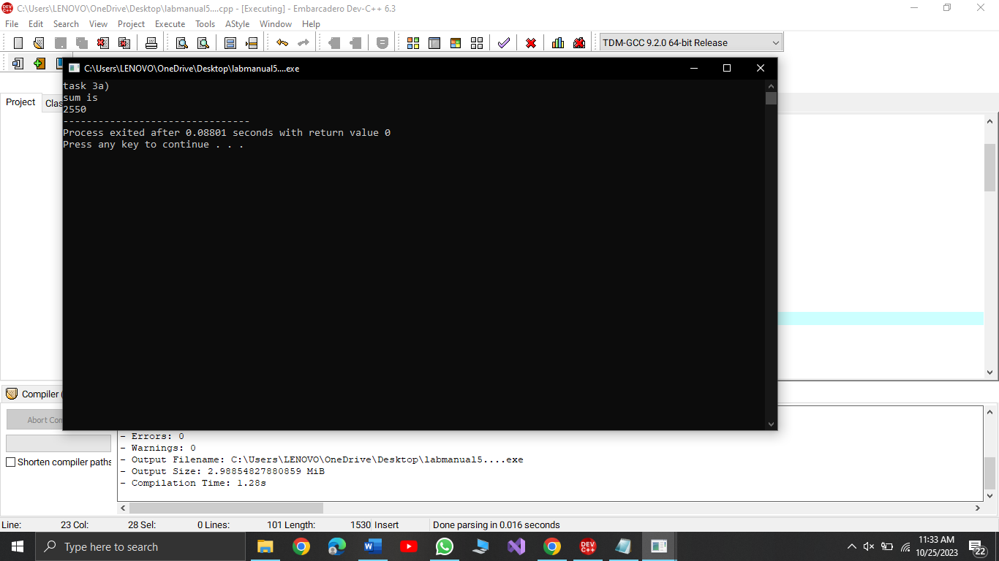

cout<<"task 3b)\n";

int sum=0,x=1;

while(x<=100){

sum=sum+(x*x);

x++;

}

cout<<"sum is \n"<<sum;

int z=0,y=0;

cout<<"task 4a)\n";

while(z<=20){

y=pow(2,z);

cout<<y<<endl;

z++;

}

cout<<"task 4b)\n";

int a,b;

int sum=0;

cout<<"enter first number\n";

cin>>a;

cout<<"enter second number\n";

cin>>b;

while(a<=b){

if(a%2!=0){

sum=sum+a;

a++;

}else{

a++;

}

}

cout<<"sum is ODD INTEGERS IN BETWEEN \n"<<sum;

return 0;

}

