Name : Faizan Ali

Class: ME-15A

462013

LAB MANUAL 8 HOMETASK

#include <iostream>

using namespace std;

int main() {

const int maxSize = 100;

int foo[maxSize];

int x;

cout << "Enter the size of the array: ";

cin >> x;

if (x <= 0 || x > maxSize) {

cout << "Invalid size. Please enter a valid size." << endl;

return 1;

}

cout << "Enter the elements of the array:" << endl;

for (int i = 0; i < x; ++i) {

cout << "Element " << i + 1 << ": ";

cin >> foo[i];

}

int mostRepeated = foo[0];

int maxCount = 1;

for (int i = 0; i < x; ++i) {

int count = 1;

for (int j = i + 1; j < x; ++j) {

if (foo[i] == foo[j])

++count;

}

if (count > maxCount) {

maxCount = count;

mostRepeated = foo[i];

}

}

cout << " most repeated element : " << mostRepeated << endl;

return 0;

}

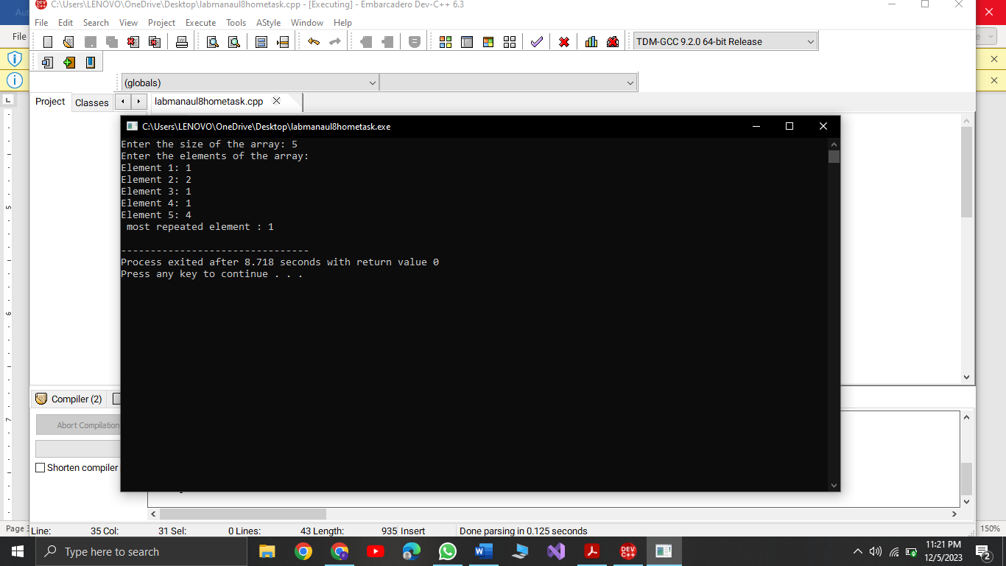

Task 2

#include <iostream>

#include <climits>

using namespace std;

int main() {

int a[8] = {13, 15, 17, 9, 99, 77, 65, 43};

int maxElement = INT_MIN;

int minElement = INT_MAX;

for (int i = 0; i < 8; ++i) {

if (a[i] > maxElement) {

maxElement = a[i];

}

if (a[i] < minElement) {

minElement = a[i];

}

}

cout << "Biggest element: " << maxElement << endl;

cout << "Smallest element: " << minElement << endl;

return 0;

}

Task 3:

#include <iostream>

using namespace std;

int main() {

const int size = 5;

int foo[size];

cout << "Enter elements for the array:\n";

for (int i = 0; i < size; ++i) {

cout << "Element " << i + 1 << ": ";

cin >> foo[i];

}

int x = foo[1]; // Element at position 2

foo[1] = foo[3]; // Swap with element at position 4

foo[3] = x; // Place the original element at position 2 in position 4

cout << "\nArray after swapping elements at positions 2 and 4:\n";

for (int i = 0; i < size; ++i) {

cout << "Element " << i + 1 << ": " << foo[i] << "\n";

}

return 0;

}

