**Name : Faizan ali**

**Sec a**

**462013**

**Lab manual 8**

**Task 1**

#include<iostream>

using namespace std;

int main(){

int x;

cout << "please enter the size of array: ";

cin >> x;

if ( x <= 0) {

cout << "please enter positive size" << endl;

return 1;

}

int arr[x];

cout << "Enter the elements of the array:" << endl;

for (int i = 0; i < x; ++i) {

cout << "element " << i + 1 << ": ";

cin >> arr[i];

}

int sum = 0;

for (int i = 0; i < x; ++i) {

sum += arr[i];

}

double average = sum / x;

cout << "Average of the array elements: " << average << endl;

return 0;

}

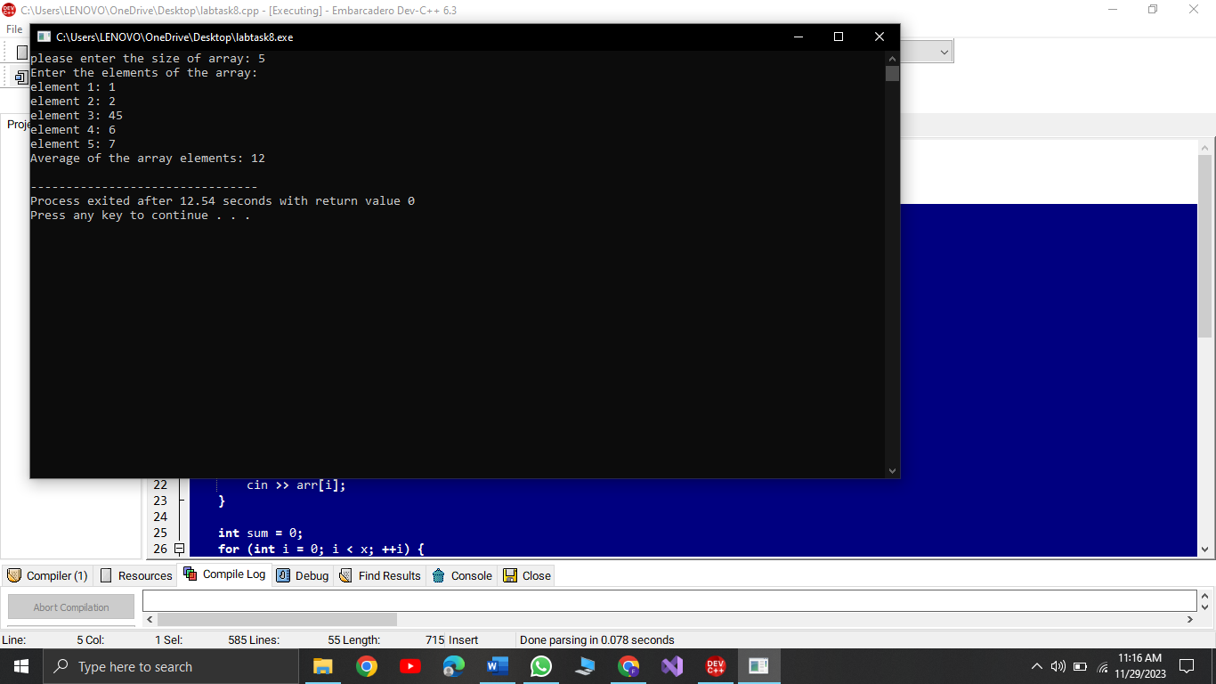

**Task 2**

int arr1[5];

int temp = 0;

cout<<"Enter 5 Values: ";

for(int i=0; i<5; i++){

cin>>arr1[i];

}

for(int i=0; i<5; i++){

for(int j=0; j<4; j++){

if(arr1[j]>arr1[j+1]){

temp = arr1[j];

arr1[j] = arr1[j+1];

arr1[j+1] = temp;

}

}

}

for(int k=0; k<5; k++){

cout<<arr1[k]<<", ";

}

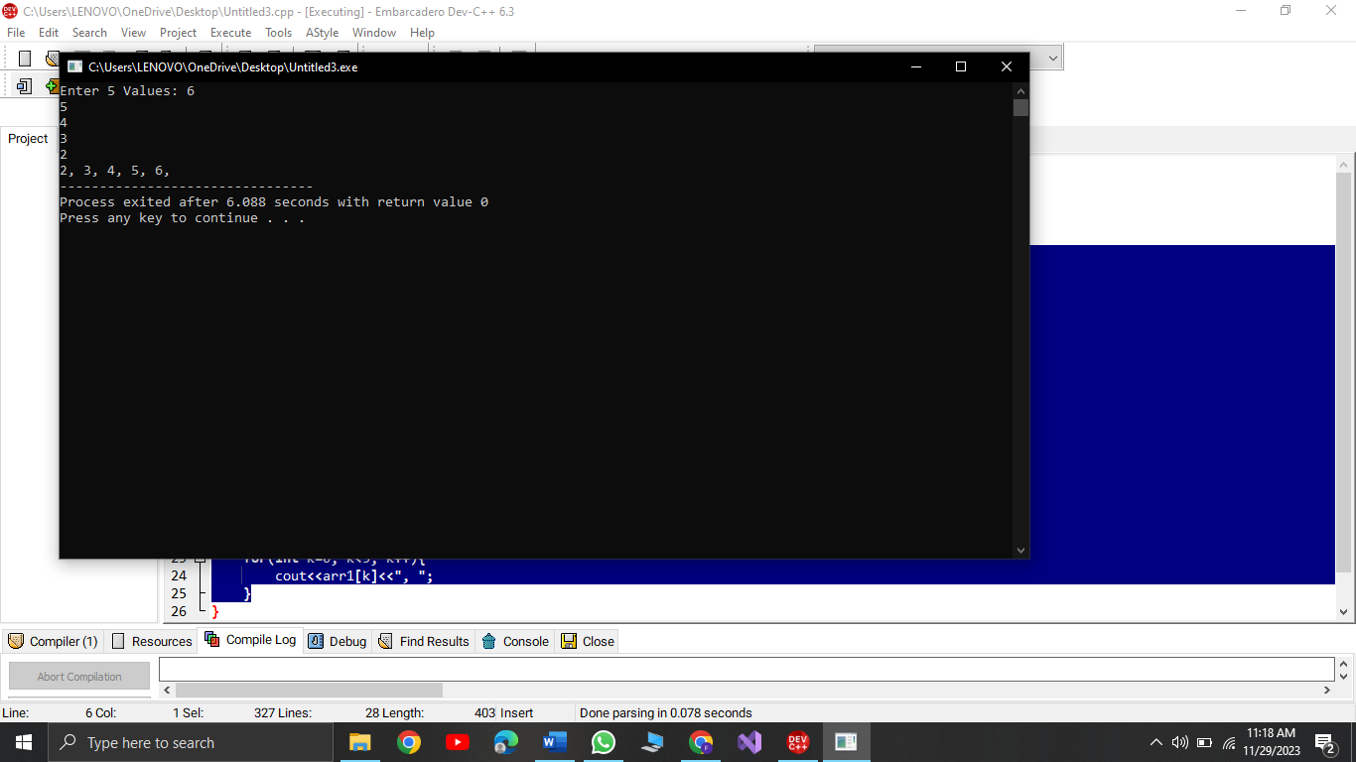

**Task 3:**

int arr1[5]={5,13,45,76,9},min=0;

for(int i=0;i<5;i++){

min= arr1[i];

for(int j=i;j<5;j++){

if(min> arr1[j]){

min=arr1[j];

arr1[j]=arr1[i];

arr1[i]=min;

}

}

}

for(int i=0;i<5;i++){

cout<<arr1[i]<<" ";

}

