NAME: FAIZAN ALI

CLASS: ME 15 A

LAB MANAUL 7

#include<iostream>

using namespace std;

int main(){

TASK 1

int arr1[10];

for(int i=0;i<10;i++){

cout<<"enter a number \n";

cin>> arr1[i];

}

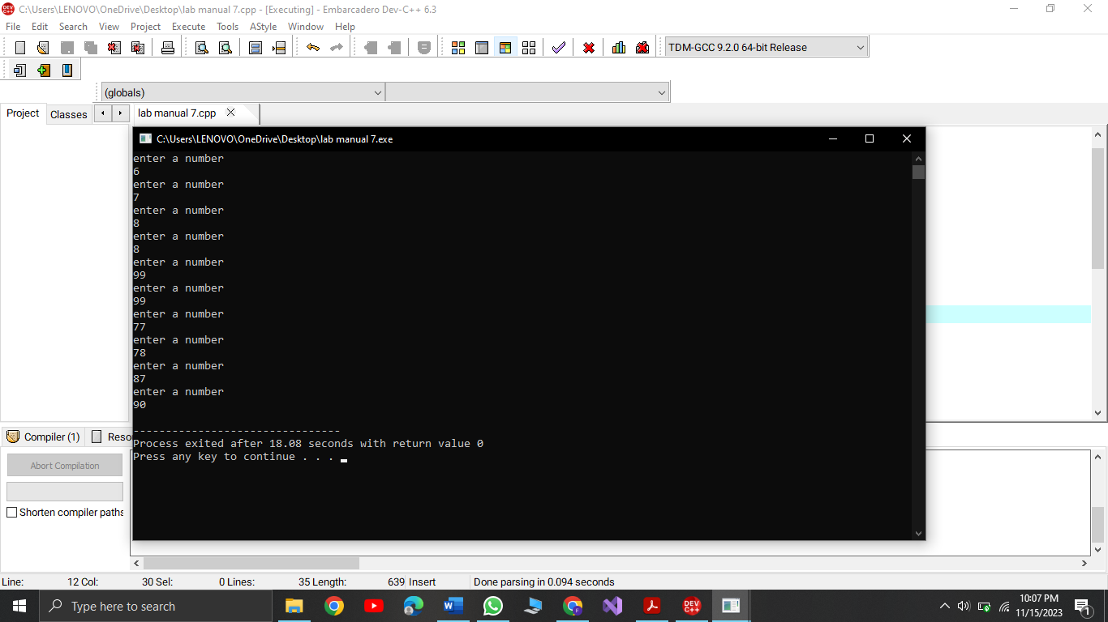

TASK 2

int b,c;

int arr2[5];

for(int i=0;i<5;i++){

cout<<"enter a number \n";

cin>> arr2[i];

}

b=arr2[0]+arr2[1]+arr2[2]+arr2[3]+arr2[4];

cout<<"the sum is"<<b<<endl;

c=arr2[0]\*arr2[1]\*arr2[2]\*arr2[3]\*arr2[4];

cout<<"the product is"<<c<<endl;

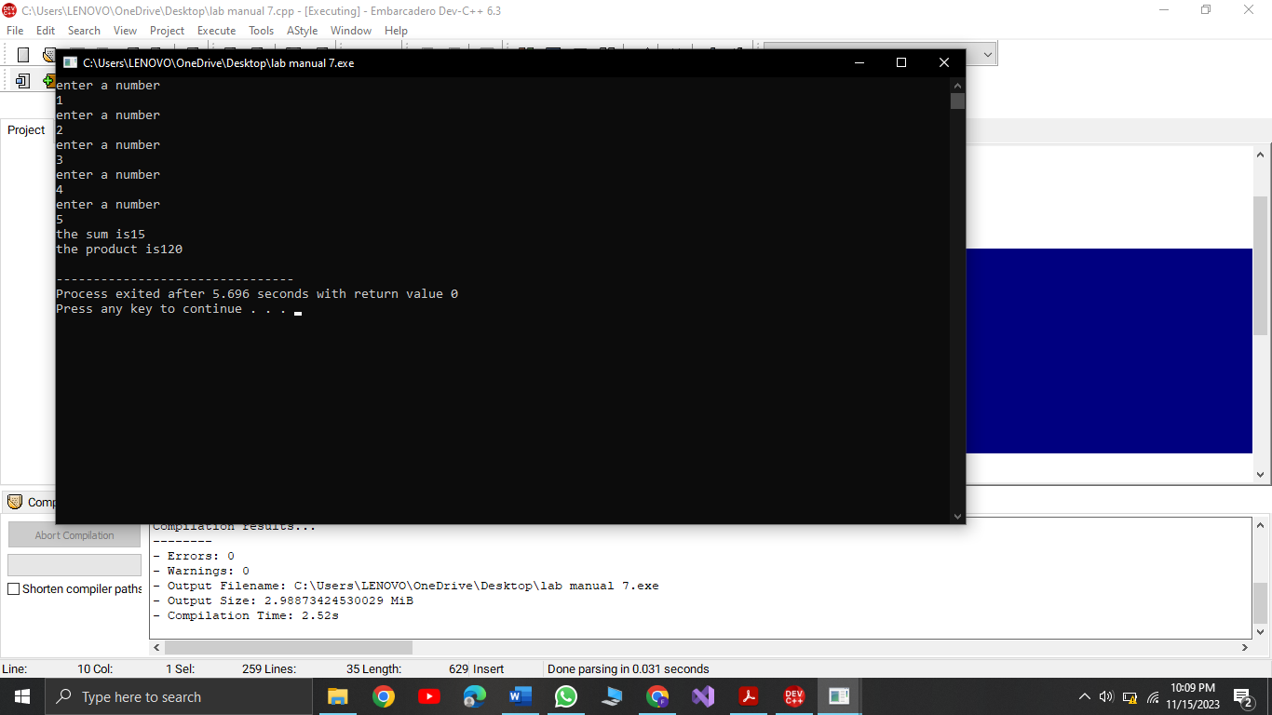

TASK 3

int arr3[15]={1,22,333,4444,55555,666666,7777777,88888888,9999999,101010,11111,1212,113,14,1};

for (int i=0;i<15;i++){

cout<<arr3[i]<<endl;

}

return 0;

}

