Software Requirements Specification
for
Duel Masters
Version 0.1

Prepared by: Faizan Dilawar
-Md00591@st.habib.edu.pk
Syed Farid Ahmed
-Sa01818@st.habib.edu.pk

July 10, 2017

Habib University
Object Oriented Programing

Table of Contents
Revision History 2
1. Introduction 2
1.1 Overview 2
1.2 Purpose 2
1.3 Intended Audience of SRS document 3
1.4 Project Scope 3
1.5 Stack Holders……………………………………………………………………………………3
2. Overall Description 3
2.1 Operating Enviroment 3
2.2 Functional Requirements 4
2.3 Non-Functional Requirements 4
2.4 Use Case Model………………………………………………………………………….………4
2.5 Use Case Description…………………………………………………………………………….5
2.6 References…………………………………………………………………………….………….5

Revision History
Revision Number | Revision Date | Nature of Revision | Version
1 | 7/10/17 | Primary Draft | 0.1

Introduction

Overview
Duel Masters is an implementation of the card based game. It is more so a turn based battle simulator where two players battle each other with their decks containing shuffled 40 cards. Provided with 5 shields, and drawing 5 cards. They charge mana each turn, which can then be used to call upon other creatures, which can further break the opponents shields. When all shields are broken the respective player becomes vulnerable and can be attacked, at which point the opposing player claims victory.

Purpose
The purpose of Duel Masters is to provide an intuitive interface in order to play the card based game, highlighting the options available at the players disposal, plus removing the limitations of physical cards by incorporating the electronic ones. This also makes it easier to organize decks and create a more fair and systematic way to play the game as the cards will be properly shuffled and there would not be a conflict in following the complex rules of the game. This would also provide the players an environment to simulate and come up with different strategies.

Intended Audience of SRS document
This document is intended for project managers, developers, and testers.

Readers of this document should have a good knowledge of the rules of Duel Masters as well as a good understanding of the C++ programing language. If the reader does not have a good grasp on Duel Masters, please see section 2.6 (References) for a link.

Project Scope
Two players can enjoy the popular "Duel Masters" variant. This game will be available for Linux, Windows, and Mac OS, it will allow people to learn how to play Duel Master if they are not familiar with it, train their skills against computer opponents so that they can enjoy the game. Some important details are that everyone can download the program and use the digital cards implemented in the game rather than relying on physical copies which are very rare in some cases.
The game Duel masters was released with the anime of the same name in 2002, from where it got increasingly popular due to its complex play style and interesting design. The game has evolved much from before but we would want to create a standalone simulator for the game so that we can slowly incorporate all of those complex concepts of the game.

Stake Holders
a. Player 1

b. Player 2

c. Any player that would like to partake in the games

Overall Description

Operating Environment:
Duel Master will be implemented on a windows machine using C++ but it should be executable on mac OS and Linux as well

2.2 Functional requirement/ Product features:
Provides the proper interface to simulate a game of duel masters.

The only performance requirement is, that the application should immediately respond to user input. The visual interface should stay painted, and up-to-date at all times.

The program will be able to import the respective players deck to the game.

Non-Functional Requirements
The system will be Open Source i.e. it works on every OS.
The system will be user friendly (Ease of use).
The maximum number of clicks for any function in the system should not exceed one click.

2.4 Use Case model

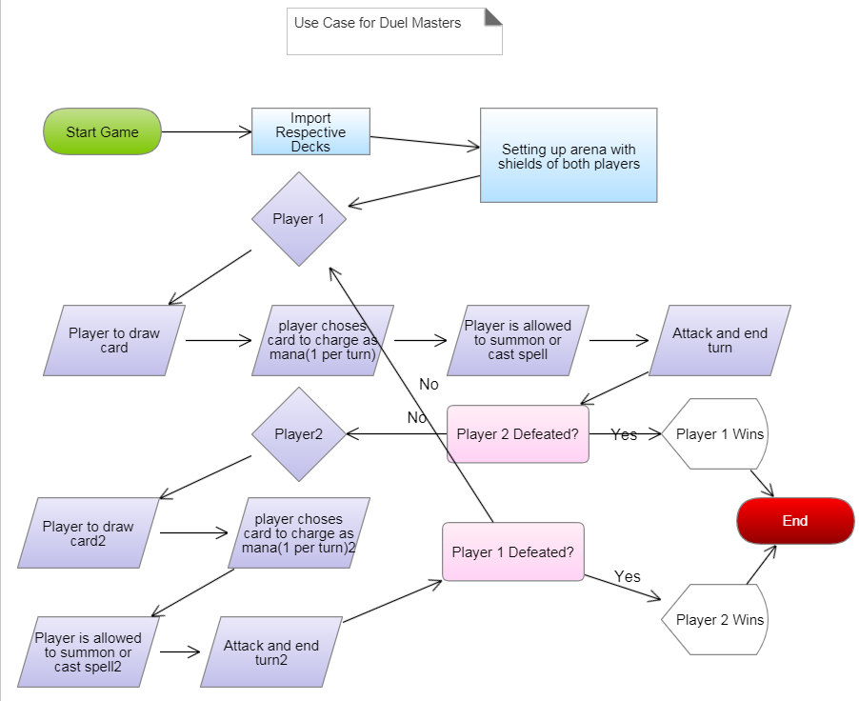

2.5 Use case Description:
Player to draw card: the player draws a card (mandatory)
Player choses a card to charge as mana, they player may only chose one card(optional)
Player is allowed to summon a creature or cast a spell given that the requirement of mana is met(optional).
Attack and end turn: The player may attack the other opponent’s creatures or the player himself, breaking shields or may choose to end his turn(mandatory).

2.6 References
http://duelmasters.wikia.com/wiki/Duel_Masters_Anime
http://duelmasters.wikia.com/wiki/How_to_Play

Update:
We tried our best to complete all the project requirements and make good visuals. Our game runs for two players and the code compiles.

