
Information Security assignment
A # 03

September 25, 2025

Name: Muhammad Faizan Yousaf
Section: BCS 7-F
Roll number: 22F-3875

Submitted to: Sir Umar Aftab

Part 1: Buffer Overflow:

Question 1:
Objective: Analyze a provided vulnerable C program (stack.c) that contains a classic stack-based buffer overflow vulnerability. Explain the vulnerability, and draw the stack layout.
Answer:
Commands:
- gcc -m32 -g -o stack -fno-stack-protector stack.c
- ls -l stack
- cat badfile
- ./stack
- gdb ./stack
- break bof
- run
- p &buffer
- info frame
- continue
- q

Screenshots:
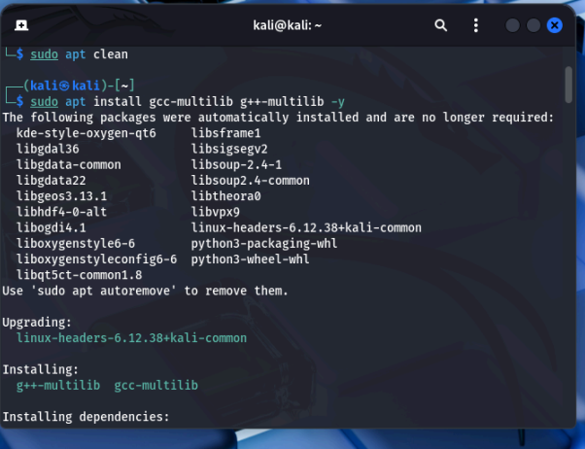
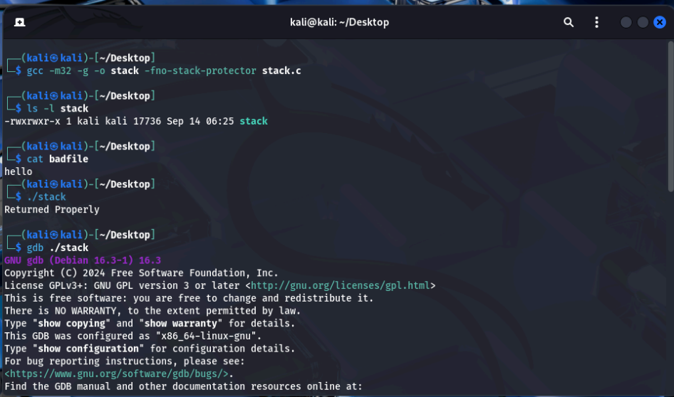
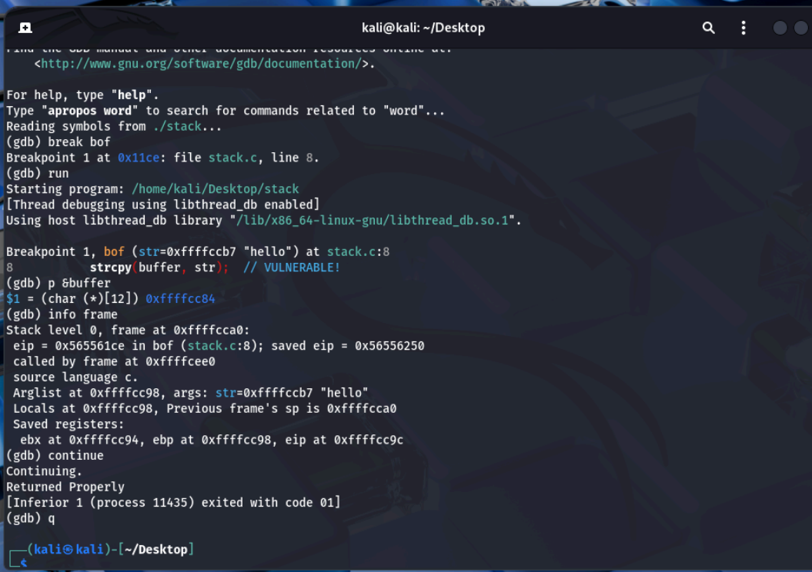

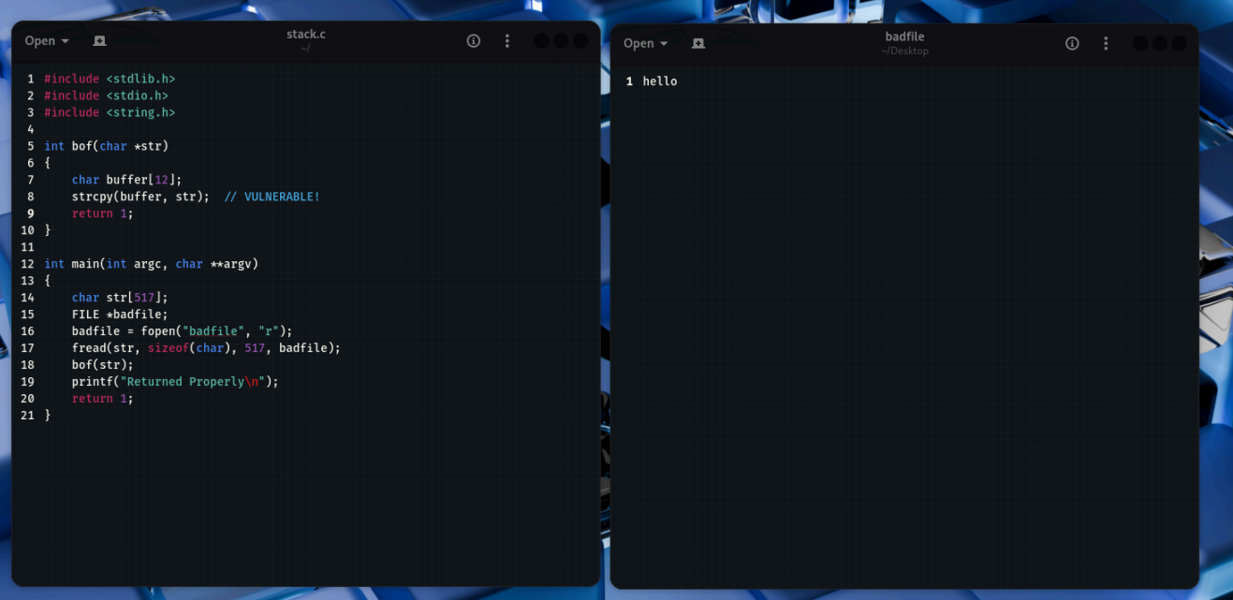

Stack Diagram:
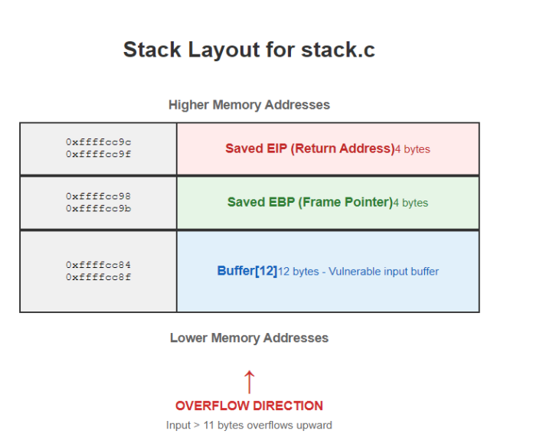

Vulnerability Analysis:
The strcpy (buffer, str) in bof copies input into a 12-byte buffer without bounds checking. Any input longer than 11 bytes overflows, overwriting the saved EBP (4 bytes) and saved EIP (4 bytes) on the stack. This allows an attacker to control the return address, potentially executing arbitrary code (e.g., shellcode). The current “hello” (5 bytes) is safe, but a 517-byte input from main could exploit this if crafted properly.

Question 2:

Objective: Build an exploit (badfile) and exploit the vulnerable program to gain a shell. Complete the provided exploit.c template and demonstrate successful exploitation.
Commands:
- sudo sysctl -w kernel.randomize_va_space=0 (Disable ASLR)
- ./stack
- gcc -m32 -o exploit exploit.c
- ls -l exploit
- ./exploit
- ls -l badfile
- xxd badfile | head
- sudo ln -sf /bin/bash /bin/sh
- ls -l /bin/sh
- ./stack
- kernel.randomize_va_space = 2 (Re-enable ASLR)

Screenshots:

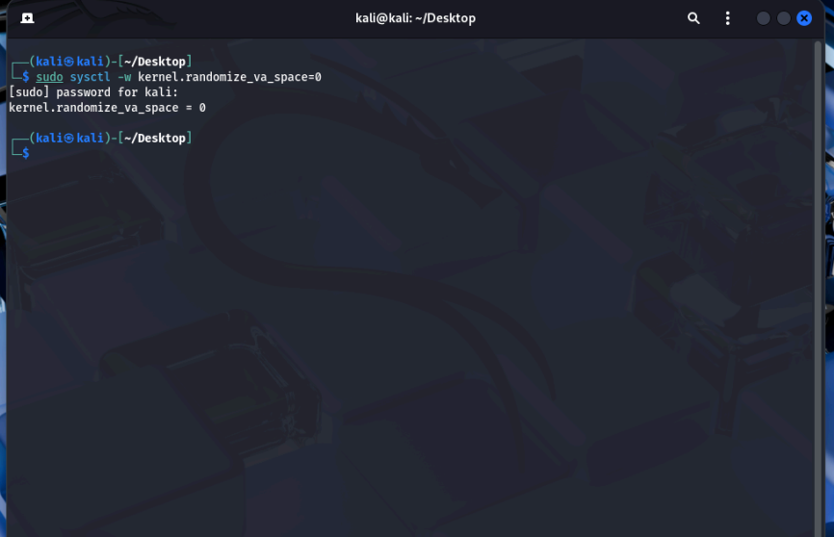

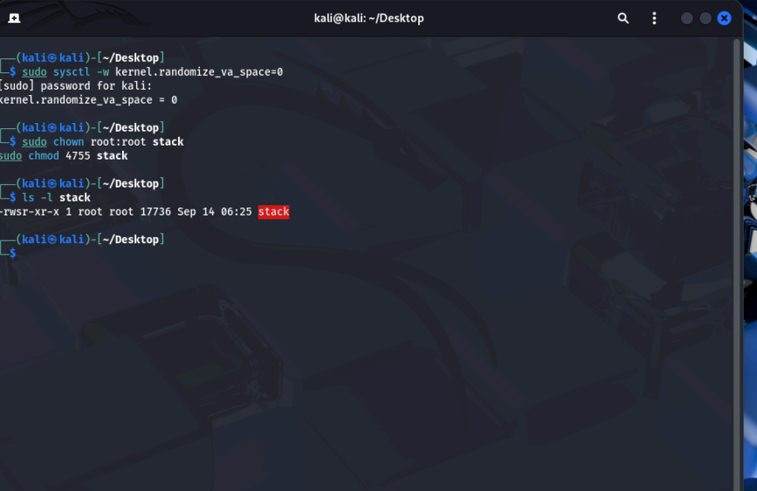

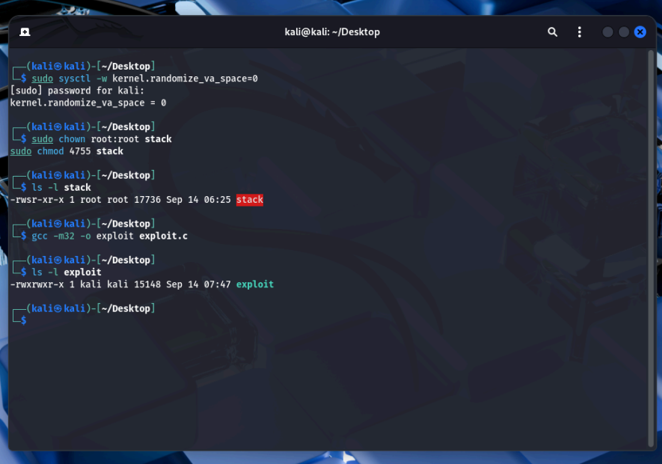
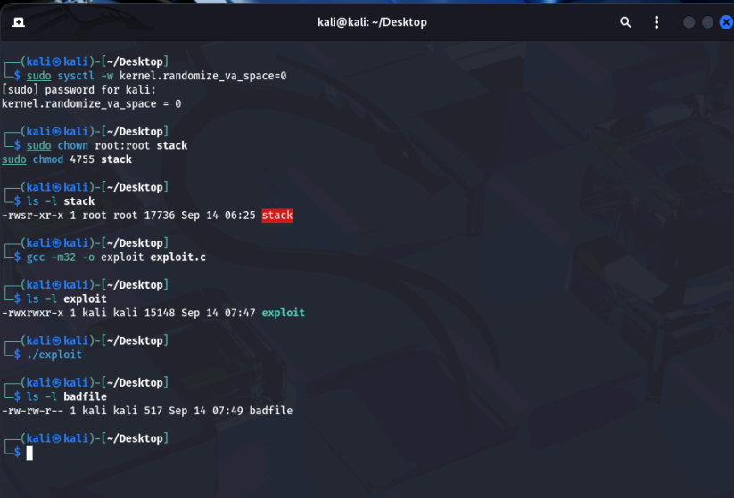

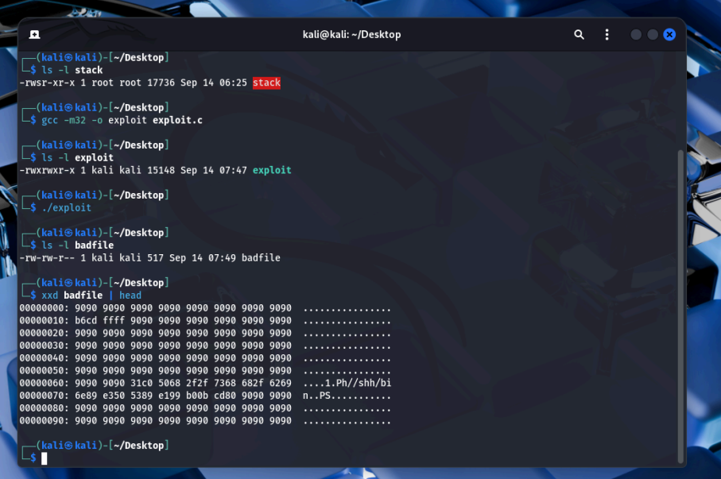
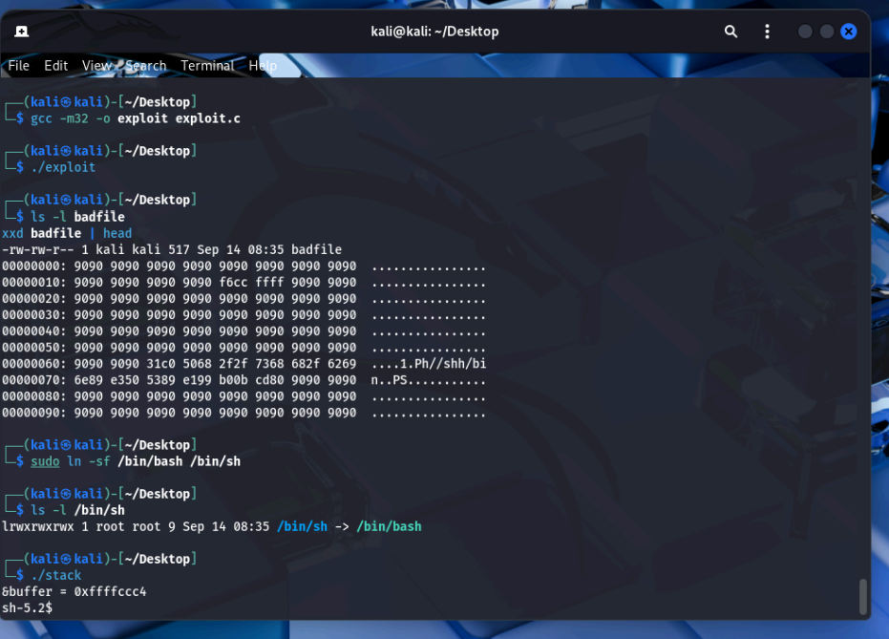

Question 3

Objective: Evaluate standard protection mechanisms and show how they affect the exploit. The protections to test: /bin/bash linkage, ASLR (address space layout randomization), and Stack Guard/Canary.

Commands:
- ls -l /bin/sh
- ./stack
- Exit
- sudo sysctl -w kernel.randomize_va_space=2
- ./stack
- gcc -m32 -g -o stack_protected stack.c
- sudo chown root:root stack_protected
- sudo chmod 4755 stack_protected
- ls -l stack_protected
- ./stack_protected

Screenshots:

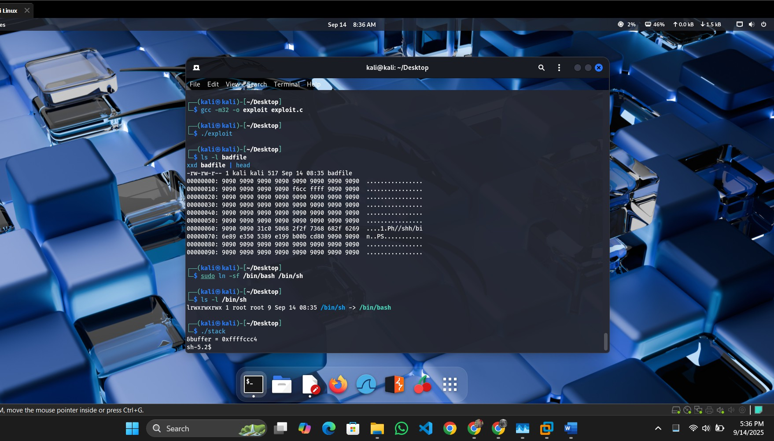

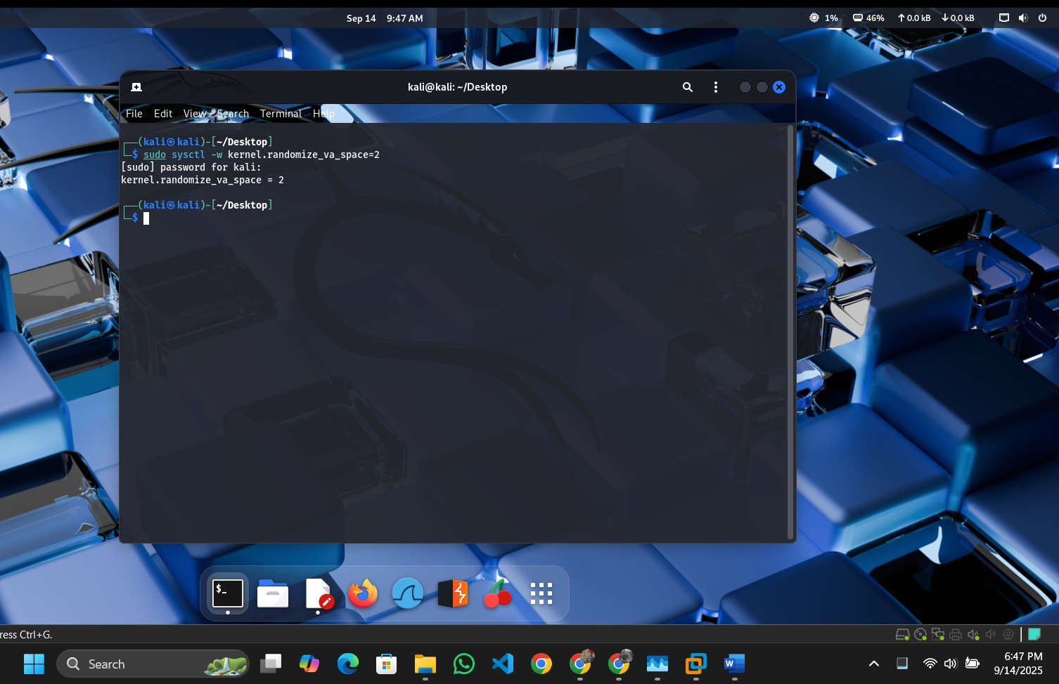
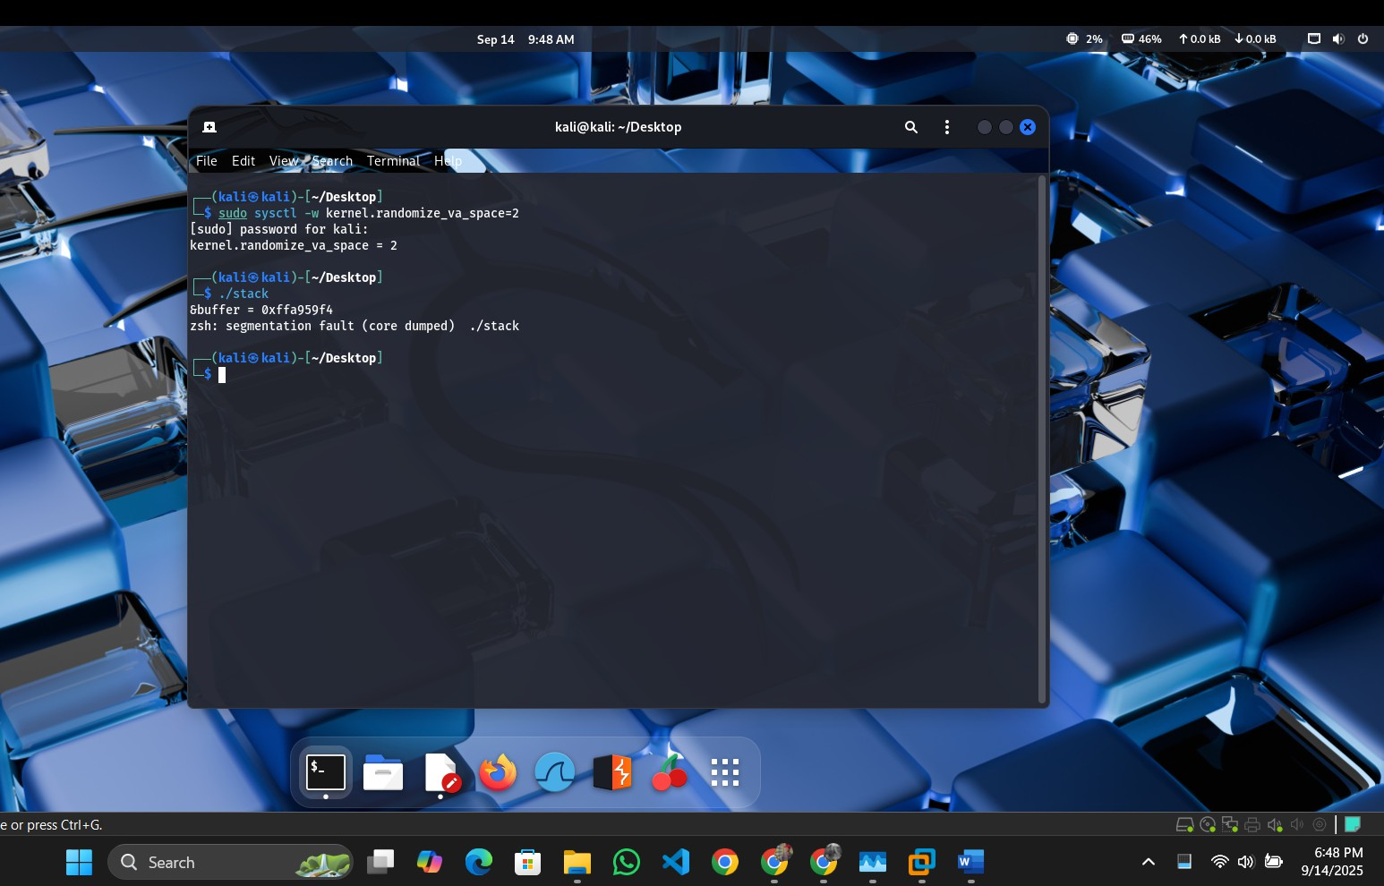

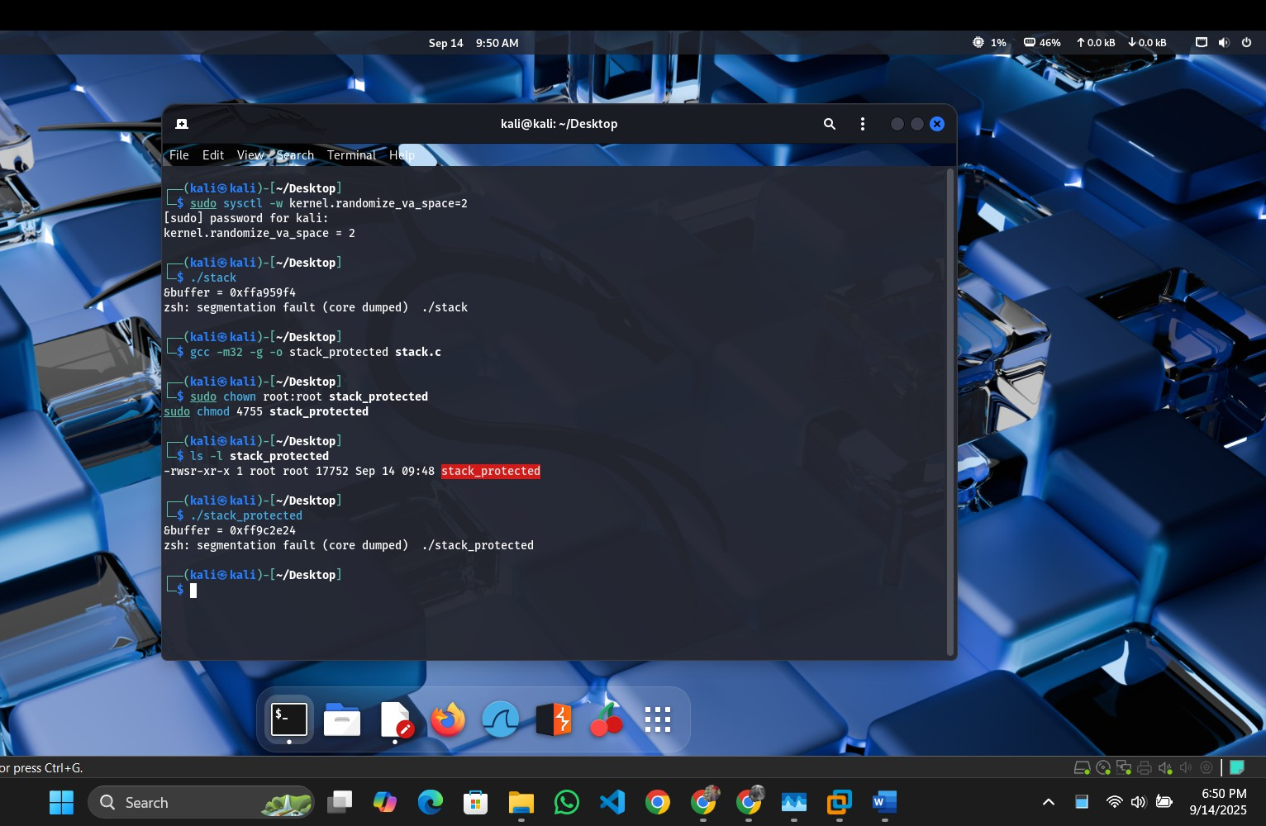

Analysis of Each Protection
- /bin/bash Linkage:
  - Effect: This does not act as a protection against the exploit. Linking /bin/sh to
/bin/bash ensures the shellcode executes a root-capable shell under setuid, as
/bin/bash respects setuid privileges while /bin/dash (default) drops them. The exploit succeeds because the shellcode (/bin/sh) runs unimpeded.
  - Why Success/Failure: The exploit succeeds because the protection mechanism is absent—bash’s setuid support enables the root shell rather than preventing it. This is a configuration choice, not a security feature.

Address Randomization (ASLR):
  - Effect: ASLR randomizes the stack base address (e.g., from 0xffffccc4 to a new value per run), making the fixed ret_addr (e.g., 0xffffcd14) invalid. The exploit fails as EIP lands in an unpredictable location.
  - Why Success/Failure: The exploit fails because the hardcoded return address no longer points to the NOP sled. ASLR effectively mitigates this type of buffer overflow by introducing randomness, requiring more advanced techniques (e.g., NOP sled brute force or ROP) to bypass.

Stack Guard (Canary):
  - Effect: The canary (a random value placed between the buffer and saved EIP) is overwritten by the 517-byte payload, triggering a stack smash detection and program termination before the shellcode executes.
  - Why Success/Failure: The exploit fails because the canary detects the overflow, aborting execution. This protection is highly effective against simple buffer overflows, as it requires the attacker to guess or bypass the canary value (e.g., via information leakage), which is impractical without additional vulnerabilities.

---------------------------------------End of Part 1--------------------------------------------

