is cp
IS (Information Security)

22F-3619M.RAFAY.ALI
22F-3875 FAIZAN YOUSUF

TOPIC : ACCESS CONTROL LIST

1. What is Access Control?
Access control is a security mechanism that regulates who can access what in a system. It ensures only authorized and authenticated users can view, modify, or use resources.
Access control answers two questions:
- Authentication: Who are you?
- Authorization: What are you allowed to do?

2. Components of Access Control
Access control works in three steps:

2.1 Identification
User claims an identity
Example: Username = Ali123

2.2 Authentication
System verifies identity
- Password
- OTP
- Fingerprint
- Smart card
- MFA/2FA

2.3 Authorization
System decides what the user can do
- Read / Write / Execute permissions
- Access to specific applications
- View/modify financial data, etc.

3. AAA Security Model (Authentication, Authorization, Auditing)

3.1 Authentication
Verifies the identity of the user.
Types of authentication:
- Something you know: Password / PIN
- Something you have: OTP token, smart card
- Something you are: Biometrics
Advanced:
- Multi-Factor Authentication (MFA)
- Biometric verification

3.2 Authorization
After authentication system gives permissions.
Authorization models:
- ACL
- DAC
- RBAC
- ABAC

3.3 Auditing
Tracks and logs all user activities.
Examples of auditing logs:
- Login / logout attempts
- File access logs
- Permission changes
- Failed attempts
- Admin activity logs
Why auditing matters?
Detect intrusions
Find suspicious behavior
Regulatory compliance (HIPAA, GDPR, PCI DSS)

4. ACCESS CONTROL MODELS

4.1 Mandatory Access Control (MAC)
Most restrictive.
Permissions controlled only by administrators.
Users cannot modify permissions.
Used in:
- Military
- Government
- Classified environments

Features:
- Security labels: Secret, Top Secret, Confidential
Strict, rigid, secure

Example:
A soldier with "Secret" clearance cannot open "Top Secret" documents.

Diagram:

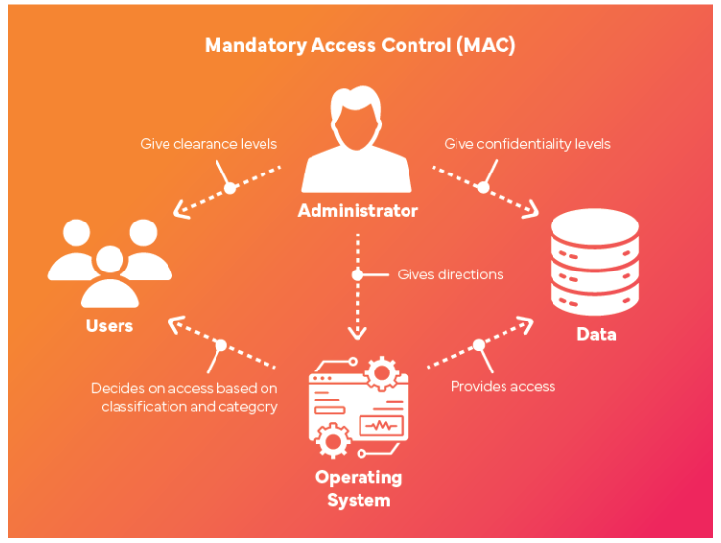

  - Discretionary Access Control (DAC)
Owner of a resource controls access.
- Flexible
- High effort
- Users can change permissions

Example:
In Windows:
Right-click folder then Properties and Permissions.

Diagram:

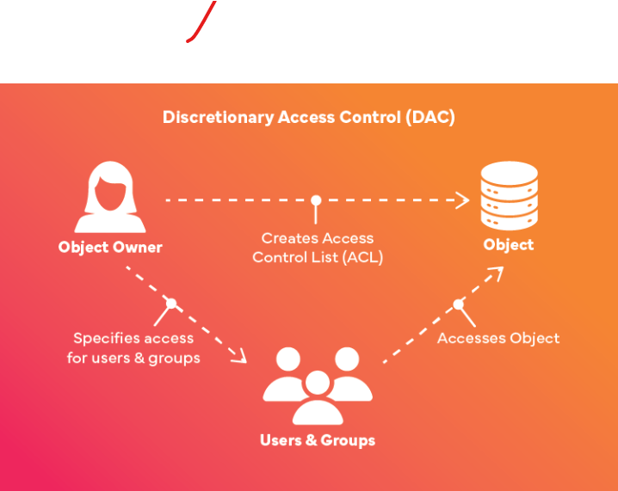

4.3 Role-Based Access Control (RBAC)
Permissions are assigned to roles, not individuals.
- Most used in industry
- Easy administration
- Reduces errors

Real example:
- Doctor read/write patient reports
- Nurse read only
- Lab tech write lab reports

Diagram:

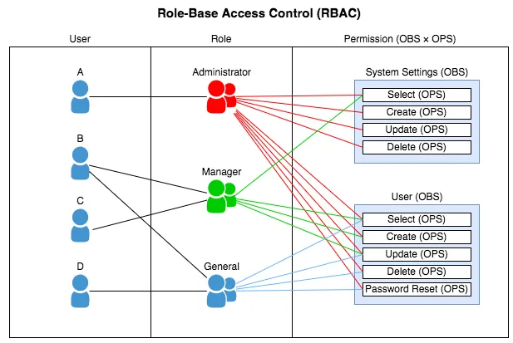

4.4 Attribute-Based Access Control (ABAC)
Access depends on attributes, not roles.
Attributes include:
- User attributes -> Department = HR
- Resource attributes -> File owner
- Environment attributes -> Location, Time

Example:
Rule:
"Allow access if user.department = Finance AND clearance = High AND access_time = WorkHours."

Diagram:
