# Objectives of Task 1:

**Replicate a smart home functionality:** program targets to replicate a smart home temperature monitoring system by using Arduino language. It showcases the use of electronic sensors like voice activation, and small sensory devices to collect data and manage assets, facilities, and services in a well-organized way. (Debele and Qian, 2020)

**Monitoring temperature:** the program uses a negative temperature coefficient thermistor to track room temperature. The analog value of the thermistor is read by using the analog-digital converter module of the Arduino. (Debele and Qian, 2020)

**LEDs-based temperature indicator:** different LEDs are turned on by the program based on specific temperature conditions. LEDs turn on different lights based on specific temperature ranges and act as visual indicators. (Debele and Qian, 2020)

**LEDs triggering system:** programming code uses microprocessors to LEDs as a warning system. It logically compares the reading of the analog-digital convertor with the temperature threshold and turns on the appropriate LED accordingly. (Debele and Qian, 2020)

# The technology used in task 1:

Arduino platform is a technology that is used in this program. This is an open-source platform used to develop programs for electronic devices. Simple and easily accessible techniques are provided by this platform that helps in building projects including reading sensors and data analysis and management. (Debele and Qian, 2020)

**Alternative methods of implementation:**

**Different temperature sensors:** as the program uses a thermistor as a temperature sensor, it could be improved to work with other temperature monitoring sensors as well. For example, a digital temperature sensor could be used which communicates through one wire protocol.

**Enhanced user interface:** in the future, this program can be further improved to provide a user interface with an LCD attached to the computer or any other hand-held device. This enhancement would allow real-time temperature visualization and other additional functionality. (Mabrouki *et al.*, 2023)

# The design proposed task 1:

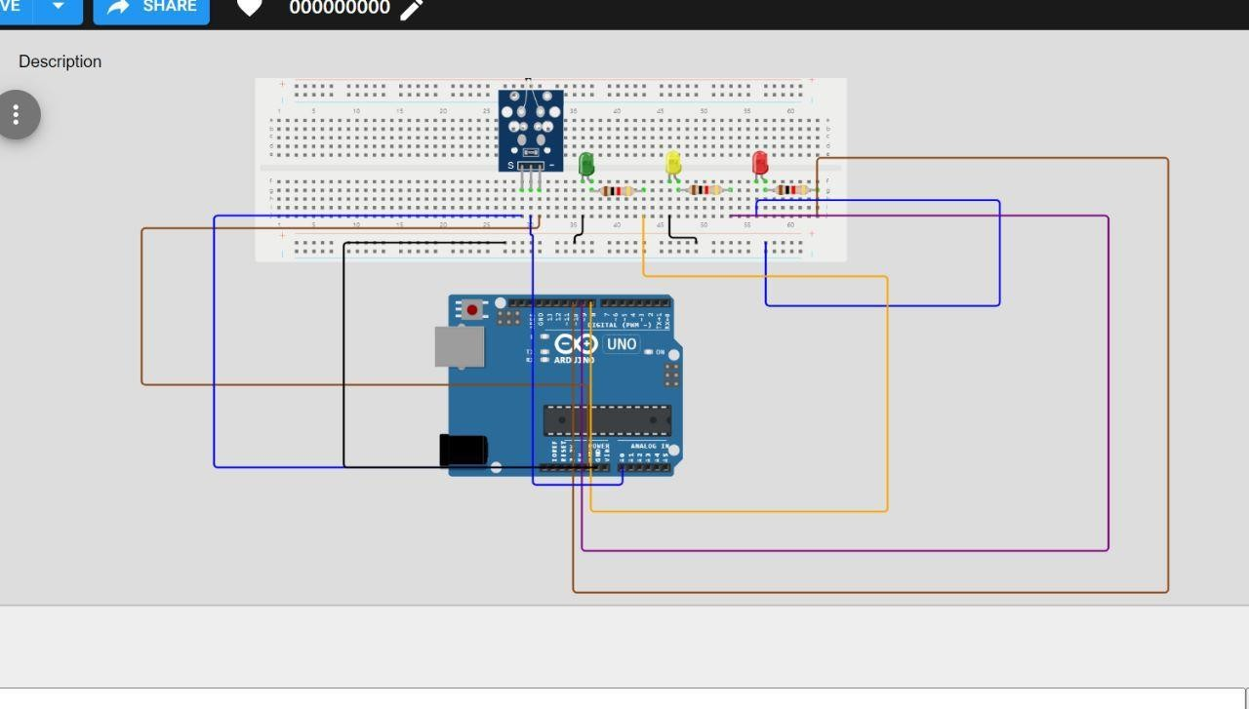

**Hardware setup:** negative temperature coefficient thermistor is connected to the one analog pin on the board. Green, red, and yellow LEDs are connected to equivalent digital pins on the board. (Mabrouki *et al.*, 2023)

**State definition:**

Three states are defined, low-temperature state for below 30 degrees Celsius, medium temperature for temperature between 30 to 45 degree Celsius and high temperature for above 45- degree temperature.

## Action in the state:

In this state, corresponding lights are turned on after analyzing the readings of the thermistor and analog-to-digital converter.

When the temperature is low, yellow light is turned on to indicate the temperature is below 30 degrees Celsius. (Mabrouki *et al.*, 2023)

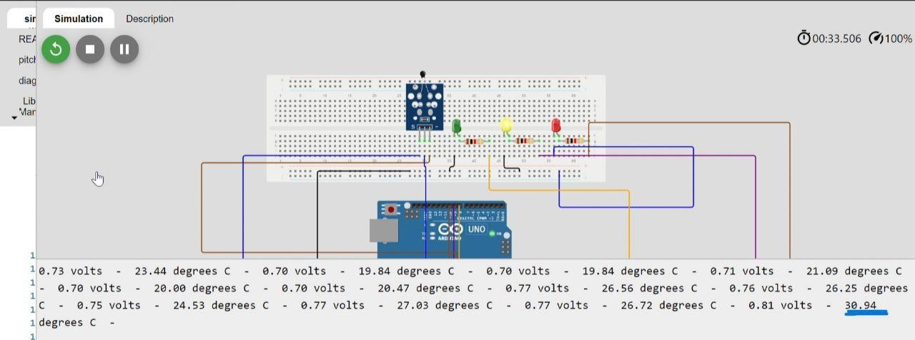

In the medium temperature range, which is between 30- and 45 degrees green light would turn on,

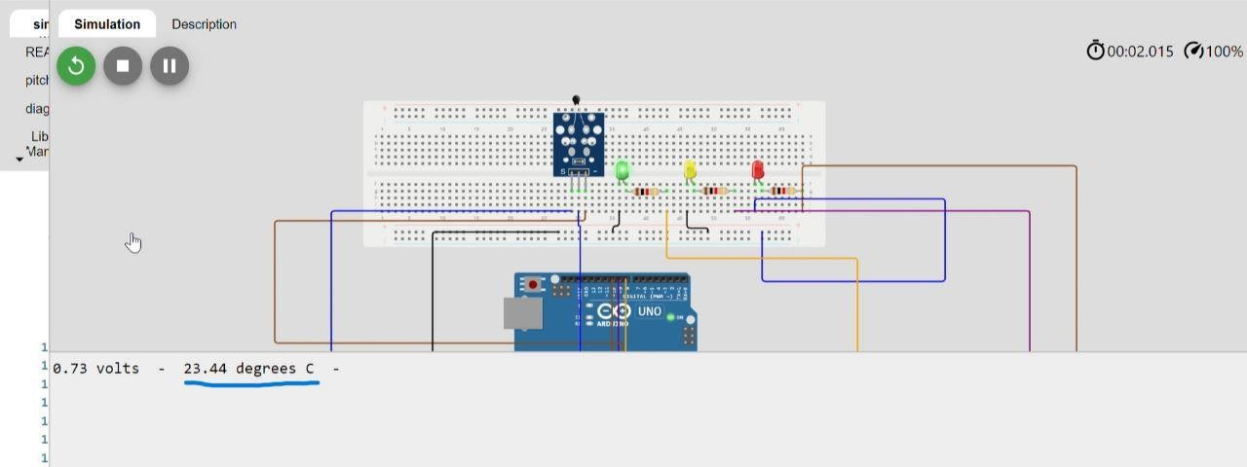

however, if the temperature exceeds 45 degrees, then the red light would turn on.

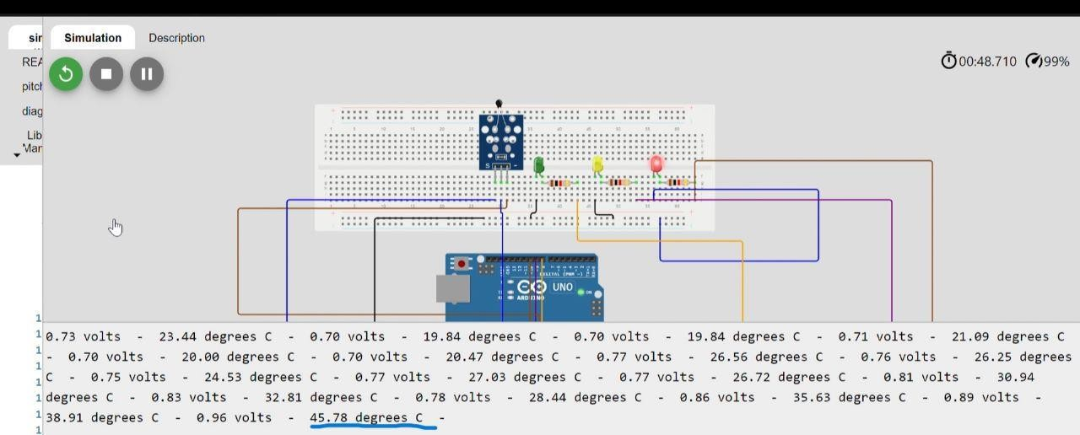

# Implementation of Task 1:

**Setup Function:** this function is called only once at the start of the program to configure an LED pin as an output pin using the pin mode function.

**Loop function:** this function is run in the main body of the program to ensure that the following functions are continuously running for the specified number of times.

* **Read analog value:** analog value from the thermistor is read using a function called analog read function and stored in the variable called thermistor value.
* **Convert analog value to temperature**: a function name convert to temperature is called to convert analog values to temperature in Celsius and then the resulting temperature is stored in a variable named temperature. (Debele and Qian, 2020)

# Pros and cons of Task 1:

## Pros:

**Modularity:** coding of the program is structured using functions that make it modular and easily understandable. Every single task is separated using functions like setup () and delay ().

**Readability:** codes are created using human-like words meaningful variable names, commented lines, and indentations that enhance the readability of the program, especially for someone who has to modify the code in the future. (Adriansyah and Dani, 2014)

## Cons:

**Lack of error handling:** for analog readings or LED control, the code does not include any error handling and validation. Due to a lack of error handling capability, if analog readings exceed range or the LED pins are not connected correctly then the code would not be able to handle such situations efficiently.

**Good programmer:** to modify or find errors in the future in the program, a good programmer is required even if the code is readable for a new programmer. (Adriansyah and Dani, 2014)

# Relevant areas of application:

This program can be applicable in environmental monitoring systems where the temperature is need to be controlled using electronic devices moreover it can also be used in-house to control heating and cooling devices based on temperature readings. (Adriansyah and Dani, 2014)

# Future enhancements:

Code can be further modified in the future to come up with **temperature unit conversion**, which means the temperature on a unit can be converted into different units like Fahrenheit and Kelvin with the application of suitable temperature formula.

With the help of the hysteresis technique, a delay or buffer of more or less than one second can be added to the temperature value to prevent LEDs from switching on and off rapidly near threshold values. (Adriansyah and Dani, 2014)

**Conclusion**

In this file we have created a code of temperature monitoring system to monitor temperature of enterprises, environmental areas, and housing areas extra. The purpose of this device is to indicated the temperature with LEDs. We have also write down its objectives, design purpose, technologies with alternative methods, pros and cons, and further enhancement

Reference list

Adriansyah, A. and Dani, A.W. (2014) Design of Small Smart Home system based on Arduino. *2014 Electrical Power, Electronics, Communicatons, Control and Informatics Seminar (EECCIS)*. [online].

Debele, G.M. and Qian, X. (2020) Automatic Room Temperature Control System Using Arduino UNO R3 and DHT11 Sensor. *2020 17th International Computer Conference on Wavelet Active Media Technology and Information Processing (ICCWAMTIP)*. [online].

Mabrouki, J., Azrour, M., Dhiba, D., Farhaoui, Y. and Hajjaji, S.E. (2023) IoT-based data logger for weather monitoring using arduino-based wireless sensor networks with remote graphical application and alerts. *Big Data Mining and Analytics*. [online]. 4 (1), pp.25–32.