TASK EXECUTION AGENT
Project Documentation
A local multi-agent task planning, research and execution application
Technology Stack
Python • CrewAI • Ollama • Qwen 2.5 • Streamlit • SQLite

Table of Contents
- 1. Abstract
- 2. Introduction
- 3. Project Objectives and Scope
- 4. System Architecture
- 5. Execution Workflow
- 6. Project Folder Structure
- 7. File-by-File Description
- 8. Libraries, Frameworks and Tools
- 9. Frontend – Streamlit Application
- 10. Example Execution
- 11. Database and Generated Outputs
- 12. Setup and Execution
- 13. Limitations and Future Enhancements
- 14. Conclusion

1. Abstract
The Task Execution Agent is a Python-based multi-agent application designed to accept a task written in natural language, organize the work into smaller steps, use appropriate tools to perform operations, and present a final response. The application uses CrewAI to coordinate specialized agents and a locally hosted Qwen 2.5 3B language model through Ollama. A Streamlit interface allows users to submit tasks, view execution results, download generated files, and review previous tasks. SQLite is used to persist task history. Custom tools support web searching, calculations, reading and writing files, and PDF generation.

2. Introduction
Many routine digital tasks involve several activities, such as understanding a request, planning the steps, collecting information, performing an operation, saving the result, and checking the output. A conventional chatbot generally responds with text, whereas a task execution system can connect language-model reasoning with Python functions that perform specific operations.
This project demonstrates a basic multi-agent approach. Each agent has a defined role. CrewAI manages the agents and their tasks in a sequential process. The language model is run locally using Ollama, avoiding the need for a paid hosted LLM API key in the configured local setup. The frontend is implemented in Streamlit.

3. Project Objectives and Scope
- Accept task instructions in natural language through a simple web interface.
- Break a user request into smaller, manageable steps.
- Use specialized AI agents for planning, research, execution and review.
- Allow agents to use custom Python tools for supported operations.
- Save task details and results in a local SQLite database.
- Generate downloadable text and PDF files where required.
- Provide dashboard and task-history pages for reviewing activity.
Scope note: the current implementation is a local prototype. It runs a predefined sequential workflow; it does not guarantee that every task can be completed autonomously or that every generated statement/file is independently verified.

4. System Architecture
The application is organized into a frontend layer, orchestration layer, agent/task layer, model configuration, tool layer, and persistence/output layer.
User
|
v
Streamlit Frontend (app.py)
|
v
Crew Orchestration (crew.py)
|----------------------|
v v
Task Definitions Agent Definitions
(tasks.py) (agents.py)
|
v
Local LLM Configuration
(config.py)
Ollama + Qwen 2.5
|
Sequential agent execution
|
v
Custom Tools (tools.py)
Web Search | Calculator | File I/O | PDF
|
---------------------------
| |
v v
Generated Files SQLite Database
outputs/ database.py
| |
-----------+---------------
v
Results shown in app.py

4.1 Main architectural components
Component | Responsibility
Frontend | Streamlit presents the Dashboard, New Task and Task History sections. It collects input and displays results.
Orchestration | CrewAI Crew in crew.py combines the agents and tasks and starts the sequential workflow using kickoff().
Agents and tasks | agents.py defines the specialized workers; tasks.py defines the instructions and expected outputs assigned to them.
LLM configuration | config.py configures CrewAI to use Qwen 2.5 3B served locally by Ollama through its OpenAI-compatible endpoint.
Tools | tools.py exposes Python functions that agents can call for web search, arithmetic, file operations and PDF generation.
Persistence | database.py uses SQLite to store task text, result, status and creation time. Generated files are stored in outputs/.

5. Execution Workflow
The current CrewAI process is sequential. The workflow is initiated when a user submits a task in the Streamlit interface.
- User input: The user enters a natural-language instruction in the New Task page and clicks Execute Task.
- Application entry: app.py validates the input and calls execute_task() from crew.py.
- Task creation: crew.py calls create_tasks() from tasks.py to construct the tasks and connect them to the corresponding agents.
- Planning: The Planner Agent interprets the request, breaks it into steps and identifies resources or tools that may be needed.
- Research: The Researcher Agent gathers relevant information. It can call the Web Search tool when external information is required.
- Execution: The Executor Agent performs the requested operations using available tools, such as Calculator, File Writer, File Reader or PDF Generator.
- Review: The Reviewer Agent examines the work and produces a final review/response based on the preceding task outputs.
- Persistence and display: The application stores the task result and status through database.py, then displays the result and generated-file download controls.
Not every task needs every tool. For example, a multiplication task can use the Calculator and File Writer tools without requiring web research. In the current fixed sequential design, however, the configured agent tasks are still part of the workflow unless the task design is changed.

6. Project Folder Structure
task_execution_agent/
|-- app.py # Streamlit user interface and application entry point
|-- agents.py # Definitions of all AI agents
|-- tools.py # Custom tools available to agents
|-- tasks.py # Task descriptions, expected outputs and context
|-- crew.py # CrewAI orchestration and kickoff()
|-- config.py # Local Qwen/Ollama LLM configuration
|-- database.py # SQLite database operations
|-- outputs/ # Generated text, Markdown and PDF files
|-- task_history.db # Local task-history database (created at runtime)
|-- requirements.txt # Python dependencies
|-- .gitignore # Files/folders excluded from Git
|-- .venv/ # Local Python virtual environment

7. File-by-File Description

app.py
Main Streamlit application. Initializes the database, displays Dashboard/New Task/Task History, accepts user input, calls execute_task(), saves the outcome, displays the result and offers downloads.

config.py
Creates and configures the CrewAI LLM object. It points to the local Ollama service and selects the Qwen 2.5 3B model. Agents import the configured LLM from this file.

agents.py
Defines the Planner, Researcher, Executor and Reviewer agents. Each agent has a role, goal, backstory, LLM, tool access and execution settings.

tools.py
Defines custom functions exposed to agents: web search, safe calculator, file reader, file writer and PDF generator. File operations are restricted to the outputs directory in the described implementation.

tasks.py
Defines the tasks assigned to each agent, including task descriptions, expected outputs and context dependencies between stages.

crew.py
Imports agents and task creation logic, builds the Crew with Process.sequential, invokes kickoff(), and returns the final result to the frontend.

database.py
Creates and accesses the SQLite task table. Provides functions to initialize the database, save tasks, retrieve task history and fetch a stored result.

8. Libraries, Frameworks and Tools
Library / Tool | Use in the project
Python | Core programming language used for application logic, agents, tools and database operations.
CrewAI | Multi-agent framework used to define agents, tasks, crews and sequential execution.
Ollama | Local model runner that serves the language model on the user's computer.
Qwen 2.5 3B | The configured local large language model used by the agents to interpret instructions and generate responses.
Streamlit | Python framework used to build the web-based frontend.
SQLite / sqlite3 | Local relational database used to store task history and results.
DuckDuckGo Search (DDGS) | Search library used by the Web Search tool to retrieve web search results.
ReportLab | Python library used to create PDF reports.
Requests | HTTP library available for making requests to local services or external endpoints where needed.
python-dotenv | Loads environment variables from a .env file if the project uses one.

8.1 Custom tools exposed to agents
Tool | Function
Web Search Tool | Searches for online information and returns result titles, links and descriptions.
Calculator Tool | Evaluates supported arithmetic expressions using a restricted/safe calculation approach.
File Reader Tool | Reads supported text files from the project's outputs directory.
File Writer Tool | Writes supported text or Markdown content into the outputs directory.
PDF Generator Tool | Creates a PDF report from supplied content and saves it in outputs/.

9. Frontend – Streamlit Application
The frontend is implemented with Streamlit and uses a sidebar for navigation. The three main sections are Dashboard, New Task and Task History.
Dashboard: Displays task counts (total, completed and failed) and a recent-task summary.
New Task: Provides a text area for the user's instruction and an Execute Task button. After execution, it displays the final reviewed response and available generated-file downloads.
Task History: Lists previously submitted tasks with their status and timestamp. A user can expand a task and view its saved result.

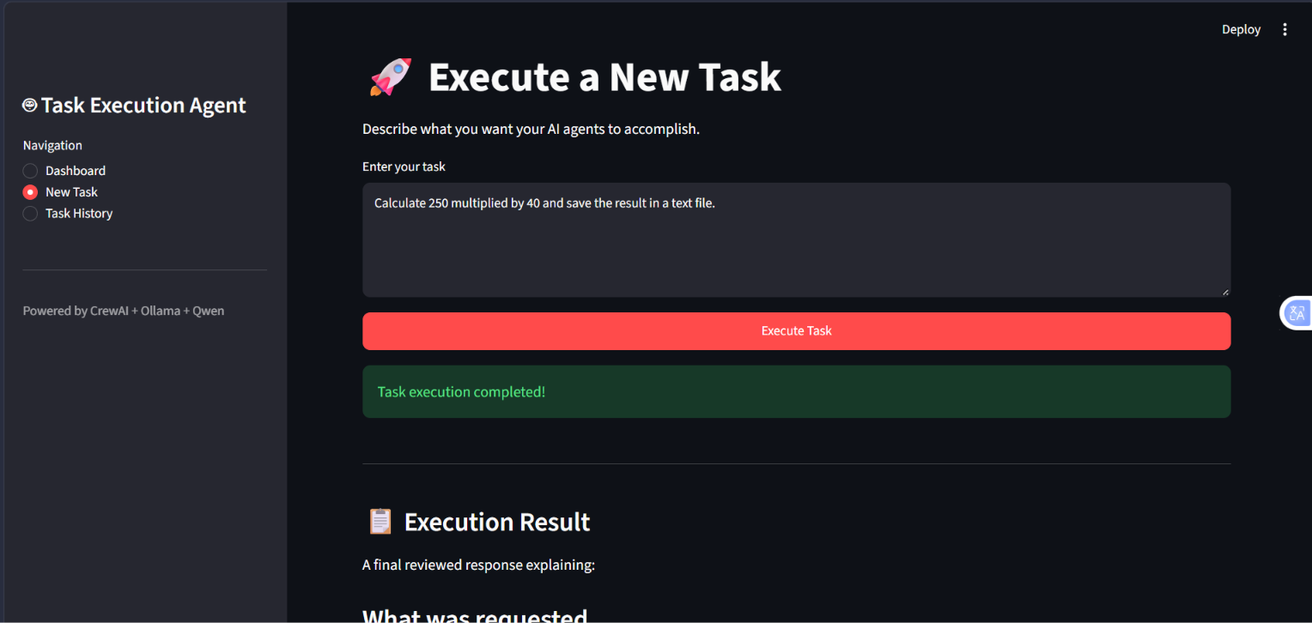
Figure 1. New Task page – users enter a task and start execution.

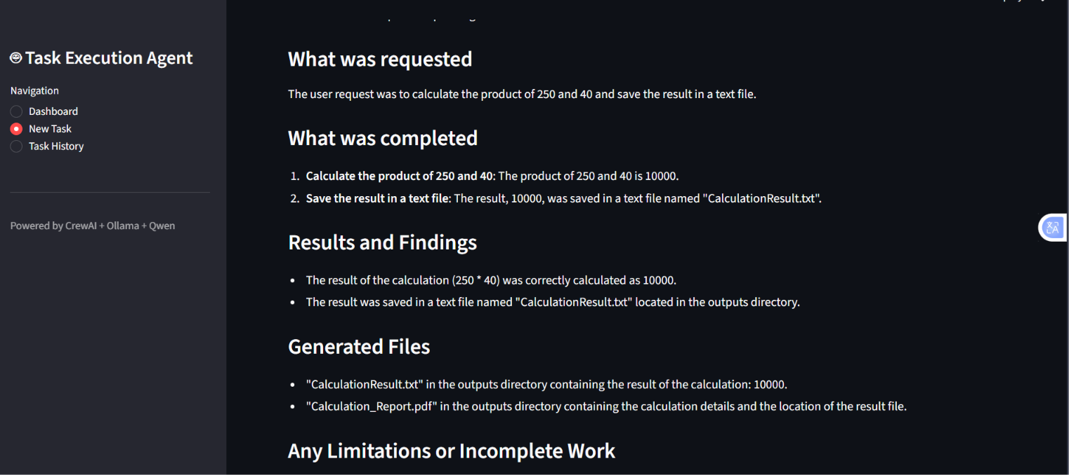
Figure 2. Execution Result – the application presents the reviewed result and completed operations.

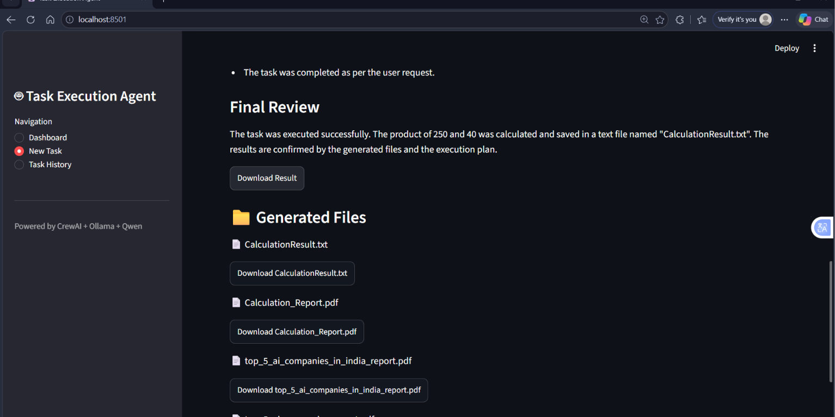
Figure 3. Generated Files – downloadable text and PDF outputs are listed.

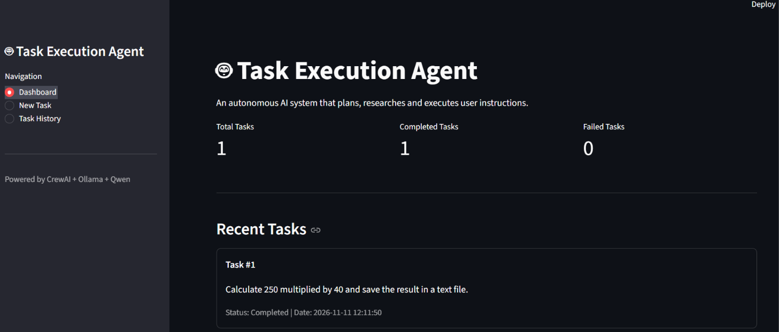
Figure 4. Dashboard – task statistics and recent task activity.

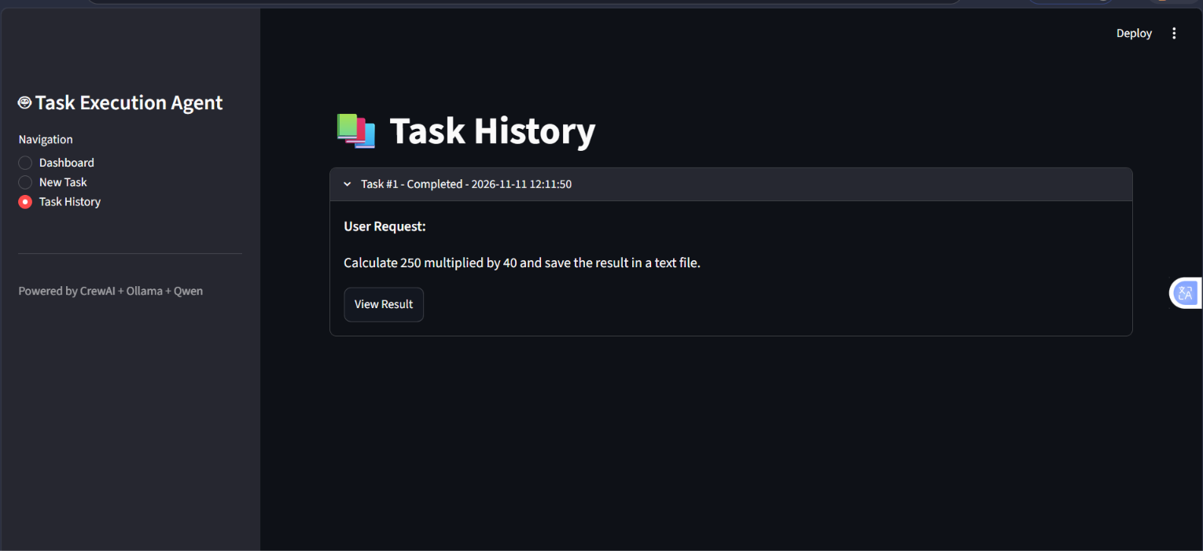
Figure 5. Task History – previously executed tasks can be opened to view their results.

10. Example Execution
Example user request:
"Calculate 250 multiplied by 40 and save the result in a text file."
The application demonstrated the following result:
- The multiplication was calculated: 250 × 40 = 10,000.
- The result was saved in CalculationResult.txt in the outputs directory.
- A PDF report named Calculation_Report.pdf was also listed in the generated files section.
- The final response was displayed in the New Task page and the task was stored in task history.
The screenshots supplied for this documentation show the application reporting this execution as completed. The example demonstrates the calculator, file-writing, PDF-generation, result-display and history features.

11. Database and Generated Outputs

11.1 SQLite task history
The database layer stores task records locally. The table described in the implementation contains an identifier, original task, result, status and creation timestamp. The Dashboard and Task History pages read these records to show activity and retrieve past results.

11.2 Output directory
Files generated by the agents are stored in the outputs directory. In the example shown in the screenshots, the application lists CalculationResult.txt and Calculation_Report.pdf. Other generated reports may also appear in this directory.

12. Setup and Execution
The following is the general local setup workflow. It assumes Python, Ollama and the required model are installed.
- Open a terminal in the project folder.
- Create and activate a virtual environment.
- Install the dependencies listed in requirements.txt.
- Start Ollama and ensure the configured Qwen model is available locally.
- Run the Streamlit application using the command below.
# Create a virtual environment (Windows PowerShell)
python -m venv .venv
# Activate it
.\.venv\Scripts\Activate.ps1
# Install project dependencies
pip install -r requirements.txt
# Start the application
streamlit run app.py
The model configured in config.py must match the model available in Ollama. The Ollama service must be running before agents make LLM requests. First test a short prompt directly with the local model if the application appears to wait without returning output.

13. Limitations and Future Enhancements

13.1 Current limitations
- The workflow is sequential and uses a fixed set of agent stages.
- Local model response time depends on the computer's CPU, GPU, memory and model-loading time.
- The quality of web research depends on search-result availability and the model's ability to summarize those results.
- The current interface uses a spinner/status message; it does not provide detailed live progress for every agent stage.
- The reviewer generates a review response, but this should not be treated as independent proof that every file or fact is correct.
- The tool set supports only the operations explicitly implemented in tools.py.

13.2 Possible future enhancements
- Show real-time progress for each agent and tool call in the Streamlit interface.
- Add robust error handling, timeouts, retry limits and clearer failure messages.
- Verify that generated files exist and contain the expected content before marking a task completed.
- Allow the planner to skip unnecessary stages or route tasks dynamically.
- Add user approval before sensitive or irreversible actions.
- Add support for more file types and additional tools.
- Add automated tests for tools, database operations and end-to-end task execution.
- Add task cancellation and background execution for long-running tasks.

14. Conclusion
The Task Execution Agent demonstrates how a local language model can be combined with a multi-agent framework and practical Python tools to carry out structured tasks. CrewAI coordinates the specialized agents, Ollama serves Qwen 2.5 locally, Streamlit provides the user interface, and SQLite stores task history. The project brings together core concepts in LLM applications, multi-agent orchestration, tool calling, frontend development and local data persistence.
The completed example shown in the frontend demonstrates a user submitting a calculation-and-file-saving request, receiving a reviewed result, downloading generated files, and viewing the task later through the dashboard and history pages.

