Experiment-10
Aim: Using the tables “DEPARTMENTS” and “EMPLOYEES” perform the following queries

Code:
(a) Employee details where department is same in both tables (INNER JOIN)
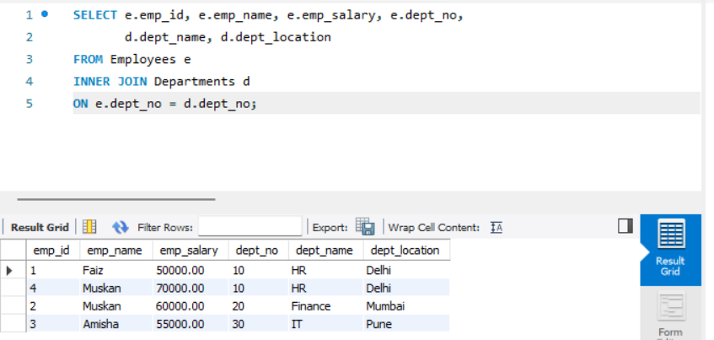

(b) Employee name and Department name (LEFT OUTER JOIN) 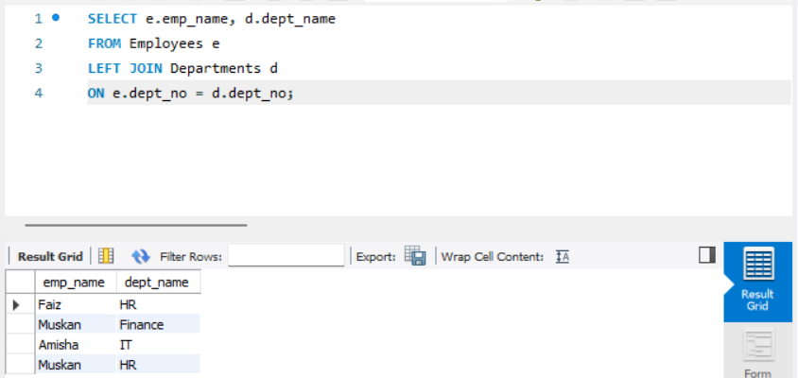
(c) Employee name and Department name (RIGHT OUTER JOIN)
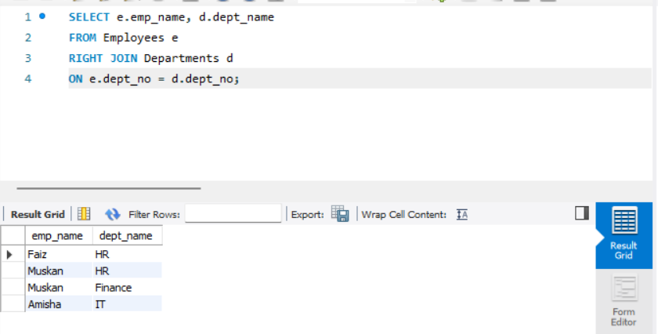

(d) Employees with salary greater than average salary