Experiment-5
Ques: EMPLOYEES (Employee_Id, First_Name, Last_Name, Email, Phone_Number, Hire_Date, Job_Id, Salary, Commission_Act, Manager_Id, Department_Id)
Code:
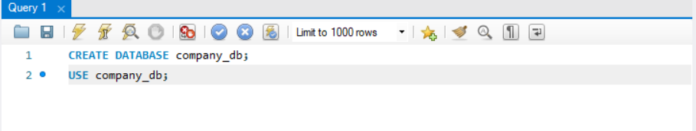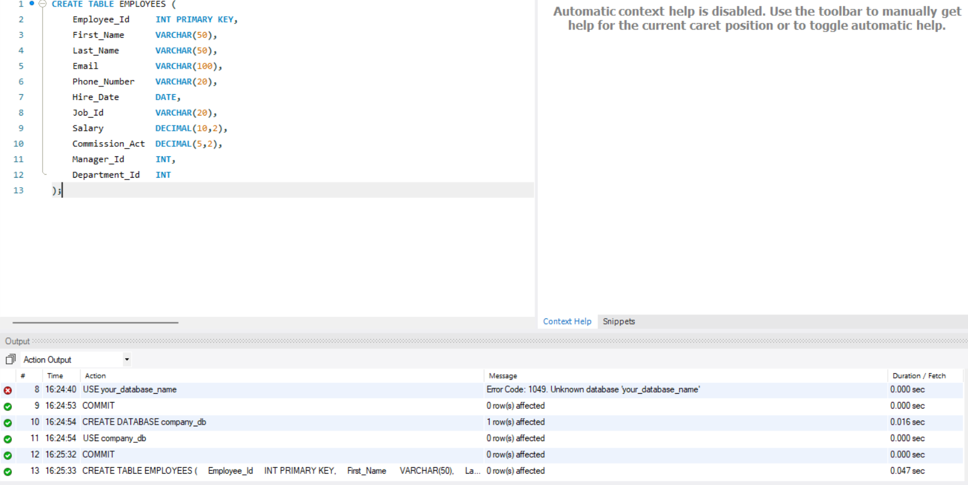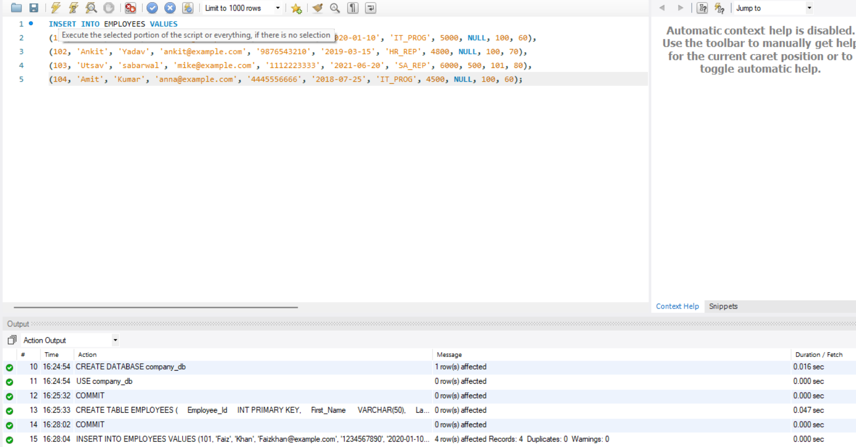
a) Find out the employee id, names, salaries of all the employees 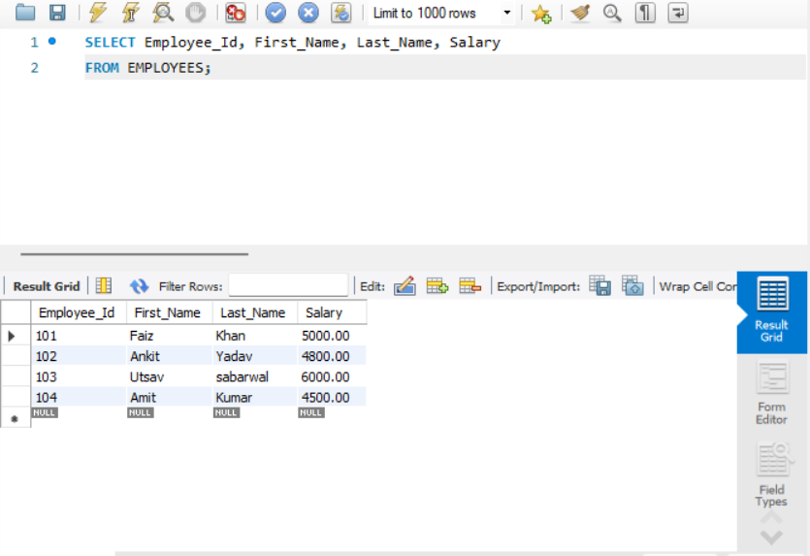

b) List out the employees who works under manager 100 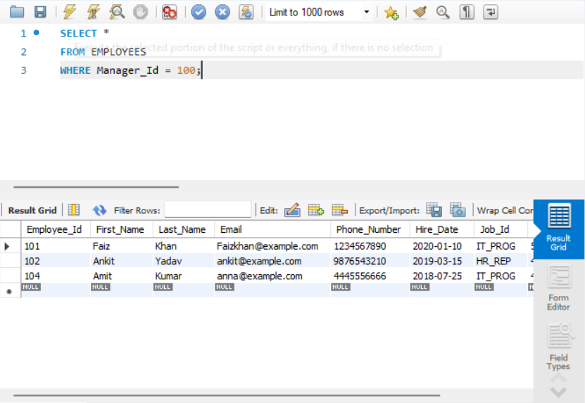

c) Find the names of the employees who have a salary greater than or equal to 4800 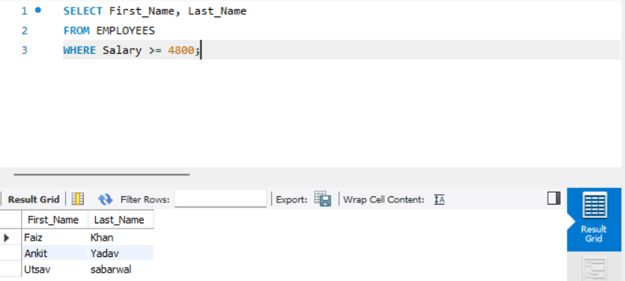
d) Employees whose last name is 'Khan'
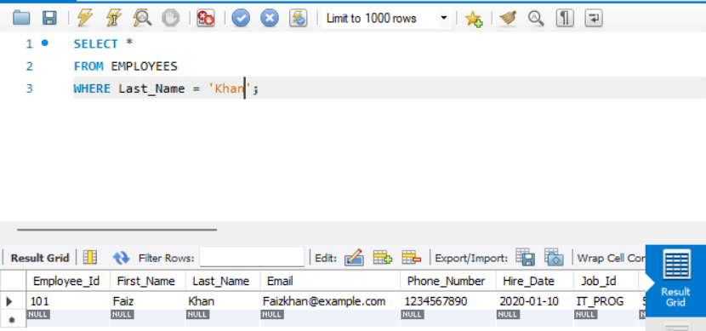
e) Employees working in departments 60, 70, and 80 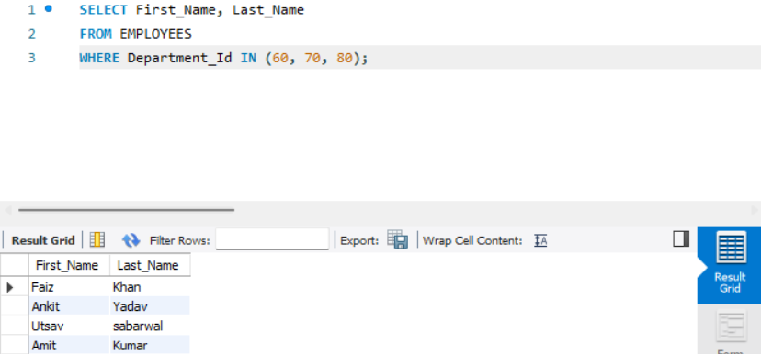
f) Display unique Manager_Id values 