Experiment-6
Ques: Create Client_master with the following fields (ClientNO, Name, Address, City, State, bal_due)
Code:
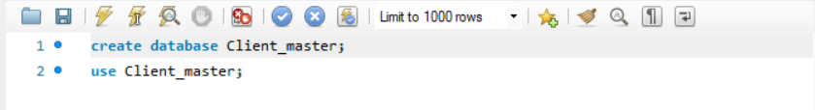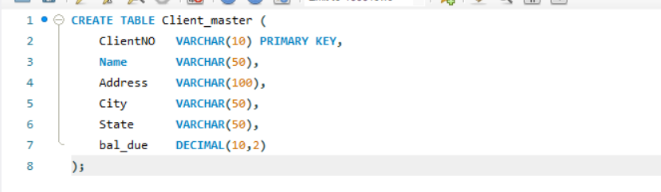
(a) Insert 5 Records
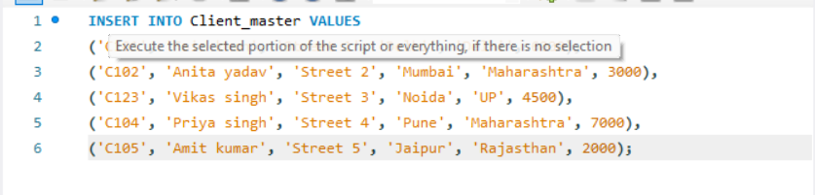
(b) Names of clients with bal_due > 5000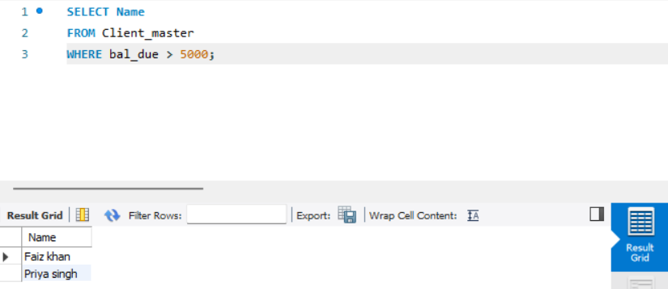
(c) Update bal_due of ClientNO “C123” to 5100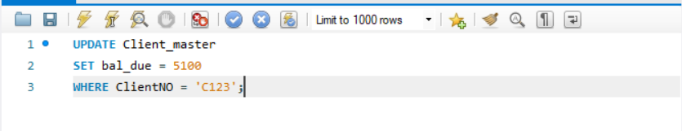
(d) Rename table Client_master to Client12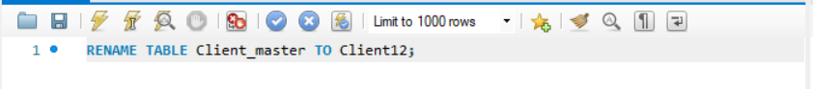
(e) Display bal_due heading as “BALANCE” 