Experiment-7
Aim: Rollback and Commit commands Create Teacher table with the following fields (Name, DeptNo, Date of joining, DeptName, Location, Salary)
CODE:
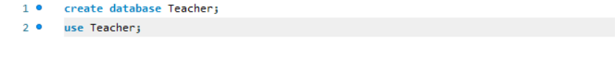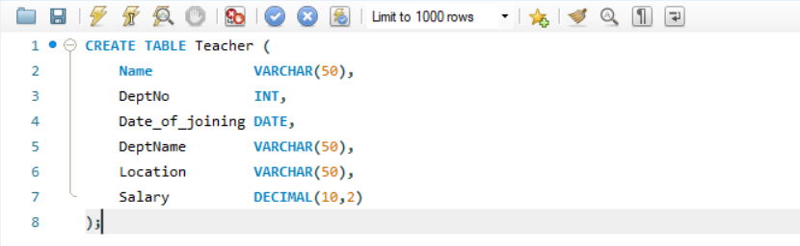
(a) Insert 5 Records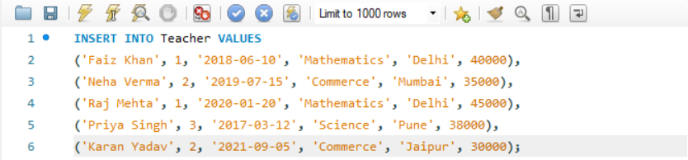
(b) Increase salary by 25% for Mathematics department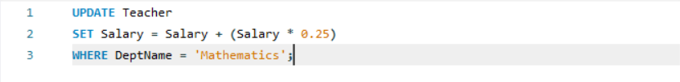
(c) Perform ROLLBACK
(d) Increase salary by 15% for Commerce department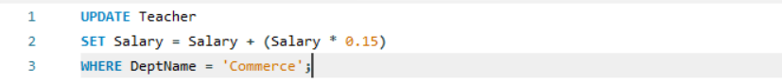
(e) Perform COMMIT

