Experiment-8
Aim; Create Sales table with the following fields ( Sales No, Salesname, Branch, Salesamount, DOB)
Code:
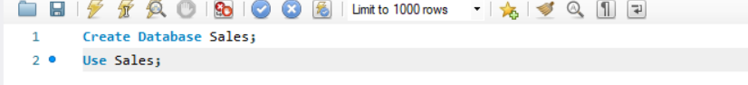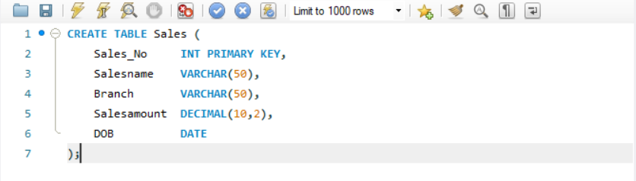
(a) Insert 5 Records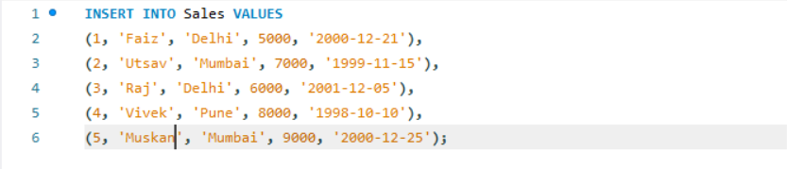
(b) Total sales amount in each branch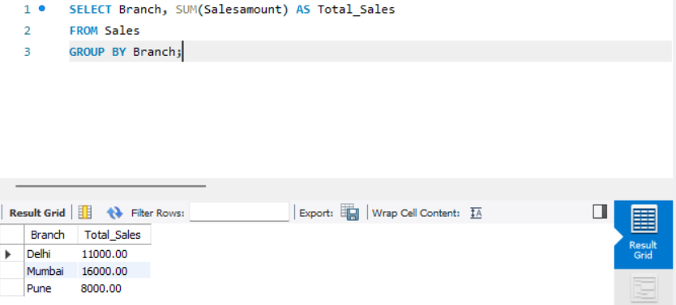
(c) Average sales amount in each branch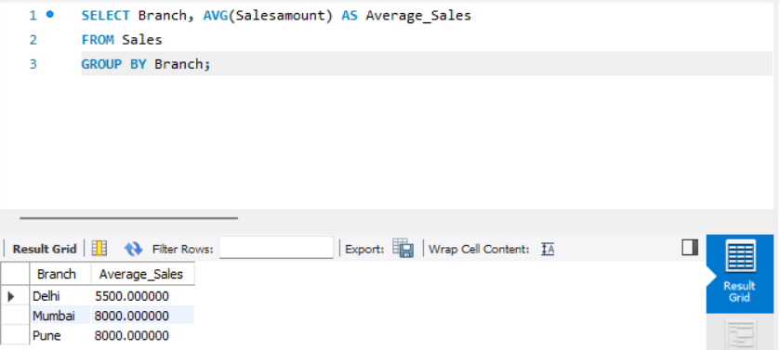
(d) Salesmen born in December (format: 21-Dec-09) 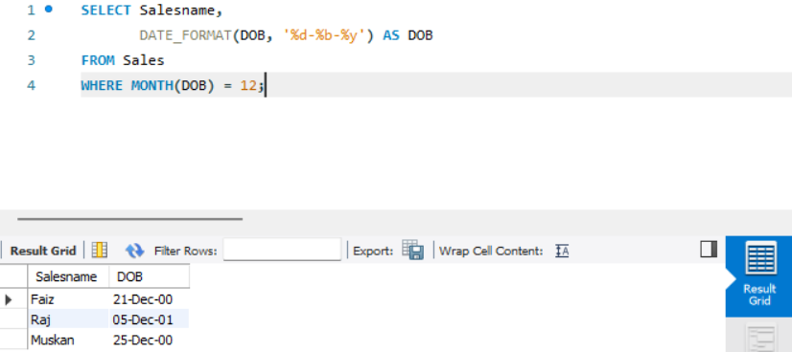
(e) Name and DOB in alphabetical order of month