Experiment-9
Aim: Consider the following tables namely “DEPARTMENTS” and “EMPLOYEES” Their schemas
Code:
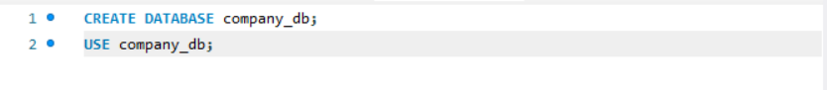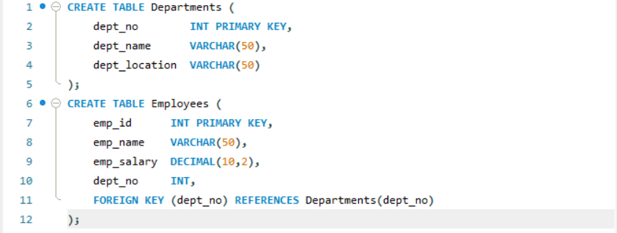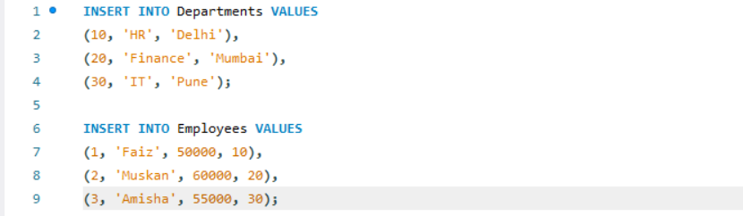
(a) Grant ALL privileges

(b) Grant SOME privileges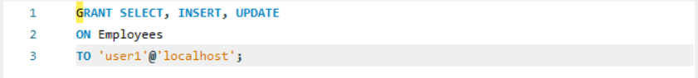
(c) Revoke ALL privileges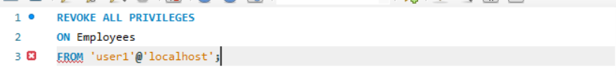
(d) Revoke SOME privileges