Experiment-4
Aim: Consider the following table: Table: CLASS
ID Name
1 Bravo
2 Alex
4 Cheng
Give the output of the following SQL script:
• INSERT INTO class VALUES (5,’Rahul’);
• COMMIT;
• UPDATE class SET name = ‘Abhijeet’ WHERE id= ‘5’;
• SAVEPOINT A;
• INSERT INTO class VALUES (6, ‘Chris’);
• SAVEPOINT B;
• INSERT INTO class VALUES (7, ‘Bravo’);
• SAVEPOINT C
• SELECT * FROM class;
• ROLLBACK TO B;
• SELECT * FROM class;
• ROLLBACK TO A;

Code: 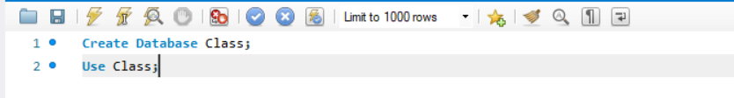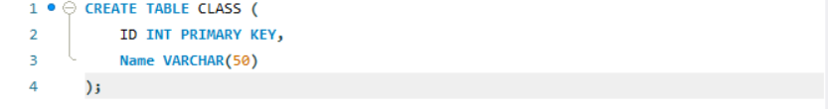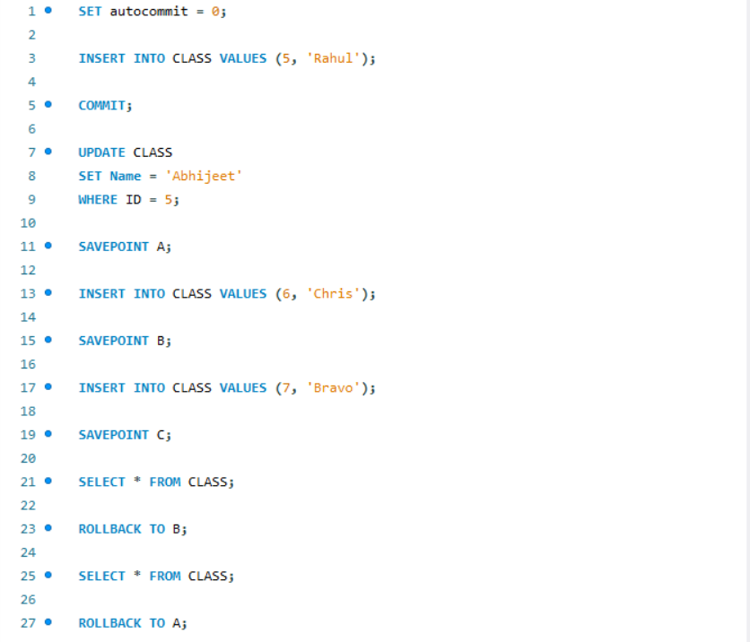

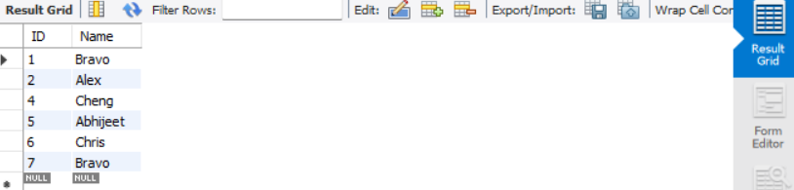

Experiment-4.2
Aim: Consider the following table: Table: ACCOUNT_TXN
Acc_ID Holder_Name Balance
101 Aman 5000
102 Bhavna 7000
103 Chirag 6000
Perform the following TCL-based SQL script and write the output after each SELECT statement:
INSERT INTO ACCOUNT_TXN VALUES (104, 'Diya', 4000);
SAVEPOINT S1;
UPDATE ACCOUNT_TXN SET Balance = Balance + 1500 WHERE Acc_ID = 101;
UPDATE ACCOUNT_TXN SET Balance = Balance - 1000 WHERE Acc_ID = 102;
SAVEPOINT S2;
DELETE FROM ACCOUNT_TXN WHERE Acc_ID = 103;
INSERT INTO ACCOUNT_TXN VALUES (105, 'Eshan', 3000);
SAVEPOINT S3;
UPDATE ACCOUNT_TXN SET Holder_Name = 'Bhavna Sharma' WHERE Acc_ID = 102;
SELECT * FROM ACCOUNT_TXN;
ROLLBACK TO S2;
SELECT * FROM ACCOUNT_TXN;
INSERT INTO ACCOUNT_TXN VALUES (106, 'Farah', 4500);
SAVEPOINT S4;
UPDATE ACCOUNT_TXN SET Balance = Balance + 500 WHERE Acc_ID IN (101,104);
SELECT * FROM ACCOUNT_TXN;
ROLLBACK TO S4;
SELECT * FROM ACCOUNT_TXN;
COMMIT;
Student Tasks
Write the output of all 4 SELECT statements in tabular format.Identify which rows are permanently saved after COMMIT.
Mention which operations were undone by:
ROLLBACK TO S2
ROLLBACK TO S4
Write the final state of the table after COMMIT.
Additional Challenge (Conceptual) 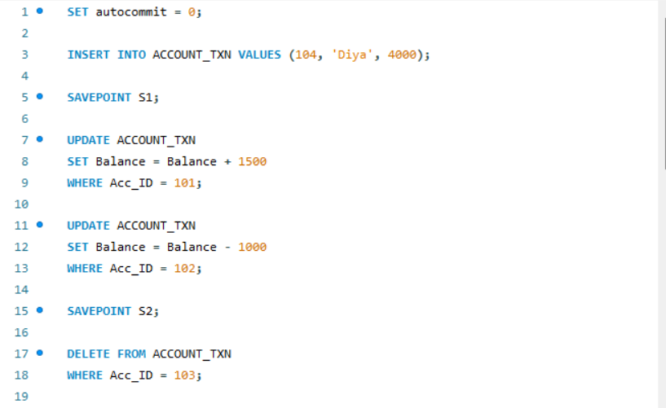
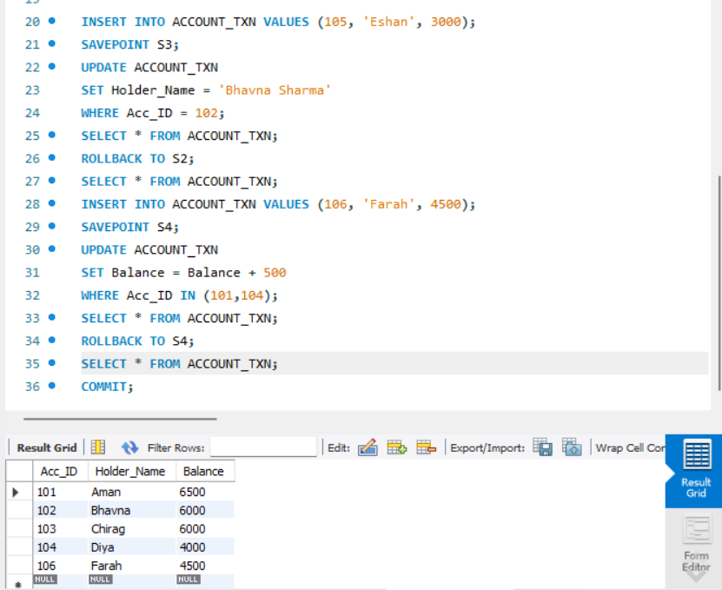
Answer the following:
Ques:What is the difference between ROLLBACK and ROLLBACK TO SAVEPOINT?
Ans: ROLLBACK
- Undoes all changes made in the current transaction
- Returns the database to the last committed state
- Does not require any savepoint
- Affects the entire transaction
- Simple and complete undo operation
ROLLBACK TO SAVEPOINT
- Undoes changes only up to a specific savepoint
- Does not cancel the entire transaction
- Requires a previously created SAVEPOINT
- Allows partial undo of changes
- Useful when working with large transactions

Ques: Can we rollback to S3 after ROLLBACK TO S2? Why/Why not?
Ans: No, we cannot rollback to S3 after performing ROLLBACK TO S2
Reason:
- When we execute ROLLBACK TO S2, all savepoints created after S2 are removed
- Since S3 was created after S2, it gets deleted
- Therefore, S3 no longer exists in the transaction

Ques: What happens if COMMIT is executed before creating any savepoint?
Ans:
- When COMMIT is executed, all changes made in the transaction are permanently saved in the database
- It ends the current transaction
- Since no SAVEPOINT was created, there is no intermediate point to return to
- After COMMIT, you cannot use ROLLBACK or ROLLBACK TO SAVEPOINT for those changes
- Any new operations will start a new transaction

