**Faizulin Artem Oleksandrovych** 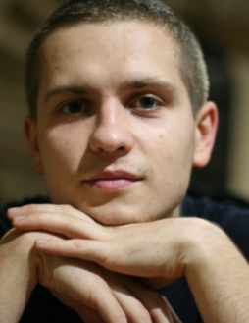

Date of birth: 22 Dec 1992

Location: Kyiv

Phone number: +380957022932

E-mail: artyom.fayzulin@gmail.com

# Front-end developer

Objective

To work on the exciting project to learn new technologies and software development practices.

Summary

**Front-end developer with 1+ years of experience**

Skill level:

PHP - intermediate

HTML (5) + CSS (3) - advanced

SASS / SCSS - advanced

Bootstrap - advanced

JavaScript, JQuery - advanced

Ajax - advanced

AngularJS - beginner

MySQL – intermediate

*Additional knowledge:* Codeigniter(MVC),Photoshop, SEO, JSON, GIT, OOP, Agile methodology

Experience

**Front-end developer**

Feb 2016 – June 2016 (6 months)

**Alser** ([http://alser.ua](http://alser.ua/))

50 to 100 employees; Construction

Responsibilities:

Developing six major websites of the company. Creating a frontend and backend scripts to improve the functionality and interface of the websites.

[***rolety.in.ua***](rolety.in.ua)[***karnizy.kiev.ua***](karnizy.kiev.ua)[***alservorota.com.ua***](alservorota.com.ua)[***zhalyuzi.org.ua***](zhalyuzi.org.ua)[***alseroboi.com.ua***](https://alseroboi.com.ua)

Projects:

**Site search**

The project was implemented by me in PHP (backend) and pure JavaScript (front-end).

**Admin panel**

Administrative panel on the principle has been established - a model view controller(MVC). In the admin panel was pulled template Altairv_2.3.0.

PHP, JQuery, MySQL, Ajax, CodeIgniter.

**Dynamic gallery of products**

The task was to create a gallery with photos that would be populated from a database, depending on the section from which it passed by. Also the user can select the section of interest to him and see all the photos without reloading the page.

PHP, JQuery, Ajax, MySQL.

Education

**Kyiv National Taras Shevchenko University** (Kyiv)

Physics, electronics and computer systems, Master Degree in solid-state electronic(Kyiv 2016).

Courses

**Kievprog**

Course Front-end developer (HTML, CSS, JS) - 3 months(Kyiv 2015).

**About myself**

Purposeful, fast learner, sociable. I like to share knowledge and learn from others. I'm really passionate about software development and tech in general. Hobbies - play video games, go to new restaurants (cafe, bars).