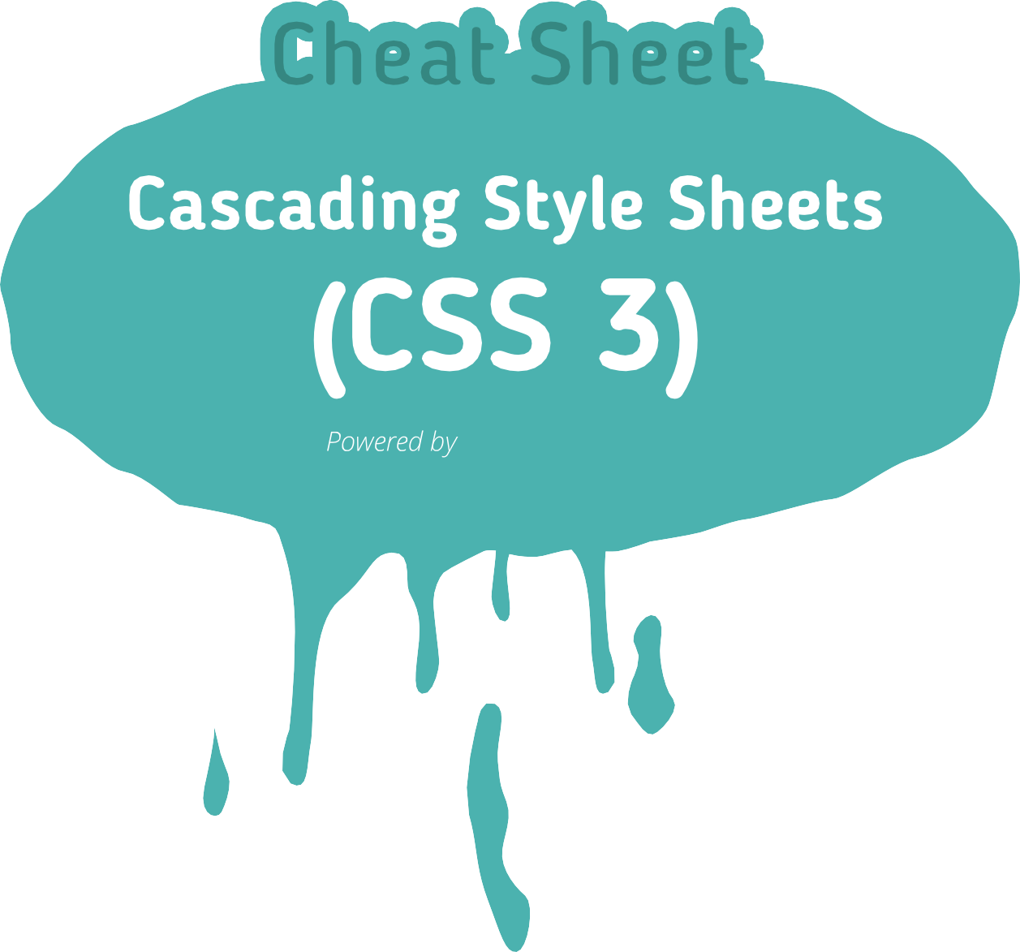

[www.hostinger.com](http://www.hostinger.com/)

BACKGROUND 1

BORDER 1

TABLE 1

BOX MODEL 2

TRANSITIONS 2

COLOR 3

FONT 3

ANIMATIONS 4

COLUMN 4

TEXT 4

SPEECH 5

TEMPLATE LAYOUT 5

3D / 2D TRANSFORM 6

GRID POSITIONING 6

HYPERLINK 6

LIST AND MARKERS 6

OUTLINE 6

GENERATED CONTENT 7

POSITIONING 7

RUBY 7

LINE BOX 8

PAGED MEDIA 8

PSUEDO-CLASS 9

PSUEDO-ELEMENTS 9

UI 9

UNITS 10

ANGELS 10

ABSOLUTE MEASUREMENT 10

COLORS 10

FREQUENCY 10

RELATIVE MEASUREMENT 10

TIME 10

SELECTOR TYPES 11



[www.hostinger.com](http://www.hostinger.com/)

## background

**background-attachment background-break**

## background-clip

**background-color**

## background-image

**background-origin**

## background-position

**background-repeat**

## background-size

*background-image background-position background-size background-repeat background-attachment background-origin background-clip background-color*

scroll | ﬁxed

bounding-box | each-box | continuous

*length*

*%*

border-box | padding-box | content-box | no-clip

*color*

transparent

*url*

none

border-box | padding-box | content-box

top left | top center | top right | center left | center center | center right | bottom left | bottom center

| bottom right

*x-% y-%*

*x-pos y-pos*

repeat | repeat-x | repeaty

| no-repeat

*length*

*%*

auto | cover | contain

## border

**border-break**

## border-bottom

**border-bottom-color border-bottom-style border-bottom-width**

## border-collapse border-color border-image

**border-left**

## border-left-color border-left-style border-left-width

**border-right**

## border-right-color

*border-width border-style border-color*

*border-width border-style color*

close

*border-bottom-width border-style*

*border-color border-color border-style*

thin | medium | thick

*length*

collapse | separate

*color image*

[ *number / % border-width*

stretch | repeat | round ] none

*border-left-width border-style border-color*

*border-color border-style*

thin | medium | thick

*length*

*border-right-width border-style border-color*

*border-color*

## border-collapse border-spacing caption-side empty-cells table-layout

collapse | separate

*length length*

top | bottom | left | right show | hide

table-layout auto | ﬁxed

## border-right-style border-right-width

*border-style*

thin | medium | thick

*length*



# [www.hostinger.com](http://www.hostinger.com/)

## border-top

**border-top-color border-top-style border-top-width**

## border-width

**border-radius**

## border-top-right-radius border-bottom-right-radius border-bottom-left-radius border-top-left-radius

**box-shadow**

## border-style

**transition**

## transition-delay transition-duration transition-property transition-timing-function

*border-top-width border-style border-color*

*border-color border-style*

thin | medium | thick

*length*

thin | medium | thick

*length*

*border-top-right-radius border-bottom-right-radius border-bottom-left-radius border-top-left-radius*

*length length length length*

inset || [ *length, length, length, length* || *<color>* ] none

none | hidden | dotted | dashed | solid | double | groove | ridge | inset | outset

transition-property transition-duration transition-timing-function transition-delay

time time

none | all

ease | linear | ease-in | ease-out | ease-in-out | cubic-Bezier (number, number, number, number)

## clear display

**ﬂoat**

## height

**max-height**

## max-width

**min-height**

## min-width

**width**

## margin

**margin-bottom**

## margin-left

**margin-right**

left | right | both | none

none | inline | block | inlineblock

| list-item | run-in | compact | table | inlinetable

| table-row-group |

table-header-group | tablefooter- group | table-row |

table-column-group | tablecolumn

| table-cell | tablecaption

| ruby | ruby-base |

ruby-text | ruby-base-group

| ruby-text-group

left | right | none auto

*length*

*%*

none

*length*

*%*

none

*length*

*%*

none | inherit

*length*

*%*

none | inherit

*length*

*%*

auto

*%*

*length*

*margin margin-top margin-right margin-bottom margin-left*

auto

*length*

*%*

auto

*length*

*%*

auto

*length*

*%*



# [www.hostinger.com](http://www.hostinger.com/)

## margin-top

**padding**

## padding-bottom

**padding-left**

## padding-right

**padding-top**

## marquee-direction marquee-loop

**marquee-play-count**

## marquee-speed marquee-style overﬂow

**overﬂow-style**

## overﬂow-x

**overﬂow-y**

## rotation rotation-point visibility

auto

*length*

*%*

*padding padding-top padding-right padding-bottom padding-left*

*length*

*%*

*length*

*%*

*length*

*%*

*length*

*%*

forward | reverse inﬁnite

*number*

inﬁnite

*integer*

slow | normal | fast scroll | slide | alternate visible | hidden | scroll |

auto | no-display | nocontent

*overﬂow-x overﬂow-y*

auto | marquee-line | marquee- block

visible | hidden | scroll | auto | no-display | nocontent

visible | hidden | scroll | auto | no-display | nocontent

*angle*

*position (paired value oﬀset)*

visibility visible | hidden | collapse

## font

**font-family**

## font-size

**font-size-adjust**

## font-stretch

**font-style**

## font-variant font-weight

## color

## opacity

*font-style font-variant font-weight*

*font-size/line-height font-family*

caption | icon | menu | message-box | smallcaption

| status-bar

*family-name generic-family* inherit

xx-small | x-small | small | medium | large | x-large | xx-large | smaller | larger | inherit

*length*

*%*

none| inherit

*number*

normal | wider | narrower |

ultra-condensed | extracondensed

| condensed | semi-condensed

| semiexpanded | expanded | extra-expanded | ultraexpanded

| inherit

normal | italic | oblique | inherit

normal | small-caps | inherit

normal | bold | bolder | lighter | 100 | 200 | 300 |

400 | 500 | 600 | 700 | 800

| 900 | inherit

inherit

*color*

inherit

*number*



# [www.hostinger.com](http://www.hostinger.com/)

## direction

**hanging-punctuation letter-spacing**

## punctuation-trim text-align

**text-align-last**

## text-decoration

**text-emphasis**

## text-indent

**text-justify**

## text-outline

**text-shadow**

## text-transform

**text-wrap**

## unicode-bidi white-space

**white-space-collapse**

## word-break

**word-spacing**

## word-wrap

ltr | rtl | inherit

none | [ start | end | endedge ] normal

*length*

*%*

none | [start | end | adjacent]

start | end | left | right | center | justify

start | end | left | right | center | justify

none | underline | overline | line-through | blink

none | [ [ accent | dot | circle

| disc] [ before | after ]? ]

*length*

*%*

auto | inter-word | interideograph

| inter-cluster | distribute | kashida | tibetan

none *color length*

none *color length*

none | capitalize | uppercase

| lowercase

normal | unrestricted | none

| suppress

normal | embed | bidioverride normal | pre | nowrap | prewrap

| pre-line

preserve | collapse | preserve- breaks | discard

normal | keep-all | loose | break-strict | break-all

normal

*length*

*%*

normal | break-word

## column-count

**column-ﬁll**

## column-gap

**column-rule**

## column-rule-color column-rule-style column-rule-width

**columns**

## column-span column-width

**animation**

## animation-delay animation-direction animation-duration animation-iteration-count

**animation-name animation-play-state animation-timing-function**

auto

*number*

auto | balance normal

*length*

*column-rule-width column-rule-style column-rule-color*

*color border-style*

thin | medium | thick

*length*

*column-width column-count*

1 | all auto

*length*

animation-name animation-duration animation-timing-function animation-delay animation-iteration-count animation-direction

time

normal | alternate time

inherit number

none | IDENT running | paused

ease | linear | ease-in | ease-out | ease-in-out | cubic-Bezier (number, number, number, number)



# [www.hostinger.com](http://www.hostinger.com/)

## cue

**cue-before**

## cue-after

**mark**

## mark-before mark-after pause

**pause-before**

## pause-after

**phonemes string rest**

## rest-before

**rest-after**

## speak

**voice-balance**

## voice-duration

*cue-before cue-after*

*uri* [ silent | x-soft | soft | medium | loud | x-loud] | none | inherit ]

*number*

*%*

*uri* [ silent | x-soft | soft | medium | loud | x-loud] | none | inherit ]

*number*

*%*

*mark-before mark-after*

*string string*

*pause-before pause-after*

none | x-weak | weak | medium | strong | x-strong

| inherit

*time*

none | x-weak | weak | medium | strong | x-strong

| inherit

*time string*

rest-before rest-after

none | x-weak | weak | medium | strong | x-strong

| inherit

*time*

none | x-weak | weak | medium | strong | x-strong

| inherit

*time*

none | normal | spell-out | digits | literal-punctuation | no-punctuation | inherit

left | center | right | leftwards

| rightwards | inherit

*number time*

## voice-family

**voice-rate**

## voice-pitch

**voice-pitch-range**

## voice-stress

**voice-volume**

## box-align box-direction box-ﬂex

**box-ﬂex-group**

## box-lines box-orient

**box-pack box-sizing**

## tab-side

inherit | [ <speciﬁc-voice, age, generic-voice, number> ]

x-slow | slow | medium | fast | x-fast | inherit

*%*

x-low | low | medium | high

| x-high | inherit

*number*

*%*

x-low | low | medium | high

| x-high | inherit

*number*

strong | moderate | none | reduced | inherit

silent | x-soft | soft | medium

| loud | x-loud | inherit

*number*

*%*

start | end | center | base normal | reverse

*number integer*

single | multiple

horizontal | vertical | inlineaxis

| block-axis

start | end | center | justify

content-box | padding-box | border-box | margin-box

top | bottom | left | right

# [www.hostinger.com](http://www.hostinger.com/)



## list-style

**list-style-image**

## list-style-position list-style-type

**marker-oﬀset**

## grid-columns

**grid-rows**

*list-style-type*

*list-style-position list-style-image*

none

*url*

Inside | outside

none | asterisks | box | check | circle | diamond | disc | hyphen | square |

decimal | decimal-leadingzero

| lower-roman | upperroman

| lower-alpha | upper- alpha | lower-greek | lower-latin | upper-latin |

hebrew | armenian | georgian

| cjk-ideographic |

hiragana | katakana | hiragana- iroha | katakana-iroha

| footnotes

auto

*length*

none | inherit

*[ length percentage relative length ]*

none | inherit

*[ length percentage relative length ]*

## backface-visibility perspective

**perspective-origin**

## transform

**transform-origin**

## transform-style

visible | hidden

none

*number*

*[ [ [ percentage>* | *<length>* |

left | center | right *] [*

*<percentage>* | *<length>* | top

| center | bottom *]? ] <length> ]*

| *[ [ [* left | center | right *]* ||

*[* top | center | bottom *] ]*

*<length> ]*

none | matrix | matrix3d | translate3d | translateX | translateY | translateZ | scale | scale3d | scaleX | scaleY | scaleZ | rotate | rotate3d | rotateX | rotateY

| rotateZ | skewX | skewY | skew | perspective

*[ [ [ <percentage>* |

*<length>* | left | center | right *] [ <percentage>* |

*<length>* | top | center |

bottom *]? ] <length> ]* |

*[ [ [* left | center | right *] || [* top | center | bottom *] ]*

*<length> ]*

ﬂat | preserve-3d



## outline

**outline-color**

## outline-oﬀset

**outline-style**

## outline-width

*outline-color outline-style outline-width*

*color*

invert

inherit

*length*

None | dotted | dashed | solid | double | groove | ridge | inset | outset

thin | medium | thick

*length*

## target

**target-name**

**target-new target-position**

# [www.hostinger.com](http://www.hostinger.com/)

*target-name target-new target-position*

current | root | parent | new

| modal

*string*

window | tab | none

above | behind | front | back



## bookmark-label

**bookmark-level**

## bookmark-target

**border-length**

## content

**counter-increment**

## counter-reset

**crop**

## display

**ﬂoat-oﬀset**

## hyphenate-after

**hyphenate-before**

## hyphenate-character

**hyphenate-lines**

## hyphenate-resource

content *attr string*

none

*integer*

self *uri attr*

auto

*length*

normal | none | inhibit

*uri*

none

*identiﬁer number*

none

*identiﬁer number*

auto

*shape*

normal | none | list-item

*length length*

auto

*integer*

auto

*integer*

auto

*integer*

no-limit

*integer*

none

*uri*

## string-set

**text-replace**

## bottom

**clip**

## left

**position right**

## top

**z-index**

## ruby-align

*identiﬁer*

*content-list*

none

*[<string> <string>]+*

auto

*%*

*length*

*shape*

auto

auto

*%*

*length*

static | relative | absolute | ﬁxed auto

*%*

*length*

auto

*%*

*length*

auto

*number*

auto | start | left | center | end | right | distribute-letter

| distribute-space | lineedge

**hyphens** none | manual | auto



## image-resolution

**marks move-to**

## page-policy quotes

normal | auto

*dpi*

[ crop || cross ] | none normal | here

*identiﬁer*

start | ﬁrst | last none

*string string string string*

**ruby-overhang ruby-position ruby-span**

# [www.hostinger.com](http://www.hostinger.com/)

auto | start | end | none before | after | right | inline attr(x) | none



## alignment-adjust

auto | baseline | beforeedge

| text-before-edge |

middle | central | after-edge

| text-after-edge | ideographic

| alphabetic | hanging

| mathematical

*length*

*%*

## line-stacking

**line-stacking-strategy**

## line-stacking-ruby

*line-stacking-strategy line-stacking-ruby line-stacking-shift*

inline-line-height | blockline- height | max-height |

grid-height

exclude-ruby | include-ruby

**alignment-baseline** baseline | use-script | before-

## baseline-shift

**dominant-baseline**

## drop-initial-after-align drop-initial-after-adjust

**drop-initial-before-align**

edge | text-beforeedge

| after-edge | textafter- edge | central | middle

| ideographic | alphabetic | hanging | mathematical

baseline | sub | super

*length*

*%*

auto | use-script | nochange

| reset-size | alphabetic

| hanging | ideographic

| mathematical |

central | middle | text-after- edge | text-before-edge

*alignment-baseline*

central | middle | after-edge

| text-after-edge | ideographic

| alphabetic | mathematical length

%

caps-height

*alignment-baseline*

## line-stacking-shift text-height

**vertical-align**

## ﬁt

**ﬁt-position**

## image-orientation

**orphans**

consider-shifts | disregardshifts

auto | font-size | text-size | max-size

Baseline | sub | super | top

| text-top | middle | bottom

| text-bottom

*length*

*%*

ﬁll | hidden | meet | slice

[top | center | bottom] || [left | center | right] *length*

*%*

auto

*angle integer*

**drop-initial-before-adjust** before-edge | text-beforeedge

| central | middle | hanging | mathematical *length*

*%*

## page

**page-break-after**

auto

*identiﬁer*

auto | always | avoid | left | right



## drop-initial-value

**drop-initial-size**

## inline-box-align

**line-height**

initial integer

auto

*integer*

*%*

*line*

initial | last

*integer*

normal *number length*

*%*

## page-break-before

**page-break-inside size**

**windows**

# [www.hostinger.com](http://www.hostinger.com/)

auto | always | avoid | left | right

auto | avoid

auto | landscape | portrait

*length integer*



## appearance

normal | inherit | [icon | window | desktop | workspace

| document | tooltip | dialog | button | pushbutton | hyperlink

| radiobutton | checkbox |

## :active

**:focus**

## :visited

an activated element

an element while the element has focus

a visited link

menuitem | tab | menu | menubar

| pull-down-menu | pop-up-menu

## :hover

an element when you mouse over it

| list-menu | radio-group |

## cursor

checkboxgroup | outline-tree | range | ﬁeld | combo-box | signature | password]

auto | crosshair | default | pointer

| move | e-resize | ne-resize |

## :link

**:disabled**

## :enabled

an unvisited link

an element while the element is disabled

an element while the element is enabled

nw-resize | nresize | se-resize |

## icon

**nav-index**

## nav-up

**nav-right**

## nav-down

**nav-left**

## resize

**::ﬁrst-letter**

## ::ﬁrst-line

sw-resize | s-resize | w-resize | text | wait | help

*url*

auto | inherit

*url*

auto | inherit

*number*

auto | inherit

*<id> [ current | root |*

*<target-name> ]*

auto | inherit

*<id> [ current | root |*

*<target-name> ]*

auto | inherit

*<id> [ current | root |*

*<target-name> ]*

auto | inherit

*<id> [ current | root |*

*<target-name> ]*

none | both | horizontal | vertical | inherit

Adds special style to the ﬁrst letter of a text

Adds special style to the ﬁrst line of a text

## :checked

**:selection**

## :lang

**:nth-child(n)**

## :nth-last-child(n)

**:ﬁrst-child**

## :last-child

**:only-child**

## :nth-of-type(n)

**:nth-last-of-type(n)**

## :last-of-type

**:ﬁrst-of-type**

## :only-of-type

**:empty**

## :root

**:not(x)**

an element (form element control) that is checked

an element that is currently selected of highlighted by the user

Allows the author to specify

a language to use in a speciﬁed element

an element that is the n-th sibling

an element that is the n-th sibling counting from the last sibling

an element that is the ﬁrst sibling an element that is the last sibling an element that is the only child

an element that is the n-th sibling of its type.

an element that is the n-th sibling of its type counting from the last sibling

an element that is the ﬁrst sibling of its type

an element that is the last sibling of its type

an element that is the only child of that type

an element that has no children root element within the document an element not represented

by the argument ‘x’

**::before** Inserts some content before

an element

Inserts some content after an element

## :target

a target element as speciﬁed by a target in a URI



**::after**

# [www.hostinger.com](http://www.hostinger.com/)

**UNITS**

**s**

seconds

## ch

**em**

## ex gd px rem vh vw vm

width of the "0" glyph found in the font for the font size used to render

1em = current font size of current element

x-height of the element's font the grid deﬁned by 'layout-grid' pixel of the viewing device

the font size of the root element the viewport's height

the viewport's width

viewport's height or width, whichever is smaller of the two

## color name rgb(x,y,z)

**rgb(x%,y%,z%) rgba(x,y,z, alpha) #rrggbb**

## hsl(hue, saturation, lightness)

**hsla(hue, saturation, lightness, alpha)**

## ﬂavor

**currentColor**

red, blue, green, dark green red = rgb(255,0,0)

red = rgb(100%,0,0) red = rgba(255,0,0)

red = #ﬀ0000 (or shorthand = #f00)

red = hsl(0, 100%, 50%)

red = hsl(0, 100%, 50%)

An accent color (typically chosen by the user) to customize the user interface of the user agent itself

computed value of the 'currentColor' keyword is the computed value of the 'color' property

## deg grad rad turn



**%**

percentage

**Hz**

hertz

**cm**

centimeter

**kHz**

kilo-hertz

**in**

inch

**mm**

millimeter

**pc**

pica (1p = 12 points)

**pt**

point (1pt = 1/72 inch)

**ms**

milli-seconds



degrees grads radians turns

# [www.hostinger.com](http://www.hostinger.com/)

**SELECTOR TYPES**

## Universal Type

**Grouping Class**

## Id

**Descendant**

## Child

**Adjacent Sibling**

## General Sibling

**Attribute**

Any element

Any element of that type

Multiple elements of diﬀerent types

Multiple elements of diﬀerent types when you don’t want to aﬀect all instances of that type

A single element type when you don’t want to aﬀect all instances of that type

An element that is below (in the document tree) another element—no matter how many levels below

An element that is directly below

(in the document tree) another element

All elements that share the same parent and elements are in the same immediate sequence

All elements that share the same parent and elements are in the same sequence (not necessarily immediate)

An element with that matches the attribute listed

* { font: 10px Arial; }

h1 { text-decoration: underline; }

h1, h2, h3 { font-family: Verdana; }

.sampleclass { textdecoration: underline; }

#sampleid { textdecoration: underline; }

#gallery h1 { textdecoration: underline; }

#title > p { font-weight: bold; }

h1 + p { font-style: italic; }

h1 ~ p { font-style: italic; }

E[selected] - att whatever the value E[att="val"] - att with a speciﬁc value E[rel~="next"] - att with a value is

a whitespace separated list

*[lang|="en"] - att value either being exactly "val" or beginning with "val" immediately followed by "-"

E[att^="val"] - att value that begins with the preﬁx "val" E[att$="val"] - att value that end with the suﬃx "val" E[att*="val"] - att value contains at least one instance of the substring "val"



# [www.hostinger.com](http://www.hostinger.com/)