Software Architecture and Design
Specification (SAD)
Automated Meeting Minutes Generator

Field | Details
Project | Automated Meeting Minutes Generator (MiniMax)
Version | 1.0
Date | September 2026
Authors | Mohammed Faizan, Kamal Kanth N, Vinay M Rampur, Anagha Kaushik
Status | Draft

Team Members & SRN
Name | SRN | Role
Mohammed Faizan | PES1UG24AM472 | Team Lead / Backend
Vinay M Rampur | PES1UG24AM455 | Backend Developer
Kamal Kanth N | PES1UG24AM434 | Frontend Developer
Anagha Kaushik | PES1UG24AM459 | Testing & Documentation

Revision History
Version | Date | Author | Change Summary
0.1 | DD-MM-2026 | Mohammed Faizan | Architecture and component design
0.2 | DD-MM-2026 | Vinay M Rampur | API design and sequence diagrams
0.3 | DD-MM-2026 | Kamal Kanth N | UX design and wireframes
0.4 | DD-MM-2026 | Anagha Kaushik | Security architecture, DB design, error handling
1.0 | DD-MM-2026 | All | Final reviewed version

Approvals
Role | Name | Signature / Email | Date
Course Coordinator

Table of Contents
- 1. Introduction
- 2. Document Overview
- 3. Architecture
- 4. Design
- 5. Appendices

1. Introduction

1.1 Purpose
This document specifies the software architecture and detailed design of the Automated Meeting Minutes Generator system. It translates the requirements defined in the SRS (v1.0) into a concrete technical blueprint that developers can follow to implement the system.

1.2 Scope
This document covers the architecture and design of the complete Meeting Minutes Generator system, including:
- The web-based frontend for audio upload, minutes viewing, and history browsing
- The backend REST API server
- The processing pipeline (Transcription stub, Text Extraction, Document Generation)
- The data persistence layer (SQLite database)
- Security architecture and threat modeling

1.3 Audience
- Developers — to understand the system architecture and implement modules
- QA Engineers — to understand component boundaries for test planning
- Security Auditors — to review the threat model and security controls
- Course Instructors — to evaluate design quality and SE process adherence
- Maintenance Teams — to understand the system for future modifications

1.4 Definitions
Term | Definition
SAD | Software Architecture and Design Document
SRS | Software Requirements Specification
STP | Software Test Plan
RTM | Requirements Traceability Matrix
REST | Representational State Transfer
API | Application Programming Interface
ORM | Object-Relational Mapping
STRIDE | Spoofing, Tampering, Repudiation, Information Disclosure, DoS, Elevation of Privilege
CRUD | Create, Read, Update, Delete
JWT | JSON Web Token
CORS | Cross-Origin Resource Sharing

2. Document Overview

2.1 How to Use This Document
This document provides architectural deliverables including:
- Section 3 (Architecture): High-level system architecture, component diagrams, technology choices, security threat model, and traceability to SRS requirements.
- Section 4 (Design): Detailed module design with UML sequence diagrams, REST API specifications, database schema, error handling strategy, and UX wireframes.
Read Section 3 first for the big picture, then Section 4 for implementation details.

2.2 Related Documents
Document | Version | Description
SRS | v1.0 | Software Requirements Specification — defines what the system must do
STP | v1.0 (pending) | Software Test Plan — defines how the system will be tested
RTM | v1.0 | Requirements Traceability Matrix — maps requirements to modules and tests

3. Architecture

3.1 Goals & Constraints
Goals:
- Modularity — Each processing stage is an independent module that can be developed, tested, and replaced independently
- Extensibility — The stub transcription module can be swapped for a real ASR engine without changing the rest of the pipeline
- Simplicity — Use straightforward, well-documented technologies suitable for a team of 4 developers
- Security — Protect user credentials and ensure data isolation between users

Constraints:
- Transcription is a stub — no real speech recognition
- Must use open-source libraries only
- Single-tenant deployment (one team/organization)
- Audio file size limited to 100 MB
- Must run on standard hardware (no GPU required)

3.2 Stakeholders & Concerns
Stakeholder | Concerns
Users (Meeting Organizer) | Fast processing, intuitive UI, accurate extraction, reliable PDF export
Developers | Clean module boundaries, simple APIs, easy debugging
Course Instructor | Proper SE process, clear architecture documentation, adherence to design patterns
QA Team | Testable components, clear interfaces, reproducible results

3.3 Component (UML) Diagram
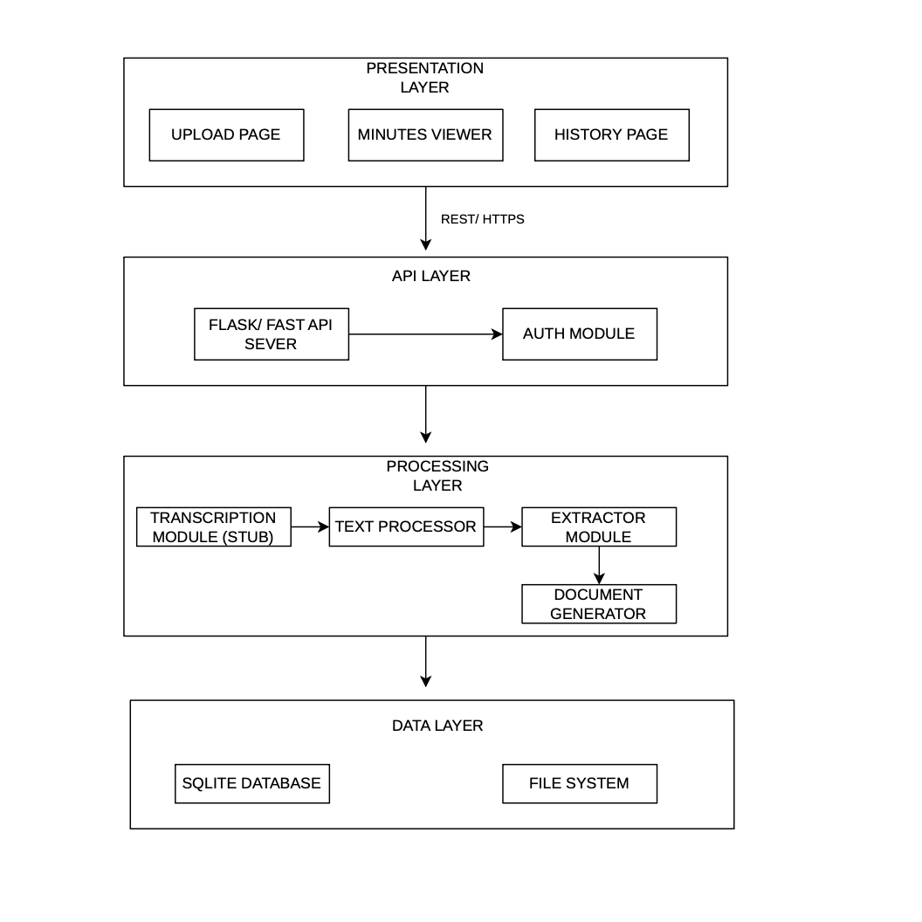
The system follows a 4-layer architecture: Presentation → API → Processing → Data.

3.4 Component Descriptions
Component | Responsibility | Key Classes/Modules
Upload Page | Audio file selection, meeting metadata input, upload trigger | UploadForm, FileValidator (frontend)
Minutes Viewer | Display generated minutes, allow action item editing, trigger PDF export | MinutesDisplay, ActionItemEditor (frontend)
History Page | List past meetings, provide search/filter, navigate to minutes | MeetingList, SearchBar (frontend)
Flask/FastAPI Server | Route HTTP requests, orchestrate pipeline, return responses | app.py, route handlers
Auth Module | User registration, login, session management, password hashing | auth.py, User model
Transcription Module (Stub) | Accept audio file reference, return simulated transcript text | transcriber.py, StubTranscriber class
Text Preprocessor | Normalize transcript (whitespace, case, line breaks) for extraction | preprocessor.py, TextNormalizer class
Extractor Module | Parse transcript using keyword patterns/regex to extract action items, deadlines, assignees, decisions, discussion points | extractor.py, ActionItemExtractor, DeadlineParser, AssigneeExtractor, DecisionExtractor
Document Generator | Assemble extracted data into Markdown using Jinja2 templates, convert to PDF | generator.py, MinutesTemplate, PDFExporter
SQLite Database | Store users, meetings, minutes, action items | models.py, SQLAlchemy ORM
File System | Store uploaded audio files and generated PDF outputs | storage.py, UUID-based file naming

3.5 Chosen Architecture Pattern and Rationale
Pattern: Layered Architecture (4 layers)
Layer | Components | Responsibility
Presentation | React / HTML+CSS+JS frontend | User interaction, display
API | Flask/FastAPI REST server | Request routing, validation, response formatting
Processing | Transcription, Preprocessor, Extractor, Generator | Business logic, data transformation
Data | SQLite + File System | Persistence, storage

Why Layered Architecture?
- Separation of concerns — Each layer has a clear responsibility; changes in one layer don't ripple through others
- Testability — Each layer can be unit tested independently
- Simplicity — Easy to understand and implement for a team of 4
- Matches the pipeline nature — The processing flow maps naturally to sequential layers

Alternatives Considered and Rejected:
Pattern | Reason for Rejection
Microservices | Overly complex for a 4-person team project; adds deployment overhead
Event-driven | Unnecessary for synchronous request-response processing
Monolithic (no layers) | Would create tightly coupled code that's hard to test and maintain

3.6 Technology Stack & Data Stores
Layer | Technology | Justification
Frontend | HTML + CSS + JavaScript (or React) | Simple, widely known, sufficient for the UI needs
Backend Framework | Python Flask / FastAPI | Lightweight, excellent for REST APIs, large ecosystem
Transcription | Custom stub module | Returns pre-defined text; swappable for Whisper API later
Text Processing | Python re (regex) + spaCy (optional) | Powerful pattern matching for keyword extraction
Template Engine | Jinja2 | Industry-standard Python templating for generating Markdown
PDF Generation | WeasyPrint | Converts HTML/CSS to PDF; open-source and reliable
ORM | SQLAlchemy | Pythonic database abstraction; supports SQLite and PostgreSQL
Database | SQLite | Zero-configuration, file-based; perfect for development and demo
Password Hashing | bcrypt | Industry-standard secure hashing algorithm
Authentication | Flask-Login / JWT | Session management with secure token-based auth

3.7 Risks & Mitigations
# | Risk | Impact | Probability | Mitigation
R1 | Stub transcription produces unrealistic text | Low quality demo | Medium | Prepare realistic pre-written transcripts from actual meeting scenarios
R2 | Keyword extraction misses action items or produces false positives | Inaccurate minutes | High | Allow users to edit extracted items (MM-F-012); refine keyword patterns iteratively
R3 | PDF generation fails for complex Markdown content | Feature unavailable | Low | Use simple, well-tested HTML templates; add fallback Markdown download
R4 | Team member unavailable during critical phase | Schedule delay | Medium | Cross-train on modules; document all code with docstrings
R5 | Merge conflicts due to all members editing same files | Lost work | Medium | Clear module ownership; frequent small commits; branch-per-feature workflow
R6 | Large audio file uploads cause server timeout | Poor user experience | Low | Enforce 100 MB file size limit (MM-F-003); chunked upload if needed

3.8 Traceability to Requirements
SRS Requirement | Design Component | SAD Section
MM-F-001, MM-F-002, MM-F-003 (Upload & Validation) | Upload Page + /upload API + FileValidator | 3.4, 4.3
MM-F-004, MM-F-005 (Transcription) | Transcription Module (Stub) | 3.4, 4.2
MM-F-018 (Text Preprocessing) | Text Preprocessor | 3.4
MM-F-006 to MM-F-009, MM-F-019, MM-F-020 (Extraction) | Extractor Module | 3.4, 4.2
MM-F-010, MM-F-011 (Document Generation & PDF) | Document Generator | 3.4, 4.2
MM-F-012 (Edit Action Items) | Minutes Viewer + /minutes API | 3.4, 4.3
MM-F-013 to MM-F-015 (History & Search) | History Page + /history, /search API + SQLite | 3.4, 4.3
MM-F-016, MM-F-017 (Auth & Meeting Setup) | Auth Module + /auth API | 3.4, 4.3
MM-SR-001 to MM-SR-006 (Security) | Security Architecture (STRIDE) | 3.9
MM-NF-001 to MM-NF-006 (Non-Functional) | Architecture decisions, tech stack | 3.5, 3.6

3.9 Security Architecture

Threat Modeling (STRIDE)
Threat Category | Threat Description | Affected Component | Mitigation | SRS Req
Spoofing | Attacker impersonates a legitimate user by stealing session token | Auth Module | Use secure HTTP-only cookies; implement session timeout (30 min); use bcrypt for password hashing | MM-SR-002, MM-SR-003
Tampering | Attacker modifies uploaded audio file or meeting data in transit | API Layer, File System | Enforce HTTPS/TLS 1.2+ for all communication; validate file integrity on server | MM-SR-001
Repudiation | User denies uploading a file or modifying minutes | API Layer | Maintain timestamped audit logs for all uploads, edits, and deletions | MM-NF-006
Information Disclosure | Unauthorized user accesses another user's meeting minutes or audio files | Data Layer, API Layer | Enforce user-based access control on all API endpoints; store files with UUID names | MM-SR-006
Denial of Service | Attacker uploads extremely large files to exhaust server resources | Upload API | Enforce 100 MB file size limit; restrict allowed MIME types; rate limiting | MM-F-003, MM-SR-005
Elevation of Privilege | Attacker exploits input fields to execute SQL injection or XSS | API Layer, Database | Validate and sanitize all inputs server-side; use parameterized queries via ORM | MM-SR-004

Security Controls Summary
Control | Implementation
Authentication | bcrypt password hashing (cost factor >= 10), secure session management
Authorization | User-based access control — users can only access their own meetings
Transport Security | HTTPS with TLS 1.2+ in production
Input Validation | Server-side validation of all inputs; MIME type checking for uploads
File Security | UUID-based filenames; files stored outside web root
Session Security | HTTP-only cookies; 30-minute inactivity timeout
Logging | Timestamped logs for all critical operations; no sensitive data in logs

4. Design

4.1 Design Overview
The system follows a sequential processing pipeline triggered by user action:
1. User uploads audio file + meeting metadata via the web UI
2. Backend validates and stores the file
3. Transcription module (stub) generates text from audio
4. Preprocessor normalizes the text
5. Extractor module identifies action items, deadlines, assignees, decisions, and discussion points
6. Document generator assembles a structured Markdown minutes document
7. User can view, edit action items, and export as PDF

4.2 UML Sequence Diagrams

Sequence Diagram 1 — Upload, Process, and Generate Minutes
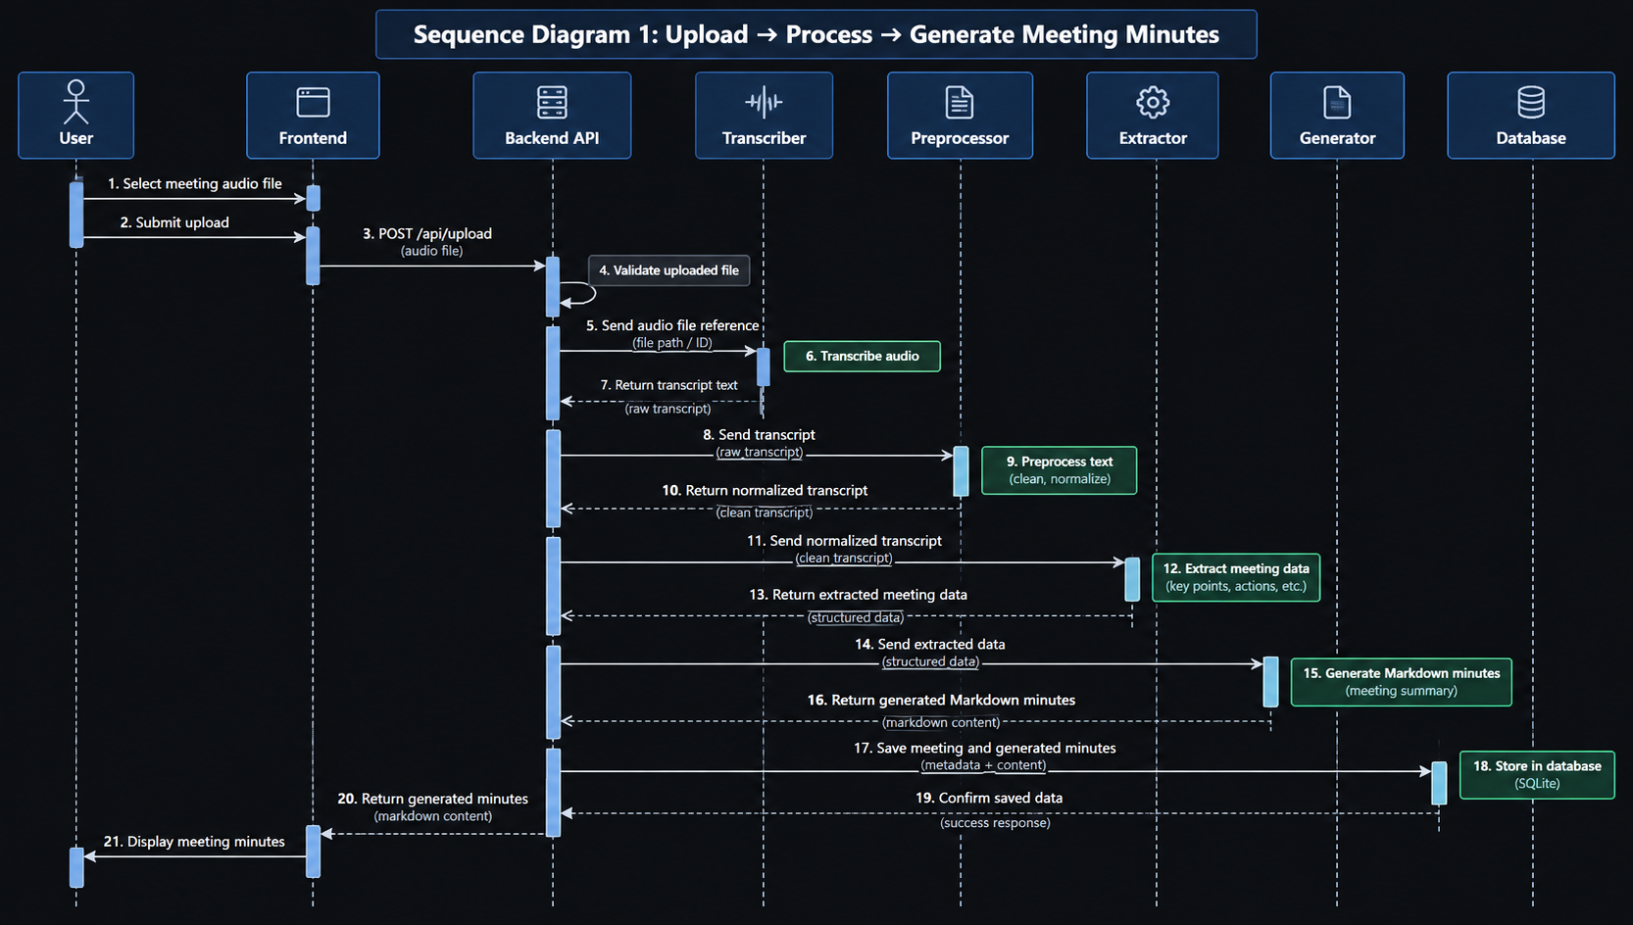

Sequence Diagram 2 — View History and Export PDF
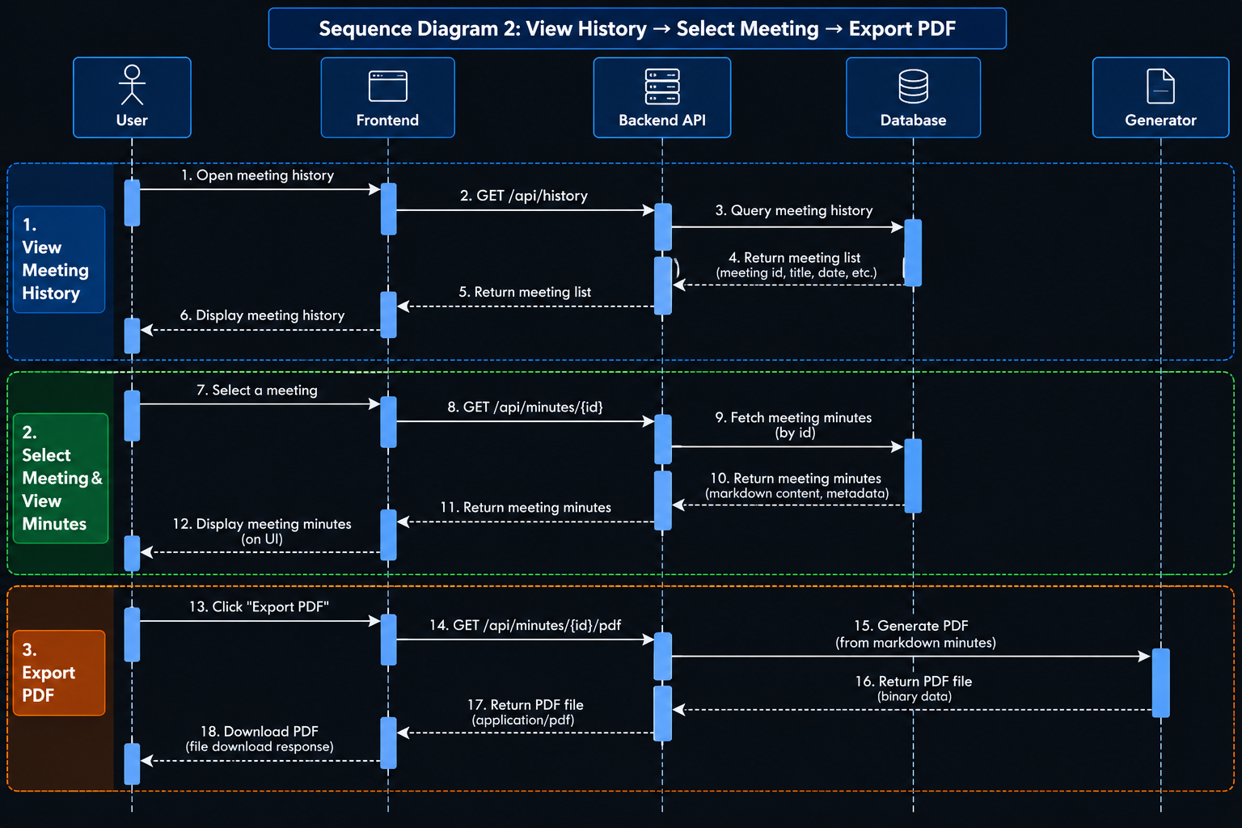

4.3 API Design

Authentication Endpoints
Endpoint | Method | Request Body | Response | Description
/api/auth/register | POST | { "email": "...", "password": "..." } | 201 { "message": "User created", "user_id": "..." } | Register new user
/api/auth/login | POST | { "email": "...", "password": "..." } | 200 { "token": "...", "user_id": "..." } | Login and receive session token
/api/auth/logout | POST | (none — token in header) | 200 { "message": "Logged out" } | End session

Upload & Processing Endpoints
Endpoint | Method | Request | Response | Description
/api/upload | POST | multipart/form-data: file, title, date, participants | 202 { "meeting_id": "...", "status": "processing" } | Upload audio and start processing
/api/meetings/{id}/status | GET | — | 200 { "status": "processing" / "complete" / "error" } | Check processing status

Minutes Endpoints
Endpoint | Method | Request | Response | Description
/api/minutes/{id} | GET | — | 200 { "meeting": {...}, "minutes": {...}, "action_items": [...] } | Get generated minutes
/api/minutes/{id}/actions | PUT | { "action_items": [...] } | 200 { "message": "Updated" } | Edit action items
/api/minutes/{id}/pdf | GET | — | 200 (binary PDF) | Download PDF export

History & Search Endpoints
Endpoint | Method | Request | Response | Description
/api/history | GET | Query: ?page=1&limit=10 | 200 { "meetings": [...], "total": N } | List past meetings (paginated)
/api/search | GET | Query: ?q=keyword&from=date&to=date | 200 { "results": [...] } | Search past minutes

Error Response Format
HTTP Code | Type | When Used
400 | VALIDATION_ERROR | Invalid input, unsupported file format, file too large
401 | AUTHENTICATION_ERROR | Missing or invalid credentials / session expired
403 | AUTHORIZATION_ERROR | User trying to access another user's data
404 | NOT_FOUND | Meeting or minutes not found
500 | INTERNAL_ERROR | Unexpected server error

4.4 Error Handling, Logging & Monitoring

Error Handling Strategy
Layer | Strategy
Frontend | Display user-friendly error messages; show form validation errors inline; show toast notifications for server errors
API Layer | Return standardized JSON error responses; catch all exceptions with a global error handler; never expose stack traces to clients
Processing Layer | Each pipeline module catches its own exceptions and returns a structured error result; pipeline coordinator handles partial failures gracefully
Data Layer | ORM handles connection errors with retry logic; database constraint violations return meaningful errors

Logging Strategy
Log Level | Usage | Example
INFO | Successful operations | [INFO] 2026-09-25T10:30:00Z - User uploaded meeting "Sprint Review"
WARNING | Recoverable issues | [WARN] 2026-09-25T10:30:05Z - No action items extracted for meeting
ERROR | Failures | [ERROR] 2026-09-25T10:30:10Z - PDF generation failed: WeasyPrint timeout
Logging Rules:
- All logs include ISO 8601 timestamps (MM-NF-006)
- No sensitive data (passwords, tokens) in logs
- Log file rotation: daily, retain 30 days
- Structured format: [LEVEL] TIMESTAMP - MESSAGE (context)

4.5 UX Design

Home Page (Audio Upload)
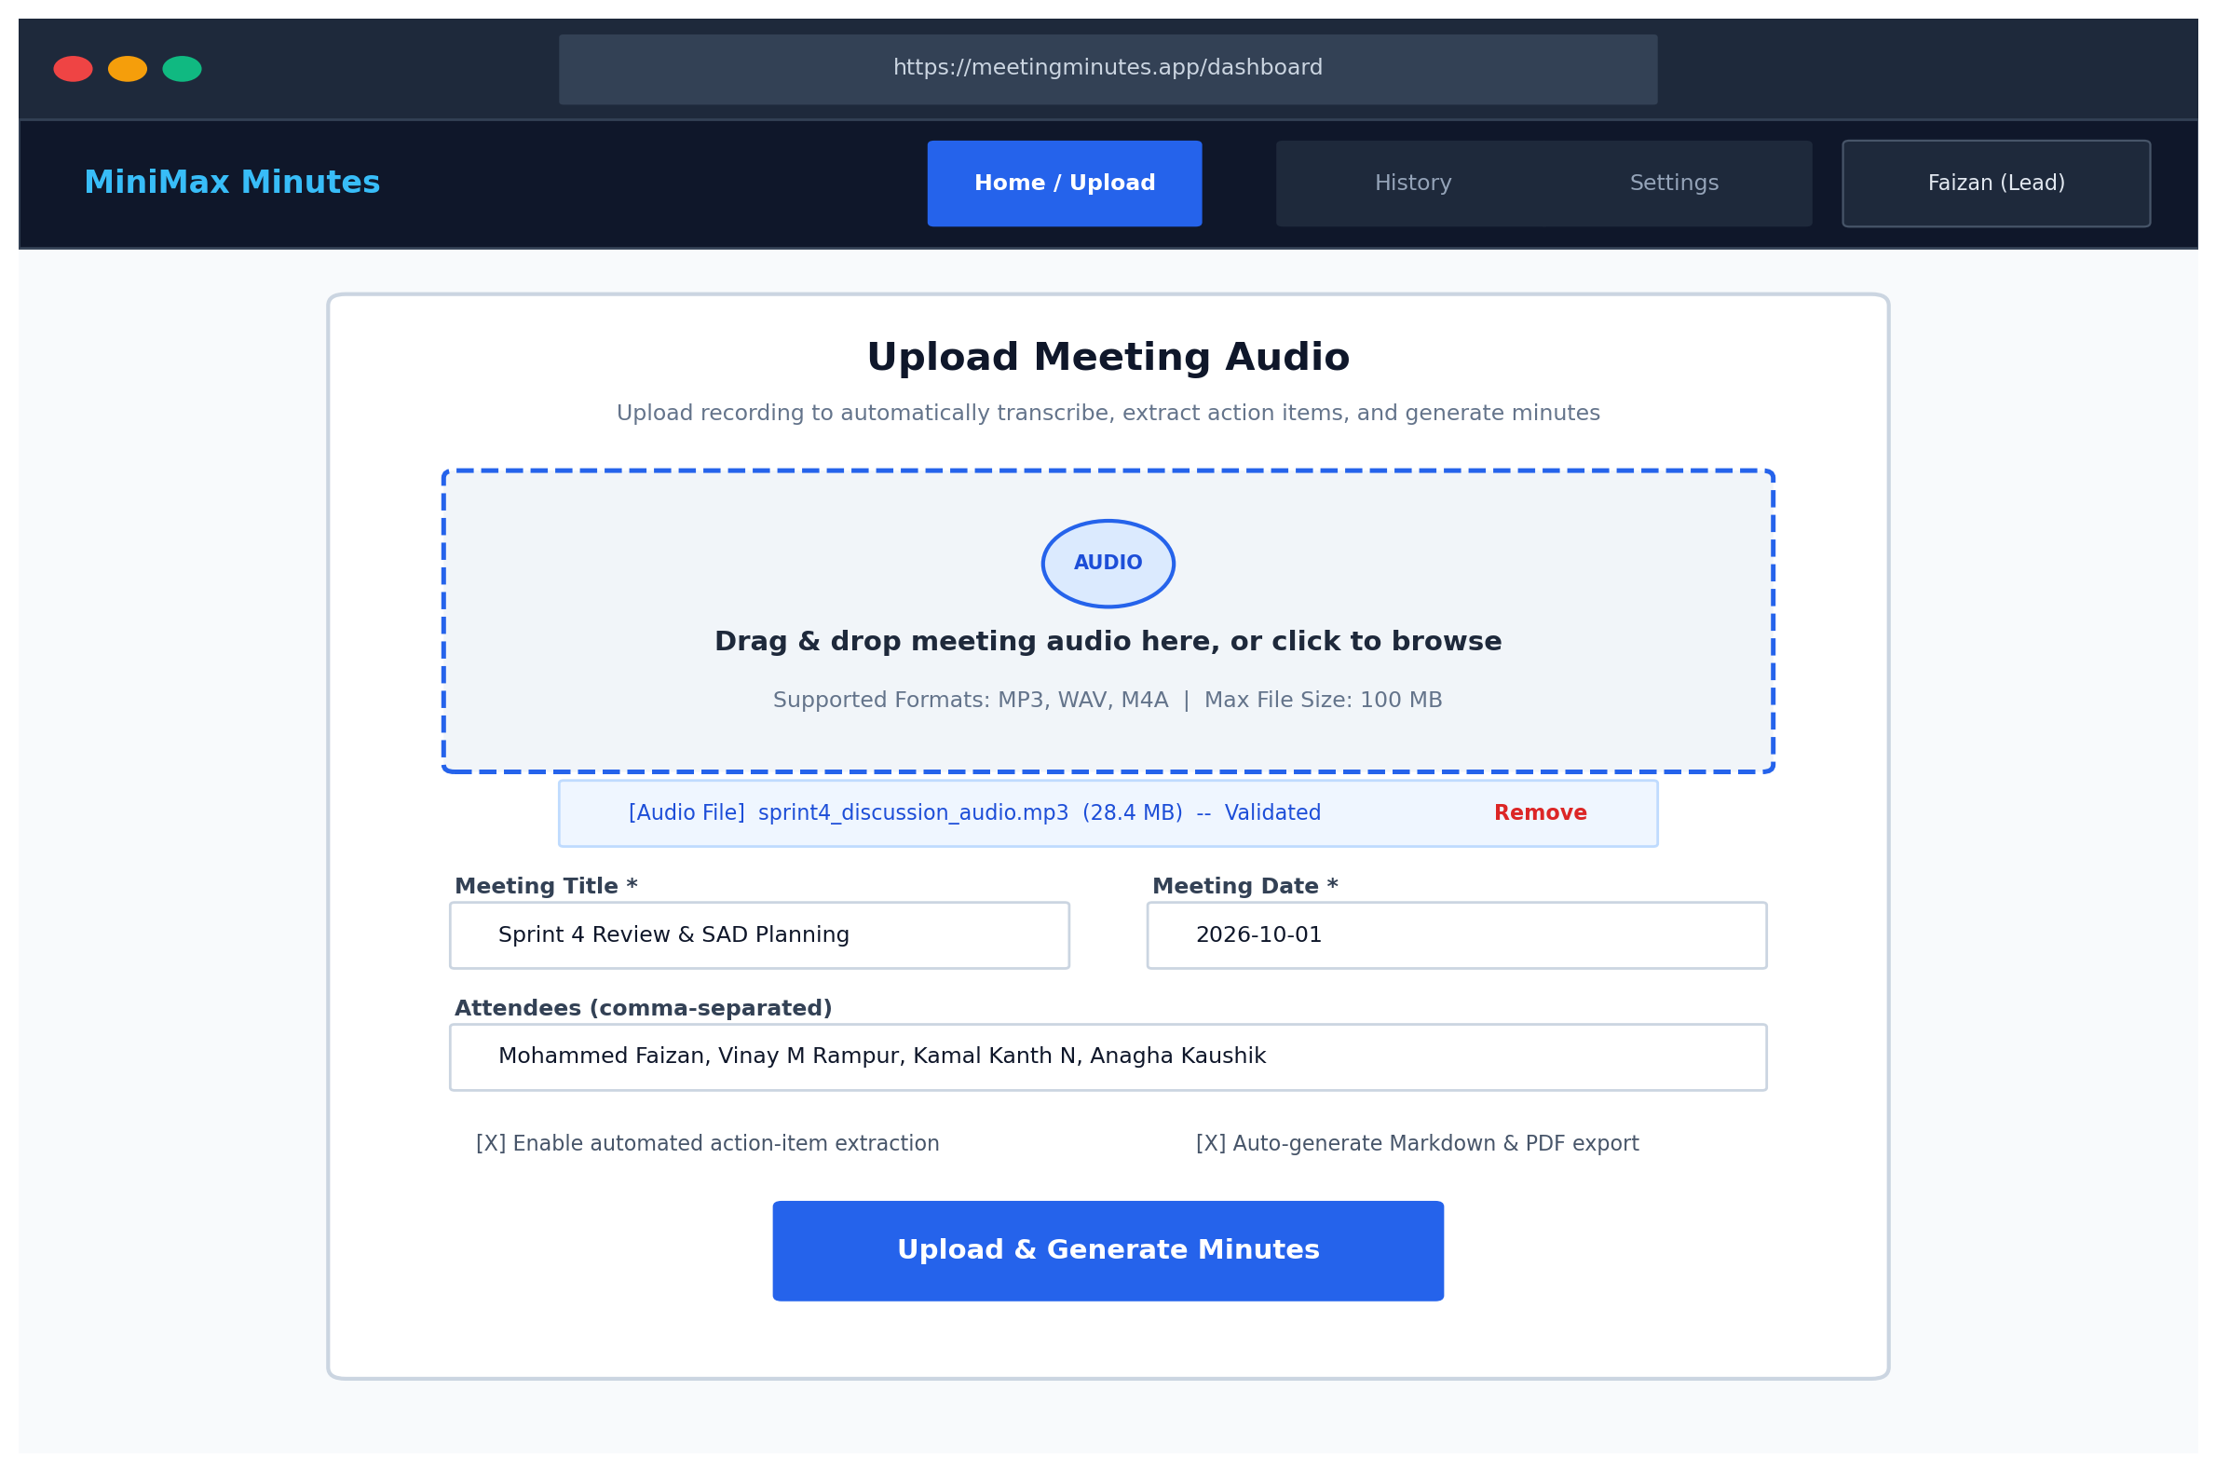

Minutes Viewer (Minutes Display & Action Items Editor)
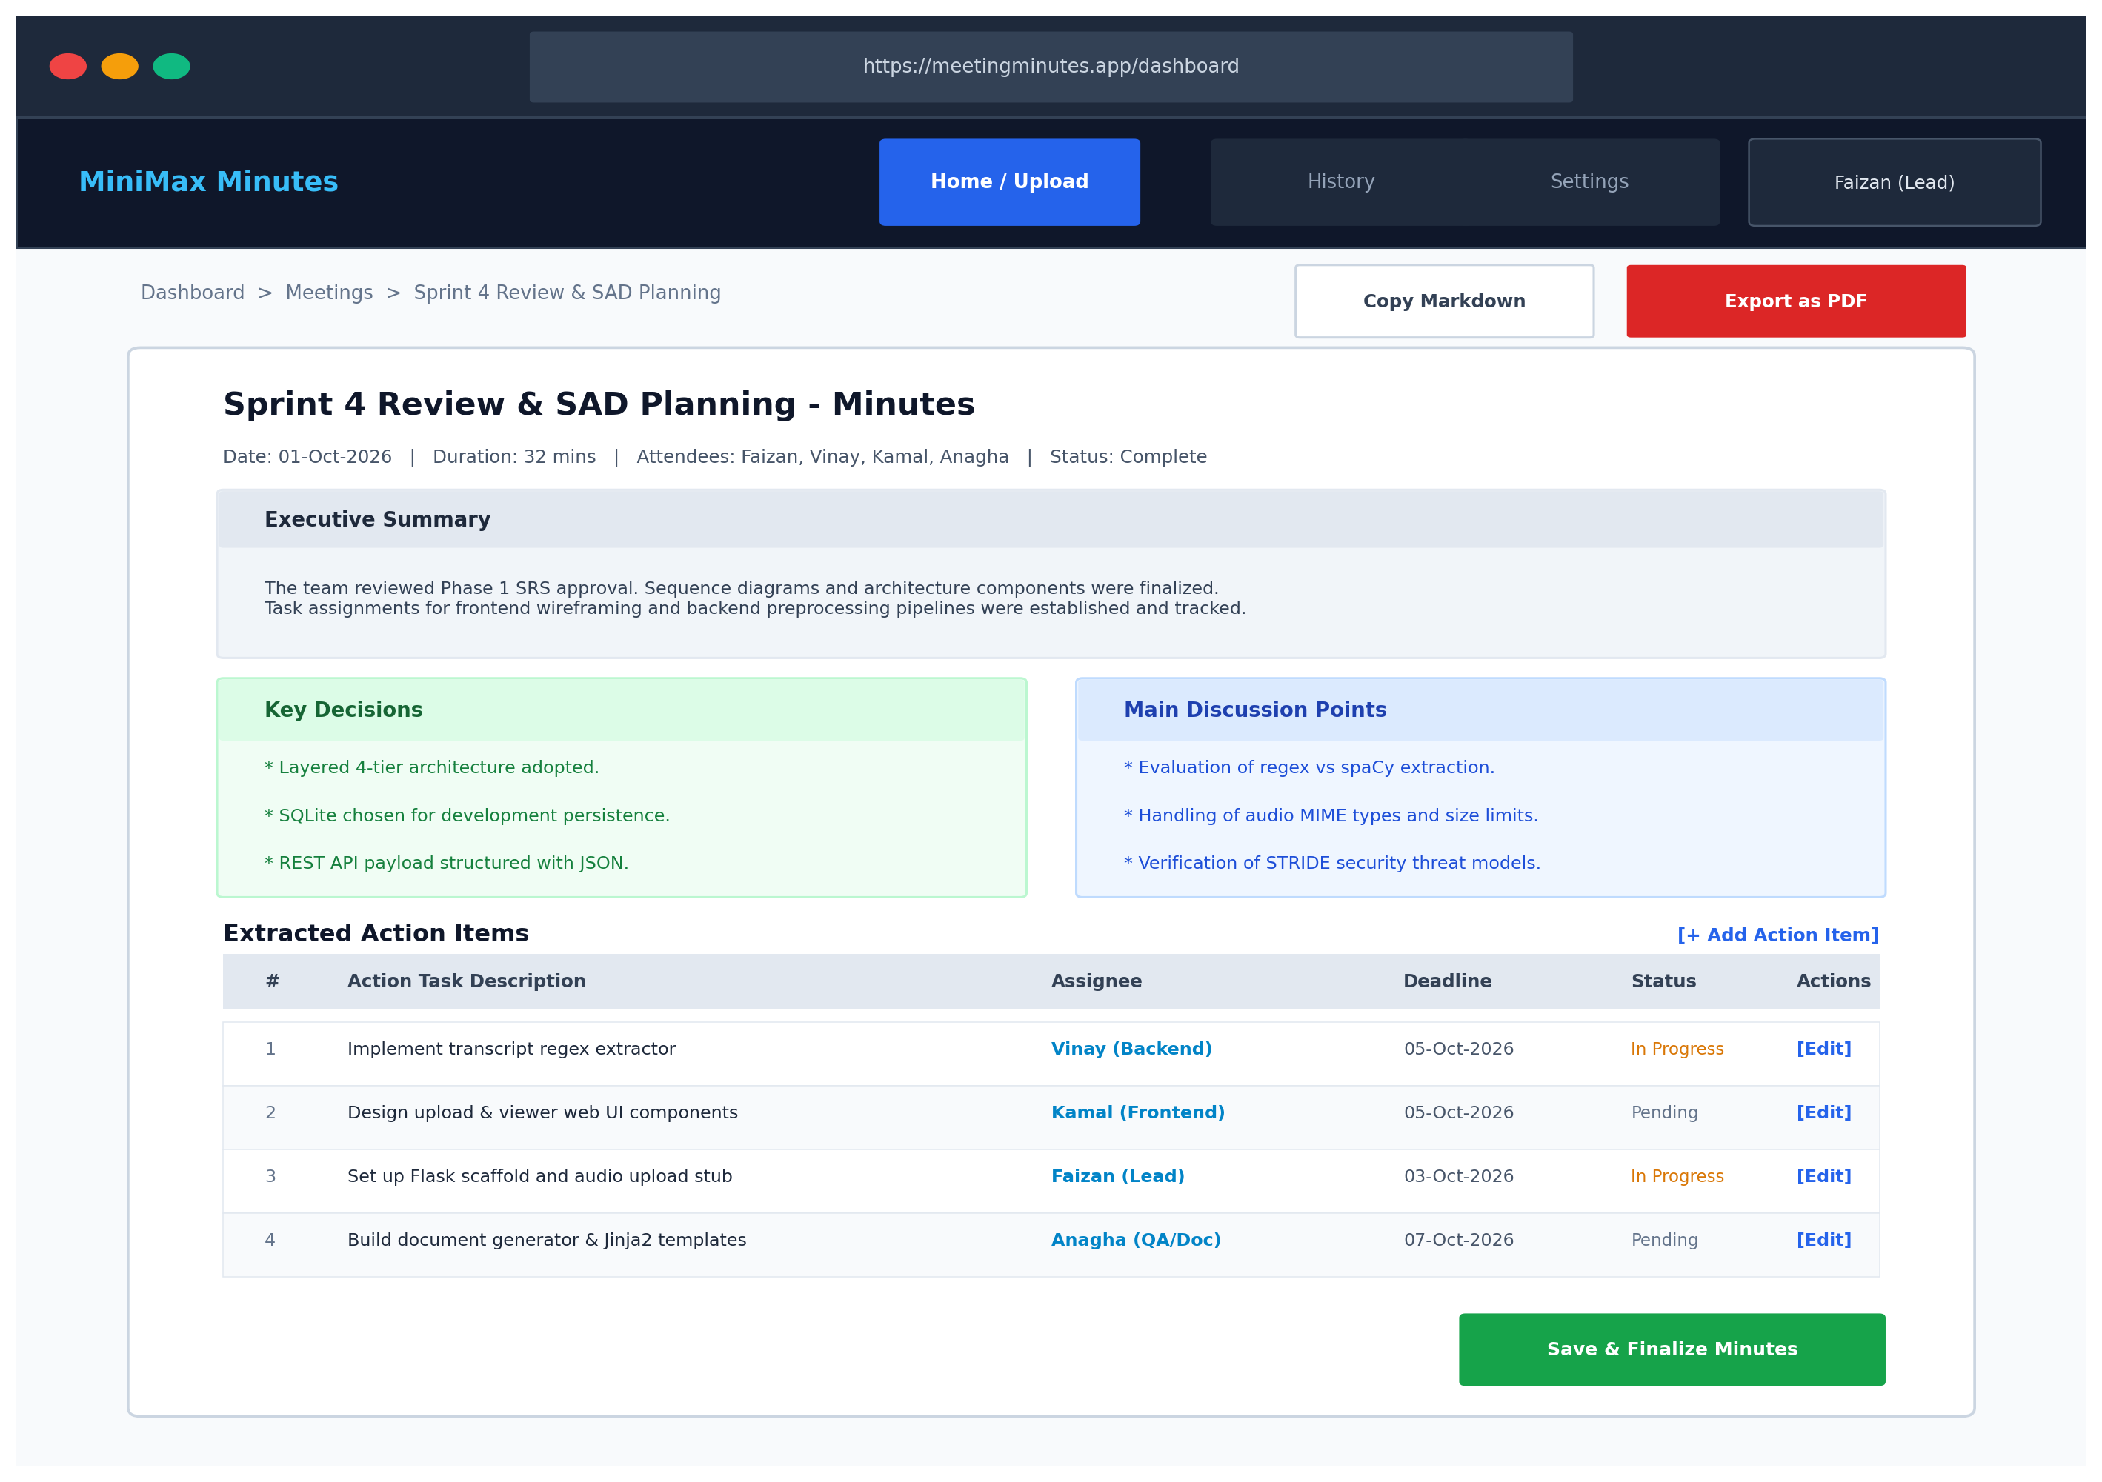

History Page (Searchable Archive)
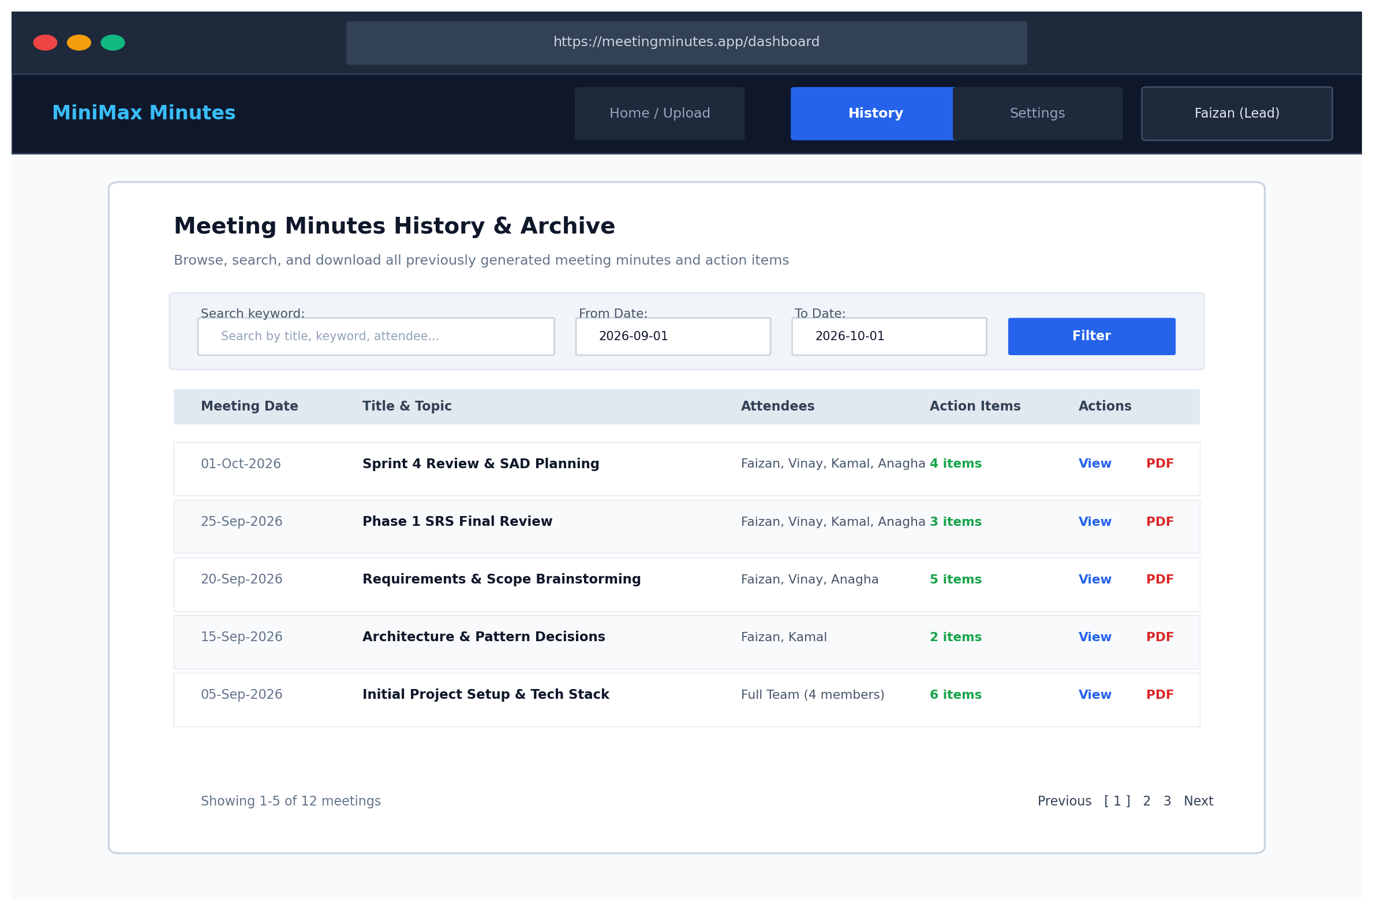

4.6 Database Design
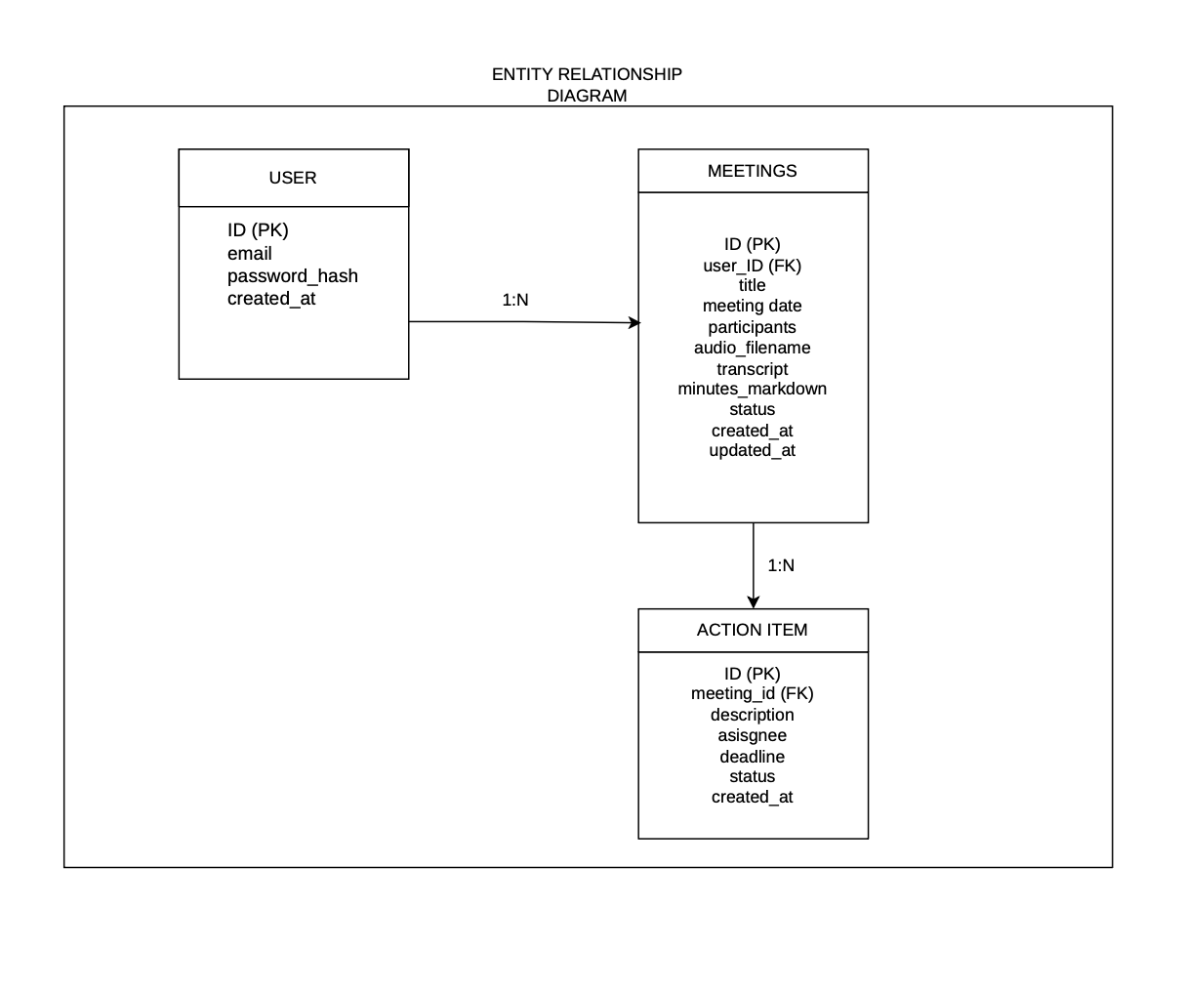
The database consists of 3 tables: users, meetings, and action_items.

Table: users
Column | Type | Constraints | Description
id | INTEGER | PRIMARY KEY, AUTOINCREMENT | Unique user ID
email | VARCHAR(255) | UNIQUE, NOT NULL | User email address
password_hash | VARCHAR(255) | NOT NULL | bcrypt hashed password
created_at | DATETIME | NOT NULL, DEFAULT NOW | Account creation timestamp

Table: meetings
Column | Type | Constraints | Description
id | INTEGER | PRIMARY KEY, AUTOINCREMENT | Unique meeting ID
user_id | INTEGER | FK → users.id, NOT NULL | Owner of the meeting
title | VARCHAR(255) | NOT NULL | Meeting title
meeting_date | DATE | NOT NULL | Date of the meeting
participants | TEXT | NULLABLE | Comma-separated participant names
audio_filename | VARCHAR(255) | NOT NULL | UUID-based stored filename
transcript | TEXT | NULLABLE | Full transcribed text
minutes_markdown | TEXT | NULLABLE | Generated Markdown minutes
status | VARCHAR(20) | NOT NULL, DEFAULT 'uploaded' | processing / complete / error
created_at | DATETIME | NOT NULL, DEFAULT NOW | Record creation timestamp
updated_at | DATETIME | NOT NULL, DEFAULT NOW | Last modification timestamp

Table: action_items
Column | Type | Constraints | Description
id | INTEGER | PRIMARY KEY, AUTOINCREMENT | Unique action item ID
meeting_id | INTEGER | FK → meetings.id, NOT NULL | Parent meeting
description | TEXT | NOT NULL | Action item text
assignee | VARCHAR(100) | NULLABLE, DEFAULT 'Unassigned' | Person responsible
deadline | DATE | NULLABLE | Due date
status | VARCHAR(20) | NOT NULL, DEFAULT 'pending' | pending / done
created_at | DATETIME | NOT NULL, DEFAULT NOW | Record creation timestamp

4.7 Open Issues & Next Steps
# | Issue | Status | Owner
1 | Finalize frontend technology choice (React vs plain HTML/CSS/JS) | Open | Kamal Kanth N
2 | Define realistic stub transcription sample texts for demo | Open | Mohammed Faizan
3 | Determine if spaCy is needed or regex alone is sufficient | Open | Vinay M Rampur
4 | Create proper UML diagrams to replace text diagrams | Open | Anagha Kaushik

5. Appendices

5.1 Glossary
See Section 1.4 (Definitions).

5.2 References
Reference | Description
IEEE 42010:2011 | Systems and software engineering — Architecture description
OWASP Top 10 | Web application security risks
STRIDE | Microsoft threat modeling methodology
Flask Documentation | https://flask.palletsprojects.com/
SQLAlchemy Documentation | https://docs.sqlalchemy.org/
WeasyPrint Documentation | https://weasyprint.org/

5.3 Tools
Tool | Usage
draw.io / diagrams.net | UML component, sequence, and ER diagrams
Figma / draw.io | UI wireframes and mockups
PlantUML | Alternative UML diagram generation
Swagger / OpenAPI | API documentation (optional)
Git & GitHub | Version control and collaboration

— End of SAD Document — Version 1.0 —

