**Chapter** Ⅰ

**Introduction and It’s Background**

# Introduction

An educational establishment that is privately managed and funded referred to as private school. School institute, in contrast to public schools, are usually tuition-base and not supported by the government. Private schools are renowned for offering topnotch instruction, more extracurricular activities, and smaller class sizes. They frequently place a high priority on education, character development, and individualized instruction, enabling students to thoroughly explore their interests and abilities. Private schools place a strong emphasis on individualized attention, a supportive community, and committed teachers in an effort to give students a wellrounded education and set them up for success in the future. The purpose of a school webpage is to provide a centralized platform for communication, information sharing, and information access for students. When looking for something specific, such as a course, it's simple to see or swiftly seek up the information you need, including the school's education contact number, activities, and update

# Background of the study

IETI Clamber is one of private school in Calamba city, and its located in Brgy San Jose burgos street near at Senior Calamba. is IETI Calamba started at year 2001 at Brgy Pabalan street Calamba City Schools often maintain websites to provide es information to students, and the community. Some reasons why schools need a webpage. Schools can showcase their programs, facilities, faculty, and achievements on their websites to attract prospective students. Overall, a well-maintained website enhances communication, accessibility, and engagement within the school community, contributing to a positive learning environment.

## Statement of the problem

1.How can the webpage help to attract the future enrollees?

2.How can the webpage optimize to all devices?

3.How can the webpage secure the devices?

## Objective of the study

* To create a webpage that can attract more students
* To be able for the user, to find the webpage easy and fast in any modern devices
* To be able create a webpage that capable to all devices

**Conceptual Framework**

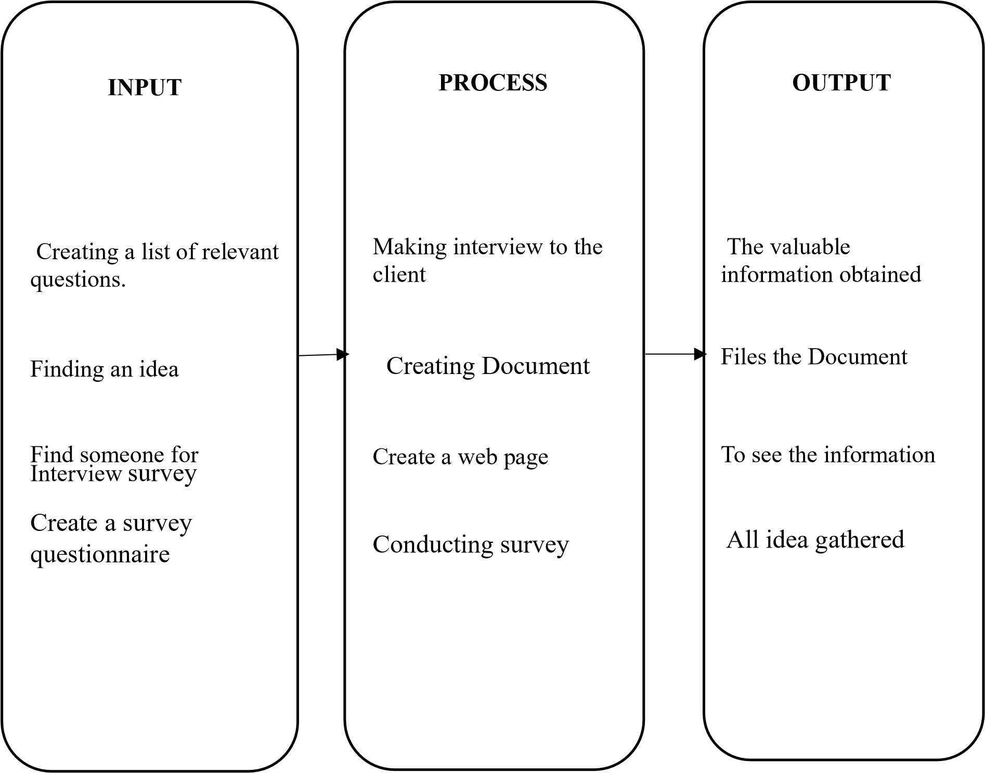

## Hypothesis

The goal of creating an easiness and optimized webpage is to inform potential students about the programs and updates offered by the school, as well as what information is available about the tuition fees and any scholarship opportunities. This would help the school attract more students by letting them know about the courses offered and providing information about the courses themselves.

## Scope and Delimitation

The scope of the web page are the faculty profiles and their areas of expertise. Student resource, including schedules, study materials, and support services. News and events related to the school. online application and registration processes. The google forms area also included.

The web page would not include personal student data for privacy reasons. In-depth financial information or transactions could be handled through a separate secure portal. Detailed research papers or sensitive academic materials may not be accessible publicly.

## Significance of the study

The findings of this study will benefit the following group of people.

**Student**: Web pages keep students updated on the latest developments in their field of study.

**Teacher:** Important announcements, such as class schedules, exam dates, and school events, can be conveniently posted on the webpage.

**Future Enrollees**: A webpage provides 24/7 accessibility, allowing potential enrollees to gather information at their convenience.

**The Researchers:** Having a well-designed webpage enhances your credibility as a researcher, making it easier for others to trust and cite your work.

**The Future Researchers:** Webpages can be updated in real-time, ensuring that researchers can stay informed about the latest developments in a particular field.

## Definition of Terms

For better understanding of the different terms used in study, the following words together with their definitions are listed.

**Publicly:** Adverb describing something done in an open or visible manner, accessible to or involving the general public.

**Renowned:** Adjective indicating something or someone widely acclaimed and highly respected, often due to excellence or achievements.

**Swiftly:** Adverb denoting a high speed or quickness in action, happening without delay.

**Well-rounded:** Adjective describing someone or something that is

comprehensive, balanced, and possesses a diverse range of skills or qualities.

## “ Formulating a Questions to be used in Interview”

1. What are the problem you encountered in terms of number of enrollee? what solution you made to solve it?

1. Does the school have webpage on its own? do you think it will help in promote the school?

3.What are the admissions school requirements?

1. What is the origin and history of IETI Calamba?

1. Upon graduation from IETI Calamba, what certificates are available to students?

1. How can the school enhance the activity for students?

1. Do you have job opening? if yes, what are the job open?

1. Can you please provide us how can we contact the school

**Chapter** II

## Review of Related Literature Studies

Foreign and Local Studies

ENROLLMENT AND BILLING SYSTEM

According to Source (2009-2010) the enrollment system will automatically get the student’s subject/section for hassle-free enrollment, this is for student without any pending back subject while for students with pending back subject, they still need to meet their department chairs/coordinator first for the advising of subjects before using the enrollment system. According to The Global Online Enrollment System (GOES) (2015) Enrollment System allows registered users to enter their own applications for U.S. Customs and Border Protection (CBP) Trusted Traveler Programs, and approved members to edit their information as needed (mistakes on the original application cannot be corrected once the application is certified your mistakes will need to be brought to the attention of CBP during your interview). Once a completed application is certified by the applicant and the non-refundable payment is successfully processed, CBP will review it and determine whether or not to conditionally approve the application

## International and Local Student Satisfaction: Resources and Capabilities Perspective

In this paper, we develop a conceptual model for assessing student satisfaction with universities and the likelihood of students recommending their institutions to other prospective students. Student satisfaction is conceptualised as a mediator between resources and capabilities and recommendation. The resources and capabilities that contribute to student satisfaction are identified as teaching, learning, technology, library, student services and student orientation. The resource needs of local and international students are compared. The data are analyse through path modelling, which results in a holistic perspective of the relationships.

## Exploring key themes and trends in international student mobility research A systematic literature review

The global landscape of higher education has witnessed a steady increase in the mobility of international students, as more individuals seek diverse academic experiences and cross-cultural learning opportunities. This paper conducts a systematic literature review to investigate trends, research directions and key themes in the literature. By utilizing the push–pull factor model the aim is to provide a comprehensive understanding of the factors influencing international students’ choices to pursue higher education and future career opportunities abroad

### Foreign and Local literature

COLLEGE INFORMATION SYSTEM

The rapid growth of Information in today’s world call for technology to be used in handling the ever increasing Information. Universities and Colleges keep tons of information about their students, academic staff, research and etcetera. Through studying the current existing system, it was easier to design and develop a functional, scalable and efficient Information System for the College of Computer Science and Information Technology. In-line with today’s technology, the College Information System eliminates most of the paper work within the college. Information concerning students, Courses and lecturers can well be managed using the system as opposed to paper work, which is associated with; time wastage, loss of information, inefficiency in updating records, and inaccuracy.

College-bound prospects perceive university

Participants felt that when Web pages address environmental content, a general mix of 70 percent text and 30 percent graphics was optimal. it would be useful to understand the impact of information that is not in the control of college and university officials but is available to prospective students. Accessing e-books through academic Library This article examines access to electronic books as provided on the Web sites of academic libraries in the Association of Research Libraries (ARL). Our goal was to discover the ways in which that access occurs and to analyze the merit of the various approaches. We found some common barriers to access, as well as many cases of exemplary access. Many libraries could improve access to e-books by providing guidance to the content of e-book packages, by including the word "book" In links from the homepage to the pages that provide e-books, by providing a one-step step limit to e- books in the catalog, by explaining which types of resources are available through search structures outside the catalog, and by featuring e-books in library publicity and instruction.

### The Importance of educational websites

An educational website Is a huge interactive platform to present various information for different types of people: future students, current students, teachers, parents, those who want to get a new profession, etc. All the sections have to be well-balanced and organized so users can easily find everything they need. It’s a common thing that students and their parents look for more information about any educational organization. To make informed decisions, they need information about the management and infrastructure, as well as about the courses and services offered. In addition, such websites are essential tools for communication and skill development for teachers, professors, and educational staff.

### Synthesis

Both using the web site help every student to be active whenever needed. This is where they base their universities so they expand the use of the web site. Their knowledge increased by using this web site they actively keep up with. And they can investigate using the internet through which they know what is happening in any sector. As competition in the education industry increases, public and private schools increasingly view the student as a consumer and market their institutions.

It examines the role of the internet in communicating educational opportunities from two angles: students’ use of the internet to gather information and make decisions. While past research has highlighted different factors influencing the effectiveness of course websites, the relative importance of these factors across various online learning experience groups remains empirically undetermined.

Recruitment pages usually use an objective approach with textual content that emphasizes facts and data to highlight the benefits of studying at the institution.

**Chapter** III

**Research Methodology**

### Research Design

The study utilized a survey-based approach to assess the effectiveness of a webpage Among school of IETI Calamba, using quantitative method researcher the we observe That the webpage is of great help to IETI Calamba to attract more student.

### Participants

The researchers selected 100 random respondent from different locations to participate in printed survey, there were 47 males and 54 females.

|  |  |  |
| --- | --- | --- |
| **Gender** | **Number of Respondents** | **Percentage** |
| Male | **46** | **46%** |
| Female | **54** | **54%** |
| Total | **100** | **100%** |

### Data Collection Tools

A printed survey with a questionnaire. In addition to requesting the testifier consent, the First piece of the question sheet included an introduction to the researchers and the study itself. Given the offline method is so important for consumers who don’t always have access to wifi or data networks Researchers have chosen to use it. By ensuring that individuals without reliable internet access can somehow make full use of the services or research findings, this approach expands accessibility inclusivity.

### Data Gathering Procedure

* On November 30, 2023, the researchers had a face-to-face meeting

the head director of IETI Calamba to conduct an interview as part of the said study.

* Following the interview, the researchers used a printed survey form to collect data regarding the IETI Calamba
* The survey was effectively carried out with the participation of 100 individuals randomly selected from various locations. These, individual we’re able to view the webpage interface and actively took part as respondents.
* Following the collection of data from the survey, the researchers initiated the process of the data interpretation.

### Data Analysis

The researchers conducted a survey using printed questionnaires to collect data from individuals residing in different locations. A total of 100 respondents participated in the survey, sharing their particular information. Afterwards, they cleaned and merged the collected data to prepare it for further analysis and utilization in their study.

The formal used to evaluate the gathered raw data is

P=F/T x 100

P =Percentage

F =Frequency

T = Total of Respondents

### Ethical Consideration

Surveys on printed forms are used as a means of collecting data for the research project, with the goal of learning what people think about the usability, dependability and functioning of the web page. In order to ensure the anonymity of the respondents' identities and foster mutual respect, the researchers manage the data they collect with the utmost secrecy.

### Survey Questionnaire

Name (Optional): ____________

Address (Optional): ____________

Age: ______________

Sex: _____________

**1.**Rate 1-5 as student how can you note the attractiveness of the webpage? (5 is highest and 1 is lowest)

**(_) 5**

**(_) 4**

**(_) 3**

**(_) 2**

### (_) 1

2.Did the webpage fulfill your satisfaction about the school?

(_) Yes

(_) No

3. Does the webpage help you to know the information of school?

(_) Strongly agree

**(_)** Agree

(_) Strongly Disagree

(_) Disagree

1. Are you satisfied with the webpage capability for mobile devices?

(_) Very Satisfied

(_) Satisfied

(_) Very Dissatisfied

(_) Dissatisfied

1. How easy is it for you to navigate and find the location of IETI Calamba through webpage?

(_) Very easy

(_) Somewhat easy

(_) Somewhat Difficult

(_) Very Difficult

1. How long it’s can take when you open the webpage?

(_) 15second

(_) 10second

(_) 5second

(_) 1second

1. How satisfied are you with the current level of security measures implemented by most websites you visit??

(_) Strongly satisfied

(_) Satisfied

(_) Strongly dissatisfied

(_) Dissatisfied

1. How frequently do you update your passwords for online accounts to enhance security?

(_) Every day

(_) Every week

(_) Every month

(_) Every year

9.On a scale of 1 to 5, how concerned are you about the security of your personal

information when using websites? ( 5 is the highest and 1 is the lowest )

(_) 5

(_) 6

(_) 3

(_) 2

(_) 1

10.Do you have any recommendations or suggestions to improve this webpage?