Слесарев Н.Д. ФИТ-231

Лабораторная работа 3: Фоновые задачи, сервисы. WorkManager. Broadcast Receiver. Content Provider

Цель работы

Освоить механизмы выполнения фоновых задач в Android приложениях. Изучить подходы к работе с сервисами, отложенными задачами, системными событиями и обменом данными между приложениями.

Контрольное задание
- Создайте приложение для управления задачами (To-Do приложение) с фоновой синхронизацией:
  - Используйте Room для локального хранения задач
  - Используйте https://jsonplaceholder.typicode.com/ вместо реального API
  - Реализуйте REST API клиент для синхронизации с сервером
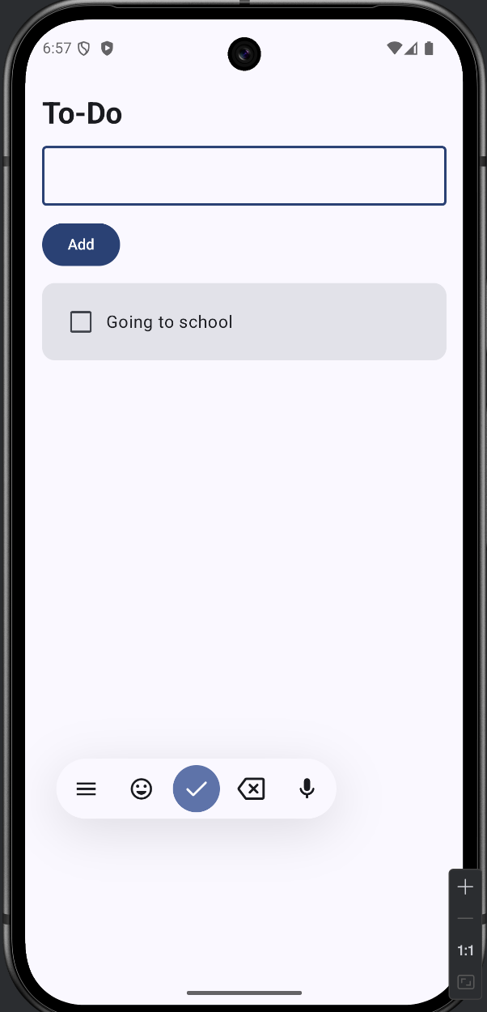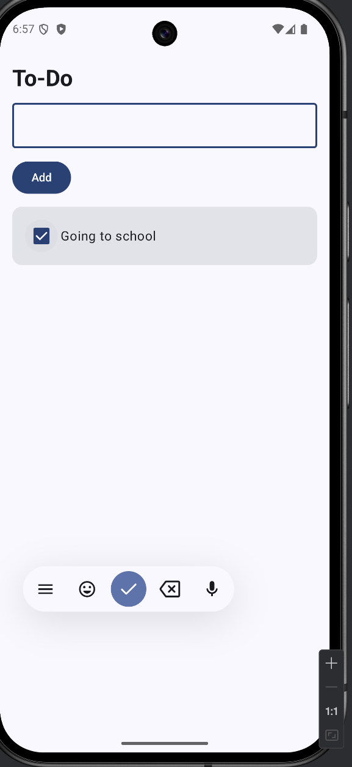
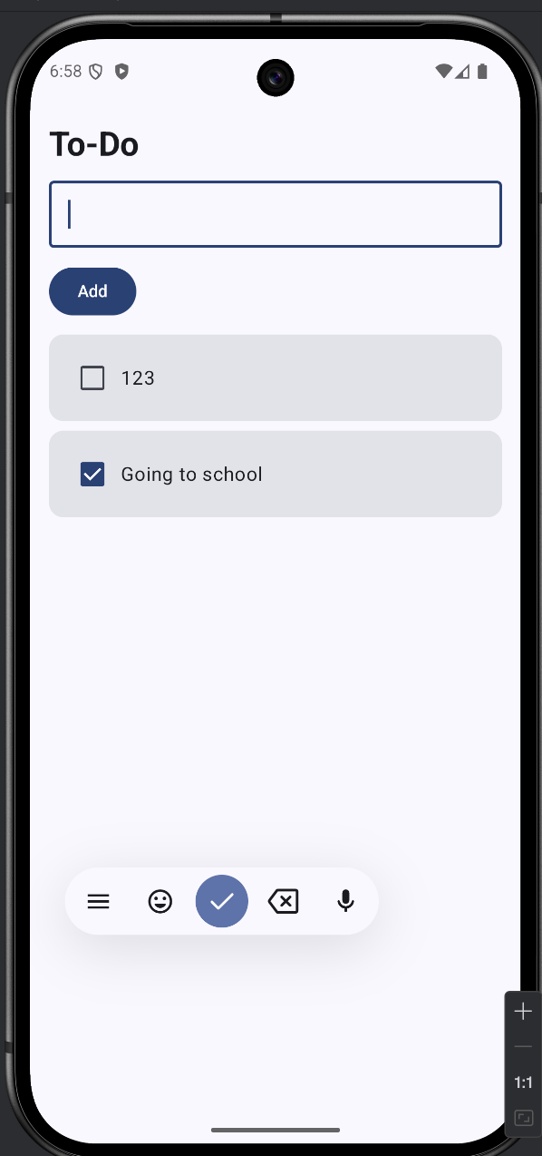
package com.example.sem6lab3
import android.os.Bundle
import androidx.activity.ComponentActivity
import androidx.activity.compose.setContent
import androidx.activity.enableEdgeToEdge
import androidx.compose.foundation.layout.Arrangement
import androidx.compose.foundation.layout.Column
import androidx.compose.foundation.layout.Row
import androidx.compose.foundation.layout.fillMaxSize
import androidx.compose.foundation.layout.fillMaxWidth
import androidx.compose.foundation.layout.padding
import androidx.compose.foundation.lazy.LazyColumn
import androidx.compose.foundation.lazy.items
import androidx.compose.material3.Button
import androidx.compose.material3.Card
import androidx.compose.material3.Checkbox
import androidx.compose.material3.MaterialTheme
import androidx.compose.material3.OutlinedTextField
import androidx.compose.material3.Scaffold
import androidx.compose.material3.Text
import androidx.compose.runtime.Composable
import androidx.compose.runtime.collectAsState
import androidx.compose.runtime.getValue
import androidx.compose.runtime.mutableStateOf
import androidx.compose.runtime.remember
import androidx.compose.runtime.setValue
import androidx.compose.ui.Alignment
import androidx.compose.ui.Modifier
import androidx.compose.ui.text.font.FontWeight
import androidx.compose.ui.unit.dp
import androidx.lifecycle.viewmodel.compose.viewModel
import com.example.sem6lab3.ui.theme.Sem6lab3Theme
class MainActivity : ComponentActivity() {
override fun onCreate(savedInstanceState: Bundle?) {
super.onCreate(savedInstanceState)
enableEdgeToEdge()
setContent {
Sem6lab3Theme {
val viewModel: TodoViewModel = viewModel(factory = TodoViewModel.factory(application))
val todos by viewModel.todos.collectAsState()
var title by remember { mutableStateOf("") }
Scaffold(modifier = Modifier.fillMaxSize()) { padding ->
Column(
modifier = Modifier
.padding(padding)
.padding(16.dp)
.fillMaxSize(),
verticalArrangement = Arrangement.spacedBy(12.dp)
) {
Text("To-Do", style = MaterialTheme.typography.headlineMedium, fontWeight = FontWeight.Bold)
OutlinedTextField(
value = title,
onValueChange = { title = it },
modifier = Modifier.fillMaxWidth(),
singleLine = true
)
Button(onClick = {
viewModel.add(title)
title = ""
}) {
Text("Add")
}
LazyColumn(verticalArrangement = Arrangement.spacedBy(8.dp)) {
items(todos, key = { it.id }) { todo ->
Card(modifier = Modifier.fillMaxWidth()) {
Row(
modifier = Modifier
.fillMaxWidth()
.padding(12.dp),
verticalAlignment = Alignment.CenterVertically
) {
Checkbox(checked = todo.completed, onCheckedChange = {
viewModel.toggle(todo)
})
Text(todo.title)
}
}
}
}
}
}
}
}
}
}

package com.example.sem6lab3.data
import androidx.room.Dao
import androidx.room.Insert
import androidx.room.OnConflictStrategy
import androidx.room.Query
import androidx.room.Update
import kotlinx.coroutines.flow.Flow
@Dao
interface TodoDao {
@Query("SELECT * FROM todos ORDER BY id DESC")
fun observeTodos(): Flow<List<TodoEntity>>
@Query("SELECT * FROM todos WHERE synced = 0")
suspend fun unsyncedTodos(): List<TodoEntity>
@Insert(onConflict = OnConflictStrategy.REPLACE)
suspend fun insert(todo: TodoEntity): Long
@Update
suspend fun update(todo: TodoEntity)
}

package com.example.sem6lab3.data
import androidx.room.Entity
import androidx.room.Index
import androidx.room.PrimaryKey
@Entity(tableName = "todos", indices = [Index(value = ["remoteId"], unique = true)])
data class TodoEntity(
@PrimaryKey(autoGenerate = true) val id: Long = 0,
val title: String,
val completed: Boolean = false,
val remoteId: Long? = null,
val synced: Boolean = false
)

package com.example.sem6lab3.data
import androidx.room.Database
import androidx.room.RoomDatabase
@Database(entities = [TodoEntity::class], version = 2)
abstract class TodoDatabase : RoomDatabase() {
abstract fun todoDao(): TodoDao
}

package com.example.sem6lab3.data
import com.example.sem6lab3.network.TodoRequest
import com.example.sem6lab3.network.TodoApi
import kotlinx.coroutines.Dispatchers
import kotlinx.coroutines.flow.Flow
import kotlinx.coroutines.withContext
class TodoRepository(
private val database: TodoDatabase,
private val api: TodoApi
) {
private val dao = database.todoDao()
val todos: Flow<List<TodoEntity>> = dao.observeTodos()
suspend fun add(title: String) = withContext(Dispatchers.IO) {
dao.insert(TodoEntity(title = title, synced = false))
}
suspend fun toggle(todo: TodoEntity) = withContext(Dispatchers.IO) {
dao.update(todo.copy(completed = !todo.completed, synced = false))
}
suspend fun sync() = withContext(Dispatchers.IO) {
dao.unsyncedTodos().forEach { todo ->
val request = TodoRequest(title = todo.title, completed = todo.completed)
val remote = if (todo.remoteId == null) {
api.createTodo(request)
} else {
api.updateTodo(todo.remoteId, request)
}
dao.update(todo.copy(remoteId = remote.id, synced = true))
}
}
}

package com.example.sem6lab3
import android.content.Context
import androidx.room.Room
import com.example.sem6lab3.data.TodoDatabase
import com.example.sem6lab3.data.TodoRepository
import com.example.sem6lab3.network.TodoApi
import com.google.gson.Gson
import retrofit2.Retrofit
import retrofit2.converter.gson.GsonConverterFactory
object AppGraph {
private var database: TodoDatabase? = null
private var api: TodoApi? = null
fun repository(context: Context) = TodoRepository(database(context), api())
private fun database(context: Context) =
database ?: synchronized(this) {
database ?: Room.databaseBuilder(
context.applicationContext,
TodoDatabase::class.java,
"todo.db"
).fallbackToDestructiveMigration().build().also { database = it }
}
private fun api() =
api ?: synchronized(this) {
api ?: Retrofit.Builder()
.baseUrl("https://jsonplaceholder.typicode.com/")
.addConverterFactory(GsonConverterFactory.create(Gson()))
.build()
.create(TodoApi::class.java)
.also { api = it }
}
}

package com.example.sem6lab3.network
import retrofit2.http.Body
import retrofit2.http.GET
import retrofit2.http.POST
import retrofit2.http.Path
import retrofit2.http.PUT
import retrofit2.http.Query
interface TodoApi {
@POST("todos")
suspend fun createTodo(@Body body: TodoRequest): TodoDto
@PUT("todos/{id}")
suspend fun updateTodo(@Path("id") id: Long, @Body body: TodoRequest): TodoDto
}

package com.example.sem6lab3.network
import com.example.sem6lab3.data.TodoEntity
data class TodoDto(
val userId: Long,
val id: Long,
val title: String,
val completed: Boolean
)
data class TodoRequest(
val title: String,
val completed: Boolean,
val userId: Long = 1
)
fun TodoDto.toEntity() = TodoEntity(title = title, completed = completed, remoteId = id, synced = true)

package com.example.sem6lab3
import android.app.Application
class TodoApp : Application() {
override fun onCreate() {
super.onCreate()
TodoSyncScheduler.schedule(this)
}
}

package com.example.sem6lab3
import android.content.Context
import androidx.work.ExistingPeriodicWorkPolicy
import androidx.work.PeriodicWorkRequestBuilder
import androidx.work.WorkManager
import java.util.concurrent.TimeUnit
object TodoSyncScheduler {
fun schedule(context: Context) {
val request = PeriodicWorkRequestBuilder<TodoSyncWorker>(15, TimeUnit.MINUTES).build()
WorkManager.getInstance(context).enqueueUniquePeriodicWork(
"todo_sync",
ExistingPeriodicWorkPolicy.UPDATE,
request
)
}
}

package com.example.sem6lab3
import android.content.Context
import androidx.work.CoroutineWorker
import androidx.work.WorkerParameters
class TodoSyncWorker(context: Context, params: WorkerParameters) : CoroutineWorker(context, params) {
override suspend fun doWork() = runCatching {
AppGraph.repository(applicationContext).sync()
Result.success()
}.getOrElse {
Result.retry()
}
}

<?xml version="1.0" encoding="utf-8"?>
<manifest xmlns:android="http://schemas.android.com/apk/res/android"
xmlns:tools="http://schemas.android.com/tools">
<uses-permission android:name="android.permission.INTERNET" />
<application
android:allowBackup="true"
android:dataExtractionRules="@xml/data_extraction_rules"
android:fullBackupContent="@xml/backup_rules"
android:icon="@mipmap/ic_launcher"
android:name=".TodoApp"
android:label="@string/app_name"
android:roundIcon="@mipmap/ic_launcher_round"
android:supportsRtl="true"
android:theme="@style/Theme.Sem6lab3">
<activity
android:name=".MainActivity"
android:exported="true"
android:label="@string/app_name"
android:theme="@style/Theme.Sem6lab3">
<intent-filter>
<action android:name="android.intent.action.MAIN" />
<category android:name="android.intent.category.LAUNCHER" />
</intent-filter>
</activity>
</application>
</manifest>

- Реализуйте периодическую синхронизацию через WorkManager:
  - Создайте SyncTasksWorker для синхронизации задач каждые 15 минут
  - Синхронизация должна выполняться только при наличии интернета
  - Сохраняйте время последней синхронизации
package com.example.sem6lab3
import android.content.Context
object SyncPrefs {
private const val FILE = "sync_prefs"
private const val KEY_LAST_SYNC = "last_sync"
fun saveLastSync(context: Context, time: Long) {
context.getSharedPreferences(FILE, Context.MODE_PRIVATE)
.edit()
.putLong(KEY_LAST_SYNC, time)
.apply()
}
fun lastSync(context: Context): Long {
return context.getSharedPreferences(FILE, Context.MODE_PRIVATE)
.getLong(KEY_LAST_SYNC, 0L)
}
}

package com.example.sem6lab3
import android.content.Context
import androidx.work.Constraints
import androidx.work.ExistingPeriodicWorkPolicy
import androidx.work.NetworkType
import androidx.work.PeriodicWorkRequestBuilder
import androidx.work.WorkManager
import java.util.concurrent.TimeUnit
object TodoSyncScheduler {
fun schedule(context: Context) {
val constraints = Constraints.Builder()
.setRequiredNetworkType(NetworkType.CONNECTED)
.build()
val request = PeriodicWorkRequestBuilder<SyncTasksWorker>(15, TimeUnit.MINUTES)
.setConstraints(constraints)
.build()
WorkManager.getInstance(context).enqueueUniquePeriodicWork(
"todo_sync",
ExistingPeriodicWorkPolicy.UPDATE,
request
)
}
}

package com.example.sem6lab3
import android.content.Context
import androidx.work.CoroutineWorker
import androidx.work.WorkerParameters
class SyncTasksWorker(context: Context, params: WorkerParameters) : CoroutineWorker(context, params) {
override suspend fun doWork(): Result = runCatching {
AppGraph.repository(applicationContext).sync()
SyncPrefs.saveLastSync(applicationContext, System.currentTimeMillis())
Result.success()
}.getOrElse {
Result.retry()
}
}

package com.example.sem6lab3.data
import com.example.sem6lab3.network.TodoRequest
import com.example.sem6lab3.network.TodoApi
import kotlinx.coroutines.Dispatchers
import kotlinx.coroutines.flow.Flow
import kotlinx.coroutines.withContext
class TodoRepository(
private val database: TodoDatabase,
private val api: TodoApi
) {
private val dao = database.todoDao()
val todos: Flow<List<TodoEntity>> = dao.observeTodos()
suspend fun add(title: String) = withContext(Dispatchers.IO) {
dao.insert(TodoEntity(title = title, synced = false))
}
suspend fun toggle(todo: TodoEntity) = withContext(Dispatchers.IO) {
dao.update(todo.copy(completed = !todo.completed, synced = false))
}
suspend fun sync() = withContext(Dispatchers.IO) {
dao.unsyncedTodos().forEach { todo ->
val request = TodoRequest(title = todo.title, completed = todo.completed)
val remote = if (todo.remoteId == null) {
api.createTodo(request)
} else {
api.updateTodo(todo.remoteId, request)
}
dao.update(todo.copy(remoteId = remote.id, synced = true))
}
}
}
package com.example.sem6lab3
import android.app.Application
class TodoApp : Application() {
override fun onCreate() {
super.onCreate()
TodoSyncScheduler.schedule(this)
}
}

- Добавьте Broadcast Receiver для отслеживания подключения к сети:
  - При восстановлении интернет-соединения запускайте немедленную синхронизацию
  - Используйте WorkManager для запуска одноразовой задачи синхронизации
package com.example.sem6lab3
import android.content.BroadcastReceiver
import android.content.Context
import android.content.Intent
import android.net.ConnectivityManager
import android.net.NetworkCapabilities
import androidx.work.Constraints
import androidx.work.ExistingWorkPolicy
import androidx.work.NetworkType
import androidx.work.OneTimeWorkRequestBuilder
import androidx.work.WorkManager
class NetworkChangeReceiver : BroadcastReceiver() {
override fun onReceive(context: Context, intent: Intent) {
if (!isConnected(context)) return
val constraints = Constraints.Builder()
.setRequiredNetworkType(NetworkType.CONNECTED)
.build()
val request = OneTimeWorkRequestBuilder<SyncTasksWorker>()
.setConstraints(constraints)
.build()
WorkManager.getInstance(context).enqueueUniqueWork(
"sync_tasks_now",
ExistingWorkPolicy.KEEP,
request
)
}
private fun isConnected(context: Context): Boolean {
val manager = context.getSystemService(Context.CONNECTIVITY_SERVICE) as ConnectivityManager
val network = manager.activeNetwork ?: return false
val caps = manager.getNetworkCapabilities(network) ?: return false
return caps.hasCapability(NetworkCapabilities.NET_CAPABILITY_INTERNET)
}
}

package com.example.sem6lab3
import android.app.Application
import android.content.IntentFilter
import android.net.ConnectivityManager
import androidx.core.content.ContextCompat
class TodoApp : Application() {
private val receiver = NetworkChangeReceiver()
override fun onCreate() {
super.onCreate()
ContextCompat.registerReceiver(
this,
receiver,
IntentFilter(ConnectivityManager.CONNECTIVITY_ACTION),
ContextCompat.RECEIVER_EXPORTED
)
TodoSyncScheduler.schedule(this)
}
}

<?xml version="1.0" encoding="utf-8"?>
<manifest xmlns:android="http://schemas.android.com/apk/res/android"
xmlns:tools="http://schemas.android.com/tools">
<uses-permission android:name="android.permission.INTERNET" />
<uses-permission android:name="android.permission.ACCESS_NETWORK_STATE" />
<application
android:allowBackup="true"
android:dataExtractionRules="@xml/data_extraction_rules"
android:fullBackupContent="@xml/backup_rules"
android:icon="@mipmap/ic_launcher"
android:name=".TodoApp"
android:label="@string/app_name"
android:roundIcon="@mipmap/ic_launcher_round"
android:supportsRtl="true"
android:theme="@style/Theme.Sem6lab3">
<activity
android:name=".MainActivity"
android:exported="true"
android:label="@string/app_name"
android:theme="@style/Theme.Sem6lab3">
<intent-filter>
<action android:name="android.intent.action.MAIN" />
<category android:name="android.intent.category.LAUNCHER" />
</intent-filter>
</activity>
</application>
</manifest>

- Создайте Content Provider для доступа к задачам:
  - Предоставьте доступ другим приложениям к списку задач
  - Реализуйте возможность чтения и добавления задач через Content Provider
<?xml version="1.0" encoding="utf-8"?>
<manifest xmlns:android="http://schemas.android.com/apk/res/android"
xmlns:tools="http://schemas.android.com/tools">
<uses-permission android:name="android.permission.INTERNET" />
<uses-permission android:name="android.permission.ACCESS_NETWORK_STATE" />
<application
android:allowBackup="true"
android:dataExtractionRules="@xml/data_extraction_rules"
android:fullBackupContent="@xml/backup_rules"
android:icon="@mipmap/ic_launcher"
android:name=".TodoApp"
android:label="@string/app_name"
android:roundIcon="@mipmap/ic_launcher_round"
android:supportsRtl="true"
android:theme="@style/Theme.Sem6lab3">
<provider
android:name=".TodoContentProvider"
android:authorities="com.example.sem6lab3.provider"
android:exported="true" />
<activity
android:name=".MainActivity"
android:exported="true"
android:label="@string/app_name"
android:theme="@style/Theme.Sem6lab3">
<intent-filter>
<action android:name="android.intent.action.MAIN" />
<category android:name="android.intent.category.LAUNCHER" />
</intent-filter>
</activity>
</application>
</manifest>

package com.example.sem6lab3
import android.content.Context
import androidx.room.Room
import com.example.sem6lab3.data.TodoDatabase
import com.example.sem6lab3.data.TodoRepository
import com.example.sem6lab3.network.TodoApi
import com.google.gson.Gson
import retrofit2.Retrofit
import retrofit2.converter.gson.GsonConverterFactory
object AppGraph {
private var database: TodoDatabase? = null
private var api: TodoApi? = null
fun repository(context: Context) = TodoRepository(databaseInstance(context), api())
fun database(context: Context) = databaseInstance(context)
private fun databaseInstance(context: Context) =
database ?: synchronized(this) {
database ?: Room.databaseBuilder(
context.applicationContext,
TodoDatabase::class.java,
"todo.db"
).fallbackToDestructiveMigration().build().also { database = it }
}
private fun api() =
api ?: synchronized(this) {
api ?: Retrofit.Builder()
.baseUrl("https://jsonplaceholder.typicode.com/")
.addConverterFactory(GsonConverterFactory.create(Gson()))
.build()
.create(TodoApi::class.java)
.also { api = it }
}
}

package com.example.sem6lab3
import android.content.ContentProvider
import android.content.ContentUris
import android.content.ContentValues
import android.content.UriMatcher
import android.database.Cursor
import android.net.Uri
import androidx.sqlite.db.SimpleSQLiteQuery
class TodoContentProvider : ContentProvider() {
private val matcher = UriMatcher(UriMatcher.NO_MATCH).apply {
addURI(TodoContract.AUTHORITY, TodoContract.PATH_TASKS, TASKS)
addURI(TodoContract.AUTHORITY, TodoContract.PATH_TASKS_ID, TASK_ID)
}
override fun onCreate() = true
override fun query(
uri: Uri,
projection: Array<out String>?,
selection: String?,
selectionArgs: Array<out String>?,
sortOrder: String?
): Cursor? {
val db = AppGraph.database(context ?: return null).openHelper.readableDatabase
val cursor = when (matcher.match(uri)) {
TASKS -> db.query(
SimpleSQLiteQuery(
"SELECT id AS _id, title, completed, remoteId, synced FROM todos ORDER BY id DESC"
)
)
TASK_ID -> {
val id = uri.lastPathSegment ?: return null
db.query(
SimpleSQLiteQuery(
"SELECT id AS _id, title, completed, remoteId, synced FROM todos WHERE id = ?",
arrayOf(id)
)
)
}
else -> throw IllegalArgumentException("Unknown uri: $uri")
}
context?.contentResolver?.let { cursor.setNotificationUri(it, uri) }
return cursor
}
override fun insert(uri: Uri, values: ContentValues?): Uri? {
if (matcher.match(uri) != TASKS) throw IllegalArgumentException("Unknown uri: $uri")
val db = AppGraph.database(context ?: return null).openHelper.writableDatabase
val data = ContentValues().apply {
put(TodoContract.COLUMN_TITLE, values?.getAsString(TodoContract.COLUMN_TITLE) ?: "")
put(TodoContract.COLUMN_COMPLETED, values?.getAsBoolean(TodoContract.COLUMN_COMPLETED) ?: false)
putNull(TodoContract.COLUMN_REMOTE_ID)
put(TodoContract.COLUMN_SYNCED, false)
}
val id = db.insert(TodoContract.TABLE_NAME, 0, data)
context?.contentResolver?.notifyChange(TodoContract.CONTENT_URI, null)
return ContentUris.withAppendedId(TodoContract.CONTENT_URI, id)
}
override fun getType(uri: Uri): String? = when (matcher.match(uri)) {
TASKS -> "vnd.android.cursor.dir/vnd.${TodoContract.AUTHORITY}.task"
TASK_ID -> "vnd.android.cursor.item/vnd.${TodoContract.AUTHORITY}.task"
else -> null
}
override fun delete(uri: Uri, selection: String?, selectionArgs: Array<out String>?): Int = 0
override fun update(
uri: Uri,
values: ContentValues?,
selection: String?,
selectionArgs: Array<out String>?
): Int = 0
companion object {
private const val TASKS = 1
private const val TASK_ID = 2
}
}

package com.example.sem6lab3
import android.net.Uri
import android.provider.BaseColumns
object TodoContract {
const val AUTHORITY = "com.example.sem6lab3.provider"
val CONTENT_URI: Uri = Uri.parse("content://$AUTHORITY/tasks")
const val PATH_TASKS = "tasks"
const val PATH_TASKS_ID = "tasks/#"
const val TABLE_NAME = "todos"
const val COLUMN_TITLE = "title"
const val COLUMN_COMPLETED = "completed"
const val COLUMN_REMOTE_ID = "remoteId"
const val COLUMN_SYNCED = "synced"
object Tasks : BaseColumns {
const val TITLE = COLUMN_TITLE
const val COMPLETED = COLUMN_COMPLETED
const val REMOTE_ID = COLUMN_REMOTE_ID
const val SYNCED = COLUMN_SYNCED
}
}
- Добавьте уведомления о важных событиях:
  - Уведомление о завершении синхронизации
  - Уведомление о добавлении новой задачи из другого приложения
package com.example.sem6lab3
import android.content.Context
import androidx.work.CoroutineWorker
import androidx.work.WorkerParameters
class SyncTasksWorker(context: Context, params: WorkerParameters) : CoroutineWorker(context, params) {
override suspend fun doWork(): Result = runCatching {
AppGraph.repository(applicationContext).sync()
SyncPrefs.saveLastSync(applicationContext, System.currentTimeMillis())
TodoNotifications.showSyncComplete(applicationContext)
Result.success()
}.getOrElse {
Result.retry()
}
}

package com.example.sem6lab3
import android.content.ContentProvider
import android.content.ContentUris
import android.content.ContentValues
import android.content.UriMatcher
import android.database.Cursor
import android.net.Uri
import androidx.sqlite.db.SimpleSQLiteQuery
class TodoContentProvider : ContentProvider() {
private val matcher = UriMatcher(UriMatcher.NO_MATCH).apply {
addURI(TodoContract.AUTHORITY, TodoContract.PATH_TASKS, TASKS)
addURI(TodoContract.AUTHORITY, TodoContract.PATH_TASKS_ID, TASK_ID)
}
override fun onCreate() = true
override fun query(
uri: Uri,
projection: Array<out String>?,
selection: String?,
selectionArgs: Array<out String>?,
sortOrder: String?
): Cursor? {
val db = AppGraph.database(context ?: return null).openHelper.readableDatabase
val cursor = when (matcher.match(uri)) {
TASKS -> db.query(
SimpleSQLiteQuery(
"SELECT id AS _id, title, completed, remoteId, synced FROM todos ORDER BY id DESC"
)
)
TASK_ID -> {
val id = uri.lastPathSegment ?: return null
db.query(
SimpleSQLiteQuery(
"SELECT id AS _id, title, completed, remoteId, synced FROM todos WHERE id = ?",
arrayOf(id)
)
)
}
else -> throw IllegalArgumentException("Unknown uri: $uri")
}
context?.contentResolver?.let { cursor.setNotificationUri(it, uri) }
return cursor
}
override fun insert(uri: Uri, values: ContentValues?): Uri? {
if (matcher.match(uri) != TASKS) throw IllegalArgumentException("Unknown uri: $uri")
val db = AppGraph.database(context ?: return null).openHelper.writableDatabase
val data = ContentValues().apply {
put(TodoContract.COLUMN_TITLE, values?.getAsString(TodoContract.COLUMN_TITLE) ?: "")
put(TodoContract.COLUMN_COMPLETED, values?.getAsBoolean(TodoContract.COLUMN_COMPLETED) ?: false)
putNull(TodoContract.COLUMN_REMOTE_ID)
put(TodoContract.COLUMN_SYNCED, false)
}
val id = db.insert(TodoContract.TABLE_NAME, 0, data)
context?.contentResolver?.notifyChange(TodoContract.CONTENT_URI, null)
TodoNotifications.showExternalTaskAdded(context ?: return null, data.getAsString(TodoContract.COLUMN_TITLE) ?: "")
return ContentUris.withAppendedId(TodoContract.CONTENT_URI, id)
}
override fun getType(uri: Uri): String? = when (matcher.match(uri)) {
TASKS -> "vnd.android.cursor.dir/vnd.${TodoContract.AUTHORITY}.task"
TASK_ID -> "vnd.android.cursor.item/vnd.${TodoContract.AUTHORITY}.task"
else -> null
}
override fun delete(uri: Uri, selection: String?, selectionArgs: Array<out String>?): Int = 0
override fun update(
uri: Uri,
values: ContentValues?,
selection: String?,
selectionArgs: Array<out String>?
): Int = 0
companion object {
private const val TASKS = 1
private const val TASK_ID = 2
}
}

package com.example.sem6lab3
import android.app.NotificationChannel
import android.app.NotificationManager
import android.content.Context
import androidx.core.app.NotificationCompat
import androidx.core.app.NotificationManagerCompat
object TodoNotifications {
private const val CHANNEL_ID = "todo_events"
private const val CHANNEL_NAME = "Todo events"
private const val SYNC_ID = 1
private const val EXTERNAL_ID = 2
fun createChannel(context: Context) {
val manager = context.getSystemService(Context.NOTIFICATION_SERVICE) as NotificationManager
val channel = NotificationChannel(CHANNEL_ID, CHANNEL_NAME, NotificationManager.IMPORTANCE_DEFAULT)
manager.createNotificationChannel(channel)
}
fun showSyncComplete(context: Context) {
val notification = NotificationCompat.Builder(context, CHANNEL_ID)
.setSmallIcon(R.mipmap.ic_launcher)
.setContentTitle("Sync complete")
.setContentText("Tasks were synchronized")
.setAutoCancel(true)
.build()
NotificationManagerCompat.from(context).notify(SYNC_ID, notification)
}
fun showExternalTaskAdded(context: Context, title: String) {
val notification = NotificationCompat.Builder(context, CHANNEL_ID)
.setSmallIcon(R.mipmap.ic_launcher)
.setContentTitle("Task added from another app")
.setContentText(title)
.setAutoCancel(true)
.build()
NotificationManagerCompat.from(context).notify(EXTERNAL_ID, notification)
}
fun showTest(context: Context) {
val notification = NotificationCompat.Builder(context, CHANNEL_ID)
.setSmallIcon(R.mipmap.ic_launcher)
.setContentTitle("Test notification")
.setContentText("Notifications work")
.setAutoCancel(true)
.build()
NotificationManagerCompat.from(context).notify(3, notification)
}
}

package com.example.sem6lab3
import android.app.Application
import android.content.IntentFilter
import android.net.ConnectivityManager
import androidx.core.content.ContextCompat
class TodoApp : Application() {
private val receiver = NetworkChangeReceiver()
override fun onCreate() {
super.onCreate()
TodoNotifications.createChannel(this)
ContextCompat.registerReceiver(
this,
receiver,
IntentFilter(ConnectivityManager.CONNECTIVITY_ACTION),
ContextCompat.RECEIVER_EXPORTED
)
TodoSyncScheduler.schedule(this)
}
}

package com.example.sem6lab3
import android.Manifest
import android.os.Bundle
import android.os.Build
import android.content.pm.PackageManager
import androidx.activity.ComponentActivity
import androidx.activity.compose.setContent
import androidx.activity.enableEdgeToEdge
import androidx.compose.foundation.layout.Arrangement
import androidx.compose.foundation.layout.Column
import androidx.compose.foundation.layout.Row
import androidx.compose.foundation.layout.fillMaxSize
import androidx.compose.foundation.layout.fillMaxWidth
import androidx.compose.foundation.layout.padding
import androidx.compose.foundation.lazy.LazyColumn
import androidx.compose.foundation.lazy.items
import androidx.compose.material3.Button
import androidx.compose.material3.Card
import androidx.compose.material3.Checkbox
import androidx.compose.material3.MaterialTheme
import androidx.compose.material3.OutlinedTextField
import androidx.compose.material3.Scaffold
import androidx.compose.material3.Text
import androidx.compose.runtime.Composable
import androidx.compose.runtime.collectAsState
import androidx.compose.runtime.getValue
import androidx.compose.runtime.mutableStateOf
import androidx.compose.runtime.remember
import androidx.compose.runtime.setValue
import androidx.compose.ui.Alignment
import androidx.compose.ui.Modifier
import androidx.compose.ui.text.font.FontWeight
import androidx.compose.ui.unit.dp
import androidx.activity.result.contract.ActivityResultContracts
import androidx.lifecycle.viewmodel.compose.viewModel
import androidx.core.content.ContextCompat
import com.example.sem6lab3.ui.theme.Sem6lab3Theme
class MainActivity : ComponentActivity() {
private val notificationPermission = registerForActivityResult(
ActivityResultContracts.RequestPermission()
) { }
override fun onCreate(savedInstanceState: Bundle?) {
super.onCreate(savedInstanceState)
enableEdgeToEdge()
if (
Build.VERSION.SDK_INT >= Build.VERSION_CODES.TIRAMISU &&
ContextCompat.checkSelfPermission(this, Manifest.permission.POST_NOTIFICATIONS) != PackageManager.PERMISSION_GRANTED
) {
notificationPermission.launch(Manifest.permission.POST_NOTIFICATIONS)
}
setContent {
Sem6lab3Theme {
val viewModel: TodoViewModel = viewModel(factory = TodoViewModel.factory(application))
val todos by viewModel.todos.collectAsState()
var title by remember { mutableStateOf("") }
Scaffold(modifier = Modifier.fillMaxSize()) { padding ->
Column(
modifier = Modifier
.padding(padding)
.padding(16.dp)
.fillMaxSize(),
verticalArrangement = Arrangement.spacedBy(12.dp)
) {
Text("To-Do", style = MaterialTheme.typography.headlineMedium, fontWeight = FontWeight.Bold)
OutlinedTextField(
value = title,
onValueChange = { title = it },
modifier = Modifier.fillMaxWidth(),
singleLine = true
)
Button(onClick = {
viewModel.add(title)
title = ""
}) {
Text("Add")
}
Button(onClick = { TodoSyncScheduler.syncNow(this@MainActivity) }) {
Text("Sync now")
}
Button(onClick = { TodoNotifications.showTest(this@MainActivity) }) {
Text("Test notification")
}
LazyColumn(verticalArrangement = Arrangement.spacedBy(8.dp)) {
items(todos, key = { it.id }) { todo ->
Card(modifier = Modifier.fillMaxWidth()) {
Row(
modifier = Modifier
.fillMaxWidth()
.padding(12.dp),
verticalAlignment = Alignment.CenterVertically
) {
Checkbox(checked = todo.completed, onCheckedChange = {
viewModel.toggle(todo)
})
Text(todo.title)
}
}
}
}
}
}
}
}
}
}

<?xml version="1.0" encoding="utf-8"?>
<manifest xmlns:android="http://schemas.android.com/apk/res/android"
xmlns:tools="http://schemas.android.com/tools">
<uses-permission android:name="android.permission.INTERNET" />
<uses-permission android:name="android.permission.ACCESS_NETWORK_STATE" />
<uses-permission android:name="android.permission.POST_NOTIFICATIONS" />
<application
android:allowBackup="true"
android:dataExtractionRules="@xml/data_extraction_rules"
android:fullBackupContent="@xml/backup_rules"
android:icon="@mipmap/ic_launcher"
android:name=".TodoApp"
android:label="@string/app_name"
android:roundIcon="@mipmap/ic_launcher_round"
android:supportsRtl="true"
android:theme="@style/Theme.Sem6lab3">
<provider
android:name=".TodoContentProvider"
android:authorities="com.example.sem6lab3.provider"
android:exported="true" />
<activity
android:name=".MainActivity"
android:exported="true"
android:label="@string/app_name"
android:theme="@style/Theme.Sem6lab3">
<intent-filter>
<action android:name="android.intent.action.MAIN" />
<category android:name="android.intent.category.LAUNCHER" />
</intent-filter>
</activity>
</application>
</manifest>

package com.example.sem6lab3
import android.content.Context
import androidx.work.Constraints
import androidx.work.ExistingPeriodicWorkPolicy
import androidx.work.ExistingWorkPolicy
import androidx.work.NetworkType
import androidx.work.PeriodicWorkRequestBuilder
import androidx.work.OneTimeWorkRequestBuilder
import androidx.work.WorkManager
import java.util.concurrent.TimeUnit
object TodoSyncScheduler {
fun schedule(context: Context) {
val constraints = Constraints.Builder()
.setRequiredNetworkType(NetworkType.CONNECTED)
.build()
val request = PeriodicWorkRequestBuilder<SyncTasksWorker>(15, TimeUnit.MINUTES)
.setConstraints(constraints)
.build()
WorkManager.getInstance(context).enqueueUniquePeriodicWork(
"todo_sync",
ExistingPeriodicWorkPolicy.UPDATE,
request
)
}
fun syncNow(context: Context) {
val constraints = Constraints.Builder()
.setRequiredNetworkType(NetworkType.CONNECTED)
.build()
val request = OneTimeWorkRequestBuilder<SyncTasksWorker>()
.setConstraints(constraints)
.build()
WorkManager.getInstance(context).enqueueUniqueWork(
"todo_sync_now",
ExistingWorkPolicy.REPLACE,
request
)
}
}
